Josh Lothringer

GEOS 567 HW 4

1)

a.

mwls1 =

-0.8833

1.4167

mwls2 =

-1.8078

1.8433

mwls3 =

-3.2667

2.5167

b. 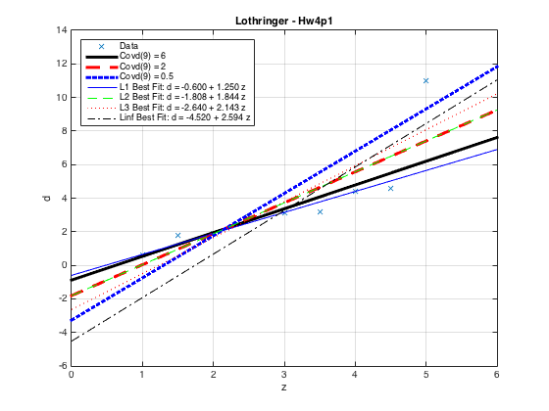

c. The larger the entry covd(9,9) in the covariance matrix for the last data point, the less the fit will ‘care’ about that point. The larger entry says that the uncertainty for that fit is larger than the other points. The fit will take this into account by not trying to fit that point as strictly. On the other hand, a smaller value will imply that the uncertainty for that point is much smaller than the others points and will therefore be fitting more strictly.

The reason that the L2 best fit and the Covd(9,9) = 2 give the same solution is because they are essentially the same thing. If all the diagonal entries of the covariance matrix are the same value, it is like have no weighting at all. Therefore, the fit will just be the unweighted least-squares solution, which is also basically what the L2 best fit is.

2.

a.

mls =

1.0000

1.0000

b. big_e =

1.9600

c. 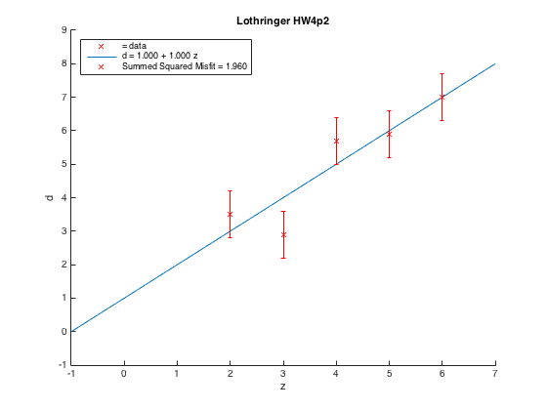

3.

a. new_mls =

0.3571

1.1429

b. new_big_e =

2.3171

c. 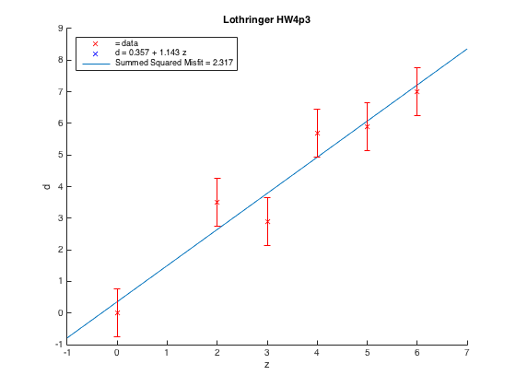

d. new_old_big_e =

2.1896

This new sum squared misfit on the original five data points is a bit larger than the one found above with the pure unweighted least squares. This is not surprising because our constraint caused a solution to be found that was *not* the best least-squares fit, which was already found using pure unweighted least squares.

e. No, the solution does not pass through the origin. This is okay, our constraint only essentially added another data point, but was in no way forcing the constraint to be satisfied.

4.

a. I find that 355 is the smallest variance to be within 0.05 of the least-squares y-intercept:

covd1 =

1 0 0 0 0 0

0 1 0 0 0 0

0 0 1 0 0 0

0 0 0 1 0 0

0 0 0 0 1 0

0 0 0 0 0 355

mwls =

0.9950

1.0011

mls =

1.0000

1.0000

b. original_big_e =

1.9600 It’s the same as the least squares solution from problem 2!

c. 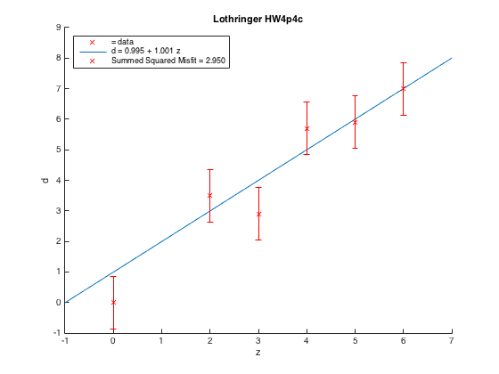

5.

a . A variance for the constraint of 0.094 gives a y-intercept of 0.0496:

covd1 =

1.0000 0 0 0 0 0

0 1.0000 0 0 0 0

0 0 1.0000 0 0 0

0 0 0 1.0000 0 0

0 0 0 0 1.0000 0

0 0 0 0 0 0.0940

b. original_big_e =

2.4618 We’ve been led ‘astray’ by the constraint!

c. 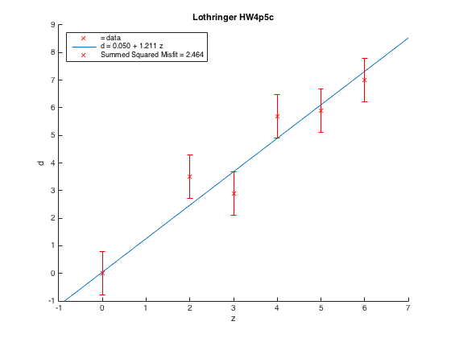

6. A variance of 0.082 and 0.084 for the fourth and last data point, respectively, give errors of 0.05 from the observed data for both of those points.

covd1 =

1.0000 0 0 0 0 0

0 1.0000 0 0 0 0

0 0 1.0000 0 0 0

0 0 0 0.0820 0 0

0 0 0 0 1.0000 0

0 0 0 0 0 0.0840

mwls =

0.0496

1.1801

new_d_pre =

2.4098 3.5898 4.7699 5.9500 7.1301 0.0496

new_d =

3.5000 2.9000 5.7000 5.9000 7.0000 0

e =

-1.0902 0.6898 -0.9301 0.0500 0.1301 0.0496

b. original_big_e =

2.5490

c.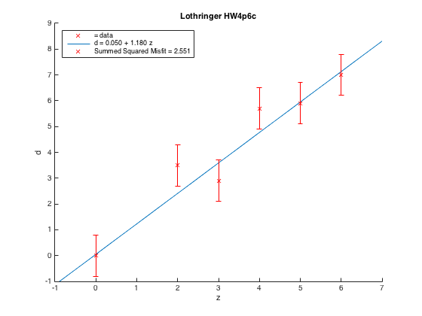

7. I’ve come to think of assigned variances as ways to modify your least-squares solution. By looking at the summed squared misfit to the original data, it’s almost as if the constraints or assigned variances are taking you away from the ‘pure’ least-squares solution. By assigning high variance to a constraint, one may recover the ‘pure’ least-squares solution.

8.

a.

lg =

0

1.2222

0.5556

b. original_big_e =

2.5156

c. 