Consolidated IPCCC Paper Development Report
  - Load- and Hardware-Aware Reallocation Coalescing in Embedded Multi-Robot Task Allocation
Recommended paper title
When Reallocation Coalescing Helps: Load- and Hardware-Dependent Tradeoffs in Embedded Multi-Robot Task Allocation
3,000 | 3,000 | 104 / 104 | 26.75x
causal trials | matched zero-compute trials | hardware parity passes | median RP2040/AGX work ratio

Recommended central claim
Reallocation coalescing is a load- and compute-pressure-dependent control. Under sparse arrivals it adds task-service latency and may increase work; under dense arrivals it can reduce allocator work, and on constrained hardware those savings can exceed the intentional wait and accelerate online task service.
This report consolidates the experiment architecture, metric definitions, statistical interpretation, related-work position, novelty boundary, final results, and paper-writing plan into one reference document.

How to use this report
- Read Sections 1-4 first for the paper thesis, experimental design, metric definitions, and statistical rules.
- Use Section 5 to understand the related-work landscape, novelty boundary, citation strategy, and likely reviewer objections.
- Use Sections 6-9 to write Results and Discussion; these sections contain the paper-facing AGX, RP2040, decomposition, bounded-policy, tail, and completion results.
- Use Section 10 for the final figure, table, Results sequence, and page-budget plan.
- Use Sections 11-13 for claim controls, exact source mapping, references, and the final writing checklist.

Report map
Section | Purpose
1 | Executive direction, headline contribution, and generalizable operating principle.
2 | Mission, coalescing policies, causal timing, hardware providers, and pairing.
3 | Primary online-service, tail, computation, mechanism, and global metrics.
4 | Replication unit, planned tests, provider matching, completion handling, and validation.
5 | Related work, direct novelty comparison, contribution boundary, citation plan, and reviewer responses.
6 | AGX load-dependent compute-service tradeoff.
7 | RP2040 load crossover and allocator-specific hardware outcomes.
8 | Latency decomposition and architecture-specific mechanism interpretation.
9 | Bounded waiting, tail behavior, initial-task sensitivity, and CBAA completion context.
10 | Recommended 5-6 page IPCCC figures, table, section sequence, and page budget.
11 | Paper-safe claims, required qualifications, and wording that must be avoided.
12 | Exact source and derivation map for every major result.
13 | Final handoff checklist and one-sentence paper conclusion.
Appendix A | Related-work references and source-quality notes.

Polished abstract
Revised IPCCC Abstract
Task allocators in dynamic multi-robot missions must decide whether to reallocate immediately when a new task appears or wait to batch several arrivals together. Reallocation coalescing has been proposed to minimize allocator runtime on constrained embedded devices at the expense of increased task-service delay. We evaluate this compute-performance tradeoff in a four-robot search-and-service mission with eight initially available tasks and 42 additional tasks released at sparse, moderate, and dense frequencies. The immediate reallocation baseline is compared with policies that wait for 2, 4, or 8 pending tasks and a four-task policy with a five-second maximum wait across four decentralized multi-robot task-allocation methods (ACBBA, CBAA, HIPC, and PI). The study includes 3,000 simulations in which measured allocator execution delays take simulator time and 3,000 paired execution delay free simulations. Additionally, a limited hardware-in-the-loop simulation suite was performed on embedded RP2040 processors. Execution time was measured on an NVIDIA Jetson AGX Orin and the embedded RP2040. Under sparse arrivals, four-task coalescing increased the median time from an online task’s release to its completion by 3.04–3.61 s on the AGX. Under dense arrivals, it saved 13.2–41.3% of AGX allocator processor work without a statistically detectable change in median task-service time. In the RP2040 experiments, all four dense-arrival paired scenarios favored coalescing. After averaging the four allocators within each scenario, it saved 24.3–29.6 s in median task-service time, with the largest gain produced by the most computationally intensive allocator. A five-second wait bound reduced the sparse-arrival penalty by 1.17–1.58 s. These results show that reallocation coalescing can be a useful mechanism for embedded devices when selected according to task-release frequency and available processing capacity.

1. Executive direction for the IPCCC paper
The paper should be a compact systems study of when batching new task releases helps or hurts a decentralized multi-robot team. It should not be written as an algorithm-ranking paper, a generic batching paper, or a proof that coalescing always reduces reallocation overhead.

1.1 The headline contribution
- A load-dependent task-service regime: Count B=4 produces a clear online service-latency penalty under sparse arrivals, a smaller penalty at medium load, and no detected median penalty on AGX at high load while saving allocator work.
- A hardware-dependent crossover: in the four matched RP2040 traces, B=4 is slower at low and medium load but faster at high load after averaging the four allocators within each trace.
- An allocator-dependent magnitude: the high-load hardware gain is dominated by HIPC, is meaningful for PI, and is much smaller or more qualified for ACBBA and CBAA.
- A bounded-wait mitigation: B=4 with W=5 s materially reduces the sparse-arrival penalty but does not return service latency to Eager levels.

1.2 The generalizable engineering principle
Generalizable result
The usefulness of reallocation coalescing is governed by the ratio between arrival-driven reallocation pressure and available allocator compute capacity. A useful implementation should therefore trigger or strengthen coalescing when task arrivals overlap and measured compute pressure rises, and relax it when arrivals are sparse.

This principle is broader than the exact 19x19 grid, four-robot team, B=4 threshold, W=5 s timeout, or RP2040 board. Those values establish one empirical operating point; the broader result is a three-way interaction among arrival density, allocator complexity, and device speed.

1.3 What is supporting evidence, not the headline
- Fewer logical allocation epochs can coexist with more allocator calls. This is real in the testbed, but its exact low-load cause depends on the simulator's global admission reset, mandatory piggyback, and post-epoch call semantics. Present it as architectural mechanism support, not a universal systems law.
- Causal timing changes CBAA completion behavior. This is useful evidence that timing can alter liveness and trajectories, but it is conditional on a finite stagnation horizon and should remain a short limitation/secondary observation.
- Mission elapsed time is secondary. It is useful for deployment context, but online release-to-completion latency directly measures the service received by tasks that arrive after mission start and is less dominated by the last-release time.

2. Experiment explained from first principles
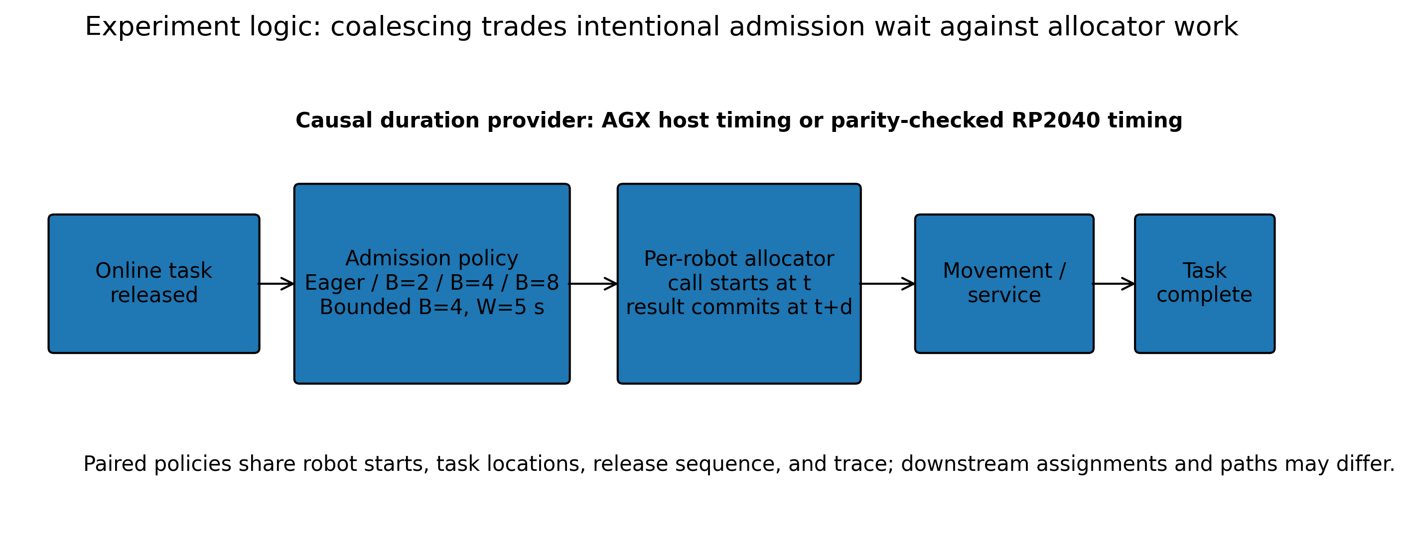
Figure 1. Causal flow of one online task through release, admission, allocation, movement, and completion.
Source: Architecture audit and final experiment plan; repo semantics in known_visit_sim/core/reallocation.py:521-686 and scheduler.py:593-817.

2.1 Mission and factorial design
Factor | Final design
Mission | Collaborative Visit on a 19x19 grid; every task cell must be physically serviced.
Team | 4 robots with deterministic paired start states.
Tasks | 50 total: 8 visible at time zero and 42 released online.
Arrival loads | Low 0.075 tasks/s; medium 0.30 tasks/s; high 1.20 tasks/s. Mean interarrival times are 13.33, 3.33, and 0.833 s.
Allocators | CBAA, ACBBA, HIPC, and PI.
Policies | Eager B=1; Count B=2, B=4, B=8; bounded B=4 with W=5 s.
Primary matrix | 4 allocators x 3 loads x 5 policies x 50 traces = 3,000 causal trials, plus 3,000 matched zero-compute trials.
Hardware subset | 104 RP2040-backed causal trials; balanced core is 96 trials = 4 allocators x 3 loads x 2 policies x 4 traces.
Verification | 144 separate trigger/engineering checks; all 104 hardware-backed trials passed allocator-output parity.

2.2 What “coalescing” changes
A new online task first enters a pending queue. Eager admits it immediately. Count policies wait until the pending depth reaches B, then admit the whole queue; the final partial tail is flushed, and mandatory execution events can piggyback pending tasks. The bounded policy admits at the first of B=4, an oldest pending age of 5 s, a final flush, or a mandatory event.
Admission is not completion. It makes the task visible to the allocators, resets the allocation epoch, and starts per-robot decision calls. Therefore coalescing can change both when a task becomes eligible for allocation and which assignments and routes the team ultimately executes.

2.3 Causal timing and the two computation providers
Each logical robot starts an allocator call at simulated time t. The result is not committed until t+d, where d is the measured AGX or RP2040 allocator duration. That robot is compute-busy during the interval, while peer robots, task releases, movement completions, and messages continue in simulated time. RP2040 calls are physically measured in sequence on a board but mapped back to independent virtual completion times. USB/serial/setup overhead is excluded from the injected allocator duration.
The zero-compute counterpart recomputes the allocator decision normally from its own evolving state but sets d=0. It is not a replay of the causal trial. Causal and zero-compute trajectories can therefore diverge through event ordering even when exogenous inputs are identical.

2.4 Paired design and what is allowed to differ
For a fixed allocator, load, and trace, all policies receive the same robot starts, task locations, release sequence, and random identifiers. Policies are not required to make the same assignments, take the same paths, produce the same number of calls, or finish at the same time. Those differences are the downstream effect being measured.

3. Exactly what the paper should measure
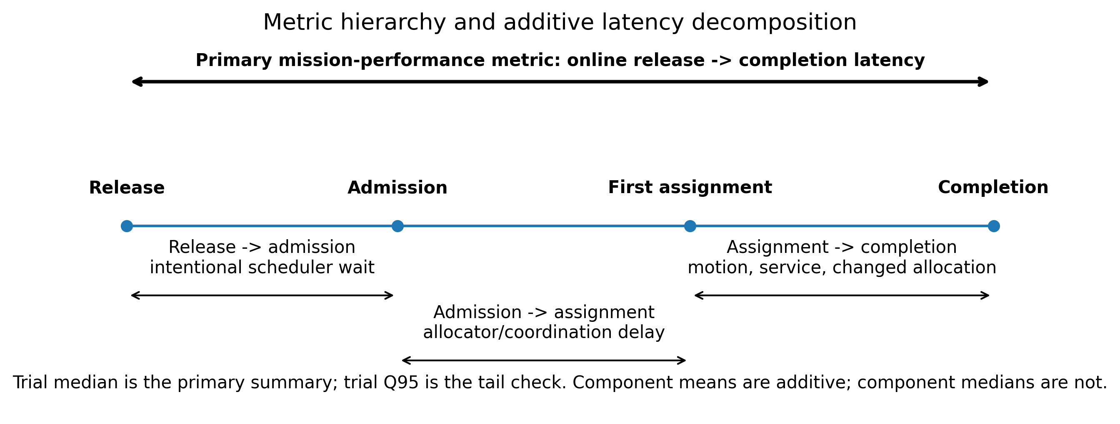
Figure 2. Metric timeline. The primary end-to-end service outcome spans release to physical completion; component means decompose where the change occurs.
Source: Paper-V2 task decomposition export and compact task-latency analysis.

3.1 Paper-facing metric hierarchy
Priority | Metric | Exact derivation | Why it is in the paper
1 - Primary mission outcome | Trial-median online release-to-completion latency | Median over the 42 online tasks in one trial: completion_time - release_time. | Direct task-service responsiveness; robust to initial time-zero tasks.
2 - Primary tail outcome | Trial Q95 online release-to-completion latency | Type-7 Q95 over online task service latencies within each trial. | Shows whether median gains hide slow-task tails.
3 - Primary computation | Provider-specific allocator processor work | Sum of valid allocator call durations over all logical robots and calls. | Actual computation demanded from AGX or RP2040; not mission wall delay.
4 - Mechanism | Allocator-call count | Number of valid per-robot choose_goal calls. | Explains whether work falls because fewer calls are made.
5 - Mechanism | Release-to-admission latency | admission_time - release_time. | Intentional waiting imposed by coalescing.
6 - Mechanism | Admission-to-first-assignment latency | first_assignment_time - admission_time. | Post-admission allocation/coordination delay.
7 - Mechanism | First-assignment-to-completion latency | completion_time - first_assignment_time. | Motion/service plus changed assignment and route; not pure compute.
8 - Secondary global | Mission elapsed time | Final required completion time - mission start. | Deployment context; sensitive to release schedule and critical path.
9 - Supporting | Completion, max steps, total steps, fallback source | Trial outcome and trajectory diagnostics. | Protects interpretation when latency is conditional or paths change.

3.2 Sign conventions that must be stated once
latency Delta = policy - Eager positive: policy is slower
work saved = Eager - policy positive: policy saves computation
calls saved = Eager - policy positive: policy makes fewer calls
hardware results: four unique traces, descriptive only

3.3 Why release-to-completion is the primary service outcome
Release-to-first-assignment is useful for mechanism, but 0.35% of causal online tasks and 0.43% of zero-compute online tasks were first assigned through a physical-service fallback when a robot reached a task before an allocator-owned assignment existed. Release-to-completion remains defined for either path and directly captures whether the task was actually serviced.

3.4 Additive decomposition rule
For valid online tasks, the task-level identity is:
release_to_completion = release_to_admission + admission_to_first_any_assignment + first_any_assignment_to_completion
Use trial means or ratios of task-level sums when showing this decomposition. Do not stack component medians and imply they add to the median total.

4. Statistical interpretation and evidence hierarchy

4.1 Replication unit
The trace is the environmental replication unit. A trial summarizes its 42 online tasks; individual tasks, calls, and epochs are not independent experimental replicates.

The AGX policy analysis forms matched trace blocks within each allocator x load stratum. Friedman tests compare the five policies; paired Wilcoxon tests compare each non-Eager policy with Eager after a significant omnibus test, with Holm adjustment. Median paired deltas receive 10,000-sample trace-bootstrap confidence intervals using seed 20260814. A global Benjamini-Hochberg result is retained only as a sensitivity check.

4.2 Hardware evidence
The balanced Eager/B=4 hardware core has 48 exact pairs but only four unique traces. Report all four trace values and summary ranges. Do not report hardware p-values or call the 104 hardware rows 104 independent scenarios.

4.3 Provider matching and completion
Every primary policy-versus-Eager estimate must compare the same timing provider. AGX and RP2040 are never pooled inside a primary estimate. Latency inference uses pairs in which both missions completed; completion discordances remain visible. CBAA estimates are therefore explicitly conditional on both policies completing the matched trace.

4.4 Validation strength
The source bundle passed 35 validation checks with zero reconciliation mismatches. The compact task-latency package passed 170 checks with 0 failures. The release/admission/assignment/completion identities reproduce the trial summaries within 1e-9 s; maximum observed decomposition residual was approximately 2.8e-14 s.

5. Related work, novelty, and contribution framing
Literature scope: Primary research papers and author/publisher manuscripts available through August 2026. Recent preprints are explicitly labeled as such.

5.1 Executive novelty verdict
The current plan is materially stronger and more generalizable than the earlier epoch-versus-call framing. The paper should be evaluated as a systems study of task-service responsiveness under online arrivals, not as a claim about the internal call structure of this simulator.
The strongest defensible contribution is: an allocator-independent empirical characterization of when intentional admission delay is outweighed by reduced post-admission computation and coordination, including a causal hardware-dependent crossover from service penalty to service benefit.
Recommended novelty statement
To the best of our knowledge, prior work has not evaluated an allocator-independent reallocation-coalescing layer across multiple decentralized MRTA methods under controlled stochastic arrival loads while using online release-to-completion latency as the primary outcome and causally injecting measured embedded allocator execution to identify a hardware-dependent service crossover.
This claim is intentionally narrower than “the first batching method” or “the first event-triggered MRTA method.” Both would be incorrect. Prior work has already studied event- versus time-triggered dynamic assignment [1], event-triggered task allocation intended to reduce computational load [2], stochastic task bundling [3], batched online optimization [4], selective replanning [5], and event-triggered consensus or communication [9], [10].
Dimension | Assessment | Reason
Algorithmic novelty | Modest | The scheduler does not replace the allocator or establish new convergence/optimality results.
Systems-method novelty | Moderate to strong | The causal per-robot timing model, provider separation, task-service metric hierarchy, and embedded parity checks form a distinctive evaluation method.
Experimental novelty | Strong for a short IPCCC paper | The study crosses arrival load, allocator family, device speed, and policy while retaining matched stochastic traces.
Generalizable insight | Strong but bounded | The arrival-pressure/compute-capacity principle is broader than B=4 or RP2040, but it is demonstrated in one mission family and four allocators.
Bounded-wait mechanism | Useful, not fundamentally new | Count-plus-timeout coalescing has clear systems precedents; the contribution is its MRTA application and measured mitigation.

5.2 Correction to the previous framing
The earlier report treated “fewer allocation epochs can produce more allocator calls” as a central contribution. The current Writer's Report correctly demotes that result. The effect is real in the testbed, but the exact chain depends on global admission reset, mandatory-event piggybacking, and post-epoch allocator-call semantics. It is therefore useful as an internal explanation of the sparse-load measurements, not as the broad thesis.
Element | Correct role | Why
Previous emphasis | Epoch reduction does not guarantee call reduction. | Too architecture-specific to carry the paper; reviewers could reasonably treat it as a simulator artifact.
Current primary result | The service cost of B=4 decreases with online arrival load while compute savings increase. | Directly measured at the task level and supported by trace-blocked AGX inference.
Current hardware result | The policy changes from service penalty at low/medium load to benefit at high load on RP2040. | Descriptive but visually consistent across all four unique hardware traces.
Current mechanism | Intentional release-to-admission wait can be repaid by lower admission-to-assignment and assignment-to-completion time. | Explains the crossover without pretending that saved processor work equals saved mission time.
Current design implication | Coalescing strength should respond to arrival density and measured compute pressure. | Generalizable systems principle and natural future adaptive-policy direction.

5.3 Current project contribution as the literature must see it
The paper studies a control layer above the allocator. Online tasks enter a pending queue. Eager admits immediately; count policies wait for B tasks; the bounded policy admits at the first of B=4, a 5-s pending-age limit, a mandatory event, or the final partial flush. Admission starts causal per-robot allocation and can change both decision timing and downstream routes.
The primary service population is the 42 online tasks, not the eight initial tasks. Each trial is summarized by median online release-to-completion latency, with Q95 as a tail check. Processor work is the provider-specific sum of valid allocator durations and is not interpreted as mission wall delay.
Evidence from current plan | Observed result | Paper interpretation
AGX, low load | B=4 increases median online service latency by 3.04–3.61 s across allocators; AGX work also increases. | Waiting dominates; coalescing should be weak or bounded.
AGX, medium load | Median penalty falls to 0.48–1.67 s while work savings reach 16.3–25.2%. | Transition regime; application latency budget matters.
AGX, high load | Work savings reach 13.2–41.3%; no median service contrast is detected. | Dense arrivals produce useful compute savings without a detected typical-service cost.
RP2040, trace average | All four traces are slower at low/medium load and faster at high load. | Hardware capability changes the sign of the operational effect.
RP2040, allocator detail | HIPC and PI show coherent median/tail gains; CBAA is small; ACBBA median improves but Q95 and mission behavior are mixed. | Compute pressure and allocator behavior jointly determine benefit.
Bounded B=4/W=5 | Reduces the low-load B=4 median penalty by 1.17–1.58 s but does not restore Eager latency. | Mitigation rather than universal solution.

5.4 Literature landscape and closest prior work
The closest literature divides into five distinct questions. The current paper overlaps each category, but its novelty lies in connecting them through the same causal service experiment.
Literature question | What prior work controls | Representative sources
When should dynamic assignment run? | Event-triggered, time-triggered, or state-triggered reassignment. | Bai et al. [1]; Hu et al. [2].
Should tasks wait or be grouped? | Execution bundling, route batching, or batched solver invocation. | Nam and Shell [3]; Tuck et al. [4]; Botros et al. [12].
How much of an old plan should be recomputed? | Partial replanning, plan repair, or bounded reoptimization. | Buckman et al. [5]; Thorne and Lopez [6].
When should distributed agents communicate or negotiate? | Event-triggered consensus and message suppression. | Aznar et al. [9]; Sao et al. [10]; Li et al. [11].
How should physical-AI requests be batched under compute pressure? | Interrupt coalescing and closed-loop robot policy serving. | Tai et al. [13]; Bansal et al. [14].

5.4.1 Dynamic trigger timing: the closest conceptual precedent
Bai, Cao, and Yan [1] are the clearest precedent for asking when dynamic assignment should be updated. They compare event-triggered reassignment after newly generated targets with time-triggered reassignment at fixed intervals, under multiple target-arrival rates, and report travel-time advantages for event-triggered methods. This work prevents any claim that choosing real-time assignment instants is new.
Difference from the current study. Bai et al. optimize vehicle travel and compare event versus periodic reassignment. The current paper instead introduces intentional admission coalescing between arrivals and decentralized allocation, uses task release-to-completion as the primary outcome, and asks when reduced allocator work repays that intentional wait. It also introduces hardware speed as a causal experimental factor.
Use in the IPCCC paper. Cite [1] in the opening Related Work paragraph to acknowledge dynamic trigger scheduling. Then state that prior trigger studies did not characterize a service-latency/hardware crossover across multiple decentralized allocators.
Hu, Li, and Qu [2] are an even closer recent title-level neighbor. Their 2025 Robotics and Autonomous Systems paper proposes event-triggered dynamic task allocation for multi-UAV tracking and explicitly motivates the trigger as a way to reduce real-time computational load. The available abstract establishes overlap in event-triggered task allocation and computation, but the full method is application-specific to moving-target tracking.
Difference. The current paper does not trigger from tracking-error or target-motion conditions. It manipulates the admission cadence of stochastically arriving tasks, separates intentional wait from post-admission service, compares four allocator families, and directly times AGX and RP2040 execution.

5.4.2 Task bundling, solver batching, and stochastic service
Nam and Shell [3] show that sequentially arriving stochastic tasks can be accumulated into execution bundles to trade task completion time against per-task route or service efficiency. Their robots wait because tasks are synergistic when executed together. The current project must therefore avoid claiming that waiting for multiple robot tasks is novel and should avoid the phrase “task bundling.”
Critical distinction. The present tasks are not merged into a physical execution bundle. They remain independent tasks; only their admission into decentralized allocation is delayed. The benefit is reduced post-admission allocation/coordination burden, not route synergy by construction.
Tuck et al. [4] process dynamic task streams with incremental SMT solving and explicitly evaluate batched online task inputs and solver runtime. This is the strongest precedent for “accumulate online tasks, then solve.” Their setting is a centralized, deadline- and capacity-constrained formal optimization problem. The current paper differs by applying one admission policy to four decentralized allocators, allowing downstream decisions and paths to diverge, and measuring causal service latency on embedded hardware.
Botros et al. [12] are highly relevant to the modern metric framing. They study stochastic dynamic vehicle routing across load regimes and optimize mean and 95th-percentile task wait times, emphasizing that moderate-load quality of service differs from classical heavy-load stability. This does not duplicate the coalescing mechanism, but it strongly supports two choices in the current plan: online task service rather than whole-mission makespan as the primary outcome, and Q95 as a required tail check.

5.4.3 Computation-aware partial replanning
Buckman, How, and Choi [5] reduce dynamic CBBA cost by controlling how much of the previous allocation is reset when new tasks appear. CBBA with Partial Replanning trades convergence time and communication burden against coordination quality. The controlled variable is replanning depth inside one allocator.
The current paper controls a different layer. It decides when released tasks become visible to an otherwise unchanged allocator. The two ideas are complementary: one controls invocation cadence, while the other controls the amount of state reconsidered per invocation.
Thorne and Lopez [6] similarly avoid expensive full reoptimization by using partial reassignment and invoking complete MRTA/MAPF optimization only when a makespan-quality bound is exceeded. Their result establishes the broad need to prevent computationally expensive eager replanning. The present paper contributes a different empirical question: can a generic admission delay improve actual online task service once hardware time is included?
SCoBA [7] and the online fleet architecture of Forte et al. [8] provide broader context. They show that allocation can be interleaved with execution and that computational overhead matters in dynamic multi-robot operation. They are not direct coalescing precedents, but they help prevent the paper from implying that causal online execution is new by itself.

5.4.4 Event-triggered consensus and communication
Aznar, Pujol, and Díez [9] adapt the frequency of CBBA-style consensus communication to significant events and environmental conflict. Their central resource is network negotiation, and their reported gains are communication efficiency and resilience. Sao et al. [10] likewise suppress CBBA broadcasts unless allocation state changes, reducing transmissions while preserving CBBA solution quality.
Difference. The current scheduler acts before negotiation by deciding when new tasks enter the allocation process. It can intentionally change task service, assignments, and paths. Its primary resource metric is allocator processor work rather than message count.
Li et al. [11] add event-triggered warm-start rescheduling with bounded trigger frequency for faults, priority arrivals, and energy deviations. The distinction from the current W=5 policy must be explicit: a minimum inter-trigger interval prevents rescheduling too frequently, whereas the present timeout is a maximum pending-task age that prevents waiting too long.

5.4.5 Systems batching and robot-serving literature
Tai et al. [13] provide the cleanest systems analogy. Interrupt coalescing delays completion notification to amortize CPU overhead, creating a direct throughput/latency tradeoff. Their calibrated-interrupt work also shows why static coalescing can fail across heterogeneous or latency-sensitive workloads. This literature supports the current engineering principle that policy strength should respond to load and semantic urgency.
Bansal et al. [14], posted in July 2026, are especially important because they move batching into closed-loop robotics. Their Armory system batches robot-policy inference on a remote GPU and shows that batching efficiency, starvation, and responsiveness depend on robot/task heterogeneity. This narrows the broad claim: the current paper is not the first to show that robot batching must be closed-loop and workload-aware.
Distinct contribution after considering Armory. Armory schedules centralized GPU inference requests from multiple robots. The current work schedules admission of online mission tasks into decentralized MRTA running on per-robot embedded processors, evaluates task release-to-physical-completion, and shows that the sign of the service effect changes with device speed and allocator complexity.

5.5 Direct novelty comparison matrix
Work | Online stochastic arrivals | Intentional waiting / batching | Primary outcome | Real embedded timing | Multiple decentralized allocators | Key boundary from this paper
Bai et al. [1] | Yes | Event vs fixed-time reassignment | Total vehicle travel | No | No | Does not study causal task-service latency or device-dependent crossover.
Hu et al. [2] | Dynamic targets | Event-triggered update | Tracking/allocation performance | Not established in accessible source | No | Application-specific event trigger; not count/age admission across loads.
Nam & Shell [3] | Yes | Execution bundles | Task completion vs execution cost | No | Policy family, not allocator family | Bundles physical service rather than allocator admission.
Tuck et al. [4] | Yes | Task batches to SMT solver | Feasibility and solver runtime | No | No | Central formal solver; one batch/solve relation differs from decentralized service chain.
Buckman et al. [5] | Yes | No; partial state reset | Convergence/runtime and solution quality | No | CBBA only | Controls how much to replan, not when to admit.
Thorne & Lopez [6] | Yes | Selective full reoptimization | Makespan quality and computation time | No | One framework | Quality-triggered replanning rather than count/age coalescing.
Aznar et al. [9] | Dynamic environment | Event-triggered consensus | Tasks completed and messages | No physical validation | CBBA-based | Controls communication pace, not online-task admission.
Sao et al. [10] | Not central | Event-driven broadcast | Messages with preserved CBBA quality | No | CBBA only | Communication suppression, not task-service coalescing.
Botros et al. [12] | Yes | Route-batch service policies | Mean and Q95 wait time | No | DVRP policies | Strong metric/load precedent; no allocator compute/hardware factor.
Tai et al. [13] | I/O requests | Count/time coalescing | Latency, CPU, throughput | Real storage hardware | N/A | Systems analogue; not decentralized robotics.
Bansal et al. [14] | Robot inference requests | Dynamic GPU batching | Robot starvation and throughput | Real GPU + 10 robots | Central serving system | Closed-loop robotics analogue; not MRTA or per-robot embedded allocation.
Current study | Yes, three rates | B=2/4/8 and B=4/W=5 | Online release-to-completion median and Q95 | AGX and parity-checked RP2040 | CBAA, ACBBA, HIPC, PI | Causal load/device crossover and allocator-dependent service effect.

5.6 What is and is not novel

5.6.1 Claims the paper should not make
- The first online or dynamic MRTA study.
- The first event-triggered or delayed task reassignment method.
- The first work to batch or bundle sequential robot tasks.
- The first computation-aware replanning method.
- The first count-plus-timeout coalescing mechanism.
- The first robotics system to show a batching/latency tradeoff.
- The first work to show that arrival load changes task-service behavior.
- The first hardware evaluation of robot allocation computation.

5.6.2 Credible contribution set
Load-dependent service regime: A matched, cross-allocator demonstration that the typical online task-service penalty decreases with arrival load while compute savings increase.
Hardware-dependent crossover: The same admission policy remains a penalty on fast hardware but can become a service benefit on constrained hardware when post-admission work dominates.
Allocator-dependent magnitude: A common scheduler produces markedly different hardware gains because allocator complexity and route consequences differ.
Causal task-service evaluation: Measured call durations delay per-robot decision commit, so computation affects the same release-to-completion metric used for operational performance.
Latency decomposition: The paper separates intentional admission waiting from post-admission assignment and service recovery, showing how a delayed policy can still finish online tasks sooner.
Bounded-wait mitigation: A practical design point that reduces sparse-load harm while retaining dense-load behavior, without claiming universal optimality.

5.6.3 Recommended contribution wording
Contribution 1 — load-aware service characterization. We characterize how count-based reallocation coalescing changes online task release-to-completion latency and allocator work across sparse, moderate, and dense arrival regimes for four decentralized allocators.
Contribution 2 — hardware-aware causal evaluation. We causally inject provider-specific AGX and parity-checked RP2040 allocator durations and identify a hardware-dependent crossover in which saved post-admission work can exceed intentional admission waiting.
Contribution 3 — practical policy guidance. We show that the operating point is allocator dependent and that a bounded-wait policy mitigates sparse-arrival harm, motivating adaptation based on arrival density and measured compute pressure.

5.7 How prior work should shape the Results and Discussion framing
Current result | What related work already establishes | Correct framing in this paper
AGX load-dependent result | Bai [1], Nam/Shell [3], Botros [12], and Tai [13] all make workload dependence expected in broad terms. | Do not claim “load matters” as the novelty. Claim that the measured service/work operating regime is established for decentralized MRTA and quantified across allocator families.
RP2040 crossover | Tai [13] and Bansal [14] show that batching can change closed-loop latency when compute is constrained. | Frame the novelty as the MRTA-specific causal crossover on embedded processors, not as the first batching crossover in any system.
Allocator heterogeneity | Buckman [5] and Thorne/Lopez [6] show that internal replanning structure changes computational behavior. | Present HIPC/PI/ACBBA/CBAA differences as evidence that one fixed coalescing strength is not universally appropriate.
Bounded W=5 | Timeout coalescing is standard in systems [13], and bounded trigger frequency appears in fleet rescheduling [11]. | Call it a practical mitigation and implementation pattern, not a fundamental algorithmic novelty.
Median and Q95 | Botros [12] explicitly separates average and 95th-percentile task wait behavior; Bansal [14] emphasizes starvation and stale actions. | Keep Q95 in the hardware table and avoid a median-only success story.
Task-service primary outcome | Dynamic routing literature centers quality of service and wait time [12]. | This strongly supports release-to-completion over mission makespan as the primary mission outcome.
Epoch/call behavior | No broad prior-work claim is needed because the exact mechanism is architecture dependent. | Use one paragraph as testbed-specific support for measured work; do not elevate it into the novelty claim or title.

5.7.1 Recommended discussion thesis
The paper should conclude that reallocation coalescing is a queueing-and-compute control, not a fixed batching heuristic. Sparse arrivals provide insufficient overlap to repay the wait. Dense arrivals increase reallocation pressure; if allocator execution is expensive relative to task dynamics, reducing post-admission work can improve service even after intentional waiting. The threshold should therefore be conditioned on both arrival density and measured compute pressure.

5.7.2 How to discuss the hardware subset
The four unique RP2040 traces are descriptive evidence, not a confirmatory hardware sample. The strongest wording is that every trace-averaged high-load result favors B=4, while algorithm-level medians and tails show that the magnitude and robustness differ. HIPC and PI support the compute-bound explanation; ACBBA demonstrates that route and tail effects can offset saved work.

5.8 Recommended Introduction and Related Work architecture
Paper location | Content discipline
Introduction paragraph 1 — operational problem | Dynamic missions release tasks during execution. Immediate reallocation improves reaction time but repeatedly invokes decentralized planning on processors whose capability may be far below desktop or edge hardware.
Introduction paragraph 2 — established solution families | Prior work uses event/time triggers, batched optimization, task bundling, partial replanning, and event-triggered consensus. These methods control when assignment occurs, which tasks are grouped, how much is recomputed, or when agents communicate.
Introduction paragraph 3 — precise gap | The literature does not clearly establish when an allocator-independent admission delay improves or harms end-to-end online task service once real embedded computation is placed on the causal execution path across multiple decentralized allocators.
Introduction paragraph 4 — study and contribution | Present the 3,000 causal + 3,000 zero-compute matrix, online release-to-completion metric, AGX/RP2040 provider separation, and load/allocator policy design.
Related Work paragraph 1 | Dynamic trigger timing and task batching: Bai, Hu, Nam/Shell, Tuck, Botros.
Related Work paragraph 2 | Computation-aware replanning: Buckman, Thorne/Lopez, Choudhury, Forte.
Related Work paragraph 3 | Event-triggered communication and systems batching: Aznar, Sao, Li, Tai, Bansal; finish with the exact gap statement.

5.9 Paper-ready Related Work draft
Dynamic task-allocation systems must decide both how to revise an assignment and when a revision is warranted. Event- and time-triggered vehicle-assignment methods have compared immediate updates after newly generated targets with periodic reassignment, while recent event-triggered multi-UAV allocation has sought to reduce real-time computational load [1], [2]. Other approaches delay or group work more explicitly: sequential stochastic task bundling trades task completion time against execution efficiency, and dynamic SMT formulations process arriving task batches while retaining solver state [3], [4]. These studies establish that online assignment timing and task accumulation are not new. Our work differs by coalescing task admission above unmodified decentralized allocators and evaluating the resulting end-to-end service latency rather than route cost or solver runtime alone.
Computation-aware online MRTA has also reduced the scope of replanning. CBBA Partial Replanning retains part of the previous bundle to reduce convergence time and communication, while TSOTAN performs rapid partial updates and invokes complete reoptimization only when a makespan-quality bound is violated [5], [6]. SCoBA and integrated online fleet architectures likewise demonstrate that assignment and execution can be interleaved under uncertainty and coordination constraints [7], [8]. These methods change the allocator or the amount of state reconsidered. Reallocation coalescing is complementary: it controls when newly released tasks are exposed to whichever allocator is already deployed.
Event-triggered decentralized methods frequently target communication. Adaptive consensus initiates or accelerates negotiation after significant events, and event-driven CBBA suppresses broadcasts when allocation state has not changed [9], [10]. Bounded-frequency rescheduling has also been used for faults, priority arrivals, and energy deviations [11]. Our scheduler instead imposes a count- or age-based admission delay before task negotiation and measures provider-specific processor work, online release-to-completion latency, and causal motion effects.
The underlying systems tradeoff resembles interrupt and inference-request coalescing. Interrupt batching reduces CPU overhead at the cost of completion latency, while recent robot-policy serving work shows that batch efficiency and closed-loop responsiveness depend on workload heterogeneity [13], [14]. We bring this systems question into decentralized MRTA, where the relevant outcome is physical task service and where allocator complexity and embedded device speed can change whether the intentional wait is repaid after admission.
Gap statement. To the best of our knowledge, prior work has not jointly evaluated an allocator-independent admission-coalescing policy across multiple decentralized MRTA methods, controlled stochastic task-arrival loads, causal provider-specific compute timing, and online task release-to-completion latency.

5.10 Core citation set and placement
Priority | Source | Why it matters | Paper placement
Must cite | Bai et al. [1] | Closest direct precedent for event- versus time-triggered dynamic assignment. | Intro/Related Work trigger paragraph.
Must cite | Hu et al. [2] | Recent event-triggered dynamic task allocation motivated by computational load. | Related Work; closest 2025 title-level neighbor.
Must cite | Nam and Shell [3] | Sequential stochastic task bundling and waiting/efficiency tradeoff. | Clarify that tasks are not execution bundles.
Must cite | Tuck et al. [4] | Batched online tasks and incremental solver runtime. | Clarify centralized solve batching vs decentralized admission.
Must cite | Buckman et al. [5] | Computation-aware partial replanning in decentralized CBBA. | Differentiate when-to-invoke from how-much-to-recompute.
Must cite | Thorne and Lopez [6] | Partial/complete reoptimization tradeoff for online MRTA/MAPF. | Computation-aware online allocation paragraph.
Must cite | Botros et al. [12] | Load regimes, mean/Q95 waiting-time quality of service. | Supports primary metric and tail analysis.
Must cite | Tai et al. [13] | Count/timeout coalescing and workload-sensitive latency/CPU tradeoff. | IPCCC systems framing.
Recommended | Aznar et al. [9] | Recent event-triggered adaptive MRTA consensus. | Avoid overclaiming event-triggered coordination.
Recommended | Sao et al. [10] | Peer-reviewed event-driven CBBA communication suppression. | Differentiate communication from task admission.
Recommended | Bansal et al. [14] | Very recent closed-loop robot batching under heterogeneous workloads. | Strengthens hardware/load systems context; label preprint.
Optional | Choudhury et al. [7] or Forte et al. [8] | General online execution and computational overhead context. | Use one if reference space is tight.
Optional | Li et al. [11] | Bounded-frequency event-triggered rescheduling. | Use if discussing W=5 design lineage.

5.11 Reviewer-objection guide
“Bai et al. already studied when to reassign.” Correct. They compare event and periodic assignment with travel objectives. This paper studies count/age admission, task-service latency, causal embedded compute, and multiple decentralized allocators.
“This is just task bundling.” No. Nam and Shell bundle physical task execution to exploit synergy. Here tasks remain independent; only allocator admission is coalesced.
“Tuck et al. already batch online tasks.” They batch inputs to a centralized incremental SMT solver. This study applies one admission policy to asynchronous decentralized allocators and evaluates physical service.
“This is partial replanning.” Partial replanning changes the amount of prior allocation state reset. Coalescing changes when newly released tasks enter replanning. They can be combined.
“Event-triggered CBBA already reduces overhead.” Those methods primarily suppress communication or adapt negotiation pace. This study delays task admission and measures processor work and task completion.
“Interrupt coalescing already uses count and timeout.” Yes; the abstract mechanism is not claimed as new. The contribution is the decentralized MRTA service regime and causal embedded crossover.
“Armory already shows workload-aware robot batching.” Armory batches central policy inference on a shared GPU. This paper concerns decentralized MRTA on per-robot embedded processors and online task service.
“The hardware result is too small.” Treat it as descriptive four-trace evidence. Show all traces and avoid p-values. The AGX matrix provides the inferential load result; hardware establishes plausibility and sign crossover.
“HIPC dominates the hardware effect.” Acknowledge it. The allocator-specific table is essential. The conclusion is compute-pressure dependence, not universal B=4 superiority.

5.12 Final contribution assessment
Final verdict
The paper is original enough for an IPCCC short paper when framed as a hardware-aware online service study, not as the invention of batching or event triggering. Its strongest novelty is the experimentally demonstrated interaction among arrival density, allocator complexity, and device speed, measured through causal online task service.
Recommended title: When Reallocation Coalescing Helps: Load- and Hardware-Dependent Tradeoffs in Embedded Multi-Robot Task Allocation
Recommended one-sentence thesis: Reallocation coalescing becomes useful when online arrival pressure and allocator compute cost are high enough that the post-admission time it removes exceeds the service delay it intentionally introduces.
Recommended discussion close: A fixed universal batch threshold is not justified; future schedulers should increase coalescing under dense arrivals and measured compute pressure, and relax or bound it when arrivals are sparse or service tails are critical.

6. Core result I - the AGX load-dependent tradeoff
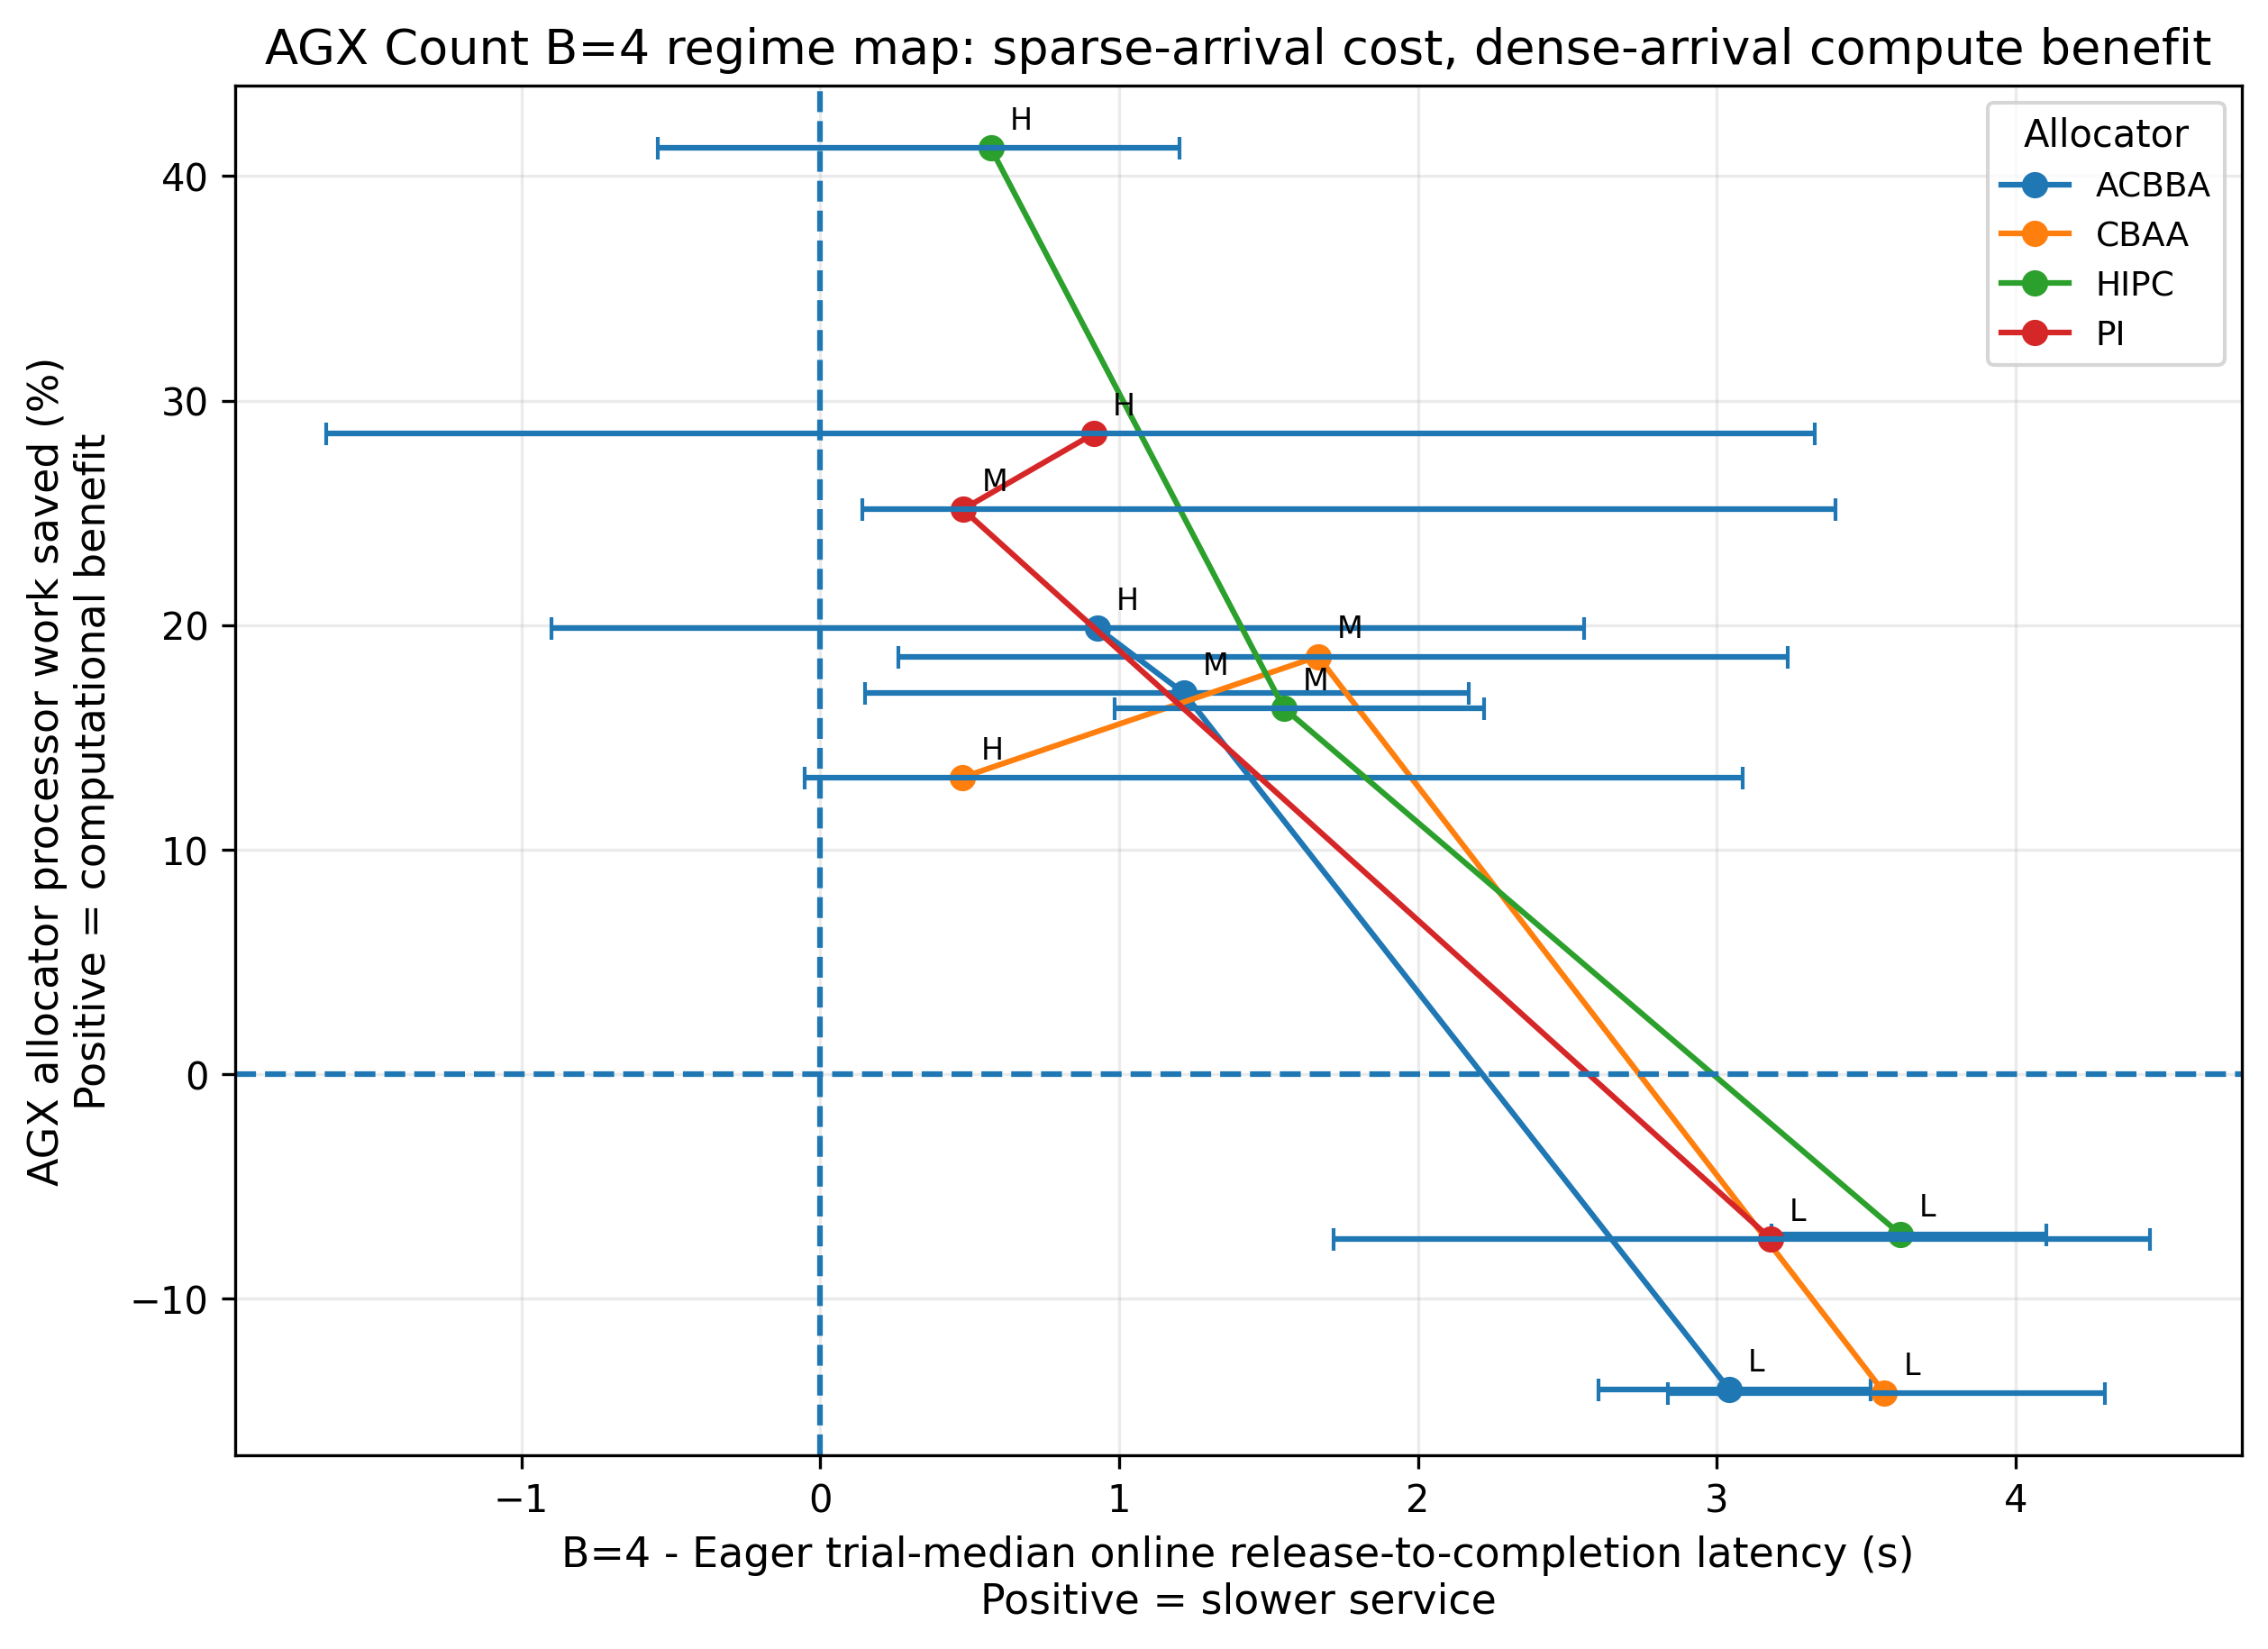
Figure 3. Recommended main tradeoff figure. Each allocator trajectory moves from low to medium to high load. Horizontal error bars are trace-bootstrap intervals for the median service-latency Delta.
Source: figure_data_main_agx_tradeoff.csv; B=4 vs Eager, causal AGX, online tasks, both-completed trace pairs.

6.1 What the figure says in one sentence
Paper-facing result
Count B=4 is harmful under sparse arrivals, becomes a useful compute/service tradeoff at medium load, and saves 13.2-41.3% of AGX allocator work at high load without a detected median task-service difference from Eager.

Alg. | Load | n | Median service Delta (s) | 95% trace bootstrap | Work saved (%) | Calls saved (%) | Holm p | Detected?
ACBBA | Low | 46 | +3.04 | [+2.60, +3.51] | -14.0 | -17.4 | <0.0001 | yes
CBAA | Low | 42 | +3.56 | [+2.84, +4.30] | -14.2 | -9.9 | <0.0001 | yes
HIPC | Low | 46 | +3.61 | [+3.18, +4.10] | -7.1 | -10.5 | <0.0001 | yes
PI | Low | 46 | +3.18 | [+1.72, +4.45] | -7.3 | -12.0 | <0.0001 | yes
ACBBA | Medium | 46 | +1.22 | [+0.15, +2.17] | +17.0 | +11.5 | 0.0487 | yes
CBAA | Medium | 38 | +1.67 | [+0.26, +3.24] | +18.6 | +25.7 | 0.0147 | yes
HIPC | Medium | 46 | +1.55 | [+0.98, +2.22] | +16.3 | +7.6 | 0.0003 | yes
PI | Medium | 46 | +0.48 | [+0.14, +3.40] | +25.2 | +23.3 | 0.0689 | no
ACBBA | High | 46 | +0.93 | [-0.90, +2.56] | +19.9 | +22.5 | 0.7141 | no
CBAA | High | 42 | +0.48 | [-0.05, +3.09] | +13.2 | -0.5 | 0.1533 | no
HIPC | High | 46 | +0.57 | [-0.54, +1.20] | +41.3 | +26.9 | 0.7953 | no
PI | High | 46 | +0.92 | [-1.65, +3.33] | +28.5 | +30.4 | 0.9178 | no

6.2 Sparse arrivals: waiting dominates
At low load, all four allocators show a 3.04-3.61 s paired median service penalty, and all four preplanned contrasts are Holm-significant. AGX work also increases rather than decreases: B=4 changes work by -14.0% for ACBBA, -14.2% for CBAA, -7.1% for HIPC, and -7.3% for PI. The policy waits for tasks that arrive roughly 13.3 s apart on average, yet the admitted batch is not large enough or frequent enough to offset its added coordination work.

6.3 Medium load: the transition regime
At medium load, median service penalties fall to 0.48-1.67 s while AGX work savings rise to 16.3-25.2%. ACBBA, CBAA, and HIPC retain detected median penalties; PI does not after Holm adjustment. This is the region in which an application-specific latency budget matters most.

6.4 High load: saved work with no detected median difference
At high load, B=4 saves 13.2-41.3% of provider-matched AGX work. Median service effects remain slightly positive (0.48-0.93 s), but none is detected after the planned procedure. The correct wording is “no detected median difference within the reported uncertainty,” not “equivalent” and not “faster.”

6.5 Direct evidence that the policy effect changes with load
After first averaging the four allocator effects within each common trace, the high-minus-low change in the B=4 service effect is -2.454 s. The repeated-load Friedman test gives chi-square=12.06 and p=0.0024; low-to-medium is -1.619 s (Holm p=0.0022), while medium-to-high is -0.470 s (Holm p=0.2069). This supports a crossover trend without claiming every adjacent load step is distinguishable.

7. Core result II - the RP2040 hardware crossover
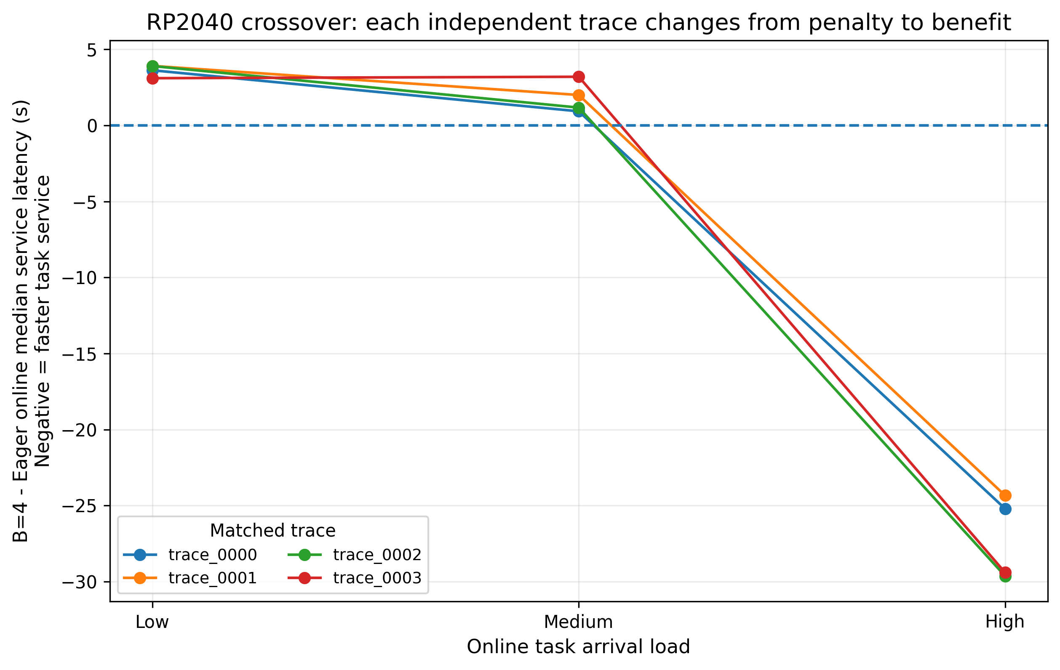
Figure 4. Recommended intuitive second figure. Each line is one independent matched hardware trace after averaging the four allocator effects within that trace.
Source: hardware_b4_online_service_latency.csv; exact RP2040 B=4 vs Eager pairs.

7.1 The visually clear result
All four trace-averaged values are positive at low load (+3.10 to +3.91 s), remain positive at medium load (+0.93 to +3.20 s), and become strongly negative at high load (-29.63 to -24.34 s). The direction is therefore consistent across the four unique hardware traces: sparse-arrival batching delays service, whereas dense-arrival batching can make the team service new tasks sooner on a constrained processor.
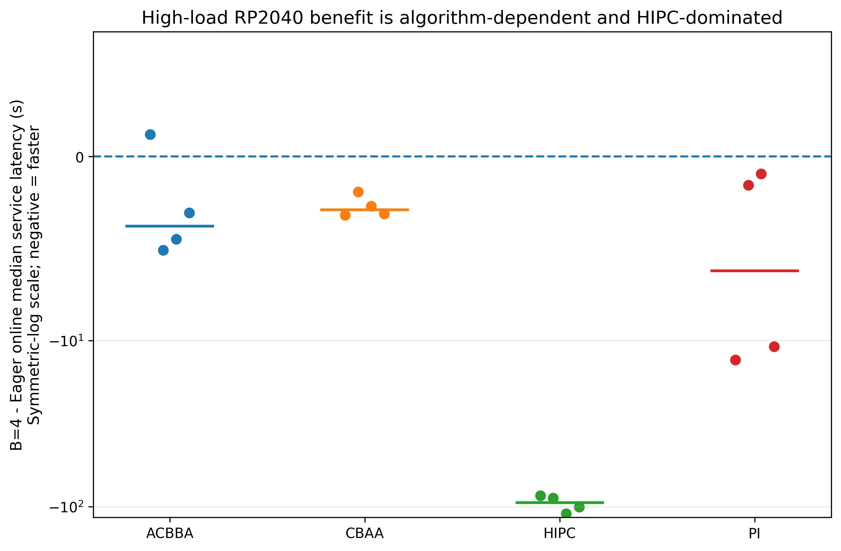
Figure 5. Descriptive high-load hardware effects by allocator. Dots are the four matched traces and horizontal bars are medians; the symmetric-log scale preserves the much larger HIPC effect.
Source: hardware_b4_online_service_latency.csv; no hardware hypothesis tests.
Alg. | Median service Delta | Median Q95 Delta | Work saved | Calls saved | Mean mission Delta | Signs | Interpretation
ACBBA | -3.78 | +12.53 | +28.0 | -1.8 | +22.3 | 3/4 faster | Median improves, Q95 and mission time worsen; route changes matter.
CBAA | -2.90 | +4.90 | +30.9 | +31.4 | -0.6 | 4/4 faster | Small median improvement; mean service near zero; conditional context.
HIPC | -94.69 | -86.24 | +57.9 | +28.9 | -88.3 | 4/4 faster | Dominant compute-bound crossover; large work and service gain.
PI | -6.20 | -10.04 | +41.9 | +44.3 | -21.9 | 4/4 faster | Meaningful work, median, tail, and mission benefit.

7.2 What the algorithm differences mean
HIPC is the clearest compute-pressure example: its high-load four-trace median service effect is -94.69 s and its median RP2040 work saving is 57.9%. PI also shows a coherent benefit. CBAA is lighter; work falls, but the mean end-to-end service change is nearly zero. ACBBA is the counterexample that prevents a simplistic “less computation means faster mission” claim: its median online service improves, but its Q95 and mean mission time worsen and its path length changes.
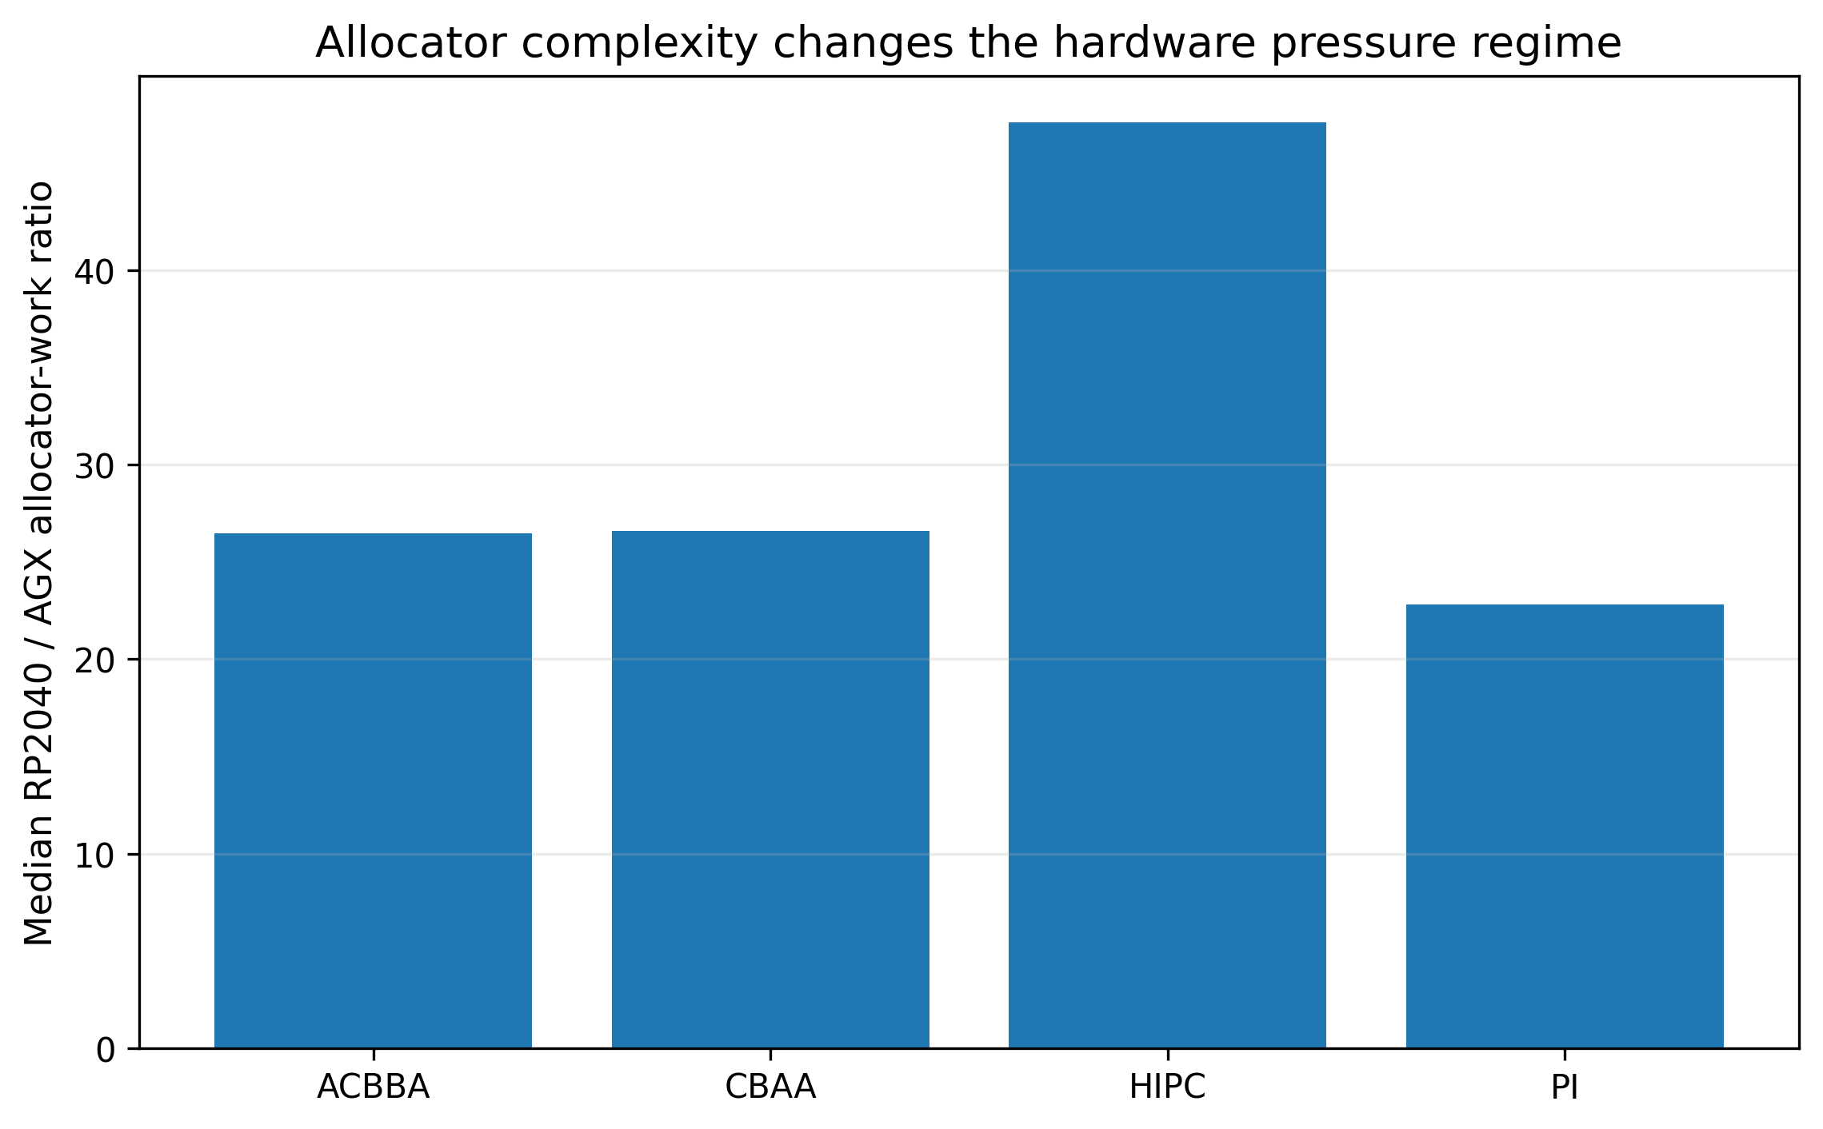
Figure 6. Median RP2040/AGX allocator-work ratio by algorithm. HIPC experiences the strongest device slowdown.
Source: hardware_summary.csv and hardware_call_complexity_summary.csv; all hardware calls passed parity.

7.3 Why hardware capability changes the sign of the result
Across all hardware-backed trials, RP2040 allocator work is a median 26.75x the AGX work; HIPC is approximately 47.6x. On AGX, the absolute saved work is often too small to compensate for intentional waiting. On RP2040, dense arrivals repeatedly expose expensive local planning, so reducing the number and complexity of calls can recover more time after admission than the policy added before admission.

8. Mechanistic interpretation - where the time goes
Alg. | Release->admission Delta | Admission->assignment Delta | Assignment->completion Delta | Total mean service Delta | Does recovery exceed waiting?
ACBBA | +0.852 | -0.880 | -0.970 | -0.998 | Yes on mean decomposition; trajectory/tail caveat remains.
CBAA | +0.852 | -1.224 | +0.527 | +0.156 | No; assignment gain is offset after assignment.
HIPC | +1.133 | -40.101 | -54.068 | -93.036 | Yes; post-admission recovery dominates.
PI | +1.110 | -4.053 | -6.763 | -9.706 | Yes; post-admission recovery dominates.

Source: task_latency_decomposition_summary.csv; high-load RP2040 Eager versus B=4; values are paired mean/ratio-of-sums decomposition in seconds.

8.1 The key high-load mechanism
Mechanistic answer
At high load, B=4 deliberately adds about 0.85-1.13 s of release-to-admission waiting. ACBBA, HIPC, and PI recover more than that after admission; CBAA does not on the mean decomposition. The hardware crossover is therefore not caused by the wait disappearing. It occurs because the post-admission system becomes faster enough to repay the wait.

8.2 What cannot be causally isolated
Admission-to-assignment is the component most directly associated with allocator timing and coordination, but assignment-to-completion includes physical motion, service, changed task ownership, and changed trajectories. The decomposition is additive and diagnostic, not a formal mediation or critical-path proof.

8.3 Architecture-specific sparse-arrival call amplification
In this simulator, a logical epoch is an admission or mandatory trigger; a call is one robot's allocator invocation, and calls can continue after the first expected calls close an epoch. Under sparse arrivals, pending tasks can piggyback on mandatory task-completion or robot-idle events. The admission globally resets allocator context and starts first-round calls for all robots; later consensus, repair, invalid-goal, or no-goal activity can remain associated with the same epoch. As a result, B=4 can reduce epoch count while increasing calls per epoch and total calls.
Use this chain to explain the observed testbed behavior, then immediately state that the precise epoch/call relationship depends on scheduler and allocator architecture. The general claim is about measured work and task service, not about epoch count alone.

9. Bounded waiting, tail latency, and failure context
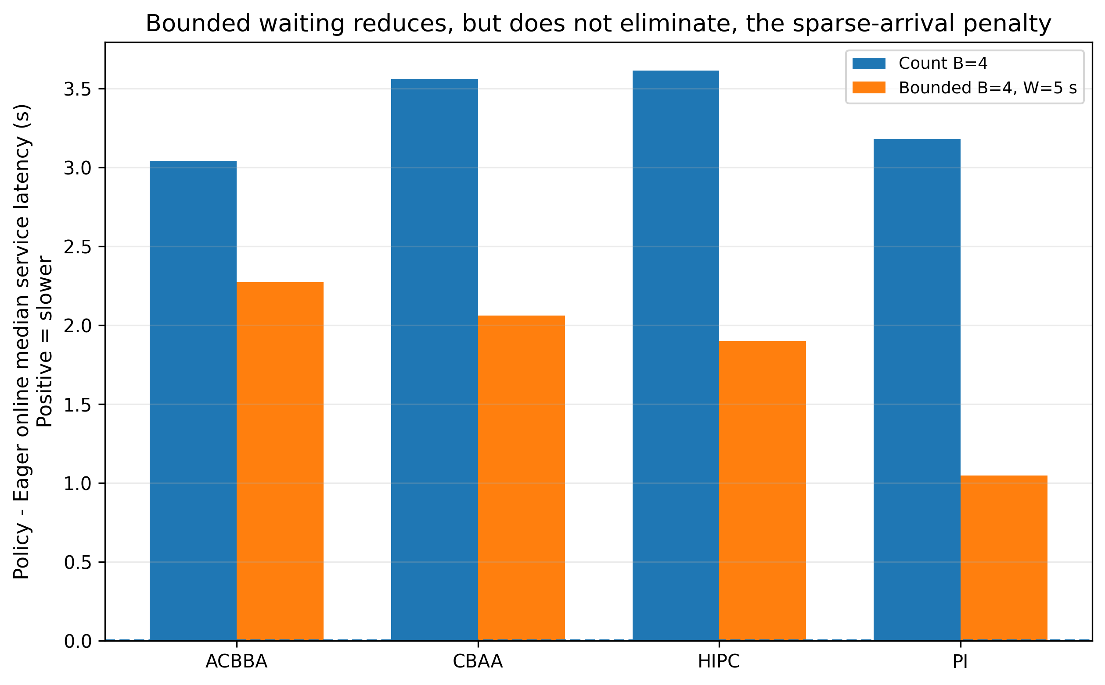
Figure 7. Low-load AGX service effects. The five-second bound reduces the B=4 penalty for every allocator but does not restore Eager-level latency.
Source: figure_data_bounded_policy.csv; online median service latency.

9.1 Bounded policy result
At low AGX load, bounded-minus-B=4 median changes range from -1.58 to -1.17 s, and Q95 changes range from -2.64 to -1.85 s. Relative to Eager, however, bounded service remains 1.05-2.27 s slower at the median and 1.24-1.72 s slower at Q95. The policy is a mitigation, not a cure. At high load bounded and unbounded B=4 are nearly identical because the batch threshold normally activates before the timeout.
Hardware evidence for bounded waiting is narrow and limited to low/medium coverage; do not generalize it to the high-load RP2040 crossover.
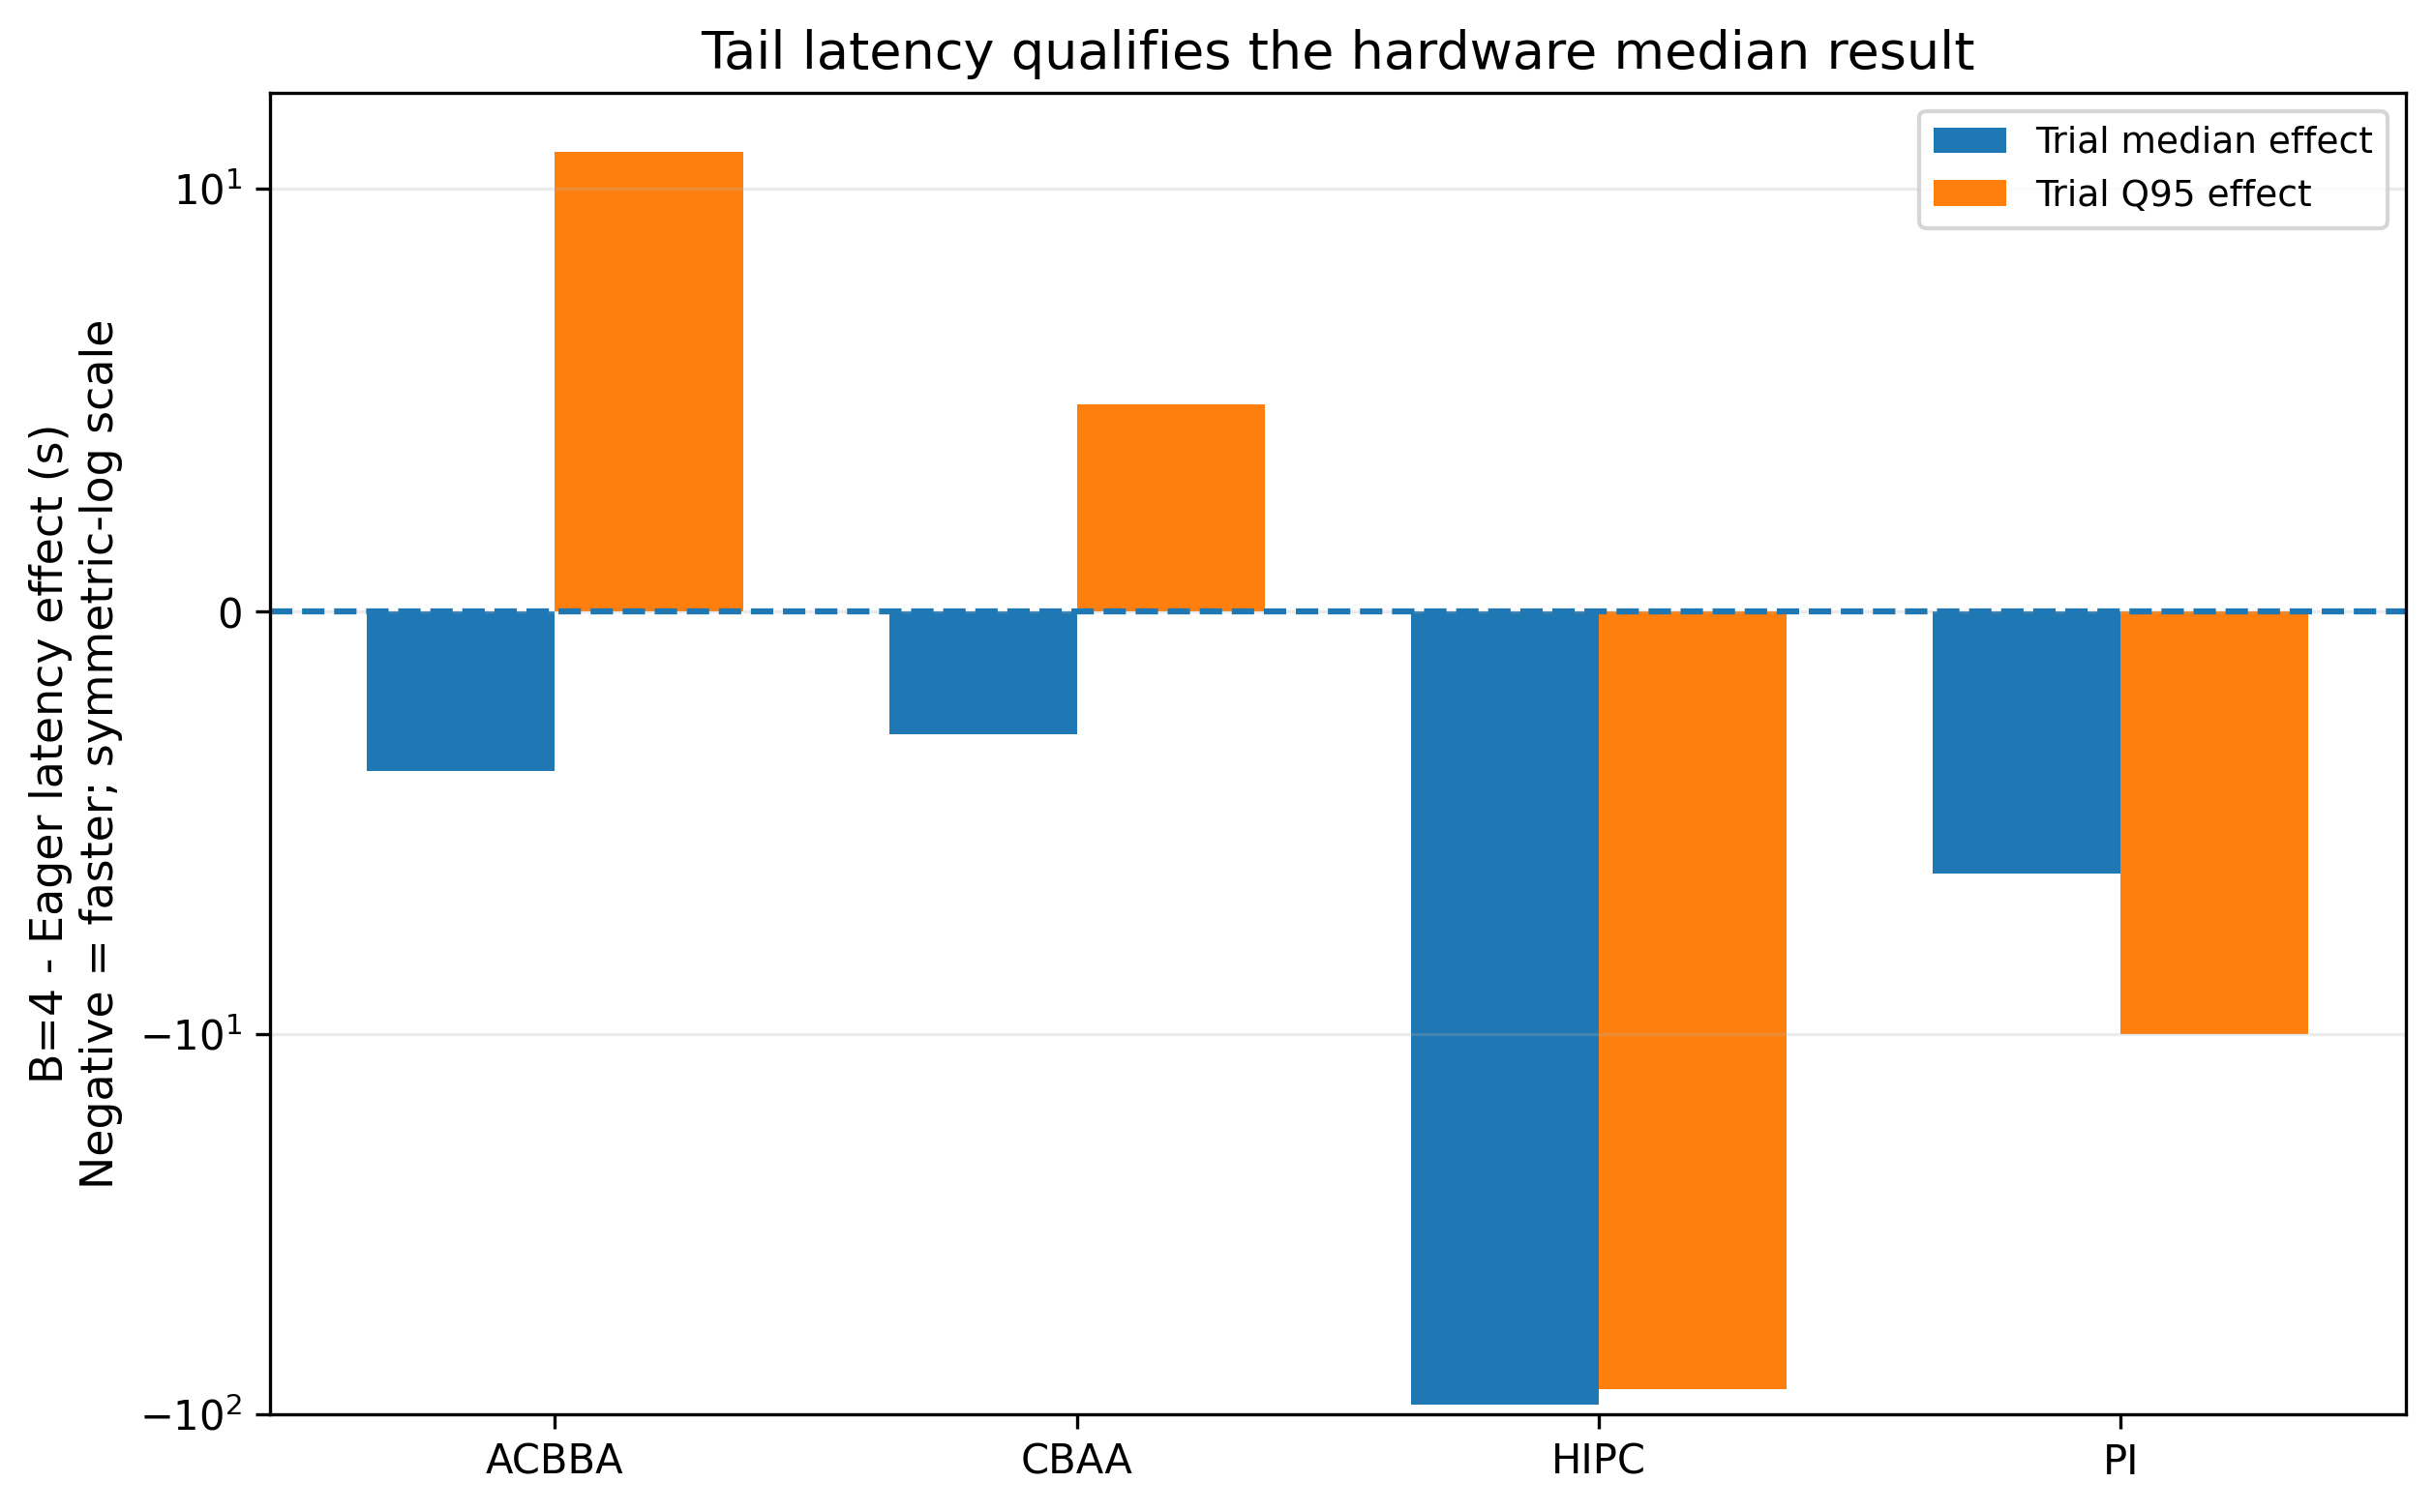
Figure 8. High-load RP2040 trial-median and trial-Q95 effects. ACBBA and CBAA show improved medians but unfavorable Q95 summaries.
Source: hardware_b4_online_service_latency.csv; descriptive four-trace summaries.

9.2 Tail latency prevents over-polishing the result
Median and Q95 effects have different signs in 23 of 96 inferential policy conditions. The paper should state that high-load hardware median service improves across the algorithm medians, but tail behavior is mixed: HIPC and PI improve at Q95, whereas ACBBA and CBAA do not. This is exactly why the trial Q95 should appear either in the hardware table or a short sentence next to the main figure.

9.3 Initial tasks and outcome population
The eight time-zero tasks are not exposed to the online admission policy in the same way as the 42 arrivals. Including all 50 can shift the B=4 effect by -1.02 to +0.76 s across AGX conditions; the direction is not uniform. Use online-only as the declared primary population and describe all-task results as a sensitivity check.

9.4 Completion and CBAA
CBAA causal policy | Completed | Rate
Eager (B=1) | 137/150 | 91.3%
Count B=2 | 144/150 | 96.0%
Count B=4 | 146/150 | 97.3%
Count B=8 | 145/150 | 96.7%
Bounded B=4, W=5 s | 146/150 | 97.3%

All 32 causal primary-matrix noncompletions occur in CBAA under the finite stagnation horizon. Latency estimates for CBAA condition on both policies completing the same trace, so they must be shown beside completion rates or explicitly labeled conditional. Do not state that coalescing “fixes” CBAA; the mechanism is an interaction among timing, allocator state, and the finite cap.

10. Recommended 5-6 page IPCCC presentation

10.1 Final results architecture
Paper element | Content | Exact encoding | Reason
Figure 1 - required | AGX B=4 compute-service tradeoff | Figure 3 of this report. X: paired online median service Delta; Y: percent AGX work saved. Connect low->medium->high within each allocator. | One figure carries the main regime result, load interaction, and allocator heterogeneity.
Figure 2 - required | RP2040 trace-level crossover | Figure 4 of this report. Four trace lines over low/medium/high load with a zero reference. | Most intuitive demonstration that the sign changes on constrained hardware.
Table I - required | High-load RP2040 deployment outcomes | Four rows: allocator, median service Delta, Q95 Delta, work saved, calls saved, mission Delta, sign count. | Prevents HIPC from hiding ACBBA/CBAA behavior and gives readers raw interpretability.
Optional inset or sentence | Bounded low-load mitigation | Show B=4 vs bounded only if space remains; otherwise give the 1.17-1.58 s reduction in text. | Useful design response, but less central than the crossover.
Do not promote | Epoch/call reversal or CBAA completion figure | Keep as one mechanism paragraph and one limitation sentence. | Architecture-dependent and too detailed for the main visual budget.

10.2 Recommended Results and Discussion sequence
- Paragraph 1 - define sign conventions and identify online release-to-completion as the primary outcome.
- Paragraph 2 - AGX low/medium/high B=4 trajectory, exact low-load range, high-load work-savings range, and trace-blocked load test.
- Paragraph 3 - RP2040 four-trace crossover and algorithm-specific high-load table.
- Paragraph 4 - latency decomposition: added wait is repaid after admission for ACBBA/HIPC/PI, with motion/trajectory caveat.
- Paragraph 5 - bounded mitigation, tail qualification, and CBAA completion caveat.
- Discussion conclusion - policy strength should respond to arrival density and measured compute pressure; fixed universal B is not justified.

10.3 Approximate page budget
Section | Budget | Content discipline
Introduction + related work | 0.9-1.1 pages | Motivate dynamic task arrival, embedded compute, and gap; 10-12 references.
Method + policies + timing | 1.0-1.2 pages | One compact timeline diagram or policy table; causal timing semantics.
Experimental design + statistics | 0.7-0.8 pages | Matrix, trace pairing, online-task unit, hardware n=4 warning.
Results + discussion | 1.7-2.0 pages | Two figures, one table, five focused result paragraphs.
Conclusion + limitations | 0.3-0.4 pages | One principle, one hardware caveat, one future adaptive trigger sentence.
References | 0.8-1.0 pages | Use compact core set; do not cite every inspiration source.

10.4 Copy-ready Results wording
AGX result paragraph
Count B=4 exhibited a load-dependent service-computation tradeoff. At low load, paired trial-median online release-to-completion latency increased by 3.04-3.61 s across the four allocators, and all contrasts remained significant after the preplanned Holm procedure. At medium load the penalty fell to 0.48-1.67 s while AGX allocator work fell by 16.3-25.2%. At high load, B=4 saved 13.2-41.3% of provider-matched allocator work, while no median service-latency contrast was detected. After averaging allocator effects within each common trace, the B=4 high-minus-low change was -2.45 s (Friedman p=0.0024), confirming that the service penalty decreases as arrival pressure rises.

Hardware result paragraph
The four-trace RP2040 core showed a descriptive crossover. Trace-averaged B=4 effects were +3.10 to +3.91 s at low load and +0.93 to +3.20 s at medium load, but -29.63 to -24.34 s at high load; every high-load trace favored coalescing. High-load allocator-specific medians ranged from -2.90 s for CBAA to -94.69 s for HIPC. The magnitude was concentrated in the compute-heavy HIPC and PI allocators, and Q95 remained unfavorable for ACBBA and CBAA, so the hardware result supports a compute-pressure-dependent operating regime rather than a universal allocator benefit.

Mechanism paragraph
High-load coalescing did not eliminate scheduler waiting. B=4 added 0.85-1.13 s of mean release-to-admission delay on RP2040, but ACBBA, HIPC, and PI recovered more time after admission than the policy added before admission. HIPC recovered approximately 40.1 s before first assignment and 54.1 s from assignment to completion, yielding a -93.0 s mean end-to-end service effect. Because the latter component includes motion and changed allocation paths, this decomposition is diagnostic rather than a formal compute-delay attribution.

11. Claim hierarchy and wording controls
Strength | Paper-safe claim | Required qualification
Strong / general | The service cost of B=4 decreases with arrival load. | Supported by trace-blocked AGX load test and consistent low-to-high pattern.
Strong / general | At high AGX load, B=4 saves allocator work with no detected median service difference. | Do not replace “no detected difference” with “equivalent.”
Moderate / hardware | High-load B=4 can accelerate online task service on constrained hardware. | Four matched traces; all trace-averaged effects favor B=4; descriptive only.
Moderate / mechanism | Saved post-admission time can exceed intentional admission waiting. | Supported for ACBBA, HIPC, and PI in mean decomposition.
Qualified / design | A five-second bound reduces sparse-arrival harm. | It reduces but does not eliminate the penalty; no high-load RP2040 bounded evidence.
Qualified / algorithm | Compute-heavy allocators benefit more. | HIPC dominates; PI contributes; exact complexity interaction not formally modeled.
Supporting / architecture | Fewer epochs do not guarantee fewer calls. | True in this scheduler; exact mechanism is architecture-dependent.
Exploratory | Coalescing changes CBAA liveness. | Finite stagnation horizon and completion selection require caution.

11.1 Wording that should not appear
- “Coalescing always reduces computation.” It increases AGX work at low load and can change calls differently from epochs.
- “B=4 improves task latency on AGX at high load.” The high-load median effects were not detected; non-detection is not proof of benefit or equality.
- “The hardware experiment has n=104 independent trials.” It has four unique traces repeated across factorial conditions.
- “The high-load hardware effect is statistically significant.” No hardware hypothesis test is justified or reported.
- “Processor work saved is mission time saved.” Work is summed over calls and logical robots and can overlap in simulated time.
- “The decomposition proves that computation caused the entire gain.” Assignment-to-completion includes route and task-choice effects.
- “Bounded B=4 is the universally best policy.” It mitigates low-load harm in this matrix; it is not fully tested at high hardware load.
- “Coalescing fixes CBAA failures.” CBAA latency is conditional on both-completed pairs and liveness remains secondary.

12. Exact source and derivation map
Result / purpose | Primary file(s) | How the number is derived
Experiment matrix and provenance | export_manifest.json; BUILD_REPORT.md; matrix_coverage.csv | Counts, hashes, campaign roots, 35/0 validation status, zero reconciliation mismatches.
Trial-level task and mechanism metrics | trial_mechanism_summary.csv | One row per causal/zero trial; online/all/initial latency summaries, work, calls, epochs, completion, steps.
Primary AGX policy inference | task_latency_inference.csv | Filter: causal, agx_host_proxy, B=4 vs Eager, online median/Q95, both-completed pairs. Friedman, Wilcoxon-Holm, bootstrap CI.
Main AGX tradeoff figure | figure_data_main_agx_tradeoff.csv | X = paired median online service Delta; Y = percent AGX work saved; labels by allocator/load.
Exact RP2040 core | hardware_b4_online_service_latency.csv | Exactly 48 Eager/B=4 pairs; board match, all four trace values, median/Q95/mean, work, calls, mission, steps.
Hardware crossover figure | figure_data_hardware_crossover.csv | Contains exact rows plus algorithm and trace-averaged summaries.
Latency decomposition | task_latency_decomposition_summary.csv | Paired mean component Deltas and ratio-of-sums shares; use any-source assignment.
Bounded policy | figure_data_bounded_policy.csv; policy_pairwise_same_provider_extended.csv | Eager/B=4/bounded same-provider comparisons by allocator and load.
Call/epoch mechanism | call_epoch_trial_summary.csv; epoch_level_causal_part01.csv.gz; epoch_level_zero_part01.csv.gz | Call class, epoch reason, first-round/post-closure status, active tasks, goal changes, provider work.
Hardware complexity/parity | hardware_call_complexity_summary.csv; hardware_call_level.csv.gz; hardware_summary.csv | RP2040/AGX ratios, per-call complexity, parity and provider metadata.
Completion/liveness | cbaa_liveness_summary.csv; cbaa_divergence_summary.csv; legitimate_noncompletions.csv | Completion denominators, CBAA stagnation, divergence context.
Architecture semantics | ARCHITECTURE_CLARIFICATION.md | Repository file:line evidence for timing, concurrency, policy triggers, work definitions, hardware bridge, zero-compute semantics.
Compact analysis validation | task_latency_analysis_validation.csv; analysis_metadata.json | 170/0 compact checks, seed 20260814, 10,000 bootstraps, source hashes.

12.1 Companion data excerpts
The companion package contains compact CSVs for the exact AGX B=4 table, the 48 hardware pairs, the trace-averaged crossover, the high-load algorithm summary, bounded mitigation, decomposition, and CBAA completion rates. These are intended for independent checking and MATLAB/LaTeX figure regeneration; the original large task-level exports remain the authoritative source.

13. Final handoff checklist for the paper writer
- Declare online release-to-completion trial median as the primary mission outcome and trial Q95 as the tail check.
- Define processor work as summed per-call processor-seconds and explicitly state that it is not mission wall delay.
- Use only same-provider policy comparisons and keep AGX and RP2040 separate.
- State that trace, not task/call/epoch, is the replication unit.
- Show Figure 3 (AGX tradeoff), Figure 4 (RP2040 crossover), and one compact high-load hardware table.
- Report all four hardware trace values or their plotted lines; no hardware p-values.
- Use “no detected median difference” for AGX high load; do not claim equivalence.
- State that bounded W=5 limits scheduler pending age at admission, not release-to-completion latency.
- Keep epoch/call reversal to one mechanistic paragraph and mark its architecture dependence.
- Place CBAA completion context next to any CBAA latency statement.
- Conclude with the adaptive operating principle: stronger coalescing under dense arrivals and high measured compute pressure; weaker or bounded coalescing under sparse arrivals.
One-sentence conclusion for the final paper
Reallocation coalescing is not a universally beneficial batching rule; it becomes useful when arrival density and allocator compute pressure are high enough that the post-admission work it removes exceeds the service delay it intentionally introduces.

Appendix A. Related-work references and source-quality notes
[1] X. Bai, M. Cao, and W. Yan, “Event- and time-triggered dynamic task assignments for multiple vehicles,” Autonomous Robots, vol. 44, no. 5, pp. 877–888, 2020. (Peer-reviewed journal.)
[2] C. Hu, Y. Li, and G. Qu, “Integrated dynamic task allocation via event-triggered for tracking ground moving targets by UAVs in urban,” Robotics and Autonomous Systems, vol. 193, Art. no. 105061, 2025. (Peer-reviewed journal; comparison in this report is limited to publisher/abstract-accessible claims.)
[3] C. Nam and D. A. Shell, “Bundling Policies for Sequential Stochastic Tasks in Multi-robot Systems,” in Distributed Autonomous Robotic Systems, Springer Proceedings in Advanced Robotics, vol. 6, pp. 237–252, 2018. (Peer-reviewed DARS chapter.)
[4] V. M. Tuck, P.-W. Chen, G. Fainekos, B. Hoxha, H. Okamoto, S. S. Sastry, and S. A. Seshia, “SMT-Based Dynamic Multi-Robot Task Allocation,” in NASA Formal Methods 2024, LNCS 14627, pp. 331–351, 2024. (Peer-reviewed conference proceedings.)
[5] N. Buckman, J. P. How, and H.-L. Choi, “Partial Replanning for Decentralized Dynamic Task Allocation,” in AIAA Scitech 2019 Forum, 2019. (Peer-reviewed conference paper; open author manuscript available.)
[6] D. Thorne and B. T. Lopez, “Multi-Robot Task Assignment and Path Finding for Time-Sensitive Missions with Online Task Generation,” arXiv:2310.06153, 2023. (Preprint.)
[7] S. Choudhury, J. K. Gupta, M. J. Kochenderfer, D. Sadigh, and J. Bohg, “Dynamic Multi-Robot Task Allocation under Uncertainty and Temporal Constraints,” Autonomous Robots, vol. 46, no. 1, pp. 231–247, 2022. (Peer-reviewed journal.)
[8] P. Forte, A. Mannucci, H. Andreasson, and F. Pecora, “Online Task Assignment and Coordination in Multi-Robot Fleets,” IEEE Robotics and Automation Letters, vol. 6, no. 3, pp. 4584–4591, 2021. (Peer-reviewed journal letter.)
[9] F. Aznar, M. Pujol, and Á. Díez, “Event-Triggered Adaptive Consensus for Multi-Robot Task Allocation,” arXiv:2604.06813, 2026. (Recent preprint; use as state-of-the-art context, not sole foundation.)
[10] V. Sao, T. D. Ho, S. Bhore, and P. B. Sujit, “Event Driven CBBA with Reduced Communication,” in 2025 International Conference on Unmanned Aircraft Systems (ICUAS), 2025. (Peer-reviewed conference paper; arXiv version available.)
[11] J. Li, S. Bakshi, J. Chu, S. Li, and D. Chen, “Auction-Based Task Allocation with Energy-Conscientious Trajectory Optimization for AMR Fleets,” arXiv:2603.21545, 2026. (Recent preprint.)
[12] A. Botros, B. Gilhuly, N. Wilde, A. Sadeghi, J. Alonso-Mora, and S. L. Smith, “Optimizing Task Waiting Times in Dynamic Vehicle Routing,” IEEE Robotics and Automation Letters, vol. 8, no. 9, pp. 5520–5527, 2023. (Peer-reviewed journal letter; important metric/load precedent.)
[13] A. Tai, I. Smolyar, M. Wei, and D. Tsafrir, “Optimizing Storage Performance with Calibrated Interrupts,” in 15th USENIX Symposium on Operating Systems Design and Implementation (OSDI), pp. 129–145, 2021. (Peer-reviewed systems conference; conceptual analogue.)
[14] R. Bansal, D. He, N. Ranawaka Arachchige, Z. Chen, S. Kim, K. Rong, and D. Xu, “Action Chunk Scheduling for Batched Robot Policy Serving,” arXiv:2608.00337, 2026. (Very recent preprint; relevant closed-loop robot-serving analogue.)
[15] M. G. Mendoza, P.-Y. Su, B. L. Ferguson, and S. S. Sastry, “Dynamic Multi-Robot Task Allocation under Uncertainty and Communication Constraints: A Game-Theoretic Approach,” arXiv:2604.11954, 2026. (Recent preprint; optional broader dynamic/decentralized compute context.)

Appendix B. Corrected-Architecture Pilot Findings and Expected Impact
Status: preliminary pilot evidence only. The corrected full experiment has not yet been run, so the values below guide the design but do not replace the final inferential results.

B.1 Architecture correction and pilot scope
The simulator and allocator boundary were revised because the prior online architecture could admit pending tasks during completion or allocator calls, destructively reset allocator state, and expose task information outside the robot messaging path. Those behaviors prevented strict coalescing bounds from being the treatment actually measured. The corrected architecture uses exact ordinary batches, a physically gated terminal residual, message-only task discovery, non-destructive admission, persistent execution bundles, autonomous event-driven recovery, and allocator-transaction timing that excludes transport and serialization. CBAA remains a single-current-task allocator but now considers the complete locally known pool and preserves its winning bid while moving.
The replacement pilot completed 512 technically valid jobs: 200 rate-confirmation jobs, 288 policy-sweep jobs, and 24 zero-compute diagnostics. It observed no piggyback admissions or final-release flushes.

B.2 Preliminary pilot selections
- Final loads: 0.075, 0.30, and 0.60 task arrivals per mission-second.
- Final policies: Eager, Count B2, Count B4, Count B8, and Bounded B4/W10.
- Bounded B4/W10 versus Eager reduced allocator processor work by about 4.9%, 4.3%, and 1.7% at low, medium, and high load, while increasing mean task latency by about 33.5%, 15.4%, and 5.1%.
- Count B4 showed a more aggressive and less uniform tradeoff: work changed by about -10.8%, +2.8%, and -10.2%, while latency increased by about 135.7%, 26.9%, and 14.4% across the same loads.
- The high-load setting remains useful because it exposes liveness sensitivity: B4/W10 completed 12/12 pilot jobs, while Eager completed 11/12. This is a diagnostic signal, not a final ranking.

B.3 Expected changes to the experiment plan
The full AGX design will retain four allocators, three loads, and five policies. Each condition will receive 50 paired traces in both host-causal and zero-time treatments, executed as 25 traces for every condition in Round 1 and the remaining 25 traces for every condition in Round 2. Round 1 verification will occur before Round 2 but will not restrict or select the second-half matrix. The three-board RP2040 subset remains Eager and Count B4 on four paired traces, for 96 hardware missions total. Old results will not be pooled with the corrected dataset.

B.4 Expected changes to the current findings
Numeric conclusions in the current report that depend on the pre-correction reallocation behavior should be treated as superseded until the full matrix is complete. Under strict coalescing, epoch counts should become policy-determined rather than completion-driven, latency penalties should be more visible, and compute savings may remain modest or non-monotonic because larger task pools can increase the cost of a single allocator transaction. CBAA results may change materially because movement no longer refreshes its winning bid. Allocator-specific completion rules—suffix release for ACBBA/HIPC and itemwise repair for PI—may also create legitimate differences in claim churn and recovery behavior. The corrected experiment is therefore expected to revise both effect sizes and some algorithm rankings, while more cleanly isolating the actual cost-versus-latency tradeoff of coalescing.

B.5 Final analysis priorities
- First establish mission completion, failure classification, and recovery incidence.
- Use mission-total allocator processor work as the principal compute outcome.
- Use mean and 95th-percentile release-to-completion latency as the principal responsiveness outcomes.
- Report mission time and team steps as operational outcomes.
- Treat traces—not tasks—as the independent replicates, pair every comparison to Eager on the same manifest, and do not compare raw bundle-claim counts as if they had identical meaning across allocators.

