iButton Temperature Data from 40 Aquatic Plots

Jana Peirce, Emily Watson-Cook

July 19 - Aug 23, 2021

Thermocron iButton data loggers were installed on July 19, 2021, in 30 thaw ponds in the NIRPO and Jorgenson Field Sites, Prudhoe Bay, Alaska, and programmed to record temperature in degrees Celsius every hour. They were retrieved on August 23, 2021.

Sensors were installed in the following locations in each pond:

* Water surface
* Above the moss layer
* At the sediment surface.

Two additional sensors were installed to record air temperature at each site (NIRPO and Jorgenson), and one sensor was installed at the water surface in a lake at the Jorgenson site.

### Raw Data (99,720 rows)

| Date | Time | iBtn ID | Temp (°C) | Plot ID | Sensor Type | Plot Type |
| --- | --- | --- | --- | --- | --- | --- |
| 2021-07-19 | 6:00:00 PM | 1 | 20.5 | 21A-01 | Aquatic forb | Water surface |
| 2021-07-19 | 6:00:00 PM | 2 | 20.5 | 21A-01 | Aquatic forb | Above moss |
| 2021-07-19 | 6:00:00 PM | 4 | 13.0 | 21A-01 | Aquatic forb | Sediment |
| 2021-07-19 | 6:00:00 PM | 5 | 21.5 | 21A-02 | Thick moss | Water surface |
| 2021-07-19 | 6:00:00 PM | 6 | 21.5 | 21A-02 | Thick moss | Above moss |
| 2021-07-19 | 6:00:00 PM | 9 | 8.5 | 21A-02 | Thick moss | Sediment |

### Average Daily Temperature (4320 rows)

| Date | iBtn ID | Plot ID | Sensor Type | Plot Type | Avg Daily Temp (°C) |
| --- | --- | --- | --- | --- | --- |
| 2021-07-19 | 1 | 21A-01 | Water surface | Aquatic forb | 20.083333 |
| 2021-07-19 | 10 | 21A-03 | Sediment | Aquatic forb | 8.833333 |
| 2021-07-19 | 101 | 21A-20 | Sediment | Lake | 15.666667 |
| 2021-07-19 | 103 | 21A-21 | Water surface | Thick moss | 20.500000 |
| 2021-07-19 | 105 | 21A-21 | Above moss | Thick moss | 20.833333 |
| 2021-07-19 | 108 | 21A-21 | Sediment | Thick moss | 7.166667 |

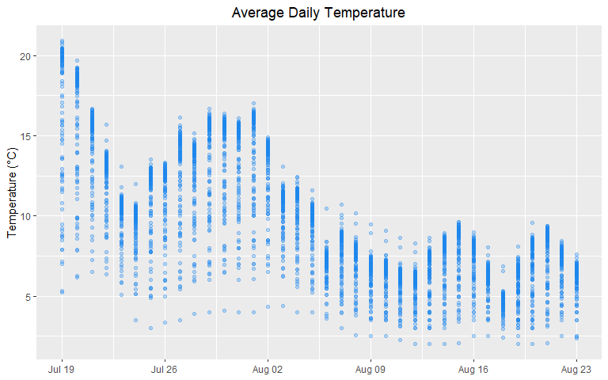

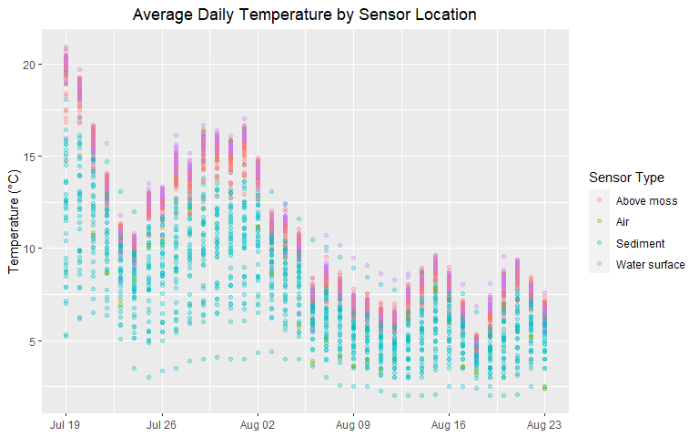

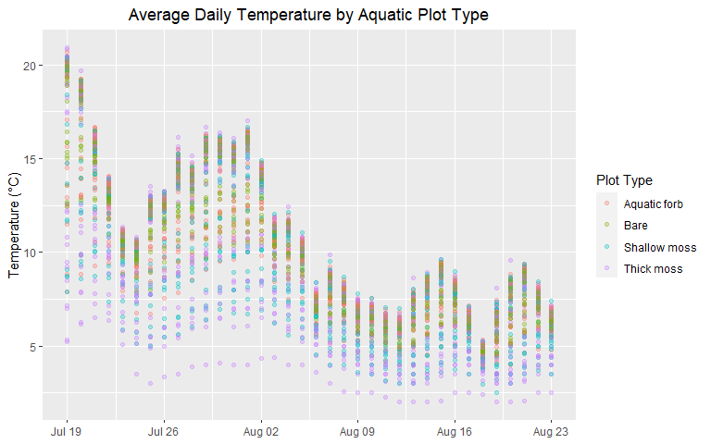

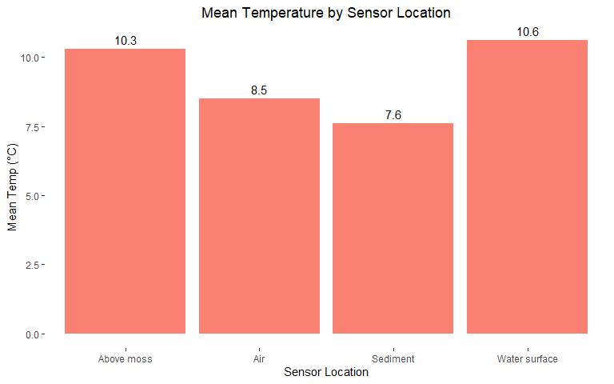

| Sensor Type | Mean Temp (°C) |
| --- | --- |
| Above moss | 10.3 |
| Air | 8.5 |
| Sediment | 7.6 |
| Water surface | 10.6 |

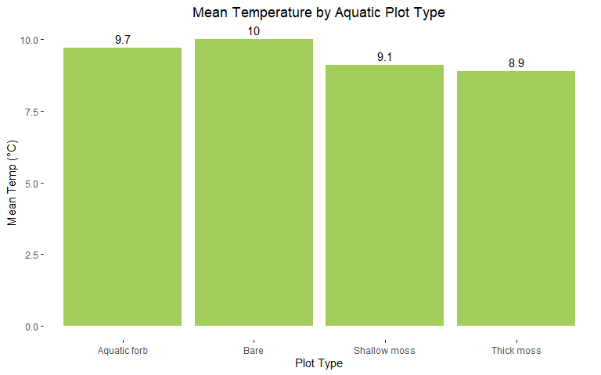

| Plot Type | Mean Temp (°C) |
| --- | --- |
| Aquatic forb | 9.7 |
| Bare | 10.0 |
| Shallow moss | 9.1 |
| Thick moss | 8.9 |

