iButton Temperature Data from 2021-2023 NIRPO Plots in Prudhoe Bay, Alaska

Jana Peirce

6 November 2023

## File prep

* Save all data with datetime info in csv before bringing into r (do not use readxl package)
* Format all times as yyyy-mm-dd before importing into r

## Date Time T02 T04 T06 T08 T09 T12 T13 T14  
## 1 2021-07-31 0:00:00 4.071 12.072 5.531 11.451 10.642 5.592 11.610 11.060  
## 2 2021-07-31 4:00:00 4.071 10.571 5.531 9.449 8.634 5.090 10.105 9.056  
## 3 2021-07-31 8:00:00 4.071 12.072 5.028 11.951 11.645 5.090 11.108 11.060  
## 4 2021-07-31 12:00:00 3.569 17.077 5.028 20.455 18.664 5.090 14.117 15.066  
## 5 2021-07-31 16:00:00 3.569 17.077 5.028 18.454 18.664 5.090 15.119 16.067  
## 6 2021-07-31 20:00:00 4.071 17.077 5.028 18.454 18.163 5.592 16.122 17.068  
## T17 T19 T20 T21 T22 T23 T24 T25 T26 T27 T28 T29  
## 1 10.601 3.564 10.642 12.064 9.075 10.059 6.063 4.047 3.583 6.120 4.573 3.583  
## 2 8.096 3.564 8.634 10.560 8.574 8.554 6.063 4.047 3.583 6.120 5.075 3.583  
## 3 11.101 3.062 11.144 11.563 7.570 10.560 5.561 4.047 3.583 5.619 5.075 3.583  
## 4 17.108 3.062 15.657 14.570 8.072 17.575 5.561 4.047 3.583 5.619 5.075 3.583  
## 5 17.108 3.062 16.660 16.072 9.075 17.074 5.561 4.047 3.583 5.619 4.573 3.583  
## 6 18.109 3.062 16.660 16.573 9.577 17.074 5.561 4.047 3.583 5.619 4.573 3.583  
## T30 T31 T33 T35 T36 T37 T39 T40 T41 T42 T43 T44  
## 1 12.147 7.049 9.577 3.053 5.075 4.631 8.023 7.065 5.104 10.141 10.128 5.062  
## 2 10.643 6.046 8.072 3.053 5.075 4.631 8.023 7.065 5.104 8.636 8.621 5.062  
## 3 11.144 5.544 10.079 3.053 5.075 4.631 7.522 7.065 5.104 11.144 9.124 5.062  
## 4 14.654 5.544 15.091 3.053 5.075 4.129 7.522 6.565 4.602 20.162 11.133 5.062  
## 5 16.658 6.547 15.592 3.053 5.075 4.129 7.522 6.565 5.104 17.658 13.141 5.062  
## 6 17.159 7.049 15.091 3.053 5.075 4.631 7.522 7.065 5.104 18.159 13.141 5.062  
## T46 T47 T48 T49 T51 T52 T53 T55 T56 T57 T58  
## 1 10.063 3.507 10.079 10.580 4.569 7.596 10.607 10.140 4.538 5.090 10.100  
## 2 8.559 3.507 8.071 9.076 4.067 7.596 9.102 8.634 4.538 5.090 8.595  
## 3 11.065 3.507 11.583 11.081 4.067 7.094 10.607 10.642 4.538 5.090 11.103  
## 4 15.573 3.006 20.101 18.096 4.067 7.094 14.117 14.153 4.538 4.588 17.116  
## 5 16.574 3.006 18.098 16.594 4.067 7.596 16.122 15.156 4.538 4.588 16.615  
## 6 16.574 3.006 18.098 17.095 4.569 8.098 16.122 15.156 4.538 4.588 16.615  
## T59 T60  
## 1 9.083 9.072  
## 2 7.575 8.070  
## 3 10.087 7.569  
## 4 17.614 7.569  
## 5 15.107 8.571  
## 6 15.107 9.072

## # A tibble: 6 × 4  
## Date Time iBtn_ID temp_c  
## <chr> <chr> <chr> <dbl>  
## 1 2021-07-31 0:00:00 T02 4.07  
## 2 2021-07-31 0:00:00 T04 12.1   
## 3 2021-07-31 0:00:00 T06 5.53  
## 4 2021-07-31 0:00:00 T08 11.5   
## 5 2021-07-31 0:00:00 T09 10.6   
## 6 2021-07-31 0:00:00 T12 5.59

## Date Time iBtn_ID temp_c Plot_ID Plot_type Transect Mission Depth  
## 1 2021-07-31 0:00:00 T02 4.071 21-22 Terrestrial T9 2021 -23  
## 2 2021-07-31 0:00:00 T04 12.072 21-25 Terrestrial T7 2021 0  
## 3 2021-07-31 0:00:00 T06 5.531 21-18 Terrestrial T8 2021 -20  
## 4 2021-07-31 0:00:00 T08 11.451 21-02 Terrestrial T8 2021 0  
## 5 2021-07-31 0:00:00 T09 10.642 21-21 Terrestrial T9 2021 0  
## 6 2021-07-31 0:00:00 T12 5.592 21-09 Terrestrial T6 2021 -14  
## Location Status  
## 1 base org layer Depth assumed based on A horizon  
## 2 surface   
## 3 base org layer   
## 4 surface   
## 5 surface   
## 6 base org layer

## Plot_ID Veg_type Transect Microrelief Surf_Geol Moisture Moist_gradient  
## 1 21-01 M2 T8 F Qti Wet tundra 2  
## 2 21-02 M2 T8 F Qti Wet tundra 5  
## 3 21-03 M4 T8 F Qt Wet tundra 5  
## 4 21-04 M4 T8 F Qt Wet tundra 5  
## 5 21-05 U3 T6 HC Qau Moist tundra 4  
## 6 21-06 U3 T6 HC Qau Moist tundra 4

## Date Time iBtn_ID temp_c Plot_ID Plot_type Transect.x Mission  
## 1 2021-07-31 0:00:00 T02 4.071 21-22 Terrestrial T9 2021  
## 2 2021-07-31 0:00:00 T04 12.072 21-25 Terrestrial T7 2021  
## 3 2021-07-31 0:00:00 T06 5.531 21-18 Terrestrial T8 2021  
## 4 2021-07-31 0:00:00 T08 11.451 21-02 Terrestrial T8 2021  
## 5 2021-07-31 0:00:00 T09 10.642 21-21 Terrestrial T9 2021  
## 6 2021-07-31 0:00:00 T12 5.592 21-09 Terrestrial T6 2021  
## Depth Location Status Veg_type Transect.y  
## 1 -23 base org layer Depth assumed based on A horizon U3 T9  
## 2 0 surface M4/Marl T7  
## 3 -20 base org layer U4 T8  
## 4 0 surface M2 T8  
## 5 0 surface U3 T9  
## 6 -14 base org layer U4 T6  
## Microrelief Surf_Geol Moisture Moist_gradient  
## 1 HC Moist tundra 4  
## 2 MP Aquatic lake vegetation 6  
## 3 DR Qti Moist tundra 4  
## 4 F Qti Wet tundra 5  
## 5 HC Moist tundra 4  
## 6 HC Qau Moist tundra 4

### Average Daily Temperature calculated (4320 rows)

| Date | iBtn ID | Plot ID | Veg Type | Plot Type | Depth | Transect | Moisture | Avg Daily Temp (°C) |
| --- | --- | --- | --- | --- | --- | --- | --- | --- |
| 2021-07-31 | T02 | 21-22 | U3 | Terrestrial | -23 | T9 | Moist tundra | 3.9 |
| 2021-07-31 | T04 | 21-25 | M4/Marl | Terrestrial | 0 | T7 | Aquatic lake vegetation | 14.3 |
| 2021-07-31 | T06 | 21-18 | U4 | Terrestrial | -20 | T8 | Moist tundra | 5.2 |
| 2021-07-31 | T08 | 21-02 | M2 | Terrestrial | 0 | T8 | Wet tundra | 15.0 |
| 2021-07-31 | T09 | 21-21 | U3 | Terrestrial | 0 | T9 | Moist tundra | 14.4 |
| 2021-07-31 | T12 | 21-09 | U4 | Terrestrial | -14 | T6 | Moist tundra | 5.3 |
| ### Average D | aily Tempe | rature cal | culated (43 | 20 rows) |  |  |  |  |

| Date | Veg Type | Location | Moisture | Surf Geol | Transect | Plot_ID | Avg Daily Temp (°C) |
| --- | --- | --- | --- | --- | --- | --- | --- |
| 2021-07-31 | M2 | base org layer | Wet tundra |  | T7 | 21-27 | 4.5 |
| 2021-07-31 | M2 | base org layer | Wet tundra |  | T9 | 21-19 | 4.0 |
| 2021-07-31 | M2 | base org layer | Wet tundra | Qau | T6 | 21-11 | 7.5 |
| 2021-07-31 | M2 | base org layer | Wet tundra | Qau | T6 | 21-14 | 5.1 |
| 2021-07-31 | M2 | base org layer | Wet tundra | Qau | T6 | 21-16 | 5.0 |
| 2021-07-31 | M2 | base org layer | Wet tundra | Qti | T8 | 21-01 | 4.8 |

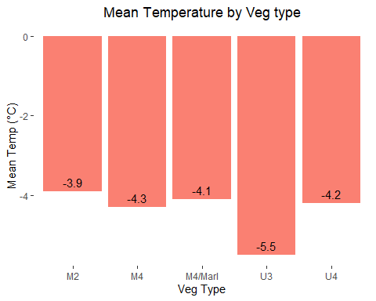

| Veg Type | Mean Temp (°C) |
| --- | --- |
| M2 | -3.9 |
| M4 | -4.3 |
| M4/Marl | -4.1 |
| U3 | -5.5 |
| U4 | -4.2 |

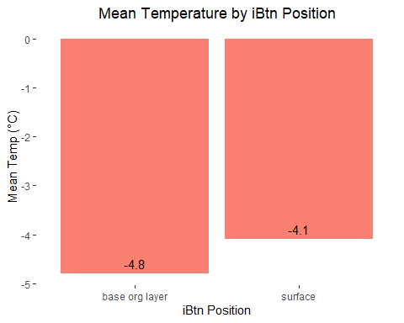

| iBtn Position | Mean Temp (°C) |
| --- | --- |
| M2 | -3.9 |
| M4 | -4.3 |
| M4/Marl | -4.1 |
| U3 | -5.5 |
| U4 | -4.2 |

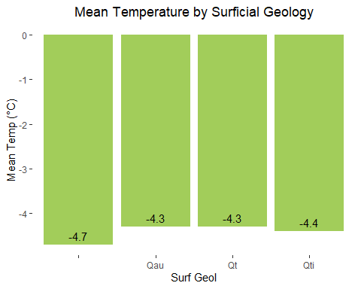

| Surficial Geology | Mean Temp (°C) |
| --- | --- |
|  | -4.7 |
| Qau | -4.3 |
| Qt | -4.3 |
| Qti | -4.4 |

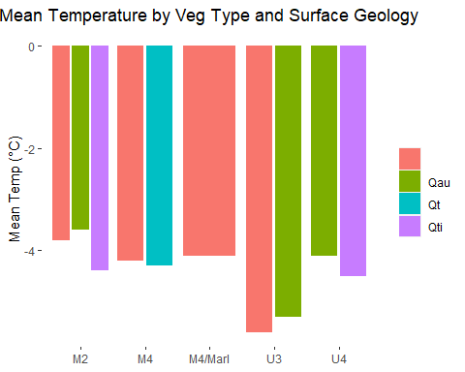

| Veg Type | Surf Geol | Mean Temp (°C) |
| --- | --- | --- |
| M2 |  | -3.8 |
| M2 | Qau | -3.6 |
| M2 | Qti | -4.4 |
| M4 |  | -4.2 |
| M4 | Qt | -4.3 |
| M4/Marl |  | -4.1 |
| U3 |  | -5.6 |
| U3 | Qau | -5.3 |
| U4 | Qau | -4.1 |
| U4 | Qti | -4.5 |
| [](iButton | s1922L_files | /figure-docx/unnamed-chunk-24-1.png) |

| Veg Type | iBtn Position | Mean Temp (°C) |
| --- | --- | --- |
| M2 |  | -3.8 |
| M2 | Qau | -3.6 |
| M2 | Qti | -4.4 |
| M4 |  | -4.2 |
| M4 | Qt | -4.3 |
| M4/Marl |  | -4.1 |
| U3 |  | -5.6 |
| U3 | Qau | -5.3 |
| U4 | Qau | -4.1 |
| U4 | Qti | -4.5 |

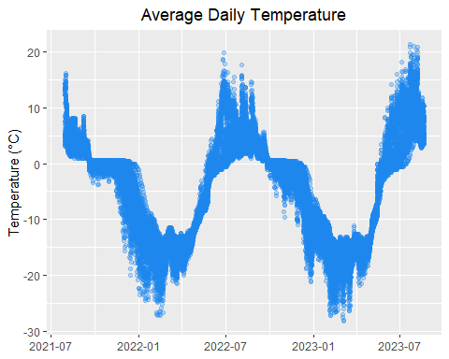

### Let’s look at the data in more detail.

Here is a plot of the average daily temperature of each iButton from all vegetation types at soil surface and the base of the organic layer.

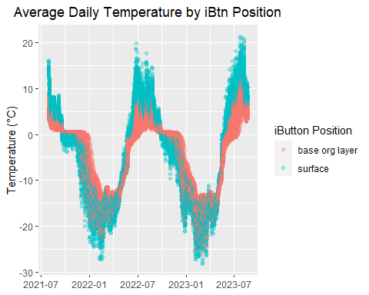 Now we can look at the just the surface data colored to indicated the vegetation type of the plot.

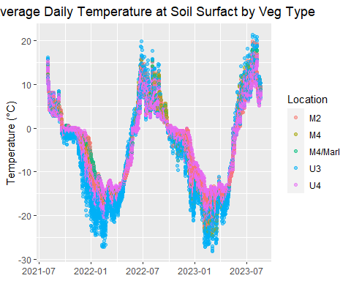 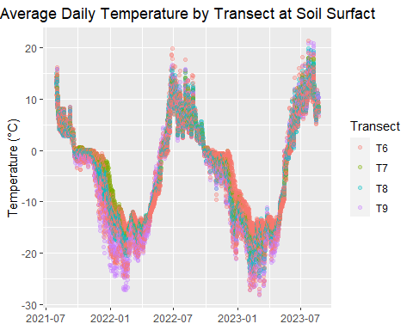 Now we can look at the just the base of the organic layer data colored to indicated the vegetation type of the plot.

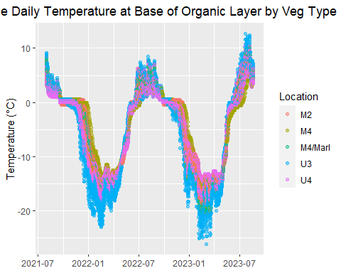

Here is a plot of the average daily temperature of each iButton by site moisture

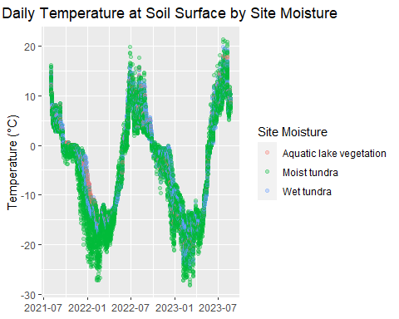

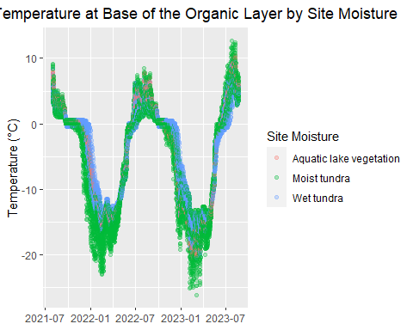

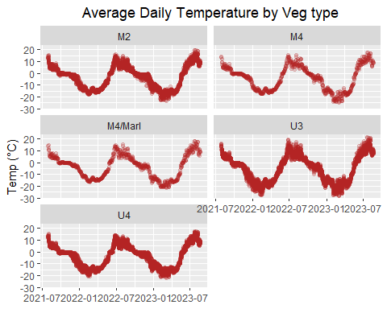

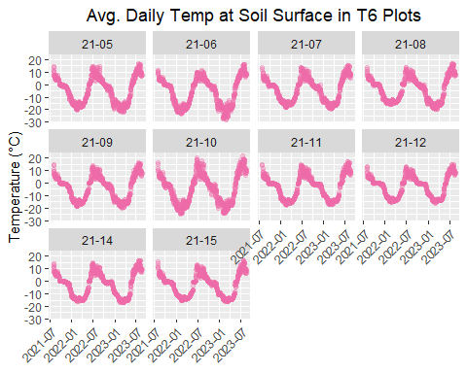

### That’s it! (for now)