Mental Model of the Modern IT Enterprise
OpenAI

1. Introduction
A modern IT enterprise should be understood as a whole system, not as a collection of disconnected technical teams. Its purpose is to align technology with business strategy, deliver change in a controlled way, run reliable services, and maintain trust through risk management, security, compliance, and assurance.
This chapter presents a practical mental model for understanding how a modern IT enterprise works. It is designed to help executives, architects, PMOs, service leaders, risk professionals, and auditors think about the enterprise using a common structure.
The core idea is simple:
A modern IT enterprise is a governed system that aligns strategy, architecture, investment, delivery, operations, and assurance to create business value with controlled risk.

2. The Five-Lens Model
A useful way to understand the enterprise is through five lenses:
- Why — strategy and value
- What — enterprise design, capabilities, policies, and architecture
- How — change, delivery, and operations
- Who — organisation, roles, and accountability
- Control — risk, security, compliance, and audit

2.1 Conceptual view

2.2 Why: Strategy and Value
The enterprise starts with purpose. IT exists to support business outcomes, improve performance, enable innovation, and protect the organisation.
Typical questions at this level include:
- What is the organisation trying to achieve?
- What value should technology create?
- Which risks are acceptable?
- Where should investment be concentrated?
Typical outputs include:
- business strategy
- digital strategy
- IT strategy
- investment priorities
- risk appetite
- target outcomes and measures
Mental point: IT starts with purpose, not technology.

2.3 What: Enterprise Design
Once strategic intent is clear, the enterprise must define what it needs in order to operate and evolve successfully.
This includes:
- business capabilities
- services
- products
- data
- applications
- platforms
- standards
- policies
- control objectives
Typical outputs include:
- capability maps
- enterprise architecture blueprints
- service catalogue
- data models
- technology standards
- policies and control frameworks
Mental point: architecture is the bridge between ambition and implementation.

2.4 How: Change and Run
A modern IT enterprise has two main operating engines:
- the change engine, which transforms the organisation
- the run engine, which operates services and technology day to day

2.4.1 Change engine
The change engine includes:
- portfolio management
- programme management
- project management
- product development
- business transformation

2.4.2 Run engine
The run engine includes:
- service management
- user support
- infrastructure and cloud operations
- application support
- monitoring and reliability
- continuity and resilience
Mental point: the enterprise must be able to change and run at the same time.

2.5 Who: Organisation and Accountability
The enterprise requires clear roles, decision rights, ownership, and reporting lines.
Typical accountability layers include:
- Board
- CEO
- CIO
- CTO
- CISO
- CDO
- PMO or Portfolio Office
- Operations leadership
- Risk, Compliance, and Audit functions
Typical questions include:
- Who decides?
- Who owns?
- Who delivers?
- Who approves?
- Who assures?
Mental point: governance is accountability made visible.

2.6 Control: Assurance and Trust
Control functions create confidence that the enterprise is secure, compliant, financially responsible, and properly governed.
These controls cut across all enterprise layers:
- risk management
- information security
- regulatory compliance
- internal control
- procurement control
- internal audit
- external assurance
Typical questions include:
- Are we secure?
- Are we compliant?
- Are risks understood?
- Are controls operating effectively?
- Can we demonstrate evidence?
Mental point: control is not bureaucracy; it is the mechanism of trust.

3. The Simplest Enterprise Sequence
The enterprise can also be understood as a simple sequence:

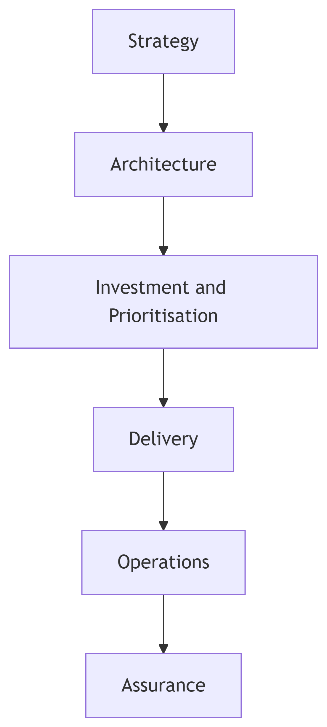

Across all of these layers sit the major control disciplines:
- Risk
- Security
- Compliance
- Audit
This sequence is useful because it shows the movement from intent to execution and then to confirmation.

4. The Three-Domain Model
Another strong mental model is to group the enterprise into three operating domains and one surrounding control domain.

4.1 Domain 1: Direct
This domain sets direction.
It includes:
- governance
- strategy
- architecture
- policy
- portfolio decisions

4.2 Domain 2: Change
This domain changes the enterprise.
It includes:
- programmes
- projects
- product development
- engineering delivery
- transformation initiatives

4.3 Domain 3: Run
This domain operates the enterprise.
It includes:
- IT services
- support
- infrastructure
- cloud and platform operations
- business continuity

4.4 Domain 4: Control
This domain surrounds the others and ensures confidence.
It includes:
- risk
- security
- compliance
- audit

4.5 Visual model

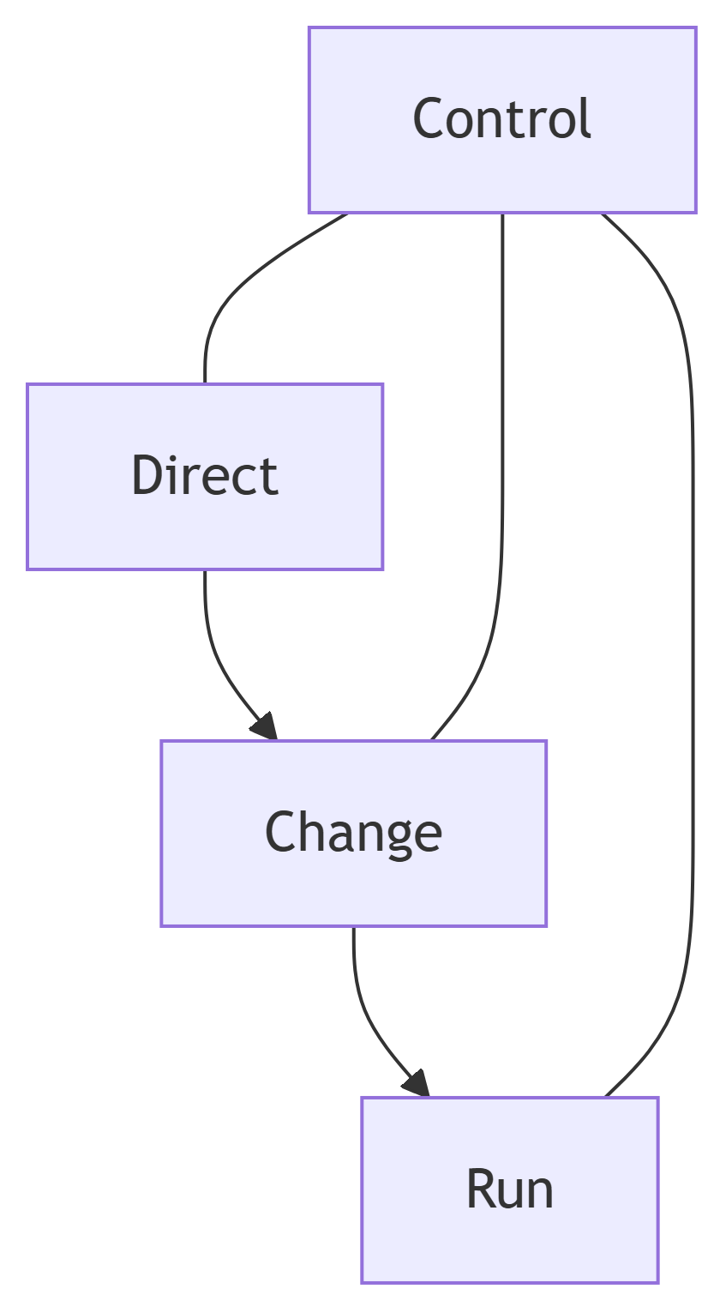

This model is useful because it separates strategic direction, delivery activity, and operational responsibility while preserving the role of independent control.

5. The Enterprise as a System of Flows
An enterprise is not only a hierarchy. It is also a system of flows.

5.1 Strategic flow
Business goals move into IT strategy, architecture, and portfolio prioritisation.

5.2 Delivery flow
Demand is converted into outcomes through delivery disciplines.

5.3 Service flow
Operational services move through request, fulfilment, support, monitoring, and improvement.

5.4 Control flow
Control disciplines work through policy, control design, execution, evidence, audit, and remediation.

5.5 Feedback flow
A modern enterprise learns through feedback.

Mental point: the enterprise is a system of decisions, services, change, and feedback loops.

6. Framework Mapping Model
No single framework covers the whole enterprise. Each framework typically governs one part of the system.
Mental domain | Primary purpose | Example frameworks
Govern | Set direction and control | COBIT, ISO/IEC 38500
Design | Shape the enterprise | TOGAF
Prioritise | Select strategic investment | MoP
Transform | Coordinate major change | MSP
Deliver | Execute projects | PRINCE2
Build and improve | Engineer solutions and platforms | Agile, DevOps
Run | Operate and support services | ITIL
Protect | Secure information and systems | ISO/IEC 27001, NIST CSF
Control | Manage uncertainty and response | MoR
Comply | Meet regulatory obligations | GDPR, NIS2, DORA, AI Act
Assure | Provide independent confidence | Internal Audit, ISO 19011

6.1 Framework interaction view

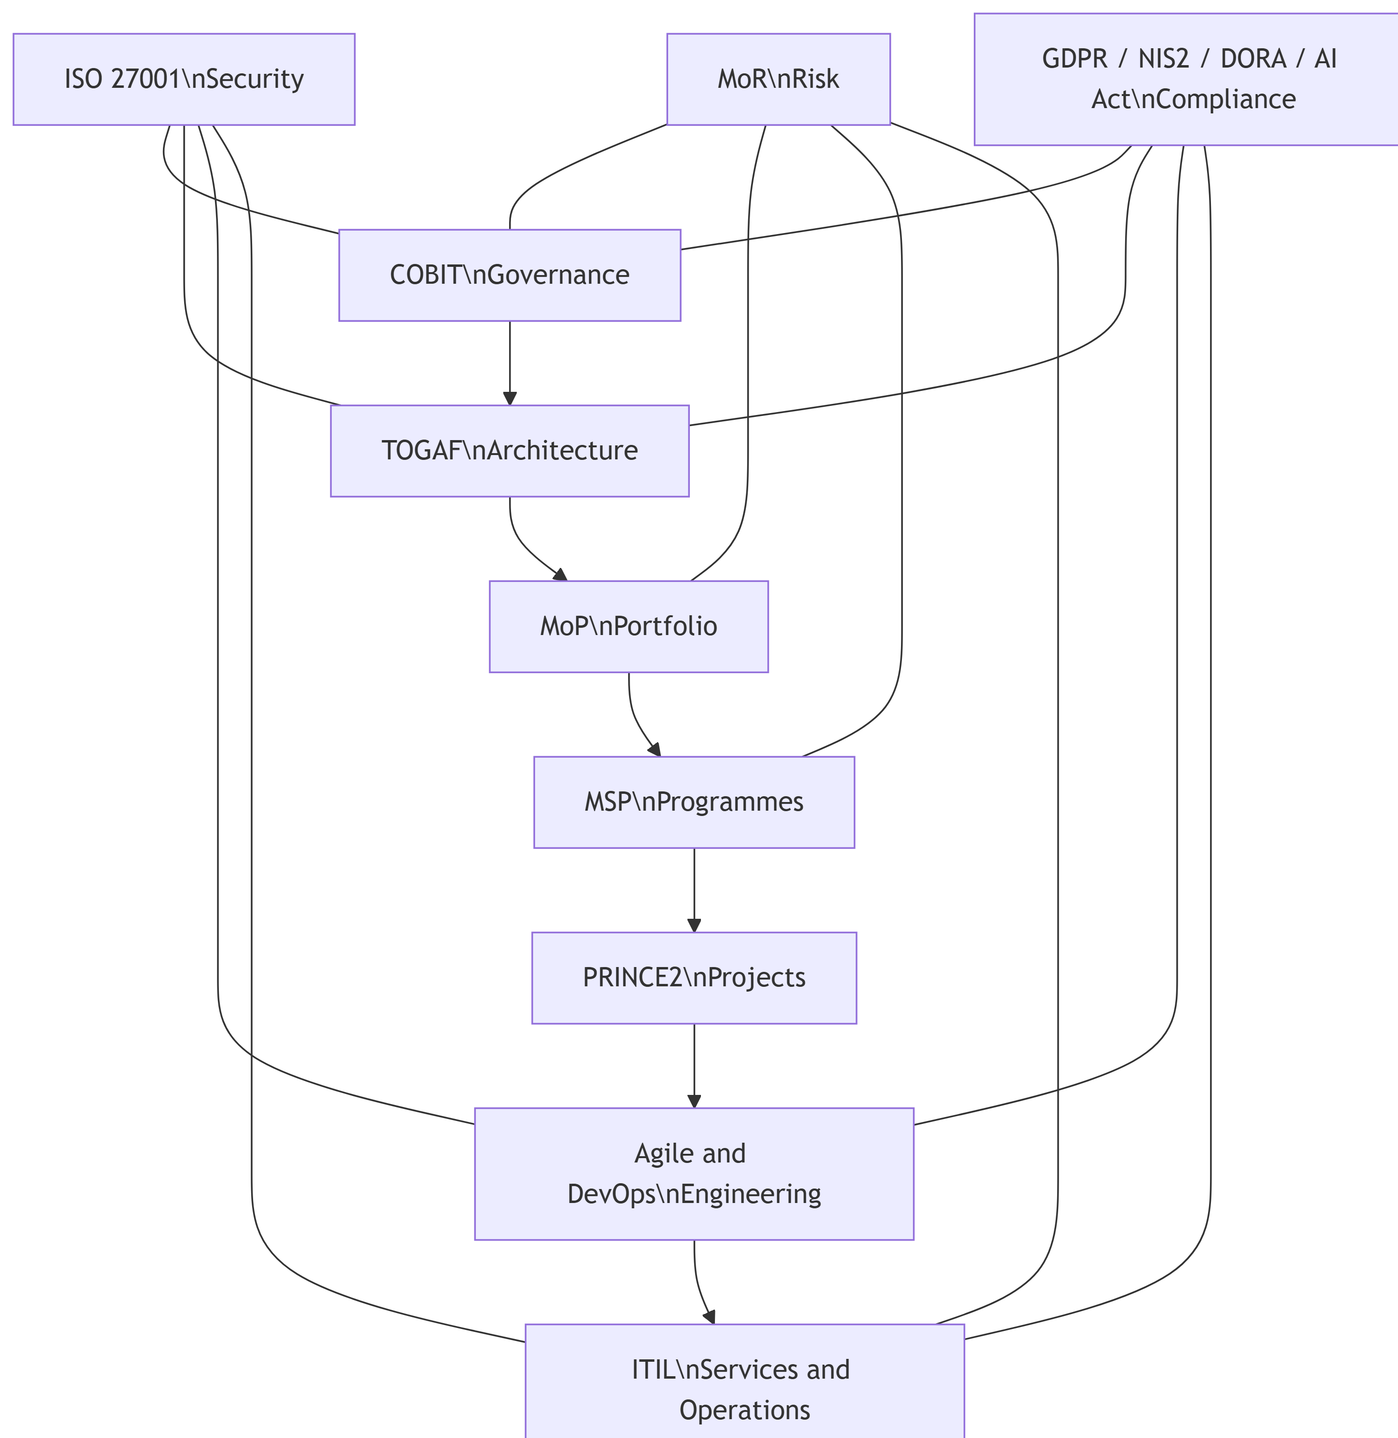

7. Executive View
For senior leadership, the model can be simplified into five questions.
The Board and executive leadership typically want confidence that:
- technology supports strategy
- money is being spent on the right priorities
- change is delivered successfully
- services are reliable and secure
- risk and compliance are under control
This is the executive essence of IT governance.

8. Practical Operating Model Sentence
A concise statement for this chapter is:
A modern IT enterprise is a governed system that directs the enterprise, changes the enterprise, runs the enterprise, controls the enterprise, and continuously improves the enterprise.

9. Key Governance Implications
This mental model leads to several important governance implications.

9.1 Alignment is essential
Strategy, architecture, delivery, and operations must be linked. If they are disconnected, the enterprise creates waste, duplication, and risk.

9.2 Accountability must be explicit
Decision rights, ownership, and assurance responsibilities should be visible and documented.

9.3 Control must be embedded
Risk, security, and compliance cannot be bolted on after the fact. They must be built into design, delivery, and operations.

9.4 Feedback must influence direction
Incidents, metrics, audits, and lessons learned should shape future strategy and improvement.

9.5 Frameworks should be integrated, not isolated
Frameworks are most valuable when used together in a coherent enterprise model rather than treated as separate compliance exercises.

10. Summary
The most useful mental shortcut for a modern IT enterprise is this:
Direct the enterprise
Change the enterprise
Run the enterprise
Control the enterprise
Improve the enterprise
This is the essence of modern IT governance.
A well-governed enterprise aligns business purpose, architectural design, investment choices, delivery capability, service operations, and assurance mechanisms into one coherent system.

11. Suggested Related Chapters
This chapter connects naturally to the following topics:
- Enterprise IT Organogram
- Visual IT Governance Universe
- Enterprise Capability Map
- Cross-Framework Process Integration
- Governance Artefact Catalogue
- Enterprise RACI Model

