## 1 Introduction

I am in charge of creating the weapons for D.R.E.A.D. This includes different weapons for damage, their projectiles, their animation, and a system to keep track of how much ammo a player has.

## Diagram Description automatically generated2 Use case diagram and scenario

### Scenario

**Name:** Kill Enemy

**Summary:** The player is trying to kill the enemy by shooting them with a weapon that must be picked up.

**Actors:** Player Character

**Preconditions:** Game is created and player has started playing the game.

**Basic sequence:**

**Step 1:** Pick up weapon

**Step 2:** Pick up ammunition

**Step 3:** Fire weapon towards enemy

**Step 4:** Ammunition tracker keeps track of how much is ammunition is left

**Exceptions:**

**Step 3:** Health reaches zero before player fires the weapon: player loses the game.

**Post Conditions:** Player has fired a weapon at (and hopefully hit) the enemy.

**Priority:** 1*

**ID:** JR01

*The priorities are 1 = must have, 2 = essential, 3 = nice to have.

## Data Flow diagram(s) from Level 0 to process description for your feature _______14

[Get the Level 0 from your team. Highlight the path to your feature]

Example:

### Data Flow Diagrams

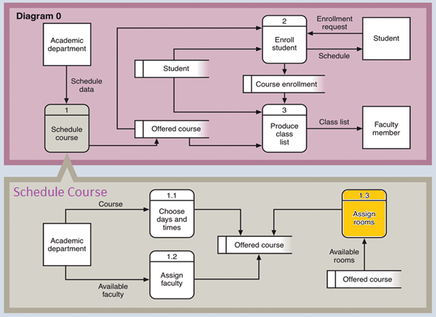

### Process Descriptions

Assign rooms*:

WHILE teacher in two places at once OR two classes in the same room

Randomly redistribute classes

END WHILE

**\*Notes**: Yours should be much longer. You could use a decision tree or decision table instead if it is more appropriate.

## Acceptance Tests ________9

[Describe the inputs and outputs of the tests you will run. Ensure you cover all the boundary cases.]

**Example for random number generator feature**

Run feature 1000 times sending output to a file.

The output file will have the following characteristics:

* Max number: 9
* Min number: 0
* Each digit between 0 and 9 appears at least 50 times
* No digit between 0 and 9 appears more than 300 times
* Consider each set of 10 consecutive outputs as a substring of the entire output. No substring may appear more than 3 times.

**Example for divide feature**

|  |  |  |  |
| --- | --- | --- | --- |
| Output | Numerator  (int) | Denominator  (int) | Notes |
| 0.5 | 1 | 2 |  |
| 0.5 | 2 | 3 | We only have 1 bit precision for outputs. Round all values to the nearest .5 |
| 0.0 | 1 | 4 | At the 0.25 mark always round to the nearest whole integer |
| 1.0 | 3 | 4 | At the 0.75 mark always round to the nearest whole integer |
| 255.5 | 5 | 0 | On divide by 0, do not flag an error. Simply return our MAX_VAL which is 255.5. |

## Timeline _________/10

[Figure out the tasks required to complete your feature]

Example:

### Work items

|  |  |  |
| --- | --- | --- |
| Task | Duration (PWks) | Predecessor Task(s) |
| 1. Requirements Collection | 5 | - |
| 2. Screen Design | 6 | 1 |
| 3. Report Design | 6 | 1 |
| 4. Database Construction | 2 | 2, 3 |
| 5. User Documentation | 6 | 4 |
| 6. Programming | 5 | 4 |
| 7. Testing | 3 | 6 |
| 8. Installation | 1 | 5, 7 |

### Pert diagram

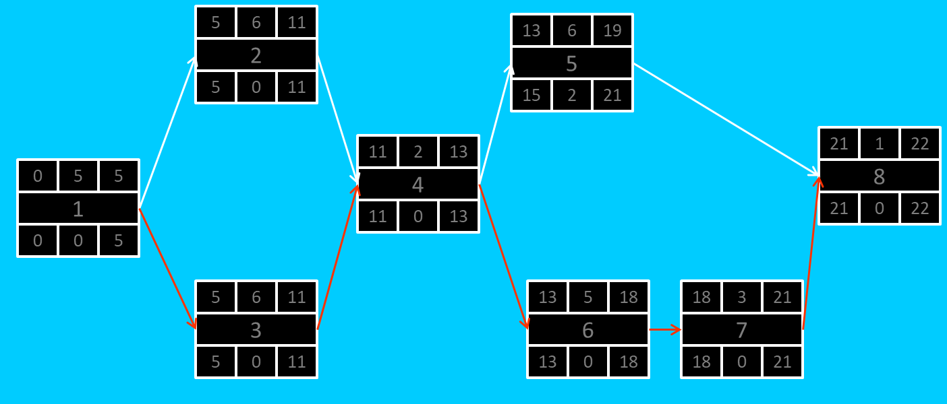

### Gantt timeline

|  |  |  |  |  |  |  |  |  |  |  |  |  |  |  |  |  |  |  |  |  |  |  |  |  |
| --- | --- | --- | --- | --- | --- | --- | --- | --- | --- | --- | --- | --- | --- | --- | --- | --- | --- | --- | --- | --- | --- | --- | --- | --- |
| 1 |  |  |  |  |  |  |  |  |  |  |  |  |  |  |  |  |  |  |  |  |  |  |  |  |
| 2 |  |  |  |  |  | 1 |  |  |  |  |  |  |  |  |  |  |  |  |  |  |  |  |  |  |
| 3 |  |  |  |  |  | 1 |  |  |  |  |  |  |  |  |  |  |  |  |  |  |  |  |  |  |
| 4 |  |  |  |  |  |  |  |  |  |  |  | 3 |  |  |  |  |  |  |  |  |  |  |  |  |
| 5 |  |  |  |  |  |  |  |  |  |  |  |  |  |  |  | 4 |  |  |  |  |  |  |  |  |
| 6 |  |  |  |  |  |  |  |  |  |  |  |  |  |  |  | 4 |  |  |  |  |  |  |  |  |
| 7 |  |  |  |  |  |  |  |  |  |  |  |  |  |  |  |  |  |  |  |  | 6 |  |  |  |
| 8 |  |  |  |  |  |  |  |  |  |  |  |  |  |  |  |  |  |  |  |  |  |  |  | 7 |
|  | 1 | 2 | 3 | 4 | 5 | 6 | 7 | 8 | 9 | 10 | 11 | 12 | 13 | 14 | 15 | 16 | 17 | 18 | 19 | 20 | 21 | 22 | 23 | 24 |