

**T.C. AYDIN ADNAN MENDERES UNIVERSITY**

**FACULTY OF ENGINEERING**

**DEPARTMENT OF COMPUTER ENGINEERING**

**CSE402 Graduation Thesis 2, Spring 2019**

**Supervisor: Fatih SOYGAZİ**

**Cukatify:Music Social Media Web Platform Final Report**

**(Bachelor of Science Thesis)**

**01.06.2020 Presentation Date**

**By:**

**Okan ÇİFTÇİ Student ID: 151805041**

# PLAGIARISM STATEMENT

This report was written by the group members and in our own words, except for quotations from published and unpublished sources which are clearly indicated and acknowledged as such. We are conscious that the incorporation of material from other works or a paraphrase of such material without acknowledgement will be treated as plagiarism according to the University Regulations. The source of any picture, graph, map or other illustration is also indicated, as is the source, published or unpublished, of any material not resulting from our own experimentation, observation or specimen collecting.

**Project Group Members:**

|  |  |  |  |
| --- | --- | --- | --- |
| Name, Lastname | Student Number | Signature | Date |
| Okan ÇİFTÇİ | 151805041 |  | 16/01/2020 |

**Project Supervisors:**

|  |  |  |  |
| --- | --- | --- | --- |
| Name, Lastname | Department | Signature | Date |
| Fatih SOYGAZİ | Computer Science Engineering |  | 16/01/2020 |

# ACKNOWLEDGEMENTS

The acknowlodgements are here

# KEYWORDS

Spotify,Music,Ontology,DBpedia,Recommendation System,Redis,NOSQL,Spring Boot,Social Media,Description Logic,Data Analysis,Collaborative Filtering,NER.

# ABSTRACT

Since the early 1950s people frequently listening music from different sources like record player,tape,mp3 player etc. This sources provide one way communication which is source to listener but with technology growth this change. Nowadays we listening music with different sources too but communication is more different between listener and source. Our goal is use to advanced learning techniques and knowledge representation to provide listeners use music sources more effectively like recommendation about new music, gain knowledge about musicians with those provided we hopefully create a web platform to people communicate each other and find music related stuff with these platform.

# ÖZET

Geçmişten günümüze müzik dinleyen insanlarla müzik arasında ki iletişime baktığımızda müzik 2010’ların başlarına kadar iletim yoluyla sadece dinleyen tarafından dinlenildi karşılıklı bir iletişim bulunmamaktaydı, teknolojinin gelişmesi ile birlikte müzik ile dinleyen arasında olan iletişim var olmaya ve artmaya devam etmektedir. Müzik dinleyen kişi çeşitli etkileşimler ile müziğin kaynağına etkide bulunabilmekte böylelikle aldığı etki farklı olmaktadır.Temel olarak amacımız kullanıcıları müzikler ile etkileşim haline geçirerek öğrenme teknikleri ile kullanıcılara çeşitli müzikler önermek, bilginin temsili ile kullanıcılara müzik grupları,sanatçılar hakkında bilgi vermek iletişimi arttırmak için kullanıcılar birbirine önermek aynı zamanda müzik dünyasında olan çeşitli etkinlikleri paylaşmak.

# TABLE OF CONTENTS

PLAGIARISM STATEMENT 2

ACKNOWLEDGEMENTS 3

KEYWORDS 4

ABSTRACT 5

ÖZET 6

TABLE OF CONTENTS 7

LIST OF FIGURES 8

LIST OF TABLES 9

LIST OF ACRONYMS/ABBREVIATIONS 10

1. INTRODUCTION 1

1.1. Description of the Problem 1

1.2. Project Goal 1

1.3. Project Output 1

1.4. Project Activities and Schedule 1

2. DESIGN 1

2.1. High Level Design 1

2.2. Detailed Design 1

2.3. Realistic Restrictions and Conditions in the Design 2

3. IMPLEMENTATION, TESTS and TEST DISCUSSIONS 2

3.1. Implementation of the Product 2

3.2. Tests and Results of Tests 2

4. CONCLUSIONS 2

4.1. Summary 2

4.2. Cost Analysis 2

4.3. Benefits of the Project 3

4.4. Future Work 3

References 3

APPENDICES 4

# LIST OF FIGURES

List of figures, if any, that appear in the main body of final report. Those in appendices must not be listed here.

Figure x.y. Title of the figure …………………………………………………………Page Number

# LIST OF TABLES

List of tables, if any, that appear in the main body of final report. Those in appendices must not be listed here.

Table x.y. Title of the table ………………………………………………………Page Number

# LIST OF ACRONYMS/ABBREVIATIONS

AI Artificial Intelligence

KR Knowledge Representation

# 1. INTRODUCTION

# 1.1. Description of the Problem

In music society there are too many changes rapidly, listeners having trouble catching new events our aim in this project solve this problem for music lovers to feel comfortable around music society and also with recommendations we want to increase communication between users. There is a platforms which are Spotify and LastFM we use Spotify and LastFM pros but also add new features to increase diversity.

# 1.2. Project Goal

Project goal is going to create a web platform for access of end users via this platform users can access and use our platform also create detailed documentation about platform and collect new datasets for data science society. Our platform main goal is increase to communication between users and music environment.

# 1.3. Project Output

Our project output is a software product which runs on a server. Software product give output like recommendations,knowledge about music society, communication between users.

# 1.4. Project Activities and Schedule

* Determine requirements our project.
* Discuss about requirements.
* Arrange requirements.
* Analysis on requirements.
* Determine technologies which using in these project.
* Finding music related ontology.
* Creating ER diagram
* Starting to development backend
* Starting to development frontend

# 2. DESIGN

# 2.1. High Level Design

* Briefly describe what you have done as high level design
* State that your high level design is provided in Appendix B: Design Specifications Document, v2.0, sections ……...Of course, your high level design must exist in the referenced sections of this appendix.

# 2.2. Detailed Design

* Briefly describe what you have done as detailed design
* State that your detail design is provided in Appendix B: Design Specifications Document, sections ……...Of course, your detailed design must exist in the referenced sections of this appendix.

# 2.3. Realistic Restrictions and Conditions in the Design

* Briefly describe restrictions in your high level/detailed design. For example, no security, limited password enforcement, serves only up to 1000 users simultaneously, does not support distributed files, etc.
* If you have already written about your design decisions related to restrictions and conditions in your design, then you can simply reference the related sections in Appendix B: Design Specifications Document, sections ……...Of course, your design decisions must exist in the referenced sections of this appendix.

# 3. IMPLEMENTATION, TESTS and TEST DISCUSSIONS

# 3.1. Implementation of the Product

* Give an overview of your implementation, basically overview of what you have written in Product Manual in Appendix C..
* State that a detailed description of your implementation is provided in Appendix C: Product Manual.

# 3.2. Tests and Results of Tests

* As in 3.1, an overview of your tests, your test results and a discussion of your test results should be in Product Manual in Appendix C.

# 4. CONCLUSIONS

# 4.1. Summary

Until now we create our main project structure with both side also access DBpedia to represent our knowledge about music society. We create posts which give us information about news about music society. We use redis for caching. We use archUnit for project architecture testing.

# 4.2. Cost Analysis

* Manpower spent in your project, in man-days, for each team member, per month and total. Assume one man-day means “actually working” for 8 hours, excluding any tea/coffee/lunch breaks. Provide a detailed table showing manpower for each month (i.e. February, March, April, May 2020) and for each team member and also totals for each month, each team member and overall manower effort.
* Any hardware and/or software bought for your project. Provide a detailed table item, brand name, model, properties and cost.
* Perform a simple cost analysis based on information you provide

# 4.3. Benefits of the Project

Our project main benefit is increase to interaction between users and music society with these project. Users can find a new music which will probably like. Users also can find new friends with these platform which will probably same taste in music also users can hear new magazines about music society.

# 4.4. Future Work

We will add user,music,post recommendation types to users also create a interface to enable communication also collect music named entities and provide login with two kinds of login one of them Spotify login other is platform login. You can keep track project following link <https://github.com/okanvk/Cukatify>

# References

<https://www.baeldung.com/>

<https://wiki.dbpedia.org/>

<https://redis.io/>

<https://spring.io/>

<https://tr.reactjs.org/>

<https://open.hpi.de/courses/semanticweb>

<https://www.palermo.edu/ingenieria/Pdf2010/CyT9/15.pdf>

<https://www.mongodb.com/>

<https://jena.apache.org/>

<https://www.archunit.org/>

<http://eecs.qmul.ac.uk/research/eecs-research-impact/semantic-web-for-music/>

<https://plantuml.com/>

# APPENDICES

|  | **Theme** | **Epic** | **User Story** |
| --- | --- | --- | --- |
|  | Access Knowledge | Search a artist or band | As a User, I would like to access a artist or band information |
|  | Access Data | Find music news all around the world | As a User, I would like to find music news from different countries and genres |
|  | Login the Platform | Use platform with more interactively | As a User,I would like login to the system to use more features |

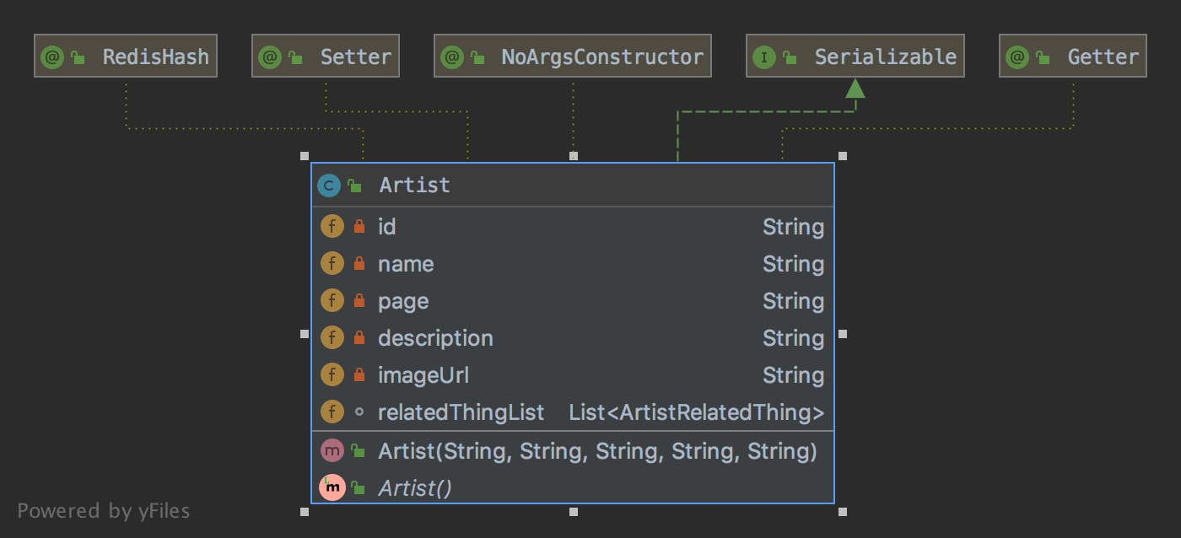

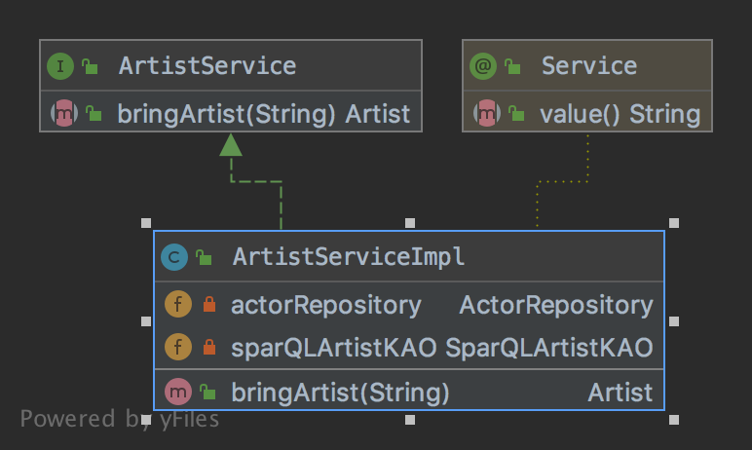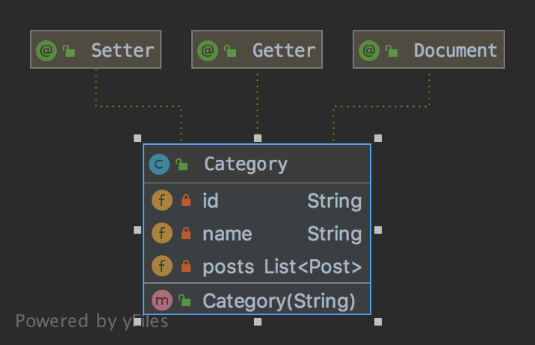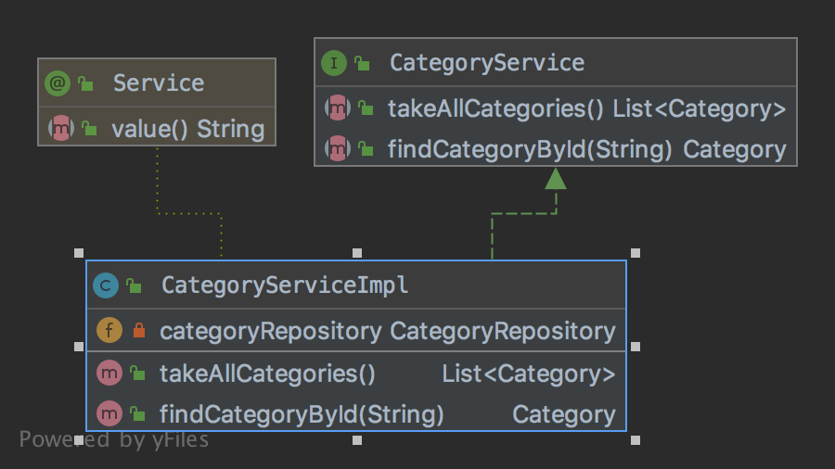

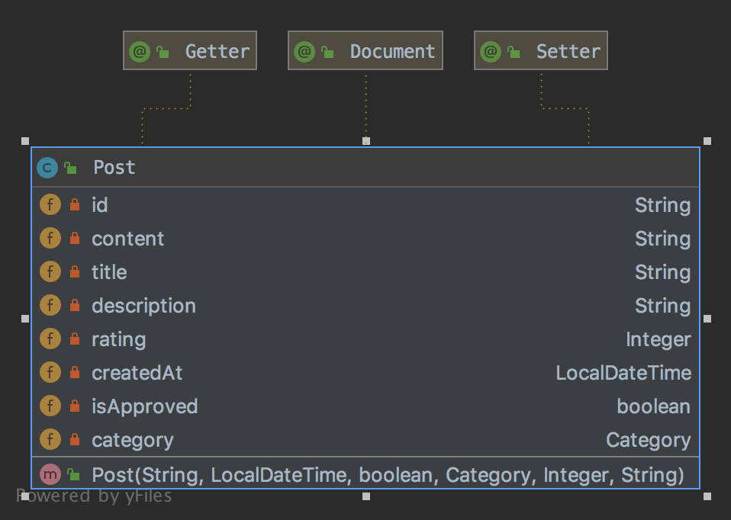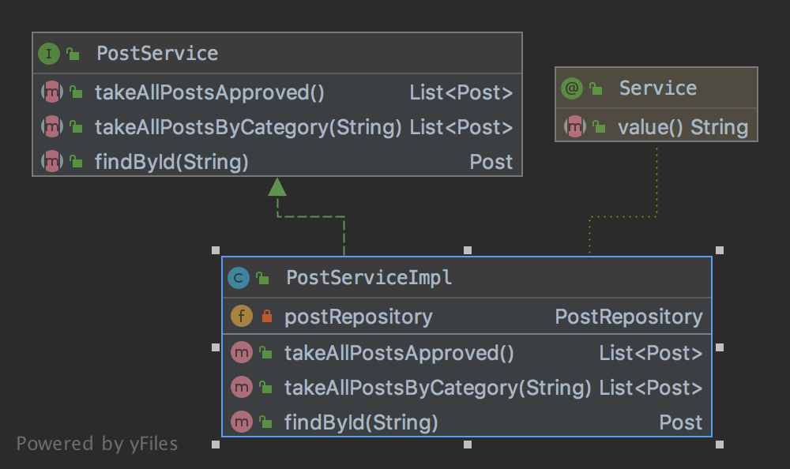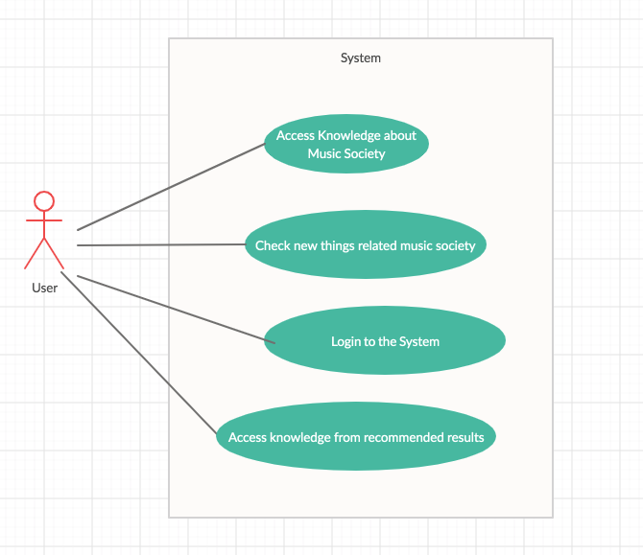

İ

