Multilevel Truncated Negative Binomial Model Results

Fixed Effects Coefficients
Estimate | Std. Error | z value | P-value | Variable
-2.3119 | 2.2513 | -1.0269 | 0.3045 | (Intercept)
-0.0013 | 0.0037 | -0.3676 | 0.7132 | import_from_slu_log
0.0058 | 0.0001 | 47.2803 | 0.0000 | age
-0.0101 | 0.0229 | -0.4396 | 0.6602 | immigrant_density
0.3492 | 0.2056 | 1.6988 | 0.0894 | state_percapita_income_log
0.0025 | 0.0232 | 0.1060 | 0.9155 | immigrant_similar
0.0068 | 0.0225 | 0.3022 | 0.7625 | immigrant_moderate
0.0104 | 0.0035 | 2.9443 | 0.0032 | sex_enc1
0.0040 | 0.0121 | 0.3298 | 0.7416 | marital_status_enc1
0.0040 | 0.0043 | 0.9406 | 0.3469 | marital_status_enc2
-0.0467 | 0.0283 | -1.6495 | 0.0990 | employment_status_enc1
0.1081 | 0.0203 | 5.3367 | 0.0000 | employment_status_enc2
0.1907 | 0.0198 | 9.6476 | 0.0000 | purpose_simple1
0.4483 | 0.0158 | 28.4441 | 0.0000 | purpose_simple2
0.1452 | 0.0136 | 10.6438 | 0.0000 | purpose_simple3
0.0079 | 0.0159 | 0.4971 | 0.6191 | purpose_simple4
0.1306 | 0.0092 | 14.1964 | 0.0000 | accomd_type_enc1
0.2359 | 0.0053 | 44.6224 | 0.0000 | accomd_type_enc2

Incident Rate Ratios (IRR) for Fixed Effects
Incident Rate Ratios for Fixed Effects
Variable | IRR | Lower CI | Upper CI | P-value
(Intercept) | 0.0991 | 0.0012 | 8.1713 | 0.3045
import_from_slu_log | 0.9987 | 0.9915 | 1.0058 | 0.7132
age | 1.0058 | 1.0056 | 1.0061 | 0.0000
immigrant_density | 0.9900 | 0.9466 | 1.0354 | 0.6602
state_percapita_income_log | 1.4179 | 0.9477 | 2.1214 | 0.0894
immigrant_similar | 1.0025 | 0.9579 | 1.0492 | 0.9155
immigrant_moderate | 1.0068 | 0.9633 | 1.0523 | 0.7625
sex_enc1 | 1.0105 | 1.0035 | 1.0175 | 0.0032
marital_status_enc1 | 1.0040 | 0.9805 | 1.0281 | 0.7416
marital_status_enc2 | 1.0040 | 0.9957 | 1.0124 | 0.3469
employment_status_enc1 | 0.9543 | 0.9028 | 1.0088 | 0.0990
employment_status_enc2 | 1.1141 | 1.0708 | 1.1592 | 0.0000
purpose_simple1 | 1.2101 | 1.1641 | 1.2579 | 0.0000
purpose_simple2 | 1.5656 | 1.5180 | 1.6147 | 0.0000
purpose_simple3 | 1.1563 | 1.1258 | 1.1877 | 0.0000
purpose_simple4 | 1.0079 | 0.9770 | 1.0399 | 0.6191
accomd_type_enc1 | 1.1395 | 1.1191 | 1.1602 | 0.0000
accomd_type_enc2 | 1.2661 | 1.2530 | 1.2793 | 0.0000

Random Effects Variance Components
No random effect variance estimated for us_state_enc.

Model R-squared (Marginal and Conditional)
Statistic | Value
R2_conditional | 0.1126
R2_marginal | 0.0720

Variance Inflation Factor (VIF)
VIF Values (Note: VIF > 5 may indicate multicollinearity)
Variable | VIF
Predictor 1 | 1.48
Predictor 2 | 1.11
Predictor 3 | 416.58
Predictor 4 | 2.14
Predictor 5 | 36.86
Predictor 6 | 428.83
Predictor 7 | 1.02
Predictor 8 | 1.17
Predictor 9 | 1.00
Predictor 10 | 1.17
Predictor 11 | 1.15

Model Comparison (Truncated vs Non-truncated)
ANOVA Model Comparison Results
Df | AIC | BIC | logLik | deviance | Chisq | Chi Df | Pr(>Chisq)
20 | 745,997.0 | 746,193.9 | -372,978.5 | 745,957.0
20 | 751,679.5 | 751,876.4 | -375,819.8 | 751,639.5 | 0 | 0 | 1

Model Fit Statistics
Statistic | Value
AIC | 745,997.0
BIC | 746,193.9
Log-likelihood | -372,978.5

Predicted vs Observed Length of Stay
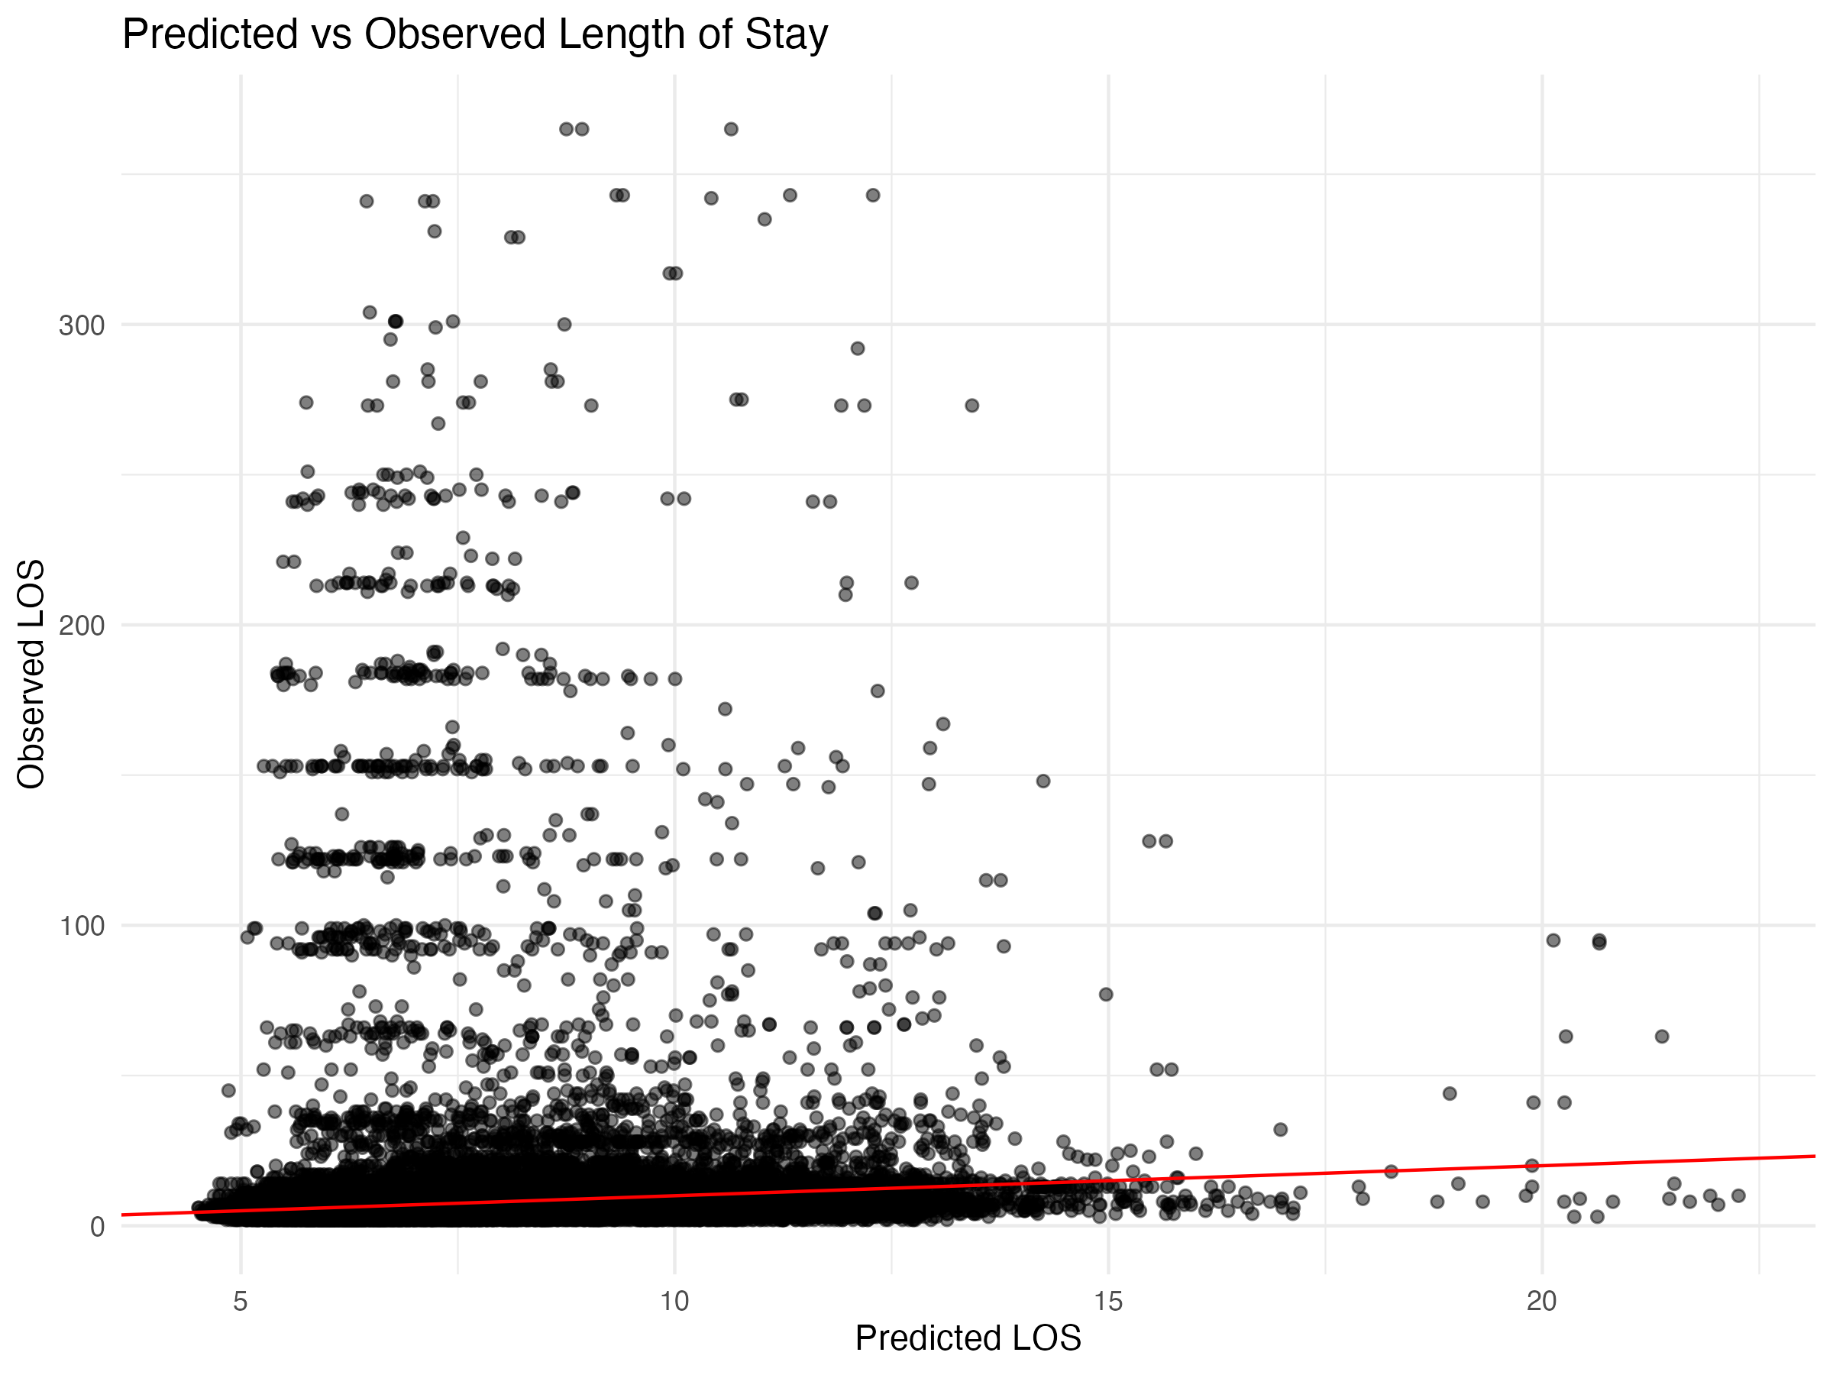

Diagnostic Plots

DHARMa Residuals
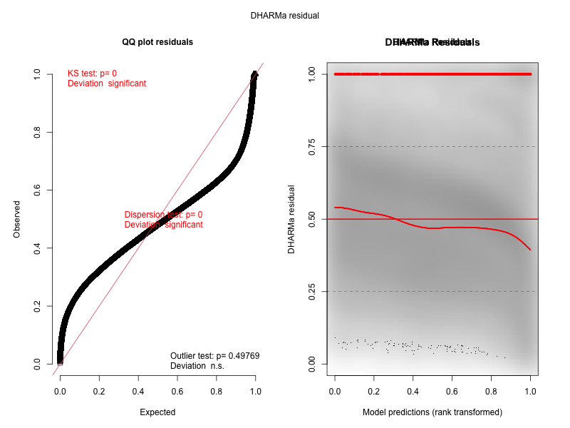

Residuals by State
