Multilevel Truncated Negative Binomial Model Results

Fixed Effects Coefficients
Estimate | Std. Error | z value | P-value | Variable
-2.6715 | 2.6142 | -1.0219 | 0.3068 | (Intercept)
-0.0021 | 0.0039 | -0.5526 | 0.5805 | import_from_slu_log
0.0058 | 0.0001 | 47.2790 | 0.0000 | age
-0.0170 | 0.0234 | -0.7293 | 0.4658 | state_unemployment
-0.0036 | 0.0020 | -1.7980 | 0.0722 | immigrant_density
0.3888 | 0.2386 | 1.6291 | 0.1033 | state_percapita_income_log
-0.0433 | 0.1081 | -0.4000 | 0.6891 | climate_distance
0.0104 | 0.0035 | 2.9440 | 0.0032 | sex_enc1
0.0040 | 0.0121 | 0.3297 | 0.7416 | marital_status_enc1
0.0040 | 0.0043 | 0.9398 | 0.3473 | marital_status_enc2
-0.0467 | 0.0283 | -1.6494 | 0.0991 | employment_status_enc1
0.1080 | 0.0203 | 5.3350 | 0.0000 | employment_status_enc2
0.1907 | 0.0198 | 9.6480 | 0.0000 | purpose_simple1
0.4483 | 0.0158 | 28.4452 | 0.0000 | purpose_simple2
0.1453 | 0.0136 | 10.6454 | 0.0000 | purpose_simple3
0.0079 | 0.0159 | 0.4994 | 0.6175 | purpose_simple4
0.1306 | 0.0092 | 14.1960 | 0.0000 | accomd_type_enc1
0.2359 | 0.0053 | 44.6219 | 0.0000 | accomd_type_enc2

Incident Rate Ratios (IRR) for Fixed Effects
Incident Rate Ratios for Fixed Effects
Variable | IRR | Lower CI | Upper CI | P-value
(Intercept) | 0.0691 | 0.0004 | 11.6155 | 0.3068
import_from_slu_log | 0.9979 | 0.9904 | 1.0054 | 0.5805
age | 1.0058 | 1.0056 | 1.0061 | 0.0000
state_unemployment | 0.9831 | 0.9391 | 1.0292 | 0.4658
immigrant_density | 0.9964 | 0.9924 | 1.0003 | 0.0722
state_percapita_income_log | 1.4751 | 0.9241 | 2.3548 | 0.1033
climate_distance | 0.9577 | 0.7747 | 1.1838 | 0.6891
sex_enc1 | 1.0105 | 1.0035 | 1.0175 | 0.0032
marital_status_enc1 | 1.0040 | 0.9805 | 1.0281 | 0.7416
marital_status_enc2 | 1.0040 | 0.9957 | 1.0124 | 0.3473
employment_status_enc1 | 0.9543 | 0.9028 | 1.0088 | 0.0991
employment_status_enc2 | 1.1141 | 1.0707 | 1.1592 | 0.0000
purpose_simple1 | 1.2101 | 1.1641 | 1.2579 | 0.0000
purpose_simple2 | 1.5657 | 1.5180 | 1.6148 | 0.0000
purpose_simple3 | 1.1564 | 1.1258 | 1.1877 | 0.0000
purpose_simple4 | 1.0080 | 0.9770 | 1.0399 | 0.6175
accomd_type_enc1 | 1.1395 | 1.1191 | 1.1602 | 0.0000
accomd_type_enc2 | 1.2661 | 1.2530 | 1.2793 | 0.0000

Random Effects Variance Components
No random effect variance estimated for us_state_enc.

Variance Inflation Factor (VIF)
VIF Values (Note: VIF > 5 may indicate multicollinearity)
Variable | VIF
Predictor 1 | 1.44
Predictor 2 | 1.10
Predictor 3 | 1.01
Predictor 4 | 1.51
Predictor 5 | 1.92
Predictor 6 | 1.80
Predictor 7 | 1.02
Predictor 8 | 1.17
Predictor 9 | 1.00
Predictor 10 | 1.17
Predictor 11 | 1.15

Model Comparison (Truncated vs Non-truncated)
ANOVA Model Comparison Results
Df | AIC | BIC | logLik | deviance | Chisq | Chi Df | Pr(>Chisq)
20 | 745,991.1 | 746,188.0 | -372,975.6 | 745,951.1
20 | 751,673.5 | 751,870.4 | -375,816.8 | 751,633.5 | 0 | 0 | 1

Model Fit Statistics
Statistic | Value
AIC | 745,991.1
BIC | 746,188.0
Log-likelihood | -372,975.6

Predicted vs Observed Length of Stay
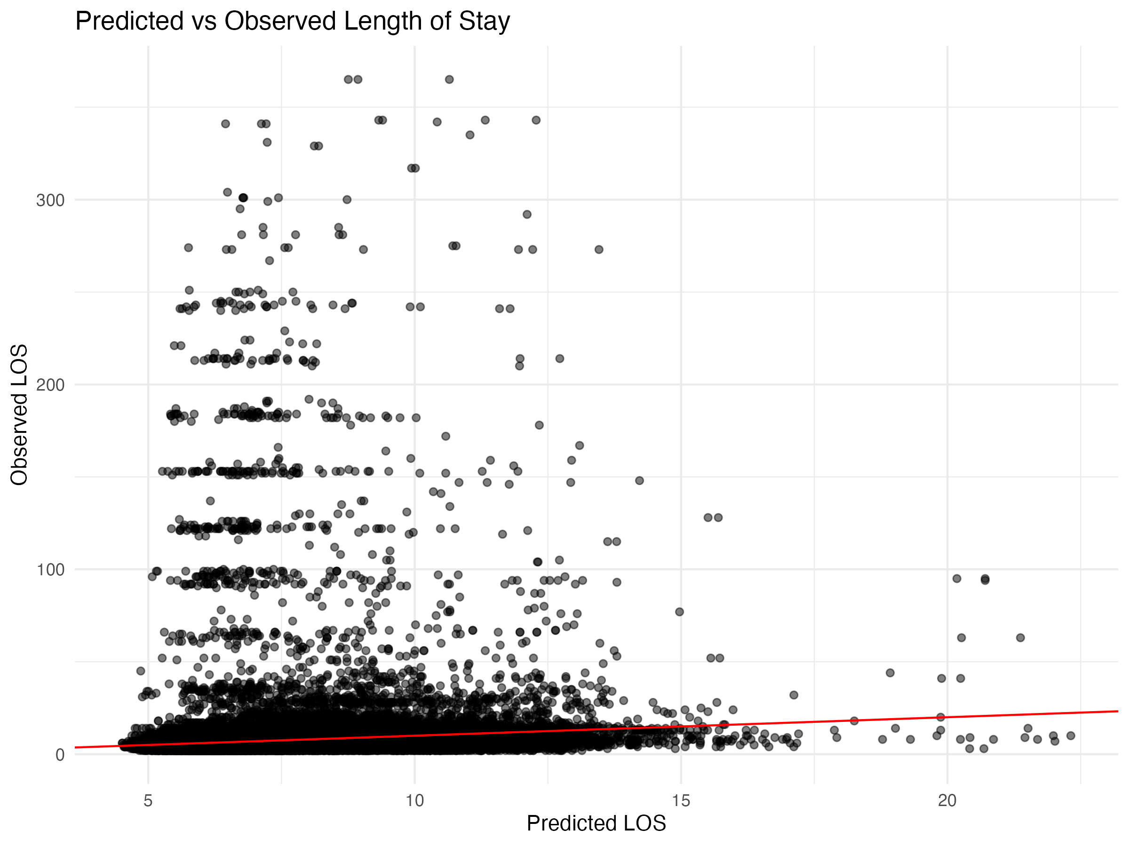

Diagnostic Plots

DHARMa Residuals
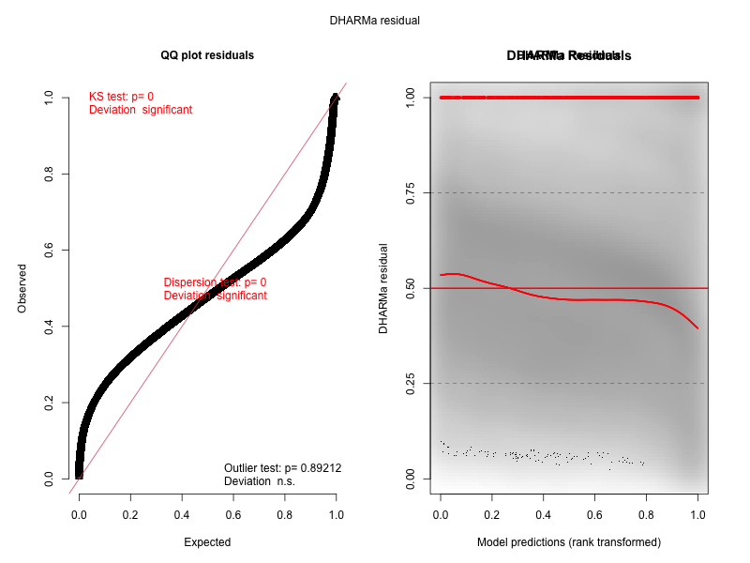

Residuals by State
