Multilevel Truncated Negative Binomial Model Results

Fixed Effects Coefficients
Estimate | Std. Error | z value | P-value | Variable
-1.5411 | 2.3560 | -0.6541 | 0.5130 | (Intercept)
-0.0020 | 0.0037 | -0.5476 | 0.5839 | import_from_slu_log
0.0058 | 0.0001 | 47.2777 | 0.0000 | age
-0.0043 | 0.0042 | -1.0050 | 0.3149 | immigrant_density_centered
0.2756 | 0.2149 | 1.2824 | 0.1997 | state_percapita_income_log
0.0052 | 0.0051 | 1.0115 | 0.3118 | immigrant_similar
0.0006 | 0.0043 | 0.1477 | 0.8826 | immigrant_moderate
0.0104 | 0.0035 | 2.9438 | 0.0032 | sex_enc1
0.0040 | 0.0121 | 0.3307 | 0.7409 | marital_status_enc1
0.0040 | 0.0043 | 0.9432 | 0.3456 | marital_status_enc2
-0.0467 | 0.0283 | -1.6496 | 0.0990 | employment_status_enc1
0.1081 | 0.0202 | 5.3383 | 0.0000 | employment_status_enc2
0.1907 | 0.0198 | 9.6462 | 0.0000 | purpose_simple1
0.4483 | 0.0158 | 28.4439 | 0.0000 | purpose_simple2
0.1452 | 0.0136 | 10.6425 | 0.0000 | purpose_simple3
0.0079 | 0.0159 | 0.4949 | 0.6207 | purpose_simple4
0.1306 | 0.0092 | 14.1977 | 0.0000 | accomd_type_enc1
0.2359 | 0.0053 | 44.6193 | 0.0000 | accomd_type_enc2

Incident Rate Ratios (IRR) for Fixed Effects
Incident Rate Ratios for Fixed Effects
Variable | IRR | Lower CI | Upper CI | P-value
(Intercept) | 0.2141 | 0.0021 | 21.6846 | 0.5130
import_from_slu_log | 0.9980 | 0.9907 | 1.0053 | 0.5839
age | 1.0058 | 1.0056 | 1.0061 | 0.0000
immigrant_density_centered | 0.9958 | 0.9875 | 1.0041 | 0.3149
state_percapita_income_log | 1.3173 | 0.8645 | 2.0074 | 0.1997
immigrant_similar | 1.0052 | 0.9952 | 1.0152 | 0.3118
immigrant_moderate | 1.0006 | 0.9922 | 1.0092 | 0.8826
sex_enc1 | 1.0105 | 1.0035 | 1.0175 | 0.0032
marital_status_enc1 | 1.0040 | 0.9805 | 1.0281 | 0.7409
marital_status_enc2 | 1.0040 | 0.9957 | 1.0124 | 0.3456
employment_status_enc1 | 0.9543 | 0.9028 | 1.0088 | 0.0990
employment_status_enc2 | 1.1142 | 1.0708 | 1.1593 | 0.0000
purpose_simple1 | 1.2101 | 1.1641 | 1.2579 | 0.0000
purpose_simple2 | 1.5656 | 1.5180 | 1.6147 | 0.0000
purpose_simple3 | 1.1563 | 1.1258 | 1.1877 | 0.0000
purpose_simple4 | 1.0079 | 0.9769 | 1.0398 | 0.6207
accomd_type_enc1 | 1.1395 | 1.1191 | 1.1602 | 0.0000
accomd_type_enc2 | 1.2661 | 1.2530 | 1.2793 | 0.0000

Random Effects Variance Components
No random effect variance estimated for us_state_enc.

Model R-squared (Marginal and Conditional)
Statistic | Value
R2_conditional | 0.1116
R2_marginal | 0.0723

Variance Inflation Factor (VIF)
VIF Values (Note: VIF > 5 may indicate multicollinearity)
Variable | VIF
Predictor 1 | 1.44
Predictor 2 | 1.11
Predictor 3 | 34.31
Predictor 4 | 1.41
Predictor 5 | 3.07
Predictor 6 | 30.35
Predictor 7 | 1.02
Predictor 8 | 1.17
Predictor 9 | 1.00
Predictor 10 | 1.17
Predictor 11 | 1.15

Model Comparison (Truncated vs Non-truncated)
ANOVA Model Comparison Results
Df | AIC | BIC | logLik | deviance | Chisq | Chi Df | Pr(>Chisq)
20 | 746,000.3 | 746,197.2 | -372,980.2 | 745,960.3
20 | 751,682.9 | 751,879.8 | -375,821.4 | 751,642.9 | 0 | 0 | 1

Model Fit Statistics
Statistic | Value
AIC | 746,000.3
BIC | 746,197.2
Log-likelihood | -372,980.2

Predicted vs Observed Length of Stay
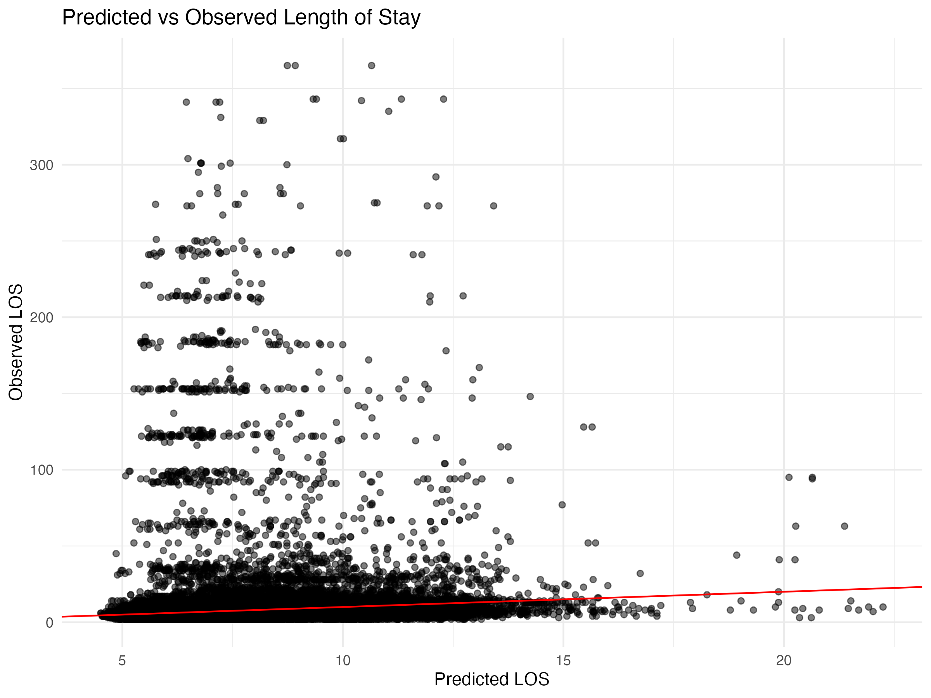

Diagnostic Plots

DHARMa Residuals
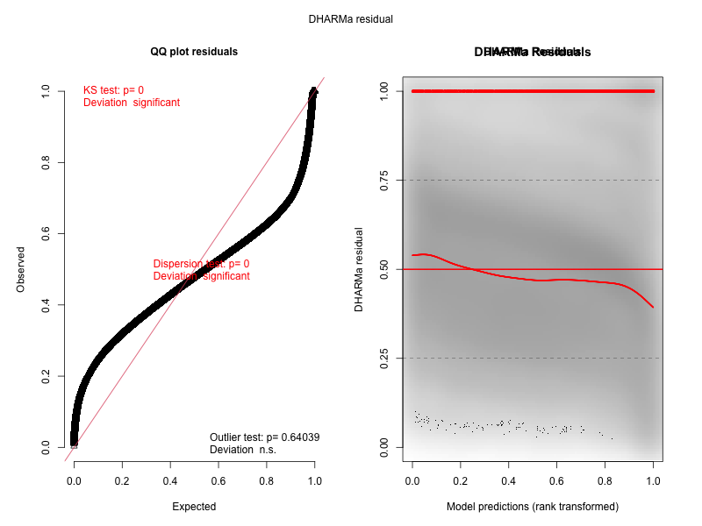

Residuals by State
