Multilevel Truncated Negative Binomial Model Results

Fixed Effects Coefficients
Estimate | Std. Error | z value | P-value | Variable
-2.5621 | 2.0177 | -1.2698 | 0.2041 | (Intercept)
-0.0022 | 0.0034 | -0.6355 | 0.5251 | import_from_slu_log
0.0058 | 0.0001 | 47.2822 | 0.0000 | age
-0.0035 | 0.0019 | -1.8075 | 0.0707 | immigrant_density
0.3720 | 0.1842 | 2.0200 | 0.0434 | state_percapita_income_log
0.0104 | 0.0035 | 2.9442 | 0.0032 | sex_enc1
0.0040 | 0.0121 | 0.3292 | 0.7420 | marital_status_enc1
0.0040 | 0.0043 | 0.9421 | 0.3461 | marital_status_enc2
-0.0467 | 0.0283 | -1.6497 | 0.0990 | employment_status_enc1
0.1081 | 0.0202 | 5.3362 | 0.0000 | employment_status_enc2
0.1907 | 0.0198 | 9.6469 | 0.0000 | purpose_simple1
0.4483 | 0.0158 | 28.4451 | 0.0000 | purpose_simple2
0.1453 | 0.0136 | 10.6442 | 0.0000 | purpose_simple3
0.0079 | 0.0159 | 0.4969 | 0.6193 | purpose_simple4
0.1306 | 0.0092 | 14.1969 | 0.0000 | accomd_type_enc1
0.2359 | 0.0053 | 44.6222 | 0.0000 | accomd_type_enc2

Incident Rate Ratios (IRR) for Fixed Effects
Incident Rate Ratios for Fixed Effects
Variable | IRR | Lower CI | Upper CI | P-value
(Intercept) | 0.0771 | 0.0015 | 4.0253 | 0.2041
import_from_slu_log | 0.9978 | 0.9911 | 1.0046 | 0.5251
age | 1.0058 | 1.0056 | 1.0061 | 0.0000
immigrant_density | 0.9965 | 0.9928 | 1.0003 | 0.0707
state_percapita_income_log | 1.4506 | 1.0111 | 2.0812 | 0.0434
sex_enc1 | 1.0105 | 1.0035 | 1.0175 | 0.0032
marital_status_enc1 | 1.0040 | 0.9805 | 1.0281 | 0.7420
marital_status_enc2 | 1.0040 | 0.9957 | 1.0124 | 0.3461
employment_status_enc1 | 0.9543 | 0.9028 | 1.0088 | 0.0990
employment_status_enc2 | 1.1141 | 1.0708 | 1.1592 | 0.0000
purpose_simple1 | 1.2101 | 1.1641 | 1.2579 | 0.0000
purpose_simple2 | 1.5657 | 1.5180 | 1.6148 | 0.0000
purpose_simple3 | 1.1563 | 1.1258 | 1.1877 | 0.0000
purpose_simple4 | 1.0079 | 0.9770 | 1.0399 | 0.6193
accomd_type_enc1 | 1.1395 | 1.1191 | 1.1602 | 0.0000
accomd_type_enc2 | 1.2661 | 1.2530 | 1.2793 | 0.0000

Random Effects Variance Components
No random effect variance estimated for us_state_enc.

Variance Inflation Factor (VIF)
VIF Values (Note: VIF > 5 may indicate multicollinearity)
Variable | VIF
Predictor 1 | 1.21
Predictor 2 | 1.10
Predictor 3 | 1.46
Predictor 4 | 1.22
Predictor 5 | 1.02
Predictor 6 | 1.17
Predictor 7 | 1.00
Predictor 8 | 1.17
Predictor 9 | 1.15

Model Comparison (Truncated vs Non-truncated)
ANOVA Model Comparison Results
Df | AIC | BIC | logLik | deviance | Chisq | Chi Df | Pr(>Chisq)
18 | 745,979.5 | 746,156.7 | -372,971.7 | 745,943.5
18 | 751,661.8 | 751,839.0 | -375,812.9 | 751,625.8 | 0 | 0 | 1

Model Fit Statistics
Statistic | Value
AIC | 745,979.5
BIC | 746,156.7
Log-likelihood | -372,971.7

Predicted vs Observed Length of Stay
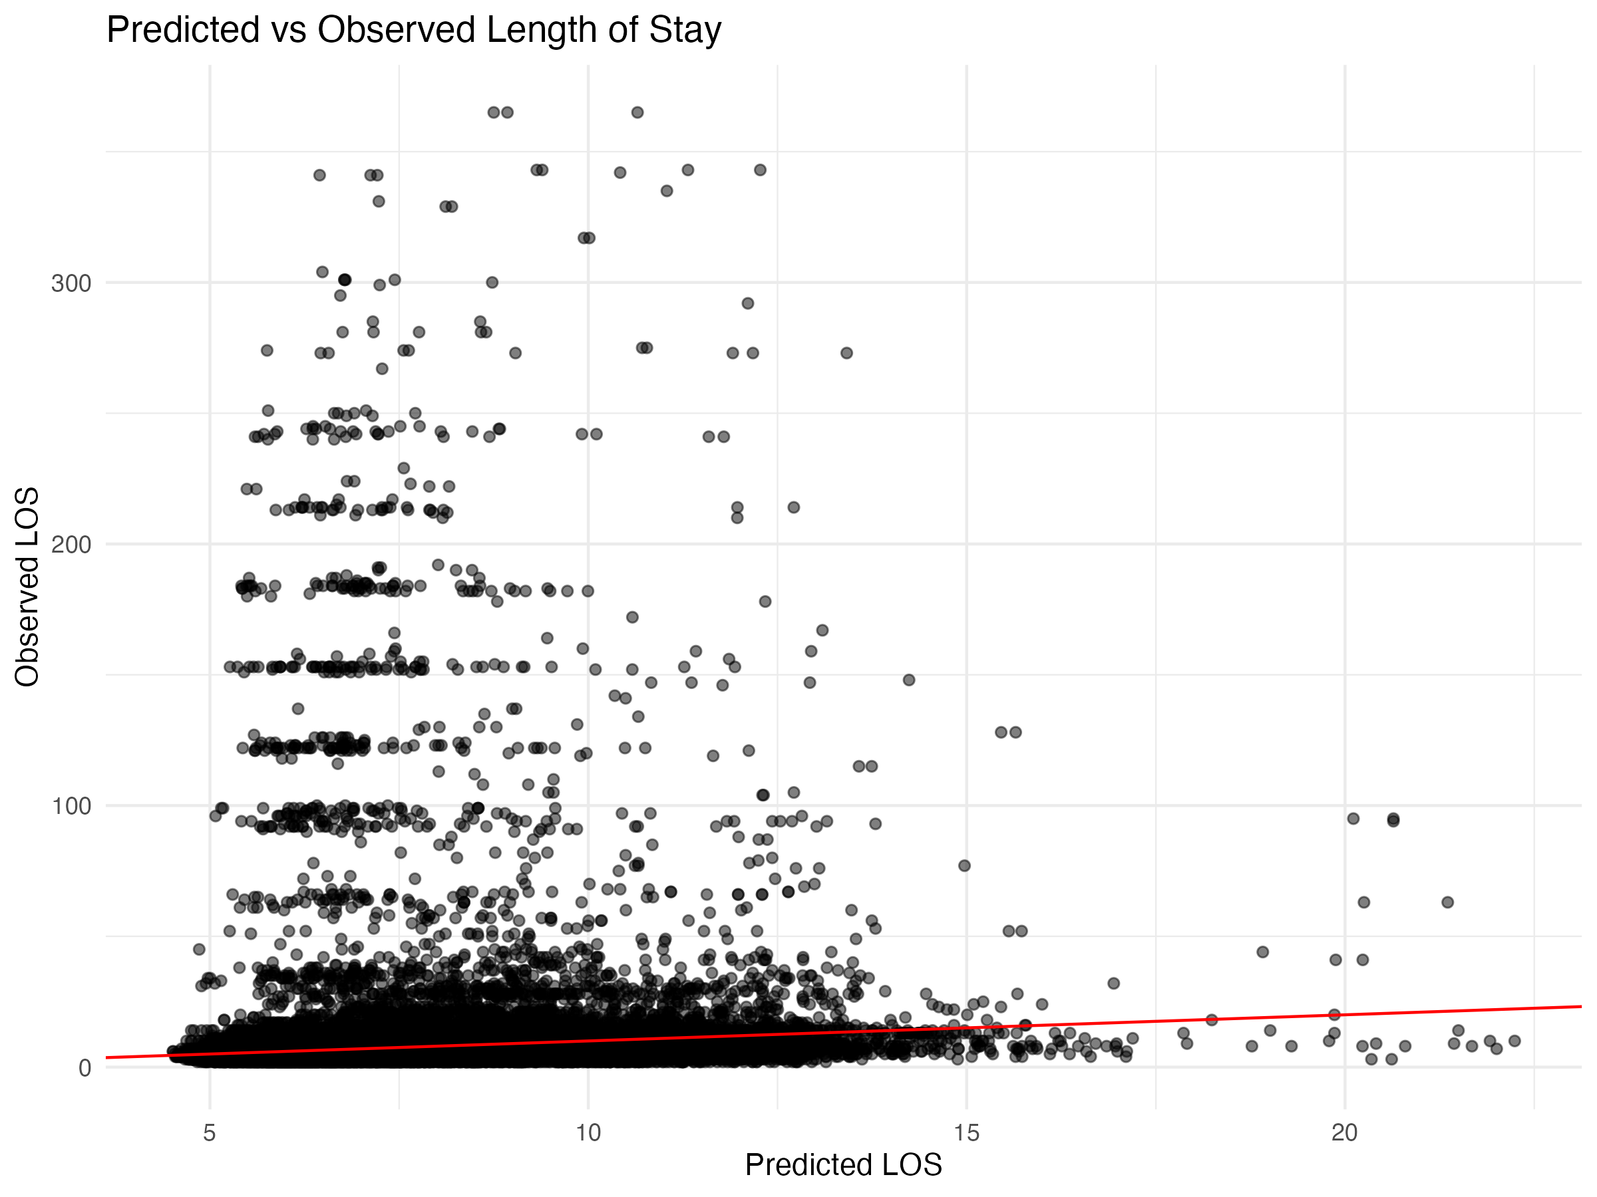

Diagnostic Plots

DHARMa Residuals
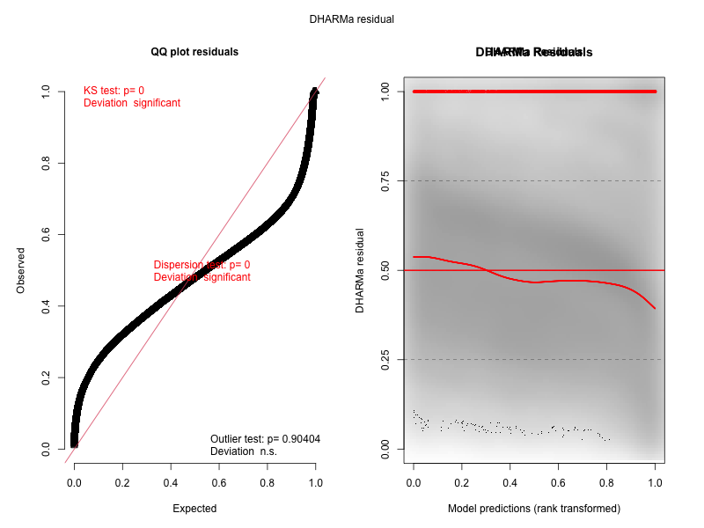

Residuals by State
