Multilevel Truncated Negative Binomial Model Results

Fixed Effects Coefficients
Estimate | Std. Error | z value | P-value | Variable
9.9123 | 41.0382 | 0.2415 | 0.8091 | (Intercept)
-0.0024 | 0.0040 | -0.5987 | 0.5494 | import_from_slu_log
0.0058 | 0.0001 | 47.2771 | 0.0000 | age
-0.0175 | 0.0237 | -0.7414 | 0.4585 | state_unemployment
-0.0035 | 0.0021 | -1.7117 | 0.0870 | immigrant_density
-1.0192 | 4.5888 | -0.2221 | 0.8242 | state_percapita_income_log
4.6137 | 15.0179 | 0.3072 | 0.7587 | economic_distance
-0.0410 | 0.1095 | -0.3739 | 0.7085 | climate_distance
0.0104 | 0.0035 | 2.9439 | 0.0032 | sex_enc1
0.0040 | 0.0121 | 0.3298 | 0.7416 | marital_status_enc1
0.0040 | 0.0043 | 0.9390 | 0.3477 | marital_status_enc2
-0.0467 | 0.0283 | -1.6488 | 0.0992 | employment_status_enc1
0.1080 | 0.0203 | 5.3353 | 0.0000 | employment_status_enc2
0.1907 | 0.0198 | 9.6481 | 0.0000 | purpose_simple1
0.4483 | 0.0158 | 28.4449 | 0.0000 | purpose_simple2
0.1453 | 0.0136 | 10.6456 | 0.0000 | purpose_simple3
0.0080 | 0.0159 | 0.4999 | 0.6171 | purpose_simple4
0.1306 | 0.0092 | 14.1960 | 0.0000 | accomd_type_enc1
0.2359 | 0.0053 | 44.6209 | 0.0000 | accomd_type_enc2

Incident Rate Ratios (IRR) for Fixed Effects
Incident Rate Ratios for Fixed Effects
Variable | IRR | Lower CI | Upper CI | P-value
(Intercept) | 20176.4294 | 0.0000 | 1726865113203492614776759928333434617856.0000 | 0.8091
import_from_slu_log | 0.9976 | 0.9899 | 1.0054 | 0.5494
age | 1.0058 | 1.0056 | 1.0061 | 0.0000
state_unemployment | 0.9826 | 0.9381 | 1.0292 | 0.4585
immigrant_density | 0.9965 | 0.9924 | 1.0005 | 0.0870
state_percapita_income_log | 0.3609 | 0.0000 | 2906.6102 | 0.8242
economic_distance | 100.8527 | 0.0000 | 612563638650090.2500 | 0.7587
climate_distance | 0.9599 | 0.7744 | 1.1898 | 0.7085
sex_enc1 | 1.0105 | 1.0035 | 1.0175 | 0.0032
marital_status_enc1 | 1.0040 | 0.9805 | 1.0281 | 0.7416
marital_status_enc2 | 1.0040 | 0.9957 | 1.0124 | 0.3477
employment_status_enc1 | 0.9544 | 0.9028 | 1.0089 | 0.0992
employment_status_enc2 | 1.1141 | 1.0707 | 1.1592 | 0.0000
purpose_simple1 | 1.2101 | 1.1641 | 1.2579 | 0.0000
purpose_simple2 | 1.5657 | 1.5180 | 1.6148 | 0.0000
purpose_simple3 | 1.1564 | 1.1258 | 1.1877 | 0.0000
purpose_simple4 | 1.0080 | 0.9770 | 1.0399 | 0.6171
accomd_type_enc1 | 1.1395 | 1.1191 | 1.1602 | 0.0000
accomd_type_enc2 | 1.2661 | 1.2530 | 1.2793 | 0.0000

Random Effects Variance Components
No random effect variance estimated for us_state_enc.

Variance Inflation Factor (VIF)
VIF Values (Note: VIF > 5 may indicate multicollinearity)
Variable | VIF
Predictor 1 | 1.58
Predictor 2 | 1.10
Predictor 3 | 1.03
Predictor 4 | 1.55
Predictor 5 | 896.78
Predictor 6 | 894.33
Predictor 7 | 1.80
Predictor 8 | 1.02
Predictor 9 | 1.17
Predictor 10 | 1.00
Predictor 11 | 1.17
Predictor 12 | 1.15

Model Comparison (Truncated vs Non-truncated)
ANOVA Model Comparison Results
Df | AIC | BIC | logLik | deviance | Chisq | Chi Df | Pr(>Chisq)
21 | 745,985.8 | 746,192.5 | -372,971.9 | 745,943.8
21 | 751,668.3 | 751,875.0 | -375,813.1 | 751,626.3 | 0 | 0 | 1

Model Fit Statistics
Statistic | Value
AIC | 745,985.8
BIC | 746,192.5
Log-likelihood | -372,971.9

Predicted vs Observed Length of Stay
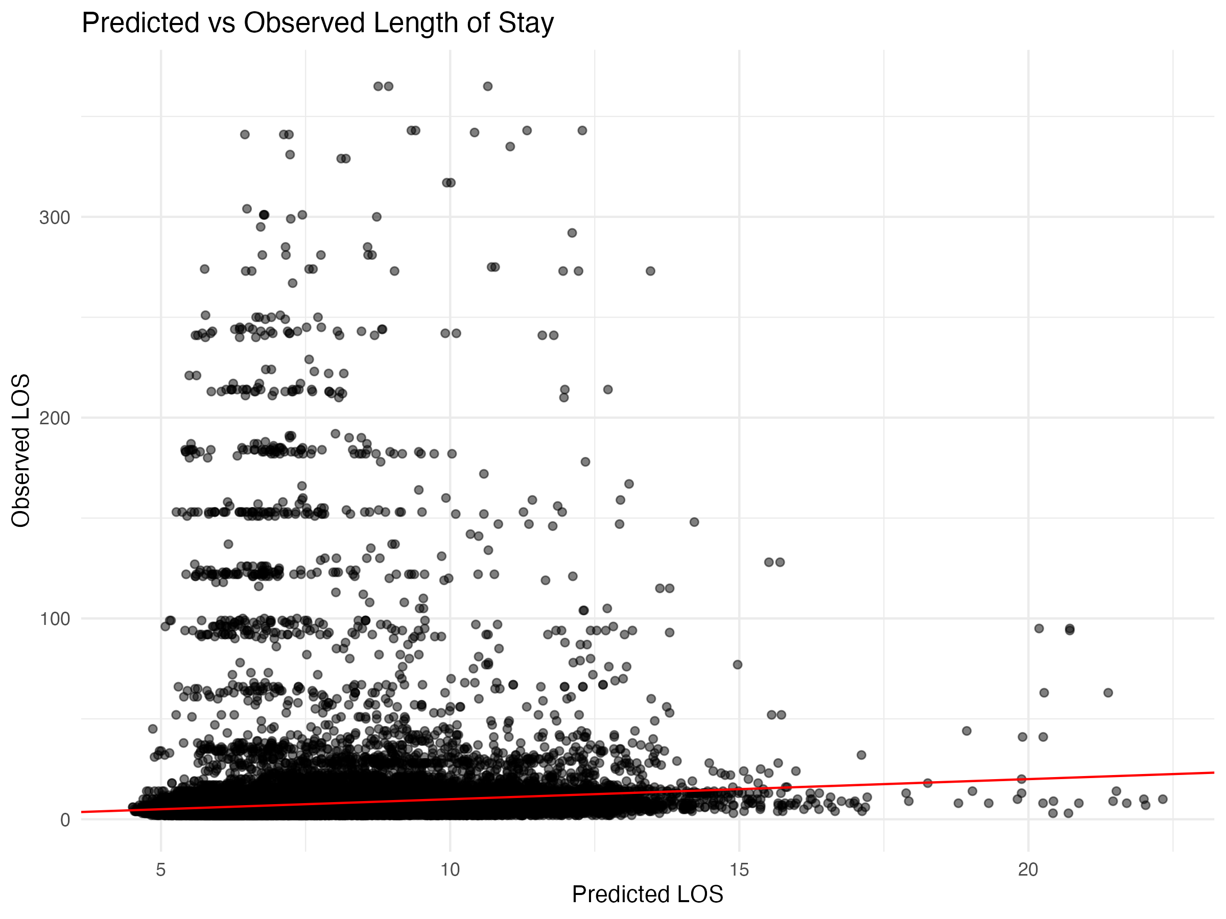

Diagnostic Plots

DHARMa Residuals
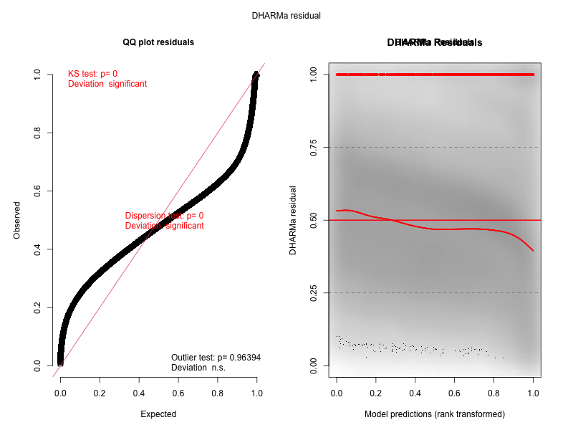

Residuals by State
