# Multilevel Truncated Negative Binomial Model Results

## Fixed Effects Coefficients

| Estimate | Std. Error | z value | P-value | Variable |
| --- | --- | --- | --- | --- |
| -2.4491 | 1.9724 | -1.2417 | 0.2144 | (Intercept) |
| 0.0010 | 0.0033 | 0.2894 | 0.7723 | import_from_slu_log |
| 0.0070 | 0.0001 | 50.8632 | 0.0000 | age |
| 0.2300 | 0.0681 | 3.3799 | 0.0007 | distance_miles_log |
| 0.1749 | 0.1837 | 0.9525 | 0.3409 | state_percapita_income_log |
| -0.0326 | 0.0218 | -1.4941 | 0.1351 | state_unemployment |
| -0.0011 | 0.0019 | -0.6002 | 0.5484 | immigrant_density |
| 0.0089 | 0.0036 | 2.4972 | 0.0125 | sex_enc1 |
| 0.0193 | 0.0121 | 1.5996 | 0.1097 | marital_status_enc1 |
| 0.0278 | 0.0044 | 6.3768 | 0.0000 | marital_status_enc2 |
| 0.1210 | 0.0203 | 5.9644 | 0.0000 | employment_status_enc1 |
| -0.0494 | 0.0283 | -1.7436 | 0.0812 | employment_status_enc2 |
| 0.3984 | 0.0232 | 17.1560 | 0.0000 | purpose_simple2 |
| 0.1218 | 0.2722 | 0.4475 | 0.6545 | purpose_simple3 |
| 0.3746 | 0.0294 | 12.7536 | 0.0000 | purpose_simple4 |
| 0.2711 | 0.0227 | 11.9546 | 0.0000 | purpose_simple5 |
| 0.1561 | 0.0092 | 16.9707 | 0.0000 | accomd_type_enc1 |
| 0.3122 | 0.0051 | 61.1642 | 0.0000 | accomd_type_enc2 |
| 0.1085 | 0.0053 | 20.5982 | 0.0000 | season_enc1 |
| 0.0815 | 0.0053 | 15.5165 | 0.0000 | season_enc2 |
| 0.1608 | 0.0054 | 29.8260 | 0.0000 | season_enc3 |
| 0.4238 | 0.0201 | 21.0700 | 0.0000 | tourist_type_enc1 |
| 0.0337 | 0.0098 | 3.4200 | 0.0006 | tourist_type_enc2 |

## Incident Rate Ratios (IRR) for Fixed Effects

Incident Rate Ratios for Fixed Effects

| Variable | IRR | Lower CI | Upper CI | P-value |
| --- | --- | --- | --- | --- |
| (Intercept) | 0.0864 | 0.0018 | 4.1241 | 0.2144 |
| import_from_slu_log | 1.0010 | 0.9945 | 1.0075 | 0.7723 |
| age | 1.0070 | 1.0067 | 1.0073 | 0.0000 |
| distance_miles_log | 1.2586 | 1.1015 | 1.4382 | 0.0007 |
| state_percapita_income_log | 1.1912 | 0.8311 | 1.7074 | 0.3409 |
| state_unemployment | 0.9679 | 0.9275 | 1.0102 | 0.1351 |
| immigrant_density | 0.9989 | 0.9952 | 1.0026 | 0.5484 |
| sex_enc1 | 1.0089 | 1.0019 | 1.0160 | 0.0125 |
| marital_status_enc1 | 1.0195 | 0.9957 | 1.0439 | 0.1097 |
| marital_status_enc2 | 1.0282 | 1.0195 | 1.0370 | 0.0000 |
| employment_status_enc1 | 1.1286 | 1.0846 | 1.1744 | 0.0000 |
| employment_status_enc2 | 0.9518 | 0.9005 | 1.0061 | 0.0812 |
| purpose_simple2 | 1.4894 | 1.4231 | 1.5588 | 0.0000 |
| purpose_simple3 | 1.1296 | 0.6625 | 1.9259 | 0.6545 |
| purpose_simple4 | 1.4544 | 1.3730 | 1.5406 | 0.0000 |
| purpose_simple5 | 1.3114 | 1.2544 | 1.3710 | 0.0000 |
| accomd_type_enc1 | 1.1690 | 1.1481 | 1.1902 | 0.0000 |
| accomd_type_enc2 | 1.3664 | 1.3528 | 1.3801 | 0.0000 |
| season_enc1 | 1.1146 | 1.1032 | 1.1262 | 0.0000 |
| season_enc2 | 1.0850 | 1.0738 | 1.0962 | 0.0000 |
| season_enc3 | 1.1744 | 1.1621 | 1.1869 | 0.0000 |
| tourist_type_enc1 | 1.5278 | 1.4688 | 1.5893 | 0.0000 |
| tourist_type_enc2 | 1.0343 | 1.0145 | 1.0544 | 0.0006 |

## Random Effects Variance Components

No random effect variance estimated for us_state_enc.

## Variance Inflation Factor (VIF)

VIF Values (Note: VIF > 5 may indicate multicollinearity)

| Variable | VIF |
| --- | --- |
| Predictor 1 | 1.25 |
| Predictor 2 | 1.37 |
| Predictor 3 | 1.41 |
| Predictor 4 | 1.31 |
| Predictor 5 | 1.23 |
| Predictor 6 | 1.67 |
| Predictor 7 | 1.02 |
| Predictor 8 | 1.22 |
| Predictor 9 | 1.01 |
| Predictor 10 | 1.32 |
| Predictor 11 | 1.10 |
| Predictor 12 | 1.05 |
| Predictor 13 | 1.07 |

## Model Comparison (Truncated vs Non-truncated)

ANOVA Model Comparison Results

| Df | AIC | BIC | logLik | deviance | Chisq | Chi Df | Pr(>Chisq) |
| --- | --- | --- | --- | --- | --- | --- | --- |
| 25 | 741,518.3 | 741,764.2 | -370,734.2 | 741,468.3 |  |  |  |
| 25 | 747,136.3 | 747,382.2 | -373,543.1 | 747,086.3 | 0 | 0 | 1 |

## Model Fit Statistics

| Statistic | Value |
| --- | --- |
| AIC | 741,518.3 |
| BIC | 741,764.2 |
| Log-likelihood | -370,734.2 |

## Predicted vs Observed Length of Stay

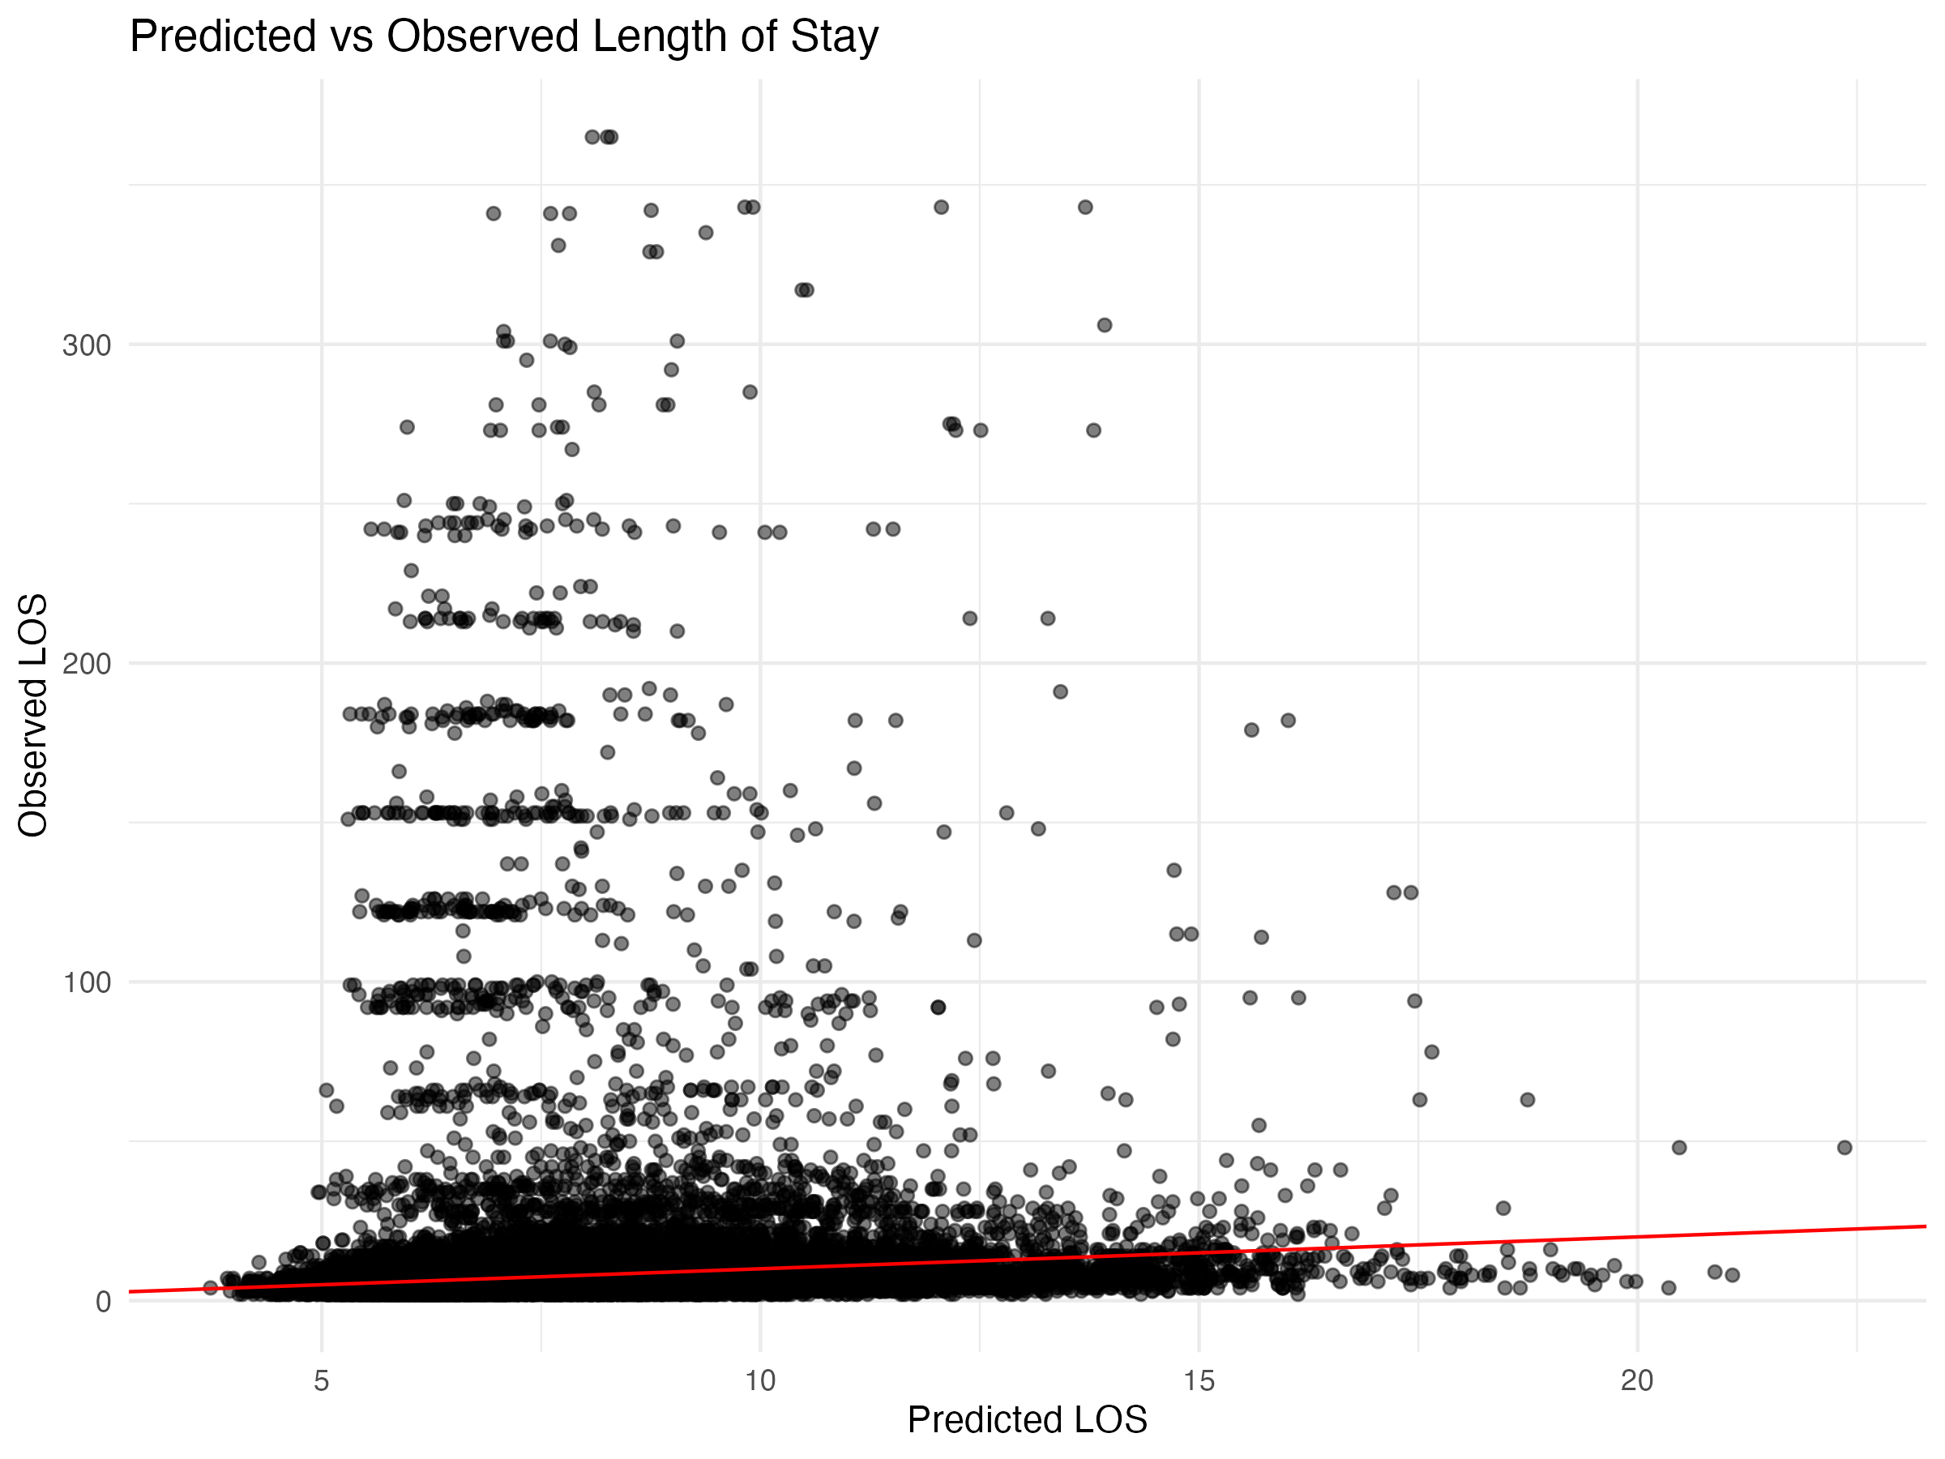

## Diagnostic Plots

### DHARMa Residuals

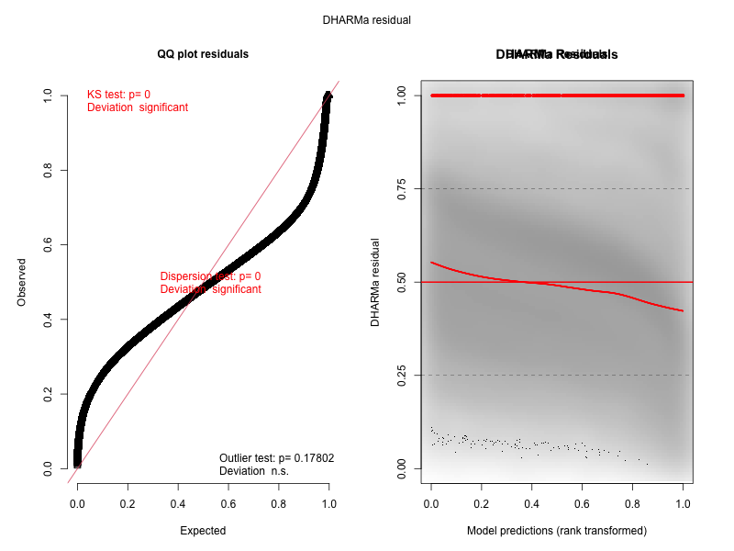

### Residuals by State

