# Project #1 - Mapping Inheritance to Relational DB

## Introduction

You are building an inventory system for a hardware store. For this project, you only have to worry about this portion of its object model:

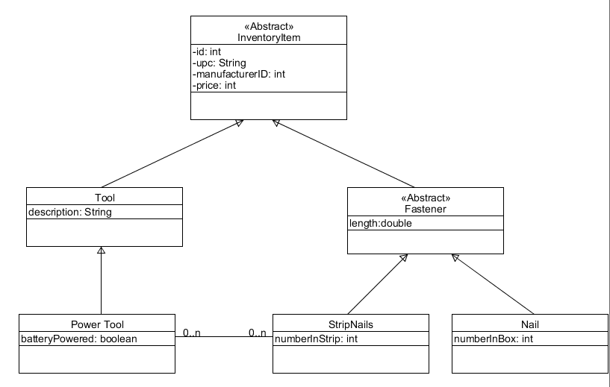

The important things to notice from this are:

* We are only worried about tools and fasteners
* Power tools are a subset of tools, but tools is NOT abstract (i.e. a hammer would be a tool, but a nail gun would be a power tool)
* There are two types of nails: individual nails and nails that are in a strip to be fed to a power nail gun
* Power tools know which strip nails work for them and the strip nails know which power tools they can be used in

## Your Mission:

Build three databases to hold this information; one based on each of the three patterns.

## Details:

* The code for each pattern should be a separate java project
* You must have the classes in the diagram including both a finder constructor and a creation constructor for every concrete class
* You must have a runner that queries the database to find all of keys in the database then use the finder constructors to build an arraylist of all of the objects