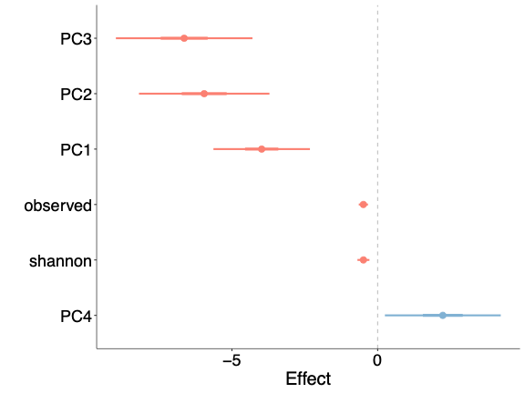
Figures
Fig 1: Plotted coefficients for the temperature predictor from our model comparison for community features, including beta diversity (measured by principal coordinates 1-4) and alpha diversity (measured by the Shannon Index and the observed number of ASVs). The thick bars represent 50% confidence intervals (CI), while the thin bars represent 95% CI. All community features show a reliable association with temperature.
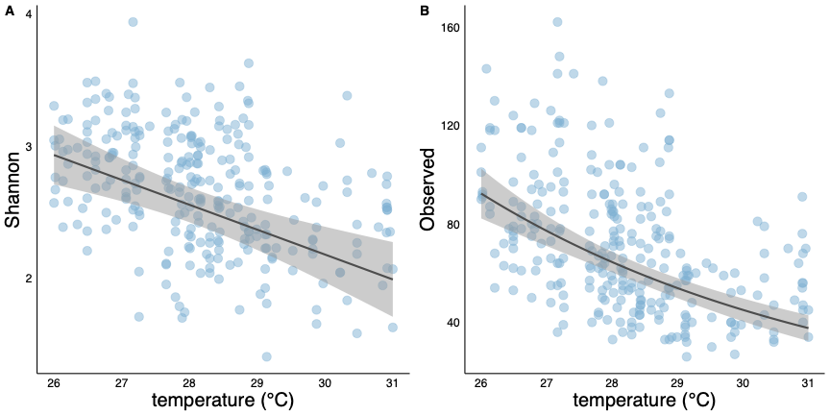
Fig 2: Plotted model results showing the relationship between alpha diversity and temperature. Panel (A) measures alpha diversity using Shannon's Index, while panel (B) uses the total number of ASVs. Both metrics demonstrate a decrease in alpha diversity as temperature increases.

Fig 3: Figure three is going to be the phylogenetic tree
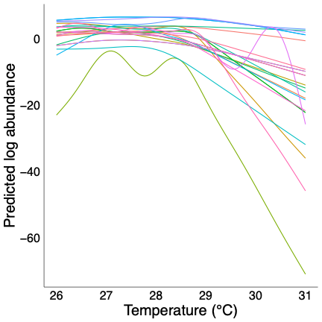

Fig 4: Plotted model results for the non-linear relationship between taxon abundance and temperature. The plot shows the predicted log abundance of each taxon across the range of temperature values. Colors represent individual taxa from the largest cluster described by the hierarchical clustering analysis. Taxa in this group exhibit a tipping point at 29 °C, before which taxa abundances remain relatively stable as temperature increases and after which taxa exhibit a decrease in abundance at different rates.

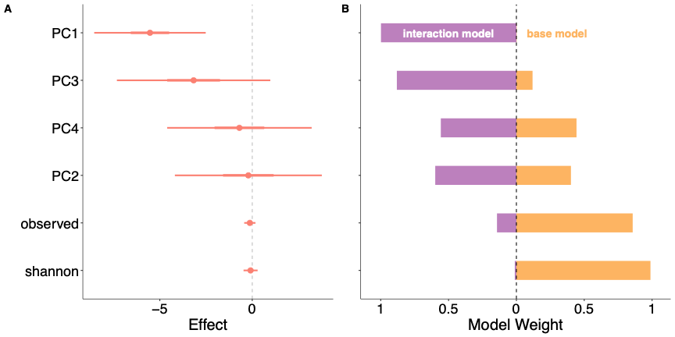
Fig 5: Model comparison results evaluating if neopterin concentration is related to community-level microbiome response to temperature. Panel (A) shows the coefficients for the interaction between temperature and neopterin for community features including beta diversity (measured by principal coordinates 1-4) and alpha diversity (measured by the Shannon Index and the observed number of ASVs). The thick bars represent 50% confidence intervals (CI), while the thin bars represent 95% CI. Principle component 1 is the only feature that shows a reliable relationship with the interaction effect. Panel (B) compares model weights between the interaction model (in purple) and the model that does not include the interaction effect (base model, in orange). The interaction model accounts for more than 50% of the model weight for all principal coordinates in contrast to the alpha diversity metrics where it accounts for very little model weight. Combined, the panels suggest that neopterin is associated with the relationship between temperature and beta diversity but not alpha diversity.

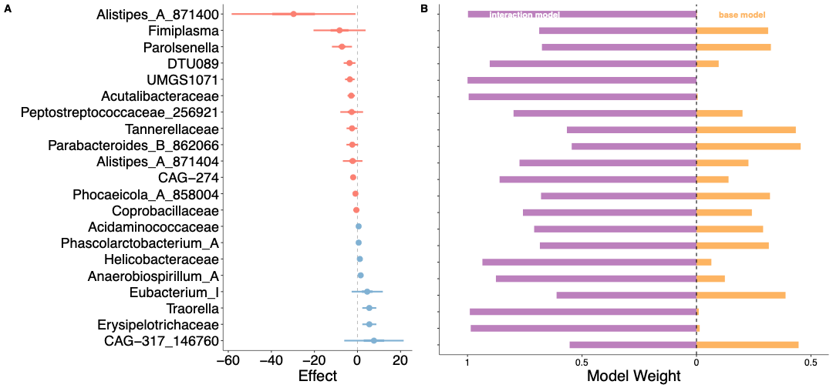
Fig 6: Model comparison results evaluating if neopterin concentration is related to taxa-level microbiome response to temperature. Panel (A) shows the coefficients for the interaction between temperature and neopterin across different taxa. The thick bars represent 50% confidence intervals (CI), while the thin bars represent 95% CI. Panel (B) compares model weights between the interaction model (in purple) and the model that does not include the interaction effect (base model, in orange). The interaction model accounts for more than 50% of the model weight for all taxa.

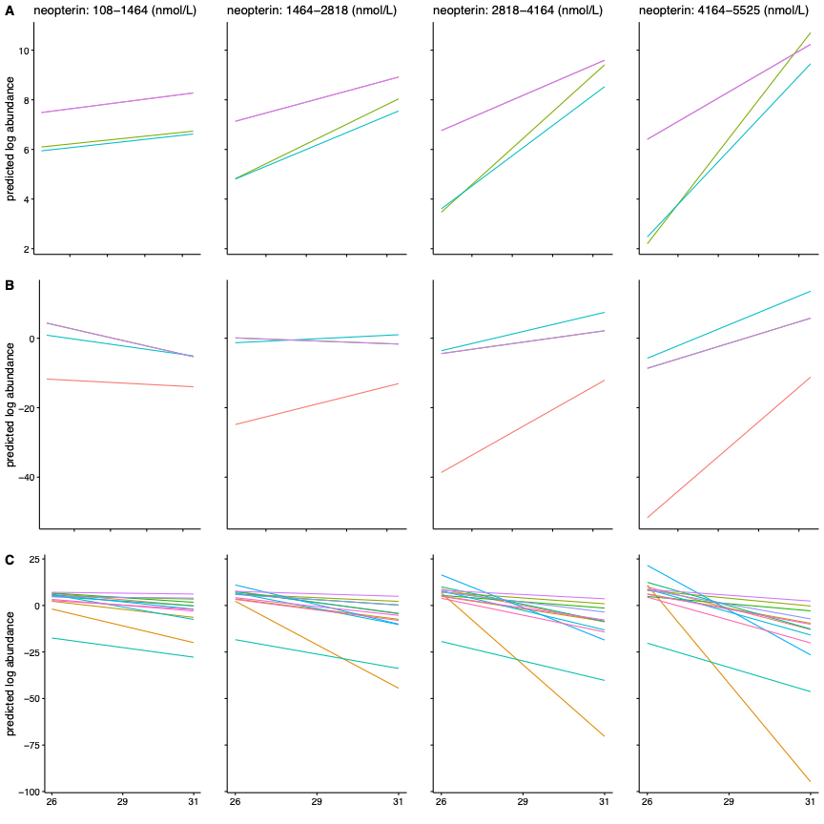
Fig 7: Plotted model results of the interaction effect between temperature and neopterin for all taxa where that interaction model accounted for more than 50% of the model weight. Colors represent individual taxa The four columns represent four discrete ranges of neopterin concentrations increasing from left to right. The rows represent the different types of effects, including the negative amplifying effect (Row A), where a stronger negative relationship with temperature is associated with high neopterin concentration. The positive amplifying effect (Row B), where a stronger positive relationship with temperature is associated with high neopterin concentration, and the reverse effect (Row C), where a negative relationship with temperature is associated with low neopterin concentration while a positive relationship is associated with high neopterin.

Supplementary figures


Fig 1S: Prevalence of ASVs plotted as total abundance versus the number of samples each ASV appears in. The dashed line at 1.39 marks the 0.5% prevalence threshold used to filter out rare ASVs. ASVs present in at least two samples were retained for downstream analysis.
Fig 2S: Scatter plot of the count of fruit feeding observations two weeks before sample collection and its relationship with temperature. The plot demonstrates a clear positive relationship where fruit consumption increases with rising temperatures.

Fig 3S: Visualization of the eigenvalues for each principal component in descending order. Principal components 1 through 4 were used for analysis, as the eigenvalues level off beyond principal component 4.
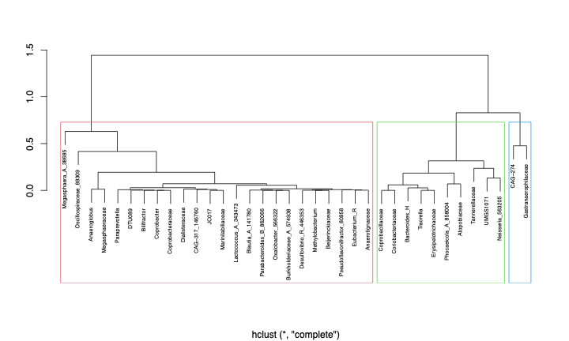
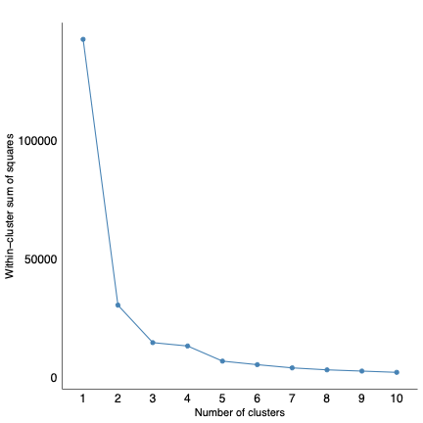
Fig 4S: Plot of the within-cluster sum of squares demonstrates a decrease in within-cluster sum of squares as the number of clusters increases. Three clusters were used for the analysis because adding more clusters did not meaningfully reduce the within-cluster sum of squares.
Fig 5S: Dendrogram of hierarchical clustering performed using hclust() with three clusters outlined. The first cluster, highlighted in red, contains the majority of taxa that exhibit a non-linear relationship with temperature.

