
16 December 2025
Dear Editor,
We are writing to request consideration for a reduction of the open access publication fee for our manuscript submitted to PLOS Biology.
This manuscript is part of a doctoral dissertation project conducted by Jordan Lucore and supported by an NSF Doctoral Dissertation Research Improvement Grant (DDRIG) awarded to Dr. Andrew Marshall and Jordan Lucore. The grant primarily funded ELISAs to quantify urinary neopterin and high-throughput sequencing for gut microbiome analyses. Given the substantial and uncertain expenses associated with lab work, publication fees were not included in the original grant budget. We have attached the budget for your reference.
Fortunately, costs were lower than initially anticipated, leaving a remaining balance of $1,481, which we can apply toward the open access publication fee. However, we do not have sufficient funds to cover the full $5,500 article processing charge.
Thank you for your time and consideration. We are happy to provide any additional information if needed.
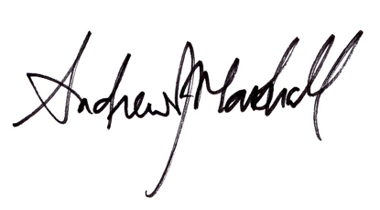
Sincerely,

Andrew J. Marshall Jordan Lucore

Professor and Associate Chair Doctoral Candidate
Department of Anthropology Department of Anthropology

Professor
Department of Ecology and Evolutionary Biology,
Program in the Environment,
Program in Computing for the Arts and Sciences, and
School of Environment and Sustainability
University of Michigan

Adjunct Professor
Faculty of Biology and Agriculture
Universitas Nasional, Indonesia

