Gut microbiome response to temperature is related to host immunity in wild a primate

Introduction:
Temperature is a primary driver of adaptation, and species have evolved unique thermal limits that characterize diverse aspects of their behavior and physiology. Rising temperatures due to climate change are predicted to push species beyond their evolved thermal tolerance and challenge them to adapt to hotter climates (Bellard et al., 2012; Bennett et al., 2021). Efforts to evaluate mechanisms by which species respond and adapt to heat stress have revealed that microbiomes may play a key role in determining the thermal tolerance of their host species (Moghadam et al., 2018; Ziegler et al., 2017) and could be important in facilitating adaptation to higher temperatures (Baldassarre et al., 2022; Fontaine & Kohl, 2023; Hector et al., 2022). Animals have evolved complex relationships with the microbial communities (i.e., microbiomes) that live on and inside them to the extent that hosts rely on their microbiomes to support diverse aspects of their functioning. Experimental research has shown that heat stress can deplete microbiome communities and has been associated with negative phenotypic, survivorship, and fitness outcomes for the host (Jaramillo & Castañeda, 2021; B. Zhang et al., 2019). The gastrointestinal tract is home to a particularly dense microbial community, the gut microbiome, that plays a crucial role in regulating host responses to environmental change (Amato, 2016), making it an ideal system to explore how species may respond to rising temperatures.
The gut microbiome is sensitive to ambient temperature, and compositional changes associated with high temperatures may harm the host by reducing the gut microbiome’s ability to carry out essential functions. For example, heat stress has been shown to alter the abundances of specific microbial taxa (Sepulveda & Moeller, 2020) and is associated with changes in host digestion and metabolism (Fontaine et al., 2018; Tajima et al., 2007; Zhu et al., 2019). High temperatures have also been associated with a decrease in community diversity (Bestion et al., 2017; Hartman et al., 2020; Moeller et al., 2020) that may impair the gut microbiome’s ability to confer colonization resistance (Horváthová et al., 2019; Li et al., 2022). The majority of research investigating how temperature affects microbiomes has been conducted in experimental settings on ectotherms because their lack of physiological thermoregulation leaves them vulnerable to temperature change [e.g. reptiles (Bestion et al., 2017; Moeller et al., 2020), amphibians (Emerson et al., 2023; Fontaine et al., 2018; Kohl & Yahn, 2016), snails (Li et al., 2022), insects (Jaramillo & Castañeda, 2021; Moghadam et al., 2018; B. Zhang et al., 2019), corals (Baldassarre et al., 2022; Ziegler et al., 2017)]. While experimental research is advantageous because it can isolate the effect of temperature on the gut microbiome, it does little to evaluate why the temperature-microbiome relationship evolved and how it functions in a natural system. Endotherms are also clearly vulnerable to the deleterious physiological impacts of high temperatures (Lovegrove et al., 2014; Lucore et al., 2024; Risely et al., 2023), and the gut microbiome likely contributes to these responses. Here, we evaluate if temperature is an important predictor for explaining gut microbiome composition in a wild population of capuchin monkeys, Cebus imitator, in Costa Rica. Much of primate gut microbiome research has examined how broad ecological factors—such as seasonality (Baniel et al., 2021; Orkin, Campos, et al., 2019), habitat disturbance (Amato et al., 2013; Barelli et al., 2015), and cross-site variation(Amato et al., 2016; Bueno De Mesquita et al., 2021)— relate to the gut microbiome, with findings often attributed to differences in host diet. However, no study has directly assessed the influence of temperature on the gut microbiome of a wild primate.
Since the gut microbiome and host maintain a bidirectional relationship— where the host can shape microbial communities (Brugman et al., 2014; Kawamoto et al., 2014; H. Zhang et al., 2015), and the microbiome supports host functions (Hooper et al., 2002; Jandhyala et al., 2015; E. K. Mallott et al., 2024)— gut microbiome response to temperature may affect specific aspects of host physiology. The immune system is closely linked to the gut microbiome via the bi-directional gut-immune axis (Chu & Mazmanian, 2013; Hooper & Macpherson, 2010) and is also sensitive to temperature, particularly high temperatures (Lucore et al., 2024; Quinteiro-Filho et al., 2010). Function in the gut-immune axis broadly involves host-driven immune mechanisms that confine the gut microbiome to the intestinal lumen (Hooper et al., 2012), as well as microbial support for the immune system where the microbiome shapes immune system development (Al Nabhani & Eberl, 2020; Chu & Mazmanian, 2013; Gensollen et al., 2016) and modulates white blood cell activity (Round & Mazmanian, 2009; Schluter et al., 2020). Therefore, the gut microbiome may regulate how the immune system responds to rising temperatures, or conversely, temperature-driven changes in immunity may alter microbiome composition. Here, we evaluate whether host immunity is associated with the gut microbiome’s relationship with temperature. We measure host immunity using neopterin, a byproduct of macrophage activity when stimulated by interferon-gamma produced by T-helper 1 cells during the cellular immune response (Murr et al., 2002). The gastrointestinal tract harbors the highest density of macrophages in the body, as they play a central role in the gut-immune axis by limiting systemic exposure to gut microbes (Kelsall, 2008). In turn, specific microbes regulate macrophage activity through microbially metabolized compounds such as short-chain fatty acids and lipopolysaccharides to maintain host tolerance towards gut communities and prevent chronic inflammatory disorders (Corrêa-Oliveira et al., 2016; Wang et al., 2020). Therefore, neopterin is likely a valuable indicator of intestinal immune activity and bidirectional interactions in the gut-immune axis. Neopterin can also be measured in urine (Higham et al., 2015; Lucore et al., 2022), making it an ideal choice for non-invasive field research, and has been associated with gut microbiome composition in wild primates (Schneider-Crease et al., 2022).
Our study aims to (1) assess the influence of temperature on microbiome composition in a wild primate population and (2) examine how gut microbiome response to temperature is related to host immunity. We collected fecal and urine samples for 11 months from 36 individual white-faced capuchins monkeys living in tropical dry forest fragments in Northwestern Costa and performed 16S rRNA sequencing (n = 277) to measure gut microbiome composition. Seasonality in tropical dry forests can be measured by rainfall (Murphy & Lugo, 1986), so our analyses account for rainfall to control for confounding ecological factors associated with season. We also account for dietary items that show a strong relationship with temperature to better isolate the relationship between temperature and the gut microbiome. Each 16S sample is matched with the average neopterin concentration from urine samples collected within three days to examine the relationship between gut microbiome composition and neopterin concentration. Air temperature was collected every 15 minutes and averaged 15 days before each fecal sample to evaluate how long-term temperature trends are associated with gut microbiome composition and host immunity. This study highlights the crucial role of temperature in shaping gut microbiome composition in wild endotherms and illustrates how temperature may affect the relationship between the gut microbiome and host immunity by impacting interactions in the gut-immune axis. Our results also offer crucial insight into how rising temperatures due to climate change may affect wild animals through changes in the microbiome and their relationship with host immunity.
Methods:
Site information and data collection
Data was collected from a wild population of C. imitator living in the Taboga Forest reserve in Guanacaste, Northwestern Costa Rica. The Taboga Forest Reserve is a 516-ha tropical dry forest fragment and forms an important piece of a fragmented biological corridor connecting the Tempisque River Basin to the Guanacaste Mountains (Tinsley Johnson et al., 2020). The Capuchinos de Taboga Research project has collected daily behavioral and endocrine data on the three groups of white-faced capuchins since 2018. All individuals are individually identified and habituated to human presence. Individual age was calculated by birth date for individuals younger than 7 years of age; for individuals older than 7 years, age was estimated based on body condition by a field team member (J.C.O.) with more than two decades of experience observing wild white-faced capuchins. A team of two or more trained field assistants collected data between 5:00 AM and 6:30 PM including detailed observations of feeding and foraging behavior using scan sampling. Scans occur every 30 minutes for 10 minutes, where feeding and foraging observations of individually identified monkeys were recorded. Individuals were recorded multiple times in one scan if they were observed engaging with different food items. Plant food items were identified on the family or genus level.
Between September 2022 and July 2023, Fecal and urine samples were collected opportunistically in conjunction with behavioral data. All samples were collected from identified individuals who appeared healthy upon visual inspection. Fecal samples were collected immediately after defecation and placed in 4mL of 98% ethanol (Amato et al., 2013). Sample contamination was avoided by wearing gloves and only collecting feces that were not in contact with the soil. Feces contaminated with urine were discarded to prevent potential contamination from urogenital microbiome (Thomas-White et al., 2018). Urine samples were collected using a clean catch method (Bergstrom et al., 2017) to avoid rainfall and fecal contamination. Urine samples were collected from leaves or the ground only when they did not appear contaminated with soil or feces. Both fecal and urine samples were immediately stored in a portable cooler and transferred to a -20°F freezer at the end of the field day. Fecal samples were stored in the freezer until shipment to the Amato Microbiome Lab at Northwestern University in Evanston IL for DNA extraction and sequencing. Urine samples remained in the freezer until assay analysis was conducted onsite in the Capuchinos de Taboga field laboratory (Beehner et al., 2022).
Temperature observations for this analysis came from the Palo Verde meteorological station, located at the Organization for Tropical Studies (OTS) Palo Verde research station (10.345°N, 85.339°E), approximately 20.81 km southwest of the Taboga Forest Reserve. Like Taboga, Palo Verde is one of Central America’s last remaining tropical dry forest fragments (Stern et al., 2002). Palo Verde temperature data have been used in previous studies of the Taboga white-faced capuchin population (Lucore et al., 2024), given the habitat similarity and close proximity to Taboga. The station records maximum and minimum air temperature every 15 minutes.

Neopterin analysis
The neopterin concentration of the urine samples was measured using a commercially available competitive exclusion neopterin enzyme-linked immunosorbent assay (Neopterin ELISA, Ref. RE59321, IBL International GMBH, Hamburg, Germany) in the Capuchinos de Taboga field laboratory. The assay has been validated for use in the Taboga capuchin population (Lucore et al., 2022). Samples were controlled for water volume using specific gravity and diluted using manufacturer assay buffer. Assays were run using manufacturer protocol, see (Lucore et al., 2022, 2024) for details.

16S rRNA extraction, sequencing, and processing
To measure gut microbiome taxonomic composition, 16S rRNA sequencing was performed at the Amato Microbiome Lab at Northwestern University, Evanston IL. DNA was extracted from all samples using the DNeasy PowerLyzer PowerSoil Kit (Qiagen, Germantown, MD, USA) with minor modifications to manufacturer protocol. Samples were incubated at 65°C for 10 minutes after adding the C1 and Powerbead solutions. Incubations of the C2 and C3 solutions were conducted in the fridge. The C6 solution was prewarmed before the final elution step. Modifications to the manufacturer’s protocol align with other protocols designed for fecal samples containing high levels of plant fiber (Amato et al., 2020; E. k. Mallott et al., 2015; Pickett et al., 2012). The hypervariable V4-V5 region of the 16s rRNA gene was amplified with PCR primer set 515F and 926R from the Earth Microbiome Project (www.earthmicrobiome.org) using a dual-indexing approach (Gohl et al., 2016); see previously described protocol for details (E. K. Mallott & Amato, 2018). Negative controls from the DNA extraction and PCR amplifications were used to control for contamination. SequalPrep Normalization was used to purify and normalize the PCR products, and products were sequenced on the Illumina MiSeq V4 platform by the Rush Genomics and Microbiome core facility. Raw DNA sequences are available in the sequence read archive (insert allocation number)
The resulting data was analyzed using the Quantitative Insights into Microbial Ecology (QIIME2) platform (Caporaso et al., 2010), v2023.9. Pair-end sequences from 900 samples yielded 28,869,202 raw sequence reads (average 32,077 per sample, range of 7 to 64851 reads). Forward and reverse reads were trimmed to 216 bases and 206 bases, respectively, to remove low-quality base pairs using a minimum Phred score of 33. Sequences were quality filtered and denoised using the Divisive Amplicon Denoising Algorithm 2 (DADA2)(Callahan et al., 2016) via the q2-dada2 pipeline. DADA2 infers Amplicon Sequence Variants (ASVs) by identifying exact sequences. Taxonomy was assigned to ASV’s using the q2-feature classifier (Bokulich et al., 2018) against version 2022.10 of the Greengenes2 database (McDonald et al., 2012, 2024) by applying the classify-sklearn model. Sequences assigned to chloroplasts and mitochondria were removed using the q2-taxa-filter-table to retain only microbial sequences for further analysis. All negative controls contained fewer than 507 reads per sample (average 29 reads per sample). All negative controls were removed after visually comparing the taxonomic composition of negative controls to non-negative samples and finding no indication of contamination. One fecal sample was also removed containing less than 1000 reads to avoid potential bias from low-coverage samples. After filtering, 797 samples were retained, containing an average of 16898 reads (range 4,944—38,941). To generate a phylogenetic tree, we used the Qiime2 plugin for SEPP (SATé-enabled phylogenetic placement) to place 16S rRNA amplicon fragments into a high-quality reference tree, which improves placement accuracy compared to de novo tree construction (Janssen et al., 2018).
The ASV count and taxonomy files generated by QIIME2 were imported into R using the {qiime2R} package (Bisanz, 2018) and saved as a phyloseq object using the {phyloseq} package (McMurdie & Holmes, 2013). Most ASV’s were found at low frequencies (Fig 1S); out of 11,916 total ASV’s, 89% were only found in one sample, and 16% were not assigned to a phylum. To avoid analyzing taxa that are artifacts of the sequencing process (Cao et al., 2021), ASV’s found in less than 0.5% of total samples were removed. After filtering, 102 additional ASV’s were removed that were not assigned at the phylum level, resulting in 1159 total remaining ASV’s. Most of the remaining ASV’s could be assigned to class (100%), order (95%) and family (93%) levels but assignment decreased substantially at the genus (60%) level.

Metadata assembly
Each gut microbiome sample was matched with relevant metadata to facilitate subsequent analyses. Microbiome samples were paired with the average neopterin value from a 7-day window, encompassing three days before, the day of, and three days after sample collection. Our time window provides a general measure of immune performance associated with the microbiome composition, enabling us to assess the relationship between the two. Maximum temperature (collected every 15 minutes) was averaged 15 days before sample collection. This time frame allowed us to evaluate the relationship between the microbiome and long-term trends in temperature. This temperature predictor has also been associated with changes in immune performance in this population (Lucore et al., 2024).
Each gut microbiome sample was also paired with all diet observations from the same individual within two weeks before sample collection, following time frames used in previous white-faced capuchin gut microbiome studies (E. K. Mallott et al., 2018; Orkin, Campos, et al., 2019). Diet diversity was quantified by modeling diet richness (i.e. the total number of unique food items recorded) as a function of the total number of feeding observations. The residuals were used as a measure of diet diversity, with negative values indicating lower-than-expected diversity and positive values indicating higher-than-expected diversity (Marshall et al., 2021). Percent consumption of each food type was calculated by dividing the total number of feeding observations for each food category (animal, flower, fruit, fungi, insect, leaves, nectar, nurse, pith, seeds) by the total number of feeding observations. Each food type was then plotted against temperature to identify diet categories that vary with temperature to control for these factors when assessing the direct effect of temperature on the microbiome. Percent fruit consumption was found to have a strong, positive relationship with temperature (Fig 2S) and is controlled for in our subsequent analyses.

Community-level composition analysis
To evaluate how gut microbiome composition is related to temperature, we generated metrics of community composition including alpha and beta diversity. Since rarefaction to account for differences in sequencing depth (i.e. choosing a fixed sequencing depth and randomly subsampling all samples to that depth) is strongly discouraged because it discards valuable data (McMurdie & Holmes, 2014), we used alternative methods to leverage the full dataset. All subsequent analyses were performed using R v4.3.1.
To measure alpha diversity, we calculated two widely used indices: Shannon’s diversity index (which accounts for both ASV richness and evenness) and observed richness (the total number of ASVs in a sample) using the estimate_richness() function from the {phyloseq} package. To measure beta diversity (i.e. community dissimilarity between samples), we generated Aitchison distances by computing the Euclidean distance between pairwise samples after performing a centered log-ratio (clr) transformation on the raw count data (Aitchison & Greenacre, 2002). A pseudo count was added to all zeros before the clr transformation using the cmultRepl() function from the {zCompositions} package, which uses Bayesian-multiplicative replacement to preserve the structure of the data and minimizes distortion compared to adding a fixed value (Palarea-Albaladejo & Martín-Fernández, 2015). Aitchison distances were used because microbiome datasets are compositional, meaning that observed read counts are constrained by sequencing depth and do not reflect absolute DNA abundances (Gloor & Reid, 2016). Aitchison distances account for the compositional nature of microbiome data by using log-ratio transformed counts, making them less sensitive to differences in sequencing depth and the removal of rare taxa (Aitchison et al., 2000) compared to traditional beta diversity metrics (e.g., Bray-Curtis, Unifrac, Jensen-Shannon divergence) that use raw counts or proportions (Gloor et al., 2017). A Principle Components Analysis was performed on the Aitchison distance matrix and the scores for the first four principal components (PC1–PC4) were extracted to capture major axes of variation in community composition. Components PC1-PC4 were selected because they explained the greatest percent variance relative to the other components (Fig 3S).
To evaluate the relationship between temperature and community composition, we built mixed models using alpha diversity indices and the first four principal components as the outcome variables. Each community metric was modeled twice, and the model fit was compared using Akaike information criterion adjusted for small sample sizes (AICc) (Akaike, 1998; Hurvich & Tsai, n.d.). The first model, m_main, included predictors for social group, age, sex, rainfall, diet diversity and fruit consumption. The second model, m_full, included all of the same predictors with an additional predictor for temperature. Both models included a random intercept for individual to control for repeated sampling and an offset for the log-transformed number of reads to control for differences in sequencing depth between samples. Fruit consumption was included as a predictor because it increased with rising temperatures (Fig 2S), and we wanted to control for this effect to better isolate the relationship between temperature and community features. We scaled all continuous predictors (i.e. age, rainfall, diet diversity, fruit consumption, temperature) for ease of coefficient interpretation. All models were fit as linear mixed models (LMM’s) with a Gaussian distribution except for observed richness, which was fit using a Gamma distribution with a log link function because the variable was continuous, positive, and left-skewed with a long right tail. We used the model weights from the AICc comparison to evaluate the importance of temperature as a predictor of community composition.
We chose to use an Information-theoretic approach for our analysis because, unlike null-hypothesis significance testing, it allows for the comparison of multiple alternative hypotheses to assess biological significance (Anderson et al., 2000; Burnham et al., 2011). In contrast, null hypothesis testing relies on a null hypothesis that is never directly observed and is inappropriate for drawing biologically meaningful conclusions (Burnham et al., 2011; Yoccoz, 1991).

Temperature differential abundance analysis
Similar to our community-level analysis, we used a comparative modeling approach to evaluate which individual taxa abundances are related to temperature. The number of reads per taxa was aggregated on the family and genus levels using the tax_glom() function in the {phyloseq} package and then used to calculate the relative abundance of each taxa by dividing the number of reads per taxa by the total number of reads per sample. Taxa with less than 0.2% average relative abundance across all samples were removed to avoid analyzing extremely low abundance taxa, resulting in 134 genera and 79 families to be used for differential abundance testing.
We built two generalized linear mixed models (GLMMs) using a negative binomial distribution with a log link function and used individual family and genera abundances as our outcome variables. Negative binomial GLMMs were used because they can effectively model over-dispersed, zero-inflated count data typical of microbiome datasets and can account for repeated measurements in longitudinal studies by incorporating random effects (X. Zhang et al., 2018). Each taxa was modeled twice and model fit was compared using AICc. The first model, m_main, included predictors for social group, age, sex, rainfall, and fruit consumption. The second model, m_full, included all of the same predictors with an additional predictor for temperature. Both models included a random intercept for individuals to control for repeated sampling and an offset for the log-transformed number of reads to control for differences in sequencing depth between samples. Similar to our community feature analysis, fruit consumption was included to better isolate the relationship between temperature and individual taxa while accounting for diet components also related to temperature. However, we did not include diet diversity as a predictor to reduce model complexity and facilitate model convergence. We scaled all continuous predictors. Model weights were used to evaluate the importance of temperature as a predictor of individual taxa abundance. Taxa where m_full held greater than 50% of the model weight were considered temperature sensitive. We then used the model weights of all genera included in the analysis to perform ancestral state reconstruction analysis using the ace() function in the {ape} package. Internal node values represent the maximum likelihood estimates of model weight under a Brownian motion model of trait evolution.
Given that the majority of individual taxa exhibited a negative relationship with temperature, we used another comparative modeling approach to assess whether the negative relationship was non-linear. First, we filtered for taxa that were temperature-sensitive (i.e. taxa where m_full held greater than 50% of the model weight). Then, we filtered for taxa with a negative beta coefficient for temperature. We built two generalized additive models (GAMs) using a negative binomial distribution with a log link function, and the taxa abundances were used as outcome variables. Both GAMs used the same predictors as m_full (i.e. social group, age, sex, rainfall, fruit consumption, temperature, random effect for ID, log total reads offset), but the first model, gam_main, modeled temperature as a linear predictor, whereas the second model, gam_full, modeled temperature with a spline. Using a spline to model the temperature predictor allowed the model to evaluate the non-linear relationship between temperature and taxa abundance. We scaled all continuous predictors. Each taxa was modeled twice, once with each model, and model fit was compared using AICc. Taxa where gam_full held greater than 50% of the model weight were considered to have a non-linear relationship with temperature.
To assess whether individual taxa exhibit a similar, non-linear relationship with temperature, we grouped taxa into clusters based on the shape of their temperature splines. For each taxon where, gam_full, held greater than 50% of the model weight, we used the gam_full model to predict abundance values over the entire temperature range on the log scale. Pairwise distances between taxa were computed using a correlation matrix because correlation-based distances are better suited for clustering by shape rather than magnitude (Tiessen et al., 2017), because individual taxa often vary drastically in abundance. Hierarchical clustering was performed using the hclust() function from the {stats} package, and three clusters were selected. The elbow method was used to determine the optimal number of clusters (Fig 4S) by selecting the point where adding another cluster did not meaningfully reduce the within-cluster sum of squares (Syakur et al., 2018). The results of each of the three clusters were visualized by plotting the predictions for each taxa.

Immune and temperature interaction analysis
To assess whether the relationship between temperature and community composition is associated with immune performance, we employed a third comparative modeling approach and used alpha diversity and the first four principal components as outcome variables. Similar to our previous approach, each community feature was modeled twice, once with each model, and model fit was compared using AICc. The first model, m_immune_main, included the same predictors as m_full (i.e. social group, age, sex, rainfall, fruit consumption, temperature, random effect for ID, log total reads offset). The second model, m_immune_full, included all of the same predictors with an additional interaction effect between temperature and neopterin. The interaction effect allowed us to test if the relationship between community composition changes depending on neopterin levels. We scaled all continuous predictors, including neopterin. All models were fit as linear mixed models (LMM’s) with a Gaussian distribution except for observed richness, which was fit using a Gamma distribution with a log link function because the variable was continuous, positive, and left-skewed with a long right tail.
To assess whether the relationship between temperature and individual taxa is associated with immune performance, we employed the same model comparison approach but used taxa abundances as outcome variables. First, we filtered for taxa that were temperature-sensitive (i.e. m_full held greater than 50% of the model weight). Then, each taxon was fitted twice, once with m_immune_main and once with m_immune_full. Model fit was compared using AICc. The only difference between these models and the community feature models is that these models were GLMMs with a negative binomial distribution and a log link function. Taxa where m_immune_full held greater than 50% of the model weight were considered to have a relationship between temperature and abundance that changes depending on neopterin levels. These taxa were then visualized using a coplot, where the relationship between taxa abundance and temperature was plotted over three ranges of neopterin values.

Results:
Gut microbiome composition is related to temperature
We found a strong relationship between temperature and the gut microbiome on the community level and across diverse taxa. To evaluate the relationship between temperature and composition on the community level, we evaluated whether adding temperature as a predictor to our model improved model fit beyond accounting for known predictors of microbiome composition (i.e., sex, social group, diet, and season). We found the model that includes temperature accounts for 100% of the model weight for all alpha and beta diversity metrics, except for principal coordinate 4, where it accounts for 90% of the model weight. Both alpha diversity indices show a reliable negative relationship with temperature (Shannon β_{temp} = -0.49, observed β_{temp} = -0.49)(Fig 1). Even though the effect size for alpha diversity indices is smaller compared to the principal components, alpha diversity reliably declines with increasing temperatures (Fig 2). Since Shannon’s diversity accounts for community evenness and observed richness reflects the total number of ASV’s, this suggests that higher temperatures are associated with reductions in both overall levels of diversity and community evenness.
Similar to the community-level analysis, we found that temperature is associated with the abundance of diverse taxa on the family and genus levels. Our model comparison approach shows that for 93 out of 163 taxa tested, the model that includes temperature as a predictor accounts for more than 50% of the model weight. Among the 93 differentially abundant taxa, 38 are families and 56 are genera spanning 8 phyla. Most taxa show a negative relationship with temperature; 83 of the taxa decline in abundance with increasing temperatures (Fig 3, coming soon). Among the taxa tested, overall declines are observed across the major phyla associated with the white-faced capuchin gut microbiome, including Firmicutes, Bacteroidota, Proteobacteria, and Actinobacteria (E. K. Mallott et al., 2018; Orkin, Campos, et al., 2019). For a subset of these taxa, the decline in abundance with increasing temperature is non-linear. In 36 out of the 83 taxa, the model with the smooth term for temperature (to model temperature as a non-linear spline) accounts for more than 50% of the model weight compared to the model with a linear temperature predictor. The non-linear relationships are grouped into three main clusters, with the first cluster containing the most taxa (24 out of the total 36 taxa)(Fig 5S). This cluster exhibits a tipping point around 29°C, where taxa abundances remain relatively stable up to 29°C before declining at higher temperatures at different rates (Fig 4).

Neopterin is associated with the gut microbiome’s relationship with temperature
Neopterin concentration is associated with the relationship between beta diversity and temperature but not with the relationship between alpha diversity and temperature. We evaluated whether adding an interaction effect between temperature and neopterin to our model that already included temperature as a predictor would improve the model fit for the community-level analysis. We found that the model that includes the interaction effect accounts for more than 50% of the model weight for all principal components and less than 15% for the alpha diversity indices (Fig 5B). Principal component 1 is the only component with reliable confidence intervals (i.e., 95% CIs do not cross zero) (Fig 5A) and accounts for the greatest proportion of variance among all principal components. This result, combined with the high model weight for all principal components, suggests that neopterin concentration is associated with the relationship between beta diversity and temperature. In contrast, the low model weight, small effect sizes, and unreliable confidence intervals for both alpha diversity indices (Fig 5B) suggest that the relationship between alpha diversity and temperature is independent of neopterin concentration.
Neopterin concentration is also associated with the relationship between temperature and the abundance of individual taxa. The same model comparison approach used for the community-level analysis shows that the interaction model accounts for more than 50% of the model weight for 21 out of the 93 individual taxa associated with temperature (Fig 6). Among these taxa, 7 are families and 14 are genera, with most of the taxa representing two phyla Firmicutes (13 taxa) and Bacteroidota (5 taxa). To interpret the interaction effect, we plotted the relationship between abundance and temperature across four discrete ranges of neopterin values. These results indicate three distinct effects: (1) a negative amplifying effect, (2) a positive amplifying effect, and (3) a reverse effect (Fig 7). The negative and positive amplifying effects suggest that a stronger relationship with temperature is associated with high neopterin concentration. The reverse effect suggests that a negative relationship with temperature is associated with low neopterin concentration while a positive relationship is associated with high neopterin. The majority of taxa (13 out of 24) exhibit a negative amplifying effect.

Discussion:
Gut microbiome response to temperature
Temperature is a key predictor of gut microbiome composition in wild, white-faced capuchin monkeys, shaping both community-level diversity and the abundance of individual microbes. Adding temperature to our models that already included established predictors of gut microbiome composition (sex, social group, diet, and season) improved model fit for community-level diversity and as well as over half the taxa tested. These findings highlight temperature as an environmental driver of microbiome variation beyond ecological predictors traditionally examined in primate gut microbiome research [e.g. season (Baniel et al., 2021; Orkin, Campos, et al., 2019), habitat disturbance (Amato et al., 2013; Barelli et al., 2015), sociality (Orkin, Webb, et al., 2019; Tung et al., 2015), and cross-site comparisons (Amato et al., 2016; Bueno De Mesquita et al., 2021)]. Our results likely reflect the direct effect of temperature rather than confounding factors such as diet or seasonal ecological changes. Since rain is a reliable predictor of season in tropical dry forests (Murphy & Lugo, 1986), we included it in our model to account for seasonal effects. Additionally, we identified dietary items strongly associated with temperature and controlled for them to isolate the effect of temperature in our models. We found that high temperatures are associated with shifts in composition that may be detrimental to the host, including lower alpha diversity (Fig. 2) and the depletion of key microbe phyla (Fig 3). Because temperature was modeled as a 15-day average, these findings capture the microbiome’s response to prolonged periods of heat exposure, during which behavioral (Campos & Fedigan, 2009) or physiological (Orkin et al., 2021) adaptations to cope with heat stress are likely less effective. Our results offer insight into how rising temperatures due to climate change may impact species via changes in microbiome composition.
The gut microbiome’s response to temperature in white-faced capuchins resembles patterns observed in experimental studies on other vertebrate species. High temperatures are associated with declines in Firmicutes abundance across several vertebrate groups, including reptiles (Bestion et al., 2017; Moeller et al., 2020), amphibians (Kohl & Yahn, 2016), mammals (Tajima et al., 2007), and birds (Zhu et al., 2019), and we also observed a decrease in Firmicutes with rising temperatures. Similarly, alpha diversity also declined with rising temperatures in our study species, which is a pattern previously observed in amphibians (Fontaine et al., 2018), reptiles (Bestion et al., 2017). These similarities among vertebrate species, now including primates, support the hypothesis that the gut microbiome exhibits a conserved response to temperature (Sepulveda & Moeller, 2020). However, unlike other species, capuchins show a decrease in all major phyla associated with their gut microbiome (Fig 3), including Firmicutes, Bacteroidota, Proteobacteria, and Actinobacteria (E. K. Mallott et al., 2018; Orkin, Campos, et al., 2019), whereas some vertebrates may show an increase in Proteobacteria with rising temperatures (Neuman et al., 2016; Soriano et al., 2018). This trend may indicate a particular sensitivity of the gut microbiome to heat in capuchins, warranting further investigation in other populations and primate species. Notably, our results mirror those from a wild population of Kalahari meerkats, where high temperatures were associated with a reduction in lactic acid-producing taxa (e.g. Lactococcus)(Risely et al., 2023). The sensitivity of lactic acid-producing bacteria to high temperatures may be detrimental to hosts as these microbes play key roles in carbohydrate digestion, host immune regulation, and colonization resistance (Balcázar et al., 2007; Bravo et al., 2022; Campana et al., 2017; Neves et al., 2005). Congruent patterns observed in wild animals may suggest that the gut microbiome of natural populations responds differently to high temperatures than those in experimental settings, offering clearer insights into climate change-driven shifts in the gut microbiome.
We show that several commensal microbial taxa exhibit a distinctly non-linear decline in abundance with rising temperatures (Fig. 4). Their abundances remain relatively stable until reaching 29C degrees, after which they decline at different rates. Since this pattern was observed across 5 different phyla, it may indicate a shared sensitivity to heat among commensal bacteria. It may also indicate a thermal maximum (Dowd et al., 2015), beyond which commensal microbes can no longer maintain stable populations in response to rising temperatures. While little is known about the resilience of commensal microbes to high temperatures (Hammer et al., 2021; Huus & Ley, 2021), pathogenic bacteria such as E. coli and Salmonella can thrive at high temperatures(Brewer et al., 2021; Rudolph et al., 2010), likely indicating a concerning ability to exploit microbiome communities at high temperatures. Our findings contribute to a broader understanding of how commensal microbes respond to rising temperatures and may help predict gut microbiome stability and resilience to pathogens at high temperatures.
The response of the capuchin gut microbiome to high temperatures may affect its role in conferring colonization resistance— the ability to protect the host from exogenous pathogens. The gut microbiome confers colonization resistance by directly outcompeting pathogens for resources and indirectly by supporting the host’s immune response (Caballero-Flores et al., 2023). Community diversity supports colonization resistance by maintaining taxa that compete with pathogens for resources (Spragge et al., 2023). We observe a decline in alpha diversity with rising temperatures (Fig. 2), suggesting that heat may impair the gut microbiome’s ability to confer colonization resistance. We also observe a decline in the abundance of several phyla shown to support host immunity (Buffie & Pamer, 2013; Sequeira et al., 2020), including key members of Firmicutes (e.g., Clostridiaceae and Lactococcus) and Bacteroidota (e.g., Barnesiella), which modulate host immunity through short-chain fatty acid metabolism (Corrêa-Oliveira et al., 2016; Jacobson et al., 2018), decrease with rising temperatures (Fig. 3). Additionally, Bifidobacterium, which secretes antibiotics that inhibit pathogen colonization (Kondepudi et al., 2012; Trejo et al., 2006), and Enterobacteriaceae, which include commensal E. coli that can help prevent infections like Salmonella (Oliveira et al., 2020; Velazquez et al., 2019), decrease at high temperatures. However, we did not observe an increase in taxa including exogenous pathogens at high temperatures. Still, evidence of compositional changes linked to weaker colonization resistance suggests that rising temperatures due to climate change could increase infection rates from exogenous pathogens, potentially harming host health. Long-term research is necessary to evaluate the health and fitness consequences of heat-induced changes to the gut microbiome but may be a mechanism by which climate change could negatively impact wild animal populations.

Gut microbiome relationship with temperature is associated with host immunity
We also found that host immunity is associated with how the gut microbiome responds to temperature, likely because temperature affects the relationship between specific microbe taxa and macrophage activity. Adding an interaction effect between neopterin and temperature to our models that already accounted for temperature improved model fit for beta diversity metrics as well as for specific taxa (Figs. 5 & 6). Changes in the taxa associated with temperature and neopterin are likely driving the observed differences in beta diversity. In contrast, adding the interaction effect did not improve model fit for alpha diversity (Fig. 5), suggesting that neopterin is not related to how alpha diversity responds to temperature. These results directly contradict a previous study on wild gelada monkeys, which found that neopterin was negatively associated with alpha diversity but showed no relationship with individual taxa (Schneider-Crease et al., 2022). We believe this discrepancy arises from differences in sampling timescales: the previous study used 30-day paired samples, whereas we analyzed samples collected within three days of each other. Since macrophage activation that produces neopterin occurs over short timescales (24–48 hours) (Higham et al., 2015; Lucore et al., 2022), close sample pairings are likely necessary to detect specific microbe-immune interactions.
Of the 21 taxa that exhibit a relationship between temperature and neopterin, 13 belong to the phylum Firmicutes and 5 belong to Bacteroidota, both of which are known for metabolizing short-chain fatty acids (SCFAs)(Sun et al., 2023). Experimental research suggests that SCFA-metabolizers help modulate host immunity, as SCFAs can up or down-regulate inflammation in part by directly influencing intestinal macrophage activity (Corrêa-Oliveira et al., 2016; Wang et al., 2020). These interactions play a key role in developing and maintaining host tolerance toward gut microbiome communities and preventing disorders caused by chronic gut inflammation (e.g. IBS, Chrons disease, Colitis)(Chang et al., 2014; F. Zhang et al., 2022). Plotting the interaction effect between taxa abundances and temperature across different neopterin levels reveals three main types of interactions: negative amplifying, positive amplifying effects, and reverse effects. The negative amplifying effect suggests that a stronger negative relationship with temperature is associated with higher levels of neopterin and the majority of taxa show this effect. Conversely, the positive amplifying effect suggests that a stronger positive relationship with temperature is also associated with higher neopterin. The reverse effect occurs when taxa can have either a positive or negative relationship with temperature—where negative relationships are associated with lower neopterin levels, while positive relationships are associated with higher neopterin levels. These distinct interactions likely reflect different mechanisms within the gut-immune axis through which temperature influences microbe regulation of intestinal macrophage activity.
The negative amplifying effect may reflect the influence of temperature on microbial downregulation of host immunity because some of the taxa, including Peptostreptococcaceae and Coprobacillaceae, are known butyrate producers (Appert et al., 2020; Ruiz-Saavedra et al., 2024)—SCFAs that have been shown to inhibit interferon-gamma signaling and suppress intestinal macrophage activity (Hamer et al., 2008; Klampfer et al., 2003). Other taxa in this group, including Parabacteroides, Tannerellaceae, and Alistipes have also been associated with anti-inflammatory effects (Kverka et al., 2011; Parker et al., 2020). Since the strongest negative relationship between abundance and temperature is associated with high neopterin, reduced abundances of these taxa at high temperatures may result in increased intestinal macrophage activity, as fewer microbes are available to downregulate immune function. Conversely, the positive amplifying and reverse effects may reflect the influence of temperature on microbial upregulation of host immunity because some of the taxa, like Phascolarctobacterium, are associated with pro-inflammatory mechanisms (Wei et al., 2023; Wu et al., 2017). Similarly, several of these taxa, such as Erysipelotrichaceae, Eubacterium and Acidaminococcaceae, are known SCFA metabolizers (Kaakoush, 2015; Mukherjee et al., 2020; Zhao et al., 2023), and SCFA’s have also been shown to upregulate intestinal macrophage activity under certain conditions (Bailón et al., 2010; Corrêa-Oliveira et al., 2016). Since the strongest positive relationship between abundance and temperature is associated with high neopterin, increased abundances of these taxa at high temperatures could cause increased macrophage activity because more microbes are available to upregulate immune function. For all of these effects, a strong relationship between abundance to temperature appears linked to increased intestinal macrophage activity, suggesting that high temperatures may drive gut inflammation by altering the abundance of taxa that regulate immune function. Chronic gut inflammation has been implicated in the development and progression of disease (Al Bander et al., 2020; Ferreira et al., 2014), therefore, elevated temperatures could negatively impact host health through their effects on the gut-immune axis.
Alternatively, since the gut-immune axis is bidirectional, host immunity may also influence how the gut microbiome responds to temperature. Immune activity is sensitive to temperature, particularly at high temperatures (Bagath et al., 2019; Lucore et al., 2024; Quinteiro-Filho et al., 2010), and host’s immune response to temperature could, in turn, amplify its effects on the microbiome. However, we predict that immune-drive effects would likely impact the entire microbiome and result in community-level effects, such as a reduction in alpha diversity because a key role of the immune system is to confine the microbiome to the intestinal lumen rather than affect specific microbes. Our findings show no effect of neopterin on the relationship between alpha diversity and temperature and indicate that the interaction is important for explaining variation in a select group of taxa known to modulate host immunity. Therefore, while our results suggest that the gut microbiome's response to temperature has downstream effects on host immunity, we find limited evidence that host immunity shapes the microbiome’s response to temperature. The gut microbiome’s response to temperature may influence known immune sensitivity to temperature, potentially explaining why changes in temperature can affect immune activity.
Even though opportunistic sampling in wild populations is not well suited for isolating the directional effects between host immunity and the gut microbiome, observing an integrated response to environmental variation across these systems may provide valuable insight into how and why the gut-immune axis evolved. Additionally, our study highlights key taxa that could drive these interactions in a natural environment, paving the way for future experimental research to evaluate directional mechanisms. Future research should aim to include more immune biomarkers, as neopterin only measures one immune mechanism involving macrophages (Murr et al., 2002) and microbiome-immune interactions occur between diverse immune cells in multiple branches of the immune system (Hooper et al., 2012).
Conclusion:
Our results underscore the significance of temperature as a key environmental driver of microbiome variation, highlighting that elevated temperatures are linked to shifts in composition that may negatively impact the host, possibly by compromising the gut microbiome's ability to confer colonization resistance. We also demonstrate that changes in the abundances of specific taxa driven by temperature may influence host immunity, particularly through microbial mediation of macrophage activity. These findings offer some of the first insights into the function of the gut-immune axis in wild animals and emphasize how gut microbiome sensitivity to high temperatures may affect host immunity. Our results also offer crucial insight into how rising temperatures due to climate change may affect wild animals through changes in the microbiome and long-term research is needed to determine how these effects will impact host health and fitness.
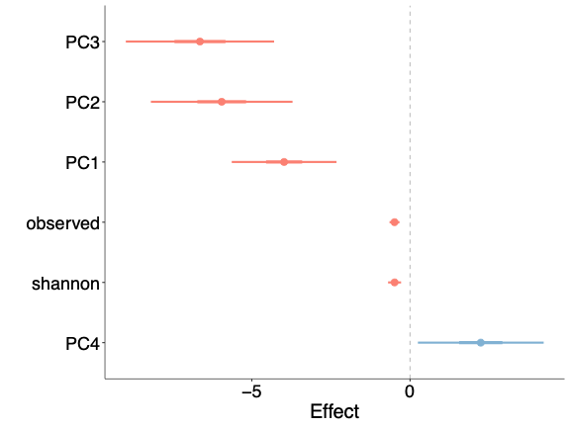
Figures
Fig 1: Plotted coefficients for the temperature predictor from our model comparison for community features, including beta diversity (measured by principal coordinates 1-4) and alpha diversity (measured by the Shannon Index and the observed number of ASVs). The thick bars represent 50% confidence intervals (CI), while the thin bars represent 95% CI. All community features show a reliable association with temperature.
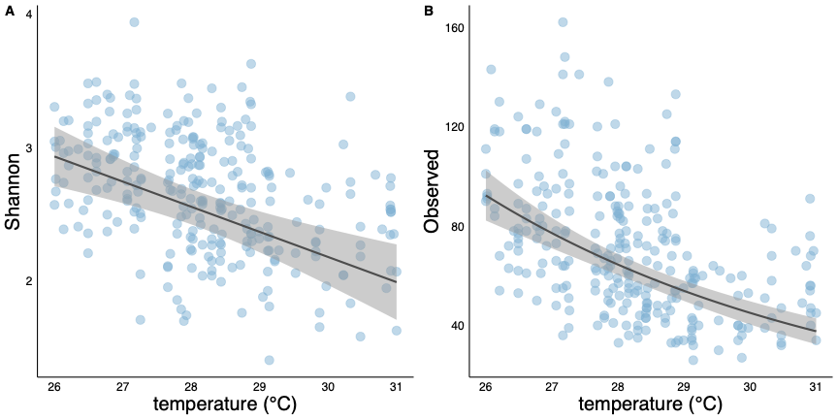
Fig 2: Plotted model results showing the relationship between alpha diversity and temperature. Panel (A) measures alpha diversity using Shannon's Index, while panel (B) uses the total number of ASVs. Both metrics demonstrate a decrease in alpha diversity as temperature increases.

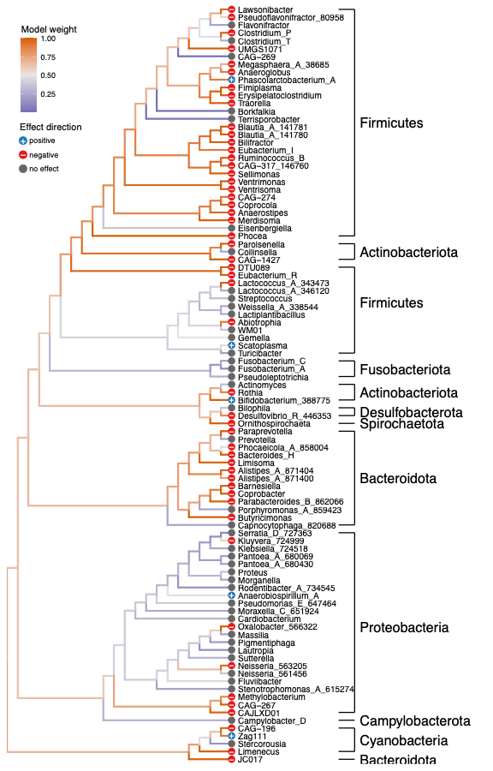

Fig 3: Cladogram of ancestral state reconstruction for all genera included in the differential abundance analysis testing the relationship between temperature and microbial abundance. Model weights were used for ancestral state reconstruction; higher model weights indicate a stronger association between genus-level abundance and temperature. Branch colors represent model weights, with high weights shown in orange and low weights in purple. Tree tips are labeled with genus names and annotated with symbols indicating the direction of the effect (positive, negative, or none). Among taxa that show a relationship with temperature, most exhibit a negative association, indicating that high temperatures are linked to decreases in abundance.

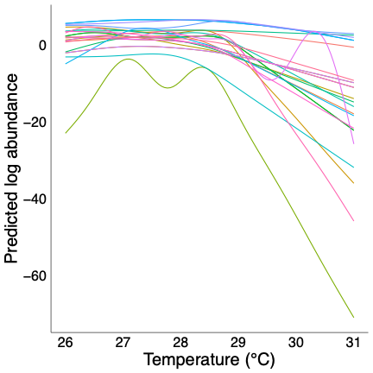

Fig 4: Plotted model results for the non-linear relationship between taxon abundance and temperature. The plot shows the predicted log abundance of each taxon across the range of temperature values. Colors represent individual taxa from the largest cluster described by the hierarchical clustering analysis. Taxa in this group exhibit a decrease in abundance after 29 °C at different rates.

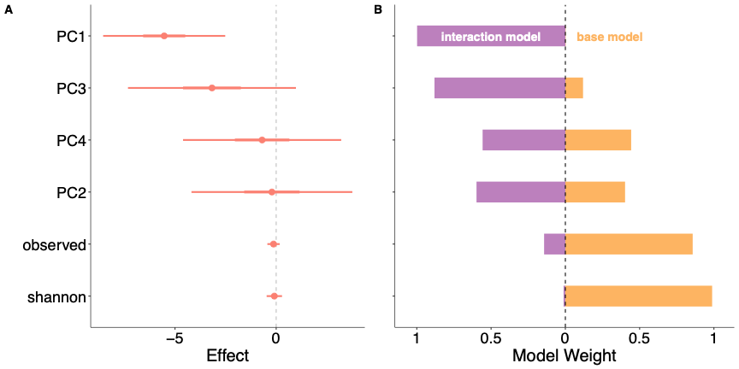
Fig 5: Model comparison results evaluating if neopterin concentration is related to community-level microbiome response to temperature. Panel (A) shows the coefficients for the interaction between temperature and neopterin for community features including beta diversity (measured by principal coordinates 1-4) and alpha diversity (measured by the Shannon Index and the observed number of ASVs). The thick bars represent 50% confidence intervals (CI), while the thin bars represent 95% CI. Principle component 1 is the only feature that shows a reliable relationship with the interaction effect. Panel (B) compares model weights between the interaction model (in purple) and the model that does not include the interaction effect (base model, in orange). The interaction model accounts for more than 50% of the model weight for all principal coordinates in contrast to the alpha diversity metrics where it accounts for very little model weight. Combined, the panels suggest that neopterin is associated with the relationship between temperature and beta diversity but not alpha diversity.

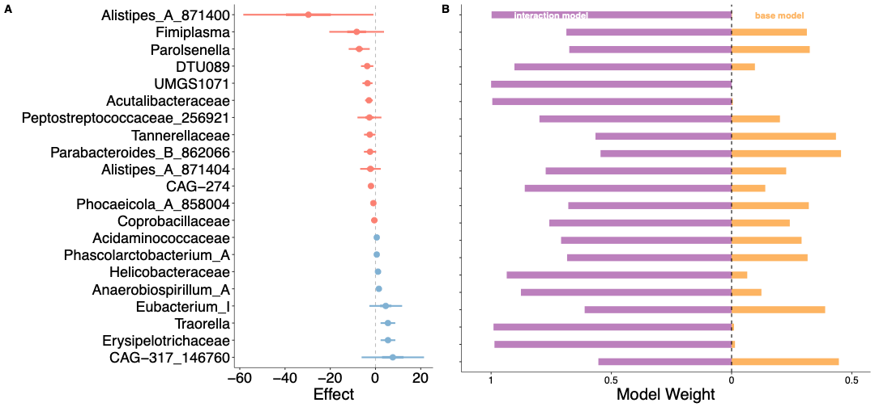
Fig 6: Model comparison results evaluating if neopterin concentration is related to taxa-level microbiome response to temperature. Panel (A) shows the coefficients for the interaction between temperature and neopterin across different taxa. The thick bars represent 50% confidence intervals (CI), while the thin bars represent 95% CI. Panel (B) compares model weights between the interaction model (in purple) and the model that does not include the interaction effect (base model, in orange). The interaction model accounts for more than 50% of the model weight for all taxa.

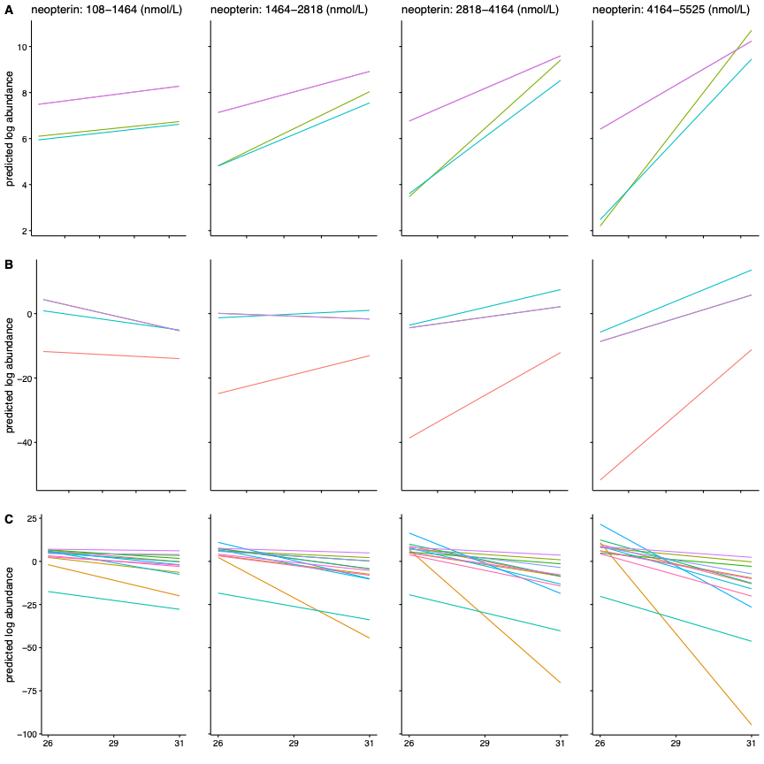
Fig 7: Plotted model results of the interaction effect between temperature and neopterin for all taxa where that interaction model accounted for more than 50% of the model weight. Colors represent individual taxa The four columns represent four discrete ranges of neopterin concentrations increasing from left to right. The rows represent the different types of effects, including the negative amplifying effect (Row A), where a stronger negative relationship with temperature is associated with high neopterin concentration. The positive amplifying effect (Row B), where a stronger positive relationship with temperature is associated with high neopterin concentration, and the reverse effect (Row C), where a negative relationship with temperature is associated with low neopterin concentration while a positive relationship is associated with high neopterin.

Supplementary figures


Fig 1S: Prevalence of ASVs plotted as total abundance versus the number of samples each ASV appears in. The dashed line at 1.39 marks the 0.5% prevalence threshold used to filter out rare ASVs. ASVs present in at least two samples were retained for downstream analysis.
Fig 2S: Scatter plot of the count of fruit feeding observations two weeks before sample collection and its relationship with temperature. The plot demonstrates a clear positive relationship where fruit consumption increases with rising temperatures.

Fig 3S: Visualization of the eigenvalues for each principal component in descending order. Principal components 1 through 4 were used for analysis, as the eigenvalues level off beyond principal component 4.
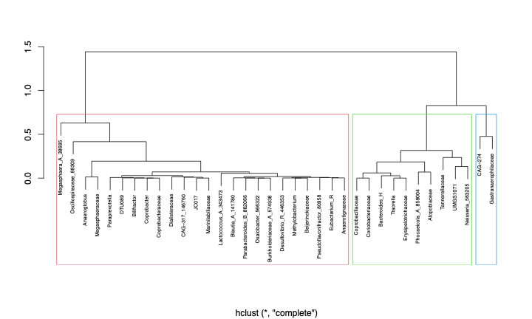
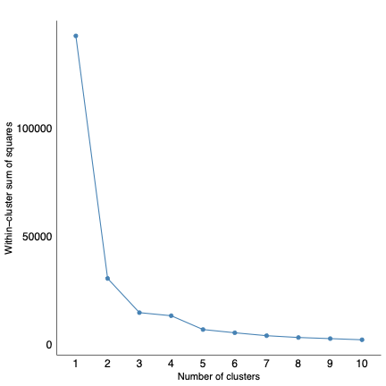
Fig 4S: Plot of the within-cluster sum of squares demonstrates a decrease in within-cluster sum of squares as the number of clusters increases. Three clusters were used for the analysis because adding more clusters did not meaningfully reduce the within-cluster sum of squares.
Fig 5S: Dendrogram of hierarchical clustering performed using hclust() with three clusters outlined. The first cluster, highlighted in red, contains the majority of taxa that exhibit a non-linear relationship with temperature.

References
Aitchison, J., Barcelo-Vidal, C., Martın-Fernandez, J. A., & Pawlowsky-Glahn, V. (2000). Logratio Analysis and Compositional Distance.
Aitchison, J., & Greenacre, M. (2002). Biplots of Compositional Data. Journal of the Royal Statistical Society Series C: Applied Statistics, 51(4), 375–392. https://doi.org/10.1111/1467-9876.00275
Akaike, H. (1998). Information Theory and an Extension of the Maximum Likelihood Principle. In E. Parzen, K. Tanabe, & G. Kitagawa (Eds.), Selected Papers of Hirotugu Akaike (pp. 199–213). Springer New York. https://doi.org/10.1007/978-1-4612-1694-0_15
Al Bander, Z., Nitert, M. D., Mousa, A., & Naderpoor, N. (2020). The Gut Microbiota and Inflammation: An Overview. International Journal of Environmental Research and Public Health, 17(20), Article 20. https://doi.org/10.3390/ijerph17207618
Al Nabhani, Z., & Eberl, G. (2020). Imprinting of the immune system by the microbiota early in life. Mucosal Immunology, 13(2), 183–189. https://doi.org/10.1038/s41385-020-0257-y
Amato, K. R. (2016). Incorporating the gut microbiota into models of human and non-human primate ecology and evolution. American Journal of Physical Anthropology, 159(S61), 196–215. https://doi.org/10.1002/ajpa.22908
Amato, K. R., Kuthyar, S., Ekanayake-Weber, M., Salmi, R., Snyder-Mackler, N., Wijayathunga, L., Vandercone, R., & Lu, A. (2020). Gut microbiome, diet, and conservation of endangered langurs in Sri Lanka. Biotropica, 52(5), 981–990. https://doi.org/10.1111/btp.12805
Amato, K. R., Martinez-Mota, R., Righini, N., Raguet-Schofield, M., Corcione, F. P., Marini, E., Humphrey, G., Gogul, G., Gaffney, J., Lovelace, E., Williams, L., Luong, A., Dominguez-Bello, M. G., Stumpf, R. M., White, B., Nelson, K. E., Knight, R., & Leigh, S. R. (2016). Phylogenetic and ecological factors impact the gut microbiota of two Neotropical primate species. Oecologia, 180(3), 717–733. https://doi.org/10.1007/s00442-015-3507-z
Amato, K. R., Yeoman, C. J., Kent, A., Righini, N., Carbonero, F., Estrada, A., Rex Gaskins, H., Stumpf, R. M., Yildirim, S., Torralba, M., Gillis, M., Wilson, B. A., Nelson, K. E., White, B. A., & Leigh, S. R. (2013). Habitat degradation impacts black howler monkey (Alouatta pigra) gastrointestinal microbiomes. The ISME Journal, 7(7), 1344–1353. https://doi.org/10.1038/ismej.2013.16
Anderson, D. R., Burnham, K. P., & Thompson, W. L. (2000). Null Hypothesis Testing: Problems, Prevalence, and an Alternative. The Journal of Wildlife Management, 64(4), 912–923. https://doi.org/10.2307/3803199
Appert, O., Garcia, A. R., Frei, R., Roduit, C., Constancias, F., Neuzil-Bunesova, V., Ferstl, R., Zhang, J., Akdis, C., Lauener, R., Lacroix, C., & Schwab, C. (2020). Initial butyrate producers during infant gut microbiota development are endospore formers. Environmental Microbiology, 22(9), 3909–3921. https://doi.org/10.1111/1462-2920.15167
Bagath, M., Krishnan, G., Devaraj, C., Rashamol, V. P., Pragna, P., Lees, A. M., & Sejian, V. (2019). The impact of heat stress on the immune system in dairy cattle: A review. Research in Veterinary Science, 126, 94–102. https://doi.org/10.1016/j.rvsc.2019.08.011
Bailón, E., Cueto-Sola, M., Utrilla, P., Rodríguez-Cabezas, M. E., Garrido-Mesa, N., Zarzuelo, A., Xaus, J., Gálvez, J., & Comalada, M. (2010). Butyrate in vitro immune-modulatory effects might be mediated through a proliferation-related induction of apoptosis. Immunobiology, 215(11), 863–873. https://doi.org/10.1016/j.imbio.2010.01.001
Balcázar, J. L., de Blas, I., Ruiz-Zarzuela, I., Vendrell, D., Gironés, O., & Muzquiz, J. L. (2007). Enhancement of the immune response and protection induced by probiotic lactic acid bacteria against furunculosis in rainbow trout (Oncorhynchus mykiss). FEMS Immunology & Medical Microbiology, 51(1), 185–193. https://doi.org/10.1111/j.1574-695X.2007.00294.x
Baldassarre, L., Ying, H., Reitzel, A. M., Franzenburg, S., & Fraune, S. (2022). Microbiota mediated plasticity promotes thermal adaptation in the sea anemone Nematostella vectensis. Nature Communications, 13(1), 3804. https://doi.org/10.1038/s41467-022-31350-z
Baniel, A., Amato, K. R., Beehner, J. C., Bergman, T. J., Mercer, A., Perlman, R. F., Petrullo, L., Reitsema, L., Sams, S., Lu, A., & Snyder-Mackler, N. (2021). Seasonal shifts in the gut microbiome indicate plastic responses to diet in wild geladas. Microbiome, 9(1), 26. https://doi.org/10.1186/s40168-020-00977-9
Barelli, C., Albanese, D., Donati, C., Pindo, M., Dallago, C., Rovero, F., Cavalieri, D., Tuohy, K. M., Hauffe, H. C., & De Filippo, C. (2015). Habitat fragmentation is associated to gut microbiota diversity of an endangered primate: Implications for conservation. Scientific Reports, 5(1), 14862. https://doi.org/10.1038/srep14862
Beehner, J. C., Alfaro, J., Allen, C., Benítez, M. E., Bergman, T. J., Buehler, M. S., Carrera, S. C., Chester, E. M., Deschner, T., Fuentes, A., Gault, C. M., Godoy, I., Jack, K. M., Kim, J. D., Kolinski, L., Kulick, N. K., Losch, T., Ordoñez, J. C., Perry, S. E., … Wasserman, M. D. (2022). Using an on-site laboratory for fecal steroid analysis in wild white-faced capuchins. General and Comparative Endocrinology, 329, 114109. https://doi.org/10.1016/j.ygcen.2022.114109
Bellard, C., Bertelsmeier, C., Leadley, P., Thuiller, W., & Courchamp, F. (2012). Impacts of climate change on the future of biodiversity. Ecology Letters, 15(4), 365–377. https://doi.org/10.1111/j.1461-0248.2011.01736.x
Bennett, J. M., Sunday, J., Calosi, P., Villalobos, F., Martínez, B., Molina-Venegas, R., Araújo, M. B., Algar, A. C., Clusella-Trullas, S., Hawkins, B. A., Keith, S. A., Kühn, I., Rahbek, C., Rodríguez, L., Singer, A., Morales-Castilla, I., & Olalla-Tárraga, M. Á. (2021). The evolution of critical thermal limits of life on Earth. Nature Communications, 12(1), 1198. https://doi.org/10.1038/s41467-021-21263-8
Bergstrom, M. L., Emery Thompson, M., Melin, A. D., & Fedigan, L. M. (2017). Using urinary parameters to estimate seasonal variation in the physical condition of female white-faced capuchin monkeys (Cebus capucinus imitator). American Journal of Physical Anthropology, 163(4), 707–715. https://doi.org/10.1002/ajpa.23239
Bestion, E., Jacob, S., Zinger, L., Di Gesu, L., Richard, M., White, J., & Cote, J. (2017). Climate warming reduces gut microbiota diversity in a vertebrate ectotherm. Nature Ecology & Evolution, 1(6), 1–3. https://doi.org/10.1038/s41559-017-0161
Bisanz, J. (2018). qiime2R: importing QIIME2 artifacts and associated data into R sessions. R Package Version 0.99.
Bokulich, N. A., Kaehler, B. D., Rideout, J. R., Dillon, M., Bolyen, E., Knight, R., Huttley, G. A., & Gregory Caporaso, J. (2018). Optimizing taxonomic classification of marker-gene amplicon sequences with QIIME 2’s q2-feature-classifier plugin. Microbiome, 6(1), 90. https://doi.org/10.1186/s40168-018-0470-z
Bravo, M., Combes, T., Martinez, F. O., Risco, D., Gonçalves, P., Garcia-Jimenez, W. L., Cerrato, R., Fernandez-Llario, P., & Gutierrez-Merino, J. (2022). Wildlife Symbiotic Bacteria Are Indicators of the Health Status of the Host and Its Ecosystem. Applied and Environmental Microbiology, 88(1), e01385-21. https://doi.org/10.1128/AEM.01385-21
Brewer, S. M., Twittenhoff, C., Kortmann, J., Brubaker, S. W., Honeycutt, J., Massis, L. M., Pham, T. H. M., Narberhaus, F., & Monack, D. M. (2021). A Salmonella Typhi RNA thermosensor regulates virulence factors and innate immune evasion in response to host temperature. PLOS Pathogens, 17(3), e1009345. https://doi.org/10.1371/journal.ppat.1009345
Brugman, S., Schneeberger ,Kerstin, Witte ,Merlijn, Klein ,Mark R, van den Bogert ,Bartholomeus, Boekhorst ,Jos, Timmerman ,Harro M, Boes ,Marianne L, Kleerebezem ,Michiel, & and Nieuwenhuis, E. E. (2014). T lymphocytes control microbial composition by regulating the abundance of Vibrio in the zebrafish gut. Gut Microbes, 5(6), 737–747. https://doi.org/10.4161/19490976.2014.972228
Bueno De Mesquita, C. P., Nichols, L. M., Gebert, M. J., Vanderburgh, C., Bocksberger, G., Lester, J. D., Kalan, A. K., Dieguez, P., McCarthy, M. S., Agbor, A., Álvarez Varona, P., Ayimisin, A. E., Bessone, M., Chancellor, R., Cohen, H., Coupland, C., Deschner, T., Egbe, V. E., Goedmakers, A., … Dunn, R. R. (2021). Structure of Chimpanzee Gut Microbiomes across Tropical Africa. mSystems, 6(3), e01269-20. https://doi.org/10.1128/mSystems.01269-20
Buffie, C. G., & Pamer, E. G. (2013). Microbiota-mediated colonization resistance against intestinal pathogens. Nature Reviews Immunology, 13(11), 790–801. https://doi.org/10.1038/nri3535
Burnham, K. P., Anderson, D. R., & Huyvaert, K. P. (2011). AIC model selection and multimodel inference in behavioral ecology: Some background, observations, and comparisons. Behavioral Ecology and Sociobiology, 65(1), 23–35. https://doi.org/10.1007/s00265-010-1029-6
Caballero-Flores, G., Pickard, J. M., & Núñez, G. (2023). Microbiota-mediated colonization resistance: Mechanisms and regulation. Nature Reviews Microbiology, 21(6), 347–360. https://doi.org/10.1038/s41579-022-00833-7
Callahan, B. J., McMurdie, P. J., Rosen, M. J., Han, A. W., Johnson, A. J. A., & Holmes, S. P. (2016). DADA2: High-resolution sample inference from Illumina amplicon data. Nature Methods, 13(7), 581–583. https://doi.org/10.1038/nmeth.3869
Campana, R., van Hemert, S., & Baffone, W. (2017). Strain-specific probiotic properties of lactic acid bacteria and their interference with human intestinal pathogens invasion. Gut Pathogens, 9(1), 12. https://doi.org/10.1186/s13099-017-0162-4
Campos, F. A., & Fedigan, L. M. (2009). Behavioral adaptations to heat stress and water scarcity in white-faced capuchins (Cebus capucinus) in Santa Rosa National Park, Costa Rica. American Journal of Physical Anthropology, 138(1), 101–111. https://doi.org/10.1002/ajpa.20908
Cao, Q., Sun, X., Rajesh, K., Chalasani, N., Gelow, K., Katz, B., Shah, V. H., Sanyal, A. J., & Smirnova, E. (2021). Effects of Rare Microbiome Taxa Filtering on Statistical Analysis. Frontiers in Microbiology, 11. https://doi.org/10.3389/fmicb.2020.607325
Caporaso, J. G., Kuczynski, J., Stombaugh, J., Bittinger, K., Bushman, F. D., Costello, E. K., Fierer, N., Peña, A. G., Goodrich, J. K., Gordon, J. I., Huttley, G. A., Kelley, S. T., Knights, D., Koenig, J. E., Ley, R. E., Lozupone, C. A., McDonald, D., Muegge, B. D., Pirrung, M., … Knight, R. (2010). QIIME allows analysis of high-throughput community sequencing data. Nature Methods, 7(5), 335–336. https://doi.org/10.1038/nmeth.f.303
Chang, P. V., Hao, L., Offermanns, S., & Medzhitov, R. (2014). The microbial metabolite butyrate regulates intestinal macrophage function via histone deacetylase inhibition. Proceedings of the National Academy of Sciences, 111(6), 2247–2252. https://doi.org/10.1073/pnas.1322269111
Chu, H., & Mazmanian, S. K. (2013). Innate immune recognition of the microbiota promotes host-microbial symbiosis. Nature Immunology, 14(7), 668–675. https://doi.org/10.1038/ni.2635
Corrêa-Oliveira, R., Fachi, J. L., Vieira, A., Sato, F. T., & Vinolo, M. A. R. (2016). Regulation of immune cell function by short-chain fatty acids. Clinical & Translational Immunology, 5(4), e73. https://doi.org/10.1038/cti.2016.17
Dowd, W. W., King, F. A., & Denny, M. W. (2015). Thermal variation, thermal extremes and the physiological performance of individuals. Journal of Experimental Biology, 218(12), 1956–1967. https://doi.org/10.1242/jeb.114926
Emerson, K. J., Fontaine, S. S., Kohl, K. D., & Woodley, S. K. (2023). Temperature and the microbial environment alter brain morphology in a larval amphibian. Journal of Experimental Biology, 226(12), jeb245333. https://doi.org/10.1242/jeb.245333
Ferreira, C. M., Vieira, A. T., Vinolo, M. A. R., Oliveira, F. A., Curi, R., & Martins, F. dos S. (2014). The Central Role of the Gut Microbiota in Chronic Inflammatory Diseases. Journal of Immunology Research, 2014(1), 689492. https://doi.org/10.1155/2014/689492
Fontaine, S. S., & Kohl, K. D. (2023). Ectotherm heat tolerance and the microbiome: Current understanding, future directions and potential applications. Journal of Experimental Biology, 226(12), jeb245761. https://doi.org/10.1242/jeb.245761
Fontaine, S. S., Novarro, A. J., & Kohl, K. D. (2018). Environmental temperature alters the digestive performance and gut microbiota of a terrestrial amphibian. Journal of Experimental Biology, 221(20), jeb187559. https://doi.org/10.1242/jeb.187559
Gensollen, T., Iyer, S. S., Kasper, D. L., & Blumberg, R. S. (2016). How colonization by microbiota in early life shapes the immune system. Science, 352(6285), 539–544. https://doi.org/10.1126/science.aad9378
Gloor, G. B., Macklaim, J. M., Pawlowsky-Glahn, V., & Egozcue, J. J. (2017). Microbiome Datasets Are Compositional: And This Is Not Optional. Frontiers in Microbiology, 8. https://doi.org/10.3389/fmicb.2017.02224
Gloor, G. B., & Reid, G. (2016). Compositional analysis: A valid approach to analyze microbiome high-throughput sequencing data. Canadian Journal of Microbiology, 62(8), 692–703. https://doi.org/10.1139/cjm-2015-0821
Gohl, D. M., Vangay, P., Garbe, J., MacLean, A., Hauge, A., Becker, A., Gould, T. J., Clayton, J. B., Johnson, T. J., Hunter, R., Knights, D., & Beckman, K. B. (2016). Systematic improvement of amplicon marker gene methods for increased accuracy in microbiome studies. Nature Biotechnology, 34(9), 942–949. https://doi.org/10.1038/nbt.3601
Hamer, H. M., Jonkers, D., Venema, K., Vanhoutvin, S., Troost, F. J., & Brummer, R.-J. (2008). Review article: The role of butyrate on colonic function. Alimentary Pharmacology & Therapeutics, 27(2), 104–119. https://doi.org/10.1111/j.1365-2036.2007.03562.x
Hammer, T. J., Le, E., & Moran, N. A. (2021). Thermal niches of specialized gut symbionts: The case of social bees. Proceedings of the Royal Society B: Biological Sciences, 288(1944), 20201480. https://doi.org/10.1098/rspb.2020.1480
Hartman, L. M., van Oppen, M. J. H., & Blackall, L. L. (2020). The Effect of Thermal Stress on the Bacterial Microbiome of Exaiptasia diaphana. Microorganisms, 8(1), Article 1. https://doi.org/10.3390/microorganisms8010020
Hector, T. E., Hoang, K. L., Li, J., & King, K. C. (2022). Symbiosis and host responses to heating. Trends in Ecology & Evolution, 37(7), 611–624. https://doi.org/10.1016/j.tree.2022.03.011
Higham, J. P., Kraus, C., Stahl-Hennig, C., Engelhardt, A., Fuchs, D., & Heistermann, M. (2015). Evaluating noninvasive markers of nonhuman primate immune activation and inflammation. American Journal of Physical Anthropology, 158(4), 673–684. https://doi.org/10.1002/ajpa.22821
Hooper, L. V., Littman, D. R., & Macpherson, A. J. (2012). Interactions Between the Microbiota and the Immune System. Science, 336(6086), 1268–1273. https://doi.org/10.1126/science.1223490
Hooper, L. V., & Macpherson, A. J. (2010). Immune adaptations that maintain homeostasis with the intestinal microbiota. Nature Reviews Immunology, 10(3), 159–169. https://doi.org/10.1038/nri2710
Hooper, L. V., Midtvedt, T., & Gordon, J. I. (2002). HOW HOST-MICROBIAL INTERACTIONS SHAPE THE NUTRIENT ENVIRONMENT OF THE MAMMALIAN INTESTINE. Annual Review of Nutrition, 22(Volume 22, 2002), 283–307. https://doi.org/10.1146/annurev.nutr.22.011602.092259
Horváthová, T., Babik, W., Kozłowski, J., & Bauchinger, U. (2019). Vanishing benefits—The loss of actinobacterial symbionts at elevated temperatures. Journal of Thermal Biology, 82, 222–228. https://doi.org/10.1016/j.jtherbio.2019.04.015
Hurvich, C. M., & Tsai, C.-L. (n.d.). Regression and time series model selection in small samples.
Huus, K. E., & Ley, R. E. (2021). Blowing Hot and Cold: Body Temperature and the Microbiome. mSystems, 6(5), 10.1128/msystems.00707-21. https://doi.org/10.1128/msystems.00707-21
Jacobson, A., Lam, L., Rajendram, M., Tamburini, F., Honeycutt, J., Pham, T., Van Treuren, W., Pruss, K., Stabler, S. R., Lugo, K., Bouley, D. M., Vilches-Moure, J. G., Smith, M., Sonnenburg, J. L., Bhatt, A. S., Huang, K. C., & Monack, D. (2018). A Gut Commensal-Produced Metabolite Mediates Colonization Resistance to Salmonella Infection. Cell Host & Microbe, 24(2), 296-307.e7. https://doi.org/10.1016/j.chom.2018.07.002
Jandhyala, S. M., Talukdar, R., Subramanyam, C., Vuyyuru, H., Sasikala, M., & Reddy, D. N. (2015). Role of the normal gut microbiota. World Journal of Gastroenterology : WJG, 21(29), 8787–8803. https://doi.org/10.3748/wjg.v21.i29.8787
Janssen, S., McDonald, D., Gonzalez, A., Navas-Molina, J. A., Jiang, L., Xu, Z. Z., Winker, K., Kado, D. M., Orwoll, E., Manary, M., Mirarab, S., & Knight, R. (2018). Phylogenetic Placement of Exact Amplicon Sequences Improves Associations with Clinical Information. mSystems, 3(3), 10.1128/msystems.00021-18. https://doi.org/10.1128/msystems.00021-18
Jaramillo, A., & Castañeda, L. E. (2021). Gut Microbiota of Drosophila subobscura Contributes to Its Heat Tolerance and Is Sensitive to Transient Thermal Stress. Frontiers in Microbiology, 12. https://doi.org/10.3389/fmicb.2021.654108
Kaakoush, N. O. (2015). Insights into the Role of Erysipelotrichaceae in the Human Host. Frontiers in Cellular and Infection Microbiology, 5. https://doi.org/10.3389/fcimb.2015.00084
Kawamoto, S., Maruya, M., Kato, L. M., Suda, W., Atarashi, K., Doi, Y., Tsutsui, Y., Qin, H., Honda, K., Okada, T., Hattori, M., & Fagarasan, S. (2014). Foxp3+ T Cells Regulate Immunoglobulin A Selection and Facilitate Diversification of Bacterial Species Responsible for Immune Homeostasis. Immunity, 41(1), 152–165. https://doi.org/10.1016/j.immuni.2014.05.016
Kelsall, B. (2008). Recent progress in understanding the phenotype and function of intestinal dendritic cells and macrophages. Mucosal Immunology, 1(6), 460–469. https://doi.org/10.1038/mi.2008.61
Klampfer, L., Huang, J., Sasazuki, T., Shirasawa, S., & Augenlicht, L. (2003). Inhibition of Interferon γ Signaling by the Short Chain Fatty Acid Butyrate1. Molecular Cancer Research, 1(11), 855–862.
Kohl, K. D., & Yahn, J. (2016). Effects of environmental temperature on the gut microbial communities of tadpoles. Environmental Microbiology, 18(5), 1561–1565. https://doi.org/10.1111/1462-2920.13255
Kondepudi, K. K., Ambalam, P., Nilsson, I., Wadström, T., & Ljungh, Å. (2012). Prebiotic-non-digestible oligosaccharides preference of probiotic bifidobacteria and antimicrobial activity against Clostridium difficile. Anaerobe, 18(5), 489–497. https://doi.org/10.1016/j.anaerobe.2012.08.005
Kverka, M., Zakostelska, Z., Klimesova, K., Sokol, D., Hudcovic, T., Hrncir, T., Rossmann, P., Mrazek, J., Kopecny, J., Verdu, E. F., & Tlaskalova-Hogenova, H. (2011). Oral administration of Parabacteroides distasonis antigens attenuates experimental murine colitis through modulation of immunity and microbiota composition. Clinical and Experimental Immunology, 163(2), 250–259. https://doi.org/10.1111/j.1365-2249.2010.04286.x
Li, S., Qian, Z., Gao, S., Shen, W., Li, X., Li, H., & Chen, L. (2022). Effect of long-term temperature stress on the intestinal microbiome of an invasive snail. Frontiers in Microbiology, 13. https://doi.org/10.3389/fmicb.2022.961502
Lovegrove, B. G., Canale, C., Levesque, D., Fluch, G., Řeháková-Petrů, M., & Ruf, T. (2014). Are Tropical Small Mammals Physiologically Vulnerable to Arrhenius Effects and Climate Change? Physiological and Biochemical Zoology, 87(1), 30–45. https://doi.org/10.1086/673313
Lucore, J. M., Beehner, J. C., White, A. F., Sinclair, L. F., Martins, V. A., Kovalaskas, S. A., Ordoñez, J. C., Bergman, T. J., Benítez, M. E., & Marshall, A. J. (2024). High temperatures are associated with decreased immune system performance in a wild primate. Science Advances, 10(48), eadq6629. https://doi.org/10.1126/sciadv.adq6629
Lucore, J. M., Marshall, A. J., Brosnan, S. F., & Benítez, M. E. (2022). Validating Urinary Neopterin as a Biomarker of Immune Response in Captive and Wild Capuchin Monkeys. Frontiers in Veterinary Science, 9. https://doi.org/10.3389/fvets.2022.918036
Mallott, E. K., & Amato, K. R. (2018). The microbial reproductive ecology of white-faced capuchins (Cebus capucinus). American Journal of Primatology, 80(8), e22896. https://doi.org/10.1002/ajp.22896
Mallott, E. K., Amato, K. R., Garber, P. A., & Malhi, R. S. (2018). Influence of fruit and invertebrate consumption on the gut microbiota of wild white-faced capuchins (Cebus capucinus). American Journal of Physical Anthropology, 165(3), 576–588. https://doi.org/10.1002/ajpa.23395
Mallott, E. K., Kuthyar, S., Lee, W., Reiman, D., Jiang, H., Chitta, S., Waters, E. A., Layden, B. T., Sumagin, R., Manzanares, L. D., Yang, G.-Y., Sardaro, M. L. S., Gray, S., Williams, L. E., Dai, Y., Curley, J. P., Haney, C. R., Liechty, E. R., Kuzawa, C. W., & Amato, K. R. (2024). The primate gut microbiota contributes to interspecific differences in host metabolism. Microbial Genomics, 10(12), 001322. https://doi.org/10.1099/mgen.0.001322
Mallott, E. k., Malhi, R. s., & Garber, P. a. (2015). High-throughput sequencing of fecal DNA to identify insects consumed by wild Weddell’s saddleback tamarins (aguinus weddelli, Cebidae, Primates) in Bolivia. American Journal of Physical Anthropology, 156(3), 474–481. https://doi.org/10.1002/ajpa.22654
Marshall, A. J., Meijaard, E., & Leighton, M. (2021). Extreme ecological specialisation in a rainforest mammal, the Bornean tufted ground squirrel, Rheithrosciurus macrotis Gray, 1857. Raffles Bulletin of Zoology, 69, 497506. https://doi.org/10.26107/RBZ-2021-0067
McDonald, D., Jiang, Y., Balaban, M., Cantrell, K., Zhu, Q., Gonzalez, A., Morton, J. T., Nicolaou, G., Parks, D. H., Karst, S. M., Albertsen, M., Hugenholtz, P., DeSantis, T., Song, S. J., Bartko, A., Havulinna, A. S., Jousilahti, P., Cheng, S., Inouye, M., … Knight, R. (2024). Greengenes2 unifies microbial data in a single reference tree. Nature Biotechnology, 42(5), 715–718. https://doi.org/10.1038/s41587-023-01845-1
McDonald, D., Price, M. N., Goodrich, J., Nawrocki, E. P., DeSantis, T. Z., Probst, A., Andersen, G. L., Knight, R., & Hugenholtz, P. (2012). An improved Greengenes taxonomy with explicit ranks for ecological and evolutionary analyses of bacteria and archaea. The ISME Journal, 6(3), 610–618. https://doi.org/10.1038/ismej.2011.139
McMurdie, P. J., & Holmes, S. (2013). phyloseq: An R Package for Reproducible Interactive Analysis and Graphics of Microbiome Census Data. PLoS ONE, 8(4), e61217. https://doi.org/10.1371/journal.pone.0061217
McMurdie, P. J., & Holmes, S. (2014). Waste Not, Want Not: Why Rarefying Microbiome Data Is Inadmissible. PLOS Computational Biology, 10(4), e1003531. https://doi.org/10.1371/journal.pcbi.1003531
Moeller, A. H., Ivey, K., Cornwall, M. B., Herr, K., Rede, J., Taylor, E. N., & Gunderson, A. R. (2020). The Lizard Gut Microbiome Changes with Temperature and Is Associated with Heat Tolerance. Applied and Environmental Microbiology, 86(17), e01181-20. https://doi.org/10.1128/AEM.01181-20
Moghadam, N. N., Thorshauge ,Pia Mai, Kristensen ,Torsten N., de Jonge ,Nadieh, Bahrndorff ,Simon, Kjeldal ,Henrik, & and Nielsen, J. L. (2018). Strong responses of Drosophila melanogaster microbiota to developmental temperature. Fly, 12(1), 1–12. https://doi.org/10.1080/19336934.2017.1394558
Mukherjee, A., Lordan ,Cathy, Ross ,R. Paul, & and Cotter, P. D. (2020). Gut microbes from the phylogenetically diverse genus Eubacterium and their various contributions to gut health. Gut Microbes, 12(1), 1802866. https://doi.org/10.1080/19490976.2020.1802866
Murphy, P. G., & Lugo, A. E. (1986). Ecology of Tropical Dry Forest. Annual Review of Ecology and Systematics, 17, 67–88.
Murr, C., Widner, B., Wirleitner, B., & Fuchs, D. (2002). Neopterin as a marker for immune system activation. Current Drug Metabolism, 3(2), 175–187. https://doi.org/10.2174/1389200024605082
Neuman, C., Hatje, E., Zarkasi, K. Z., Smullen, R., Bowman, J. P., & Katouli, M. (2016). The effect of diet and environmental temperature on the faecal microbiota of farmed Tasmanian Atlantic Salmon (almo salar L.). Aquaculture Research, 47(2), 660–672. https://doi.org/10.1111/are.12522
Neves, A. R., Pool, W. A., Kok, J., Kuipers, O. P., & Santos, H. (2005). Overview on sugar metabolism and its control in Lactococcus lactis—The input from in vivo NMR. FEMS Microbiology Reviews, 29(3), 531–554. https://doi.org/10.1016/j.fmrre.2005.04.005
Oliveira, R. A., Ng, K. M., Correia, M. B., Cabral, V., Shi, H., Sonnenburg, J. L., Huang, K. C., & Xavier, K. B. (2020). Klebsiella michiganensis transmission enhances resistance to Enterobacteriaceae gut invasion by nutrition competition. Nature Microbiology, 5(4), 630–641. https://doi.org/10.1038/s41564-019-0658-4
Orkin, J. D., Campos, F. A., Myers, M. S., Cheves Hernandez, S. E., Guadamuz, A., & Melin, A. D. (2019). Seasonality of the gut microbiota of free-ranging white-faced capuchins in a tropical dry forest. The ISME Journal, 13(1), 183–196. https://doi.org/10.1038/s41396-018-0256-0
Orkin, J. D., Montague, M. J., Tejada-Martinez, D., De Manuel, M., Del Campo, J., Cheves Hernandez, S., Di Fiore, A., Fontsere, C., Hodgson, J. A., Janiak, M. C., Kuderna, L. F. K., Lizano, E., Martin, M. P., Niimura, Y., Perry, G. H., Valverde, C. S., Tang, J., Warren, W. C., De Magalhães, J. P., … Melin, A. D. (2021). The genomics of ecological flexibility, large brains, and long lives in capuchin monkeys revealed with fecalFACS. Proceedings of the National Academy of Sciences, 118(7), e2010632118. https://doi.org/10.1073/pnas.2010632118
Orkin, J. D., Webb, S. E., & Melin, A. D. (2019). Small to modest impact of social group on the gut microbiome of wild Costa Rican capuchins in a seasonal forest. American Journal of Primatology, 81(10–11), e22985. https://doi.org/10.1002/ajp.22985
Palarea-Albaladejo, J., & Martín-Fernández, J. A. (2015). zCompositions—R package for multivariate imputation of left-censored data under a compositional approach. Chemometrics and Intelligent Laboratory Systems, 143, 85–96. https://doi.org/10.1016/j.chemolab.2015.02.019
Parker, B. J., Wearsch, P. A., Veloo, A. C. M., & Rodriguez-Palacios, A. (2020). The Genus Alistipes: Gut Bacteria With Emerging Implications to Inflammation, Cancer, and Mental Health. Frontiers in Immunology, 11. https://doi.org/10.3389/fimmu.2020.00906
Pickett, S. B., Bergey, C. M., & Di Fiore, A. (2012). A Metagenomic Study of Primate Insect Diet Diversity. American Journal of Primatology, 74(7), 622–631. https://doi.org/10.1002/ajp.22014
Quinteiro-Filho, W. M., Ribeiro, A., Ferraz-de-Paula, V., Pinheiro, M. L., Sakai, M., Sá, L. R. M., Ferreira, A. J. P., & Palermo-Neto, J. (2010). Heat stress impairs performance parameters, induces intestinal injury, and decreases macrophage activity in broiler chickens. Poultry Science, 89(9), 1905–1914. https://doi.org/10.3382/ps.2010-00812
Risely, A., Müller-Klein, N., Schmid, D. W., Wilhelm, K., Clutton-Brock, T. H., Manser, M. B., & Sommer, S. (2023). Climate change drives loss of bacterial gut mutualists at the expense of host survival in wild meerkats. Global Change Biology, 29(20), 5816–5828. https://doi.org/10.1111/gcb.16877
Round, J. L., & Mazmanian, S. K. (2009). The gut microbiota shapes intestinal immune responses during health and disease. Nature Reviews Immunology, 9(5), 313–323. https://doi.org/10.1038/nri2515
Rudolph, B., Gebendorfer, K. M., Buchner, J., & Winter, J. (2010). Evolution of Escherichia coli for Growth at High Temperatures *. Journal of Biological Chemistry, 285(25), 19029–19034. https://doi.org/10.1074/jbc.M110.103374
Ruiz-Saavedra, S., Arboleya, S., Nogacka, A. M., González del Rey, C., Suárez, A., Diaz, Y., Gueimonde, M., Salazar, N., González, S., & de los Reyes-Gavilán, C. G. (2024). Commensal Fecal Microbiota Profiles Associated with Initial Stages of Intestinal Mucosa Damage: A Pilot Study. Cancers, 16(1), Article 1. https://doi.org/10.3390/cancers16010104
Schluter, J., Peled, J. U., Taylor, B. P., Markey, K. A., Smith, M., Taur, Y., Niehus, R., Staffas, A., Dai, A., Fontana, E., Amoretti, L. A., Wright, R. J., Morjaria, S., Fenelus, M., Pessin, M. S., Chao, N. J., Lew, M., Bohannon, L., Bush, A., … Xavier, J. B. (2020). The gut microbiota is associated with immune cell dynamics in humans. Nature, 588(7837), 303–307. https://doi.org/10.1038/s41586-020-2971-8
Schneider-Crease, I. A., Feder, J. A., Baniel, A., McCann, C., Haile, A. A., Abebe, B., Fitzgerald, L., Gomery, M. A., Simberloff, R. A., Petrie, Z. L., Gabriel, S., Dorny, P., Fashing, P. J., Nguyen, N., Bergman, T. J., Beehner, J. C., Snyder-Mackler, N., & Lu, A. (2022). Urinary neopterin reflects immunological variation associated with age, helminth parasitism, and the microbiome in a wild primate. Scientific Reports, 12(1), 21307. https://doi.org/10.1038/s41598-022-25298-9
Sepulveda, J., & Moeller, A. H. (2020). The Effects of Temperature on Animal Gut Microbiomes. Frontiers in Microbiology, 11, 384. https://doi.org/10.3389/fmicb.2020.00384
Sequeira, R. P., McDonald, J. A. K., Marchesi, J. R., & Clarke, T. B. (2020). Commensal Bacteroidetes protect against Klebsiella pneumoniae colonization and transmission through IL-36 signalling. Nature Microbiology, 5(2), 304–313. https://doi.org/10.1038/s41564-019-0640-1
Soriano, E. L., Ramírez, D. T., Araujo, D. R., Gómez-Gil, B., Castro, L. I., & Sánchez, C. G. (2018). Effect of temperature and dietary lipid proportion on gut microbiota in yellowtail kingfish Seriola lalandi juveniles. Aquaculture, 497, 269–277. https://doi.org/10.1016/j.aquaculture.2018.07.065
Spragge, F., Bakkeren, E., Jahn, M. T., B. N. Araujo, E., Pearson, C. F., Wang, X., Pankhurst, L., Cunrath, O., & Foster, K. R. (2023). Microbiome diversity protects against pathogens by nutrient blocking. Science, 382(6676), eadj3502. https://doi.org/10.1126/science.adj3502
Stern, M., Quesada, M., & Stoner, K. E. (2002). Changes in composition and structure of a tropical dry forest following intermittent Cattle grazing. Revista de Biología Tropical, 50(3–4), 1021–1034.
Sun, Y., Zhang ,Shanshan, Nie ,Qixing, He ,Huijun, Tan ,Huizi, Geng ,Fang, Ji ,Haihua, Hu ,Jielun, & and Nie, S. (2023). Gut firmicutes: Relationship with dietary fiber and role in host homeostasis. Critical Reviews in Food Science and Nutrition, 63(33), 12073–12088. https://doi.org/10.1080/10408398.2022.2098249
Syakur, M. A., Khotimah, B. K., Rochman, E. M. S., & Satoto, B. D. (2018). Integration K-Means Clustering Method and Elbow Method For Identification of The Best Customer Profile Cluster. IOP Conference Series: Materials Science and Engineering, 336(1), 012017. https://doi.org/10.1088/1757-899X/336/1/012017
Tajima, K., Nonaka, I., Higuchi, K., Takusari, N., Kurihara, M., Takenaka, A., Mitsumori, M., Kajikawa, H., & Aminov, R. I. (2007). Influence of high temperature and humidity on rumen bacterial diversity in Holstein heifers. Anaerobe, 13(2), 57–64. https://doi.org/10.1016/j.anaerobe.2006.12.001
Thomas-White, K., Forster, S. C., Kumar, N., Van Kuiken, M., Putonti, C., Stares, M. D., Hilt, E. E., Price, T. K., Wolfe, A. J., & Lawley, T. D. (2018). Culturing of female bladder bacteria reveals an interconnected urogenital microbiota. Nature Communications, 9(1), 1557. https://doi.org/10.1038/s41467-018-03968-5
Tiessen, A., Cubedo-Ruiz, E. A., & Winkler, R. (2017). Improved Representation of Biological Information by Using Correlation as Distance Function for Heatmap Cluster Analysis. American Journal of Plant Sciences, 8(3), Article 3. https://doi.org/10.4236/ajps.2017.83035
Tinsley Johnson, E., Benítez, M. E., Fuentes, A., McLean, C. R., Norford, A. B., Ordoñez, J. C., Beehner, J. C., & Bergman, T. J. (2020). High density of white-faced capuchins (Cebus capucinus) and habitat quality in the Taboga Forest of Costa Rica. American Journal of Primatology, 82(2), e23096. https://doi.org/10.1002/ajp.23096
Trejo, F. M., Minnaard, J., Perez, P. F., & De Antoni, G. L. (2006). Inhibition of Clostridium difficile growth and adhesion to enterocytes by Bifidobacterium supernatants. Anaerobe, 12(4), 186–193. https://doi.org/10.1016/j.anaerobe.2006.03.004
Tung, J., Barreiro, L. B., Burns, M. B., Grenier, J.-C., Lynch, J., Grieneisen, L. E., Altmann, J., Alberts, S. C., Blekhman, R., & Archie, E. A. (2015). Social networks predict gut microbiome composition in wild baboons. eLife, 4, e05224. https://doi.org/10.7554/eLife.05224
Velazquez, E. M., Nguyen, H., Heasley, K. T., Saechao, C. H., Gil, L. M., Rogers, A. W. L., Miller, B. M., Rolston, M. R., Lopez, C. A., Litvak, Y., Liou, M. J., Faber, F., Bronner, D. N., Tiffany, C. R., Byndloss, M. X., Byndloss, A. J., & Bäumler, A. J. (2019). Endogenous Enterobacteriaceae underlie variation in susceptibility to Salmonella infection. Nature Microbiology, 4(6), 1057–1064. https://doi.org/10.1038/s41564-019-0407-8
Wang, J., Chen, W.-D., & Wang, Y.-D. (2020). The Relationship Between Gut Microbiota and Inflammatory Diseases: The Role of Macrophages. Frontiers in Microbiology, 11. https://doi.org/10.3389/fmicb.2020.01065
Wei, Y., Ma ,Xi, Zhao ,Jiang-chao, Wang ,Xiu-qi, & and Gao, C. (2023). Succinate metabolism and its regulation of host-microbe interactions. Gut Microbes, 15(1), 2190300. https://doi.org/10.1080/19490976.2023.2190300
Wu, F., Guo, X., Zhang, J., Zhang, M., Ou, Z., & Peng, Y. (2017). Phascolarctobacterium faecium abundant colonization in human gastrointestinal tract. Experimental and Therapeutic Medicine, 14(4), 3122–3126. https://doi.org/10.3892/etm.2017.4878
Yoccoz, N. G. (1991). Use, Overuse, and Misuse of Significance Tests in Evolutionary Biology and Ecology. Bulletin of the Ecological Society of America, 72(2), 106–111.
Zhang, B., Leonard, S. P., Li, Y., & Moran, N. A. (2019). Obligate bacterial endosymbionts limit thermal tolerance of insect host species. Proceedings of the National Academy of Sciences, 116(49), 24712–24718. https://doi.org/10.1073/pnas.1915307116
Zhang, F., Fan, D., Huang, J., & Zuo, T. (2022). The gut microbiome: Linking dietary fiber to inflammatory diseases. Medicine in Microecology, 14, 100070. https://doi.org/10.1016/j.medmic.2022.100070
Zhang, H., Sparks, J. B., Karyala, S. V., Settlage, R., & Luo, X. M. (2015). Host adaptive immunity alters gut microbiota. The ISME Journal, 9(3), 770–781. https://doi.org/10.1038/ismej.2014.165
Zhang, X., Pei, Y.-F., Zhang, L., Guo, B., Pendegraft, A. H., Zhuang, W., & Yi, N. (2018). Negative Binomial Mixed Models for Analyzing Longitudinal Microbiome Data. Frontiers in Microbiology, 9. https://doi.org/10.3389/fmicb.2018.01683
Zhao, X.-N., Liu, S.-X., Wang, Z.-Z., Zhang, S., & You, L.-L. (2023). Roxadustat alleviates the inflammatory status in patients receiving maintenance hemodialysis with erythropoiesis-stimulating agent resistance by increasing the short-chain fatty acids producing gut bacteria. European Journal of Medical Research, 28(1), 230. https://doi.org/10.1186/s40001-023-01179-3
Zhu, L., Liao, R., Wu, N., Zhu, G., & Yang, C. (2019). Heat stress mediates changes in fecal microbiome and functional pathways of laying hens. Applied Microbiology and Biotechnology, 103(1), 461–472. https://doi.org/10.1007/s00253-018-9465-8
Ziegler, M., Seneca, F. O., Yum, L. K., Palumbi, S. R., & Voolstra, C. R. (2017). Bacterial community dynamics are linked to patterns of coral heat tolerance. Nature Communications, 8(1), 14213. https://doi.org/10.1038/ncomms14213

