Advance OOP Lab Report
        - How did you come up with JUnit Test Cases? Is it a black-box or white-box approach.
        - What Assumptions did you come up with?
        - What are the various test cases considered for testing the correctness of the chosen functions?
        - Why do you think those test cases are enough to test the correctness of the functions?
        - Screenshots of Junit Test Cases
        - Sample Screenshots
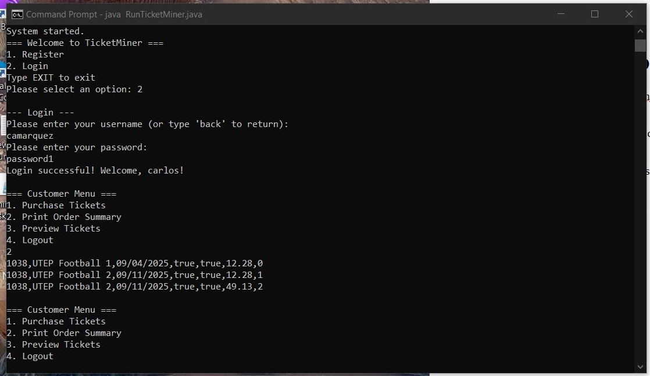Figure 1: Customer logs in and previews order summary
Figure 3: Customer logs in and previews order history
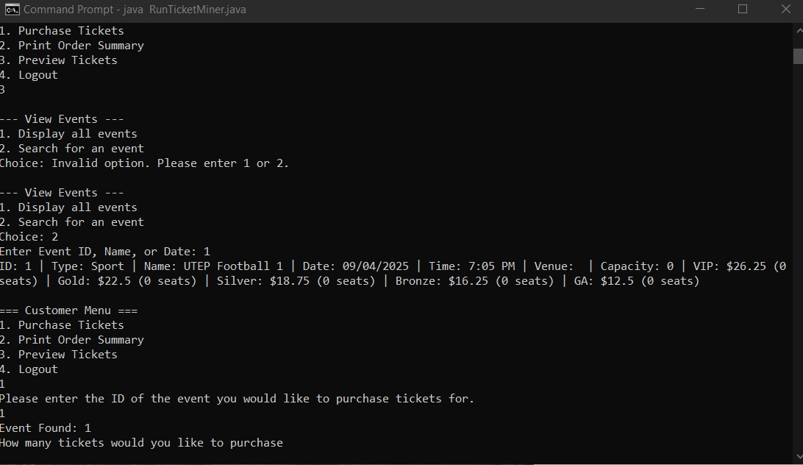Figure 2: Customer previews for the event with the ID 2

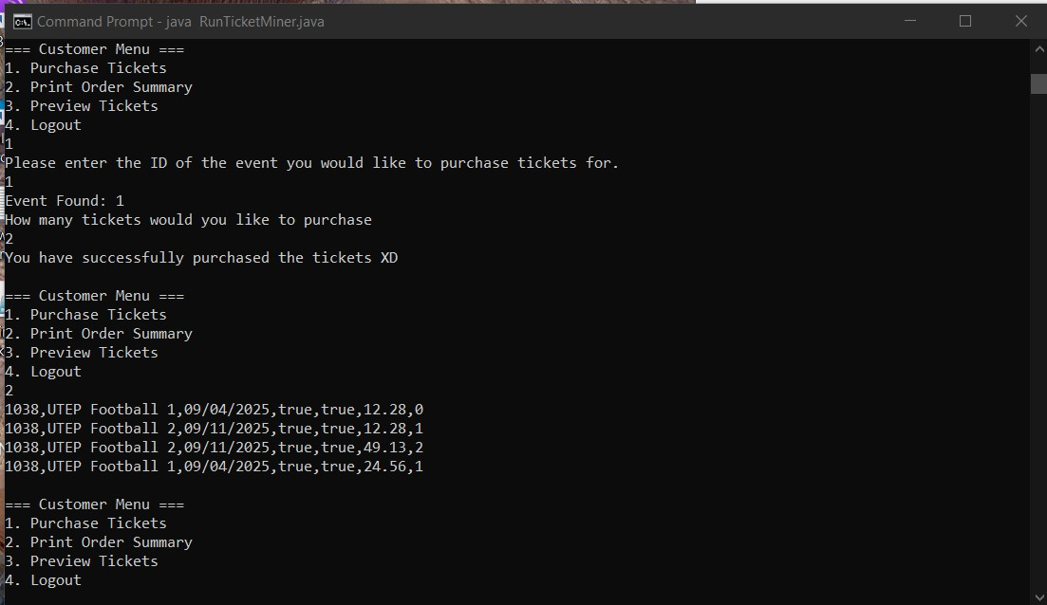Figure 4: Customer buys two tickets for event 1 with the updated customerHistory

