Explain the 4 bits, 3 for hue and 1 for intensity

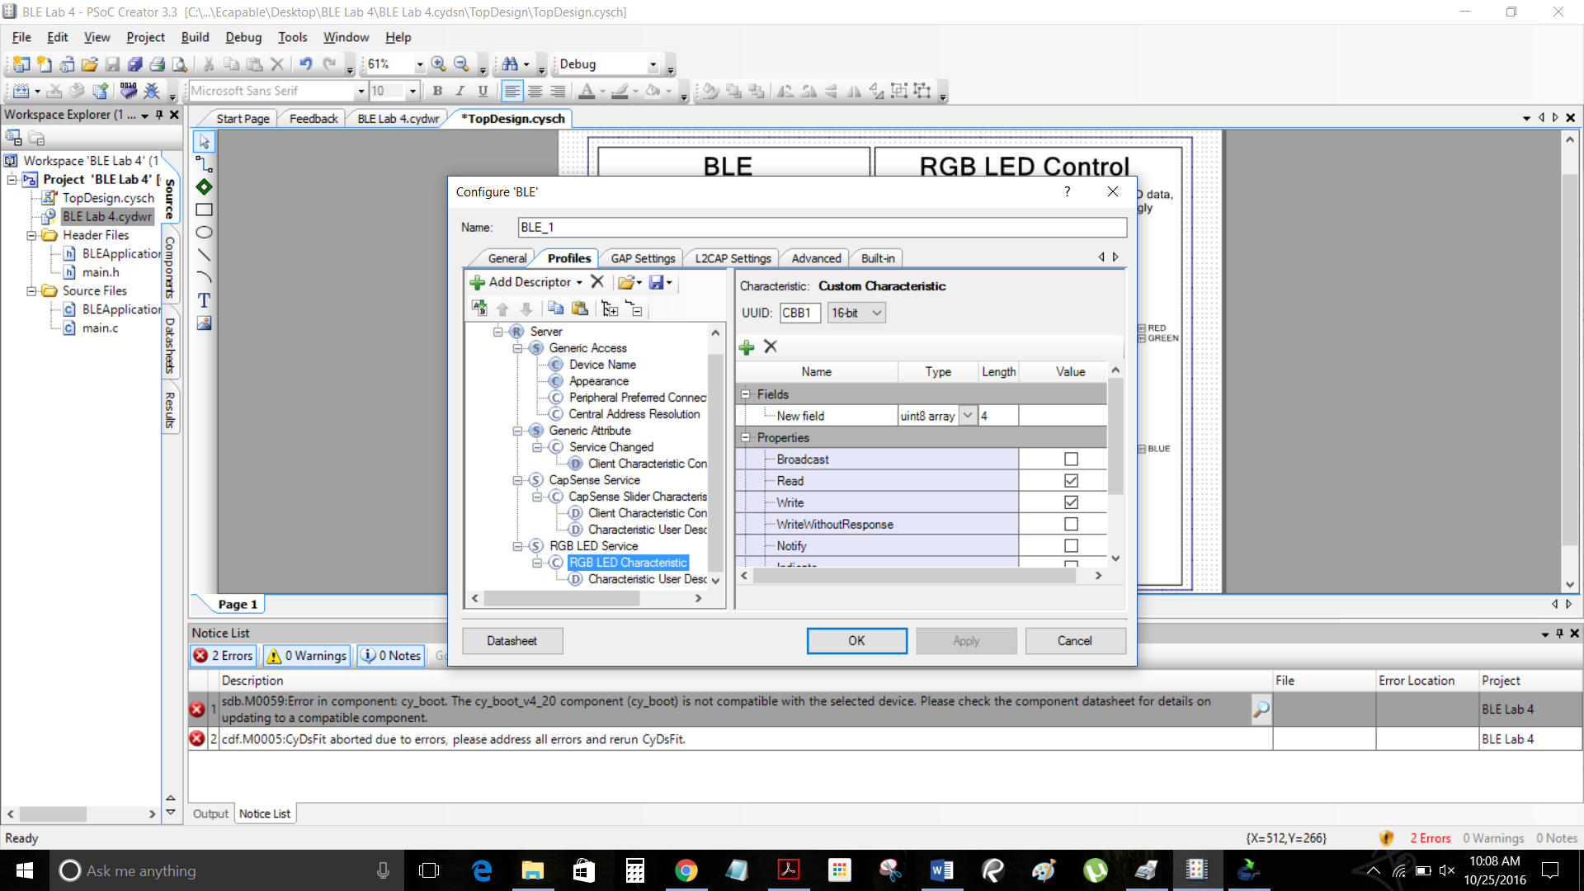

Succesfykk build

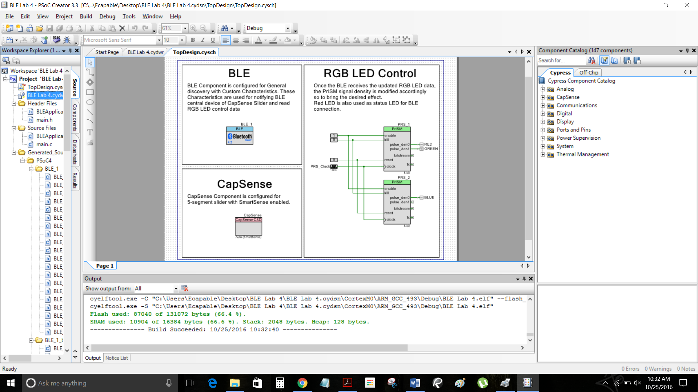

Successful program

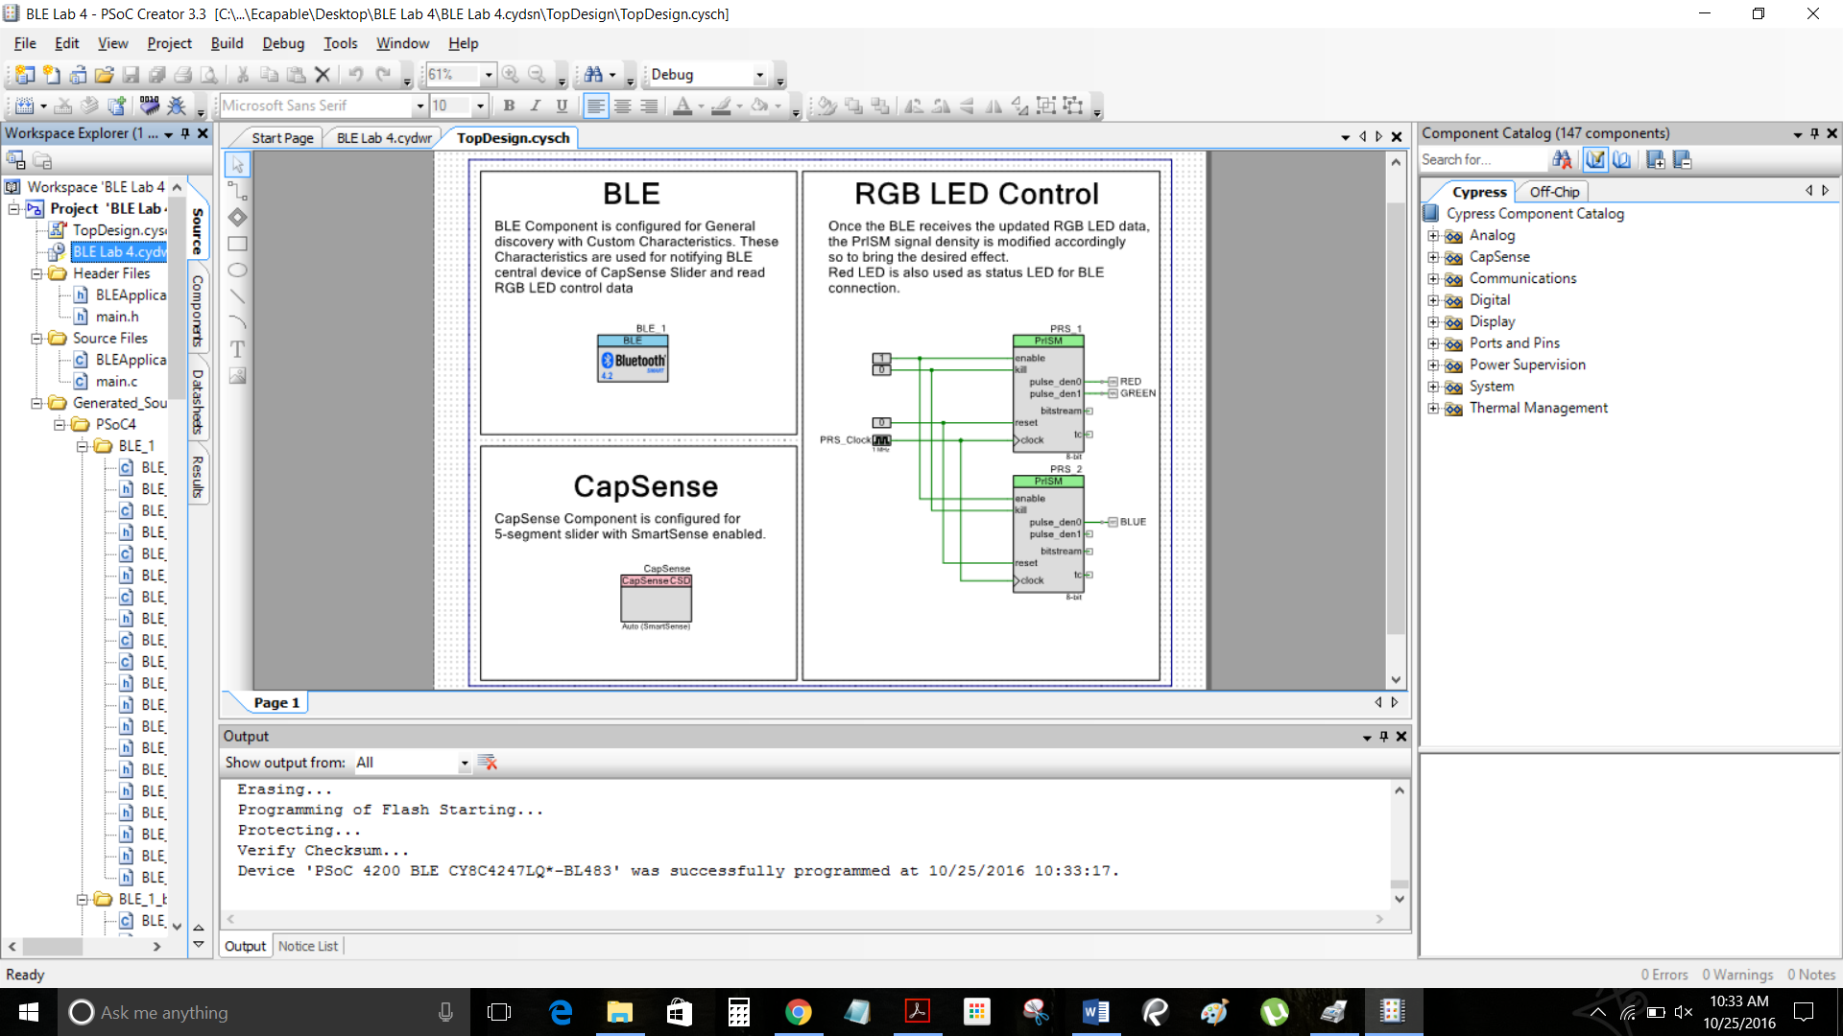

After writing a value of 00 00 FF FF the LED was blue and max intensity in the

**RGB LED Characteristic attribute**

We then made a red LED by writing the value of FF 00 00 FF and max intensity. **RGB LED Characteristic attribute**

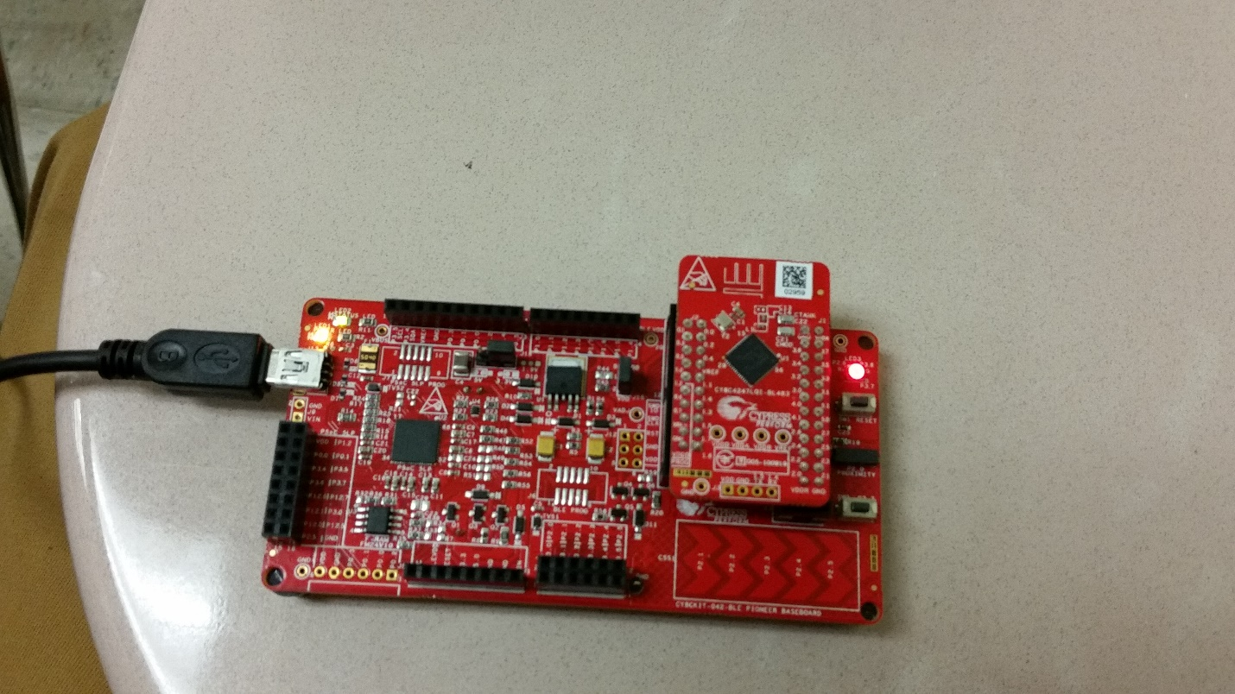 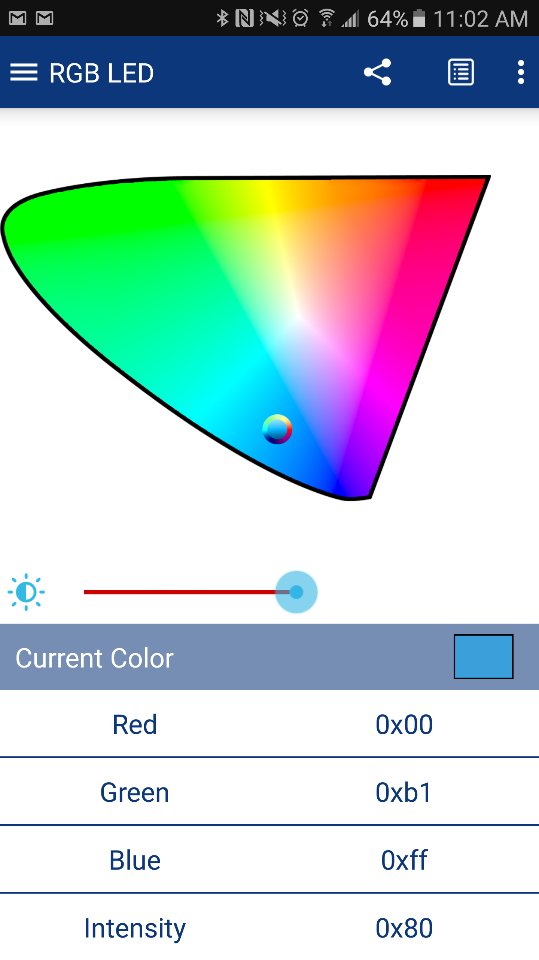

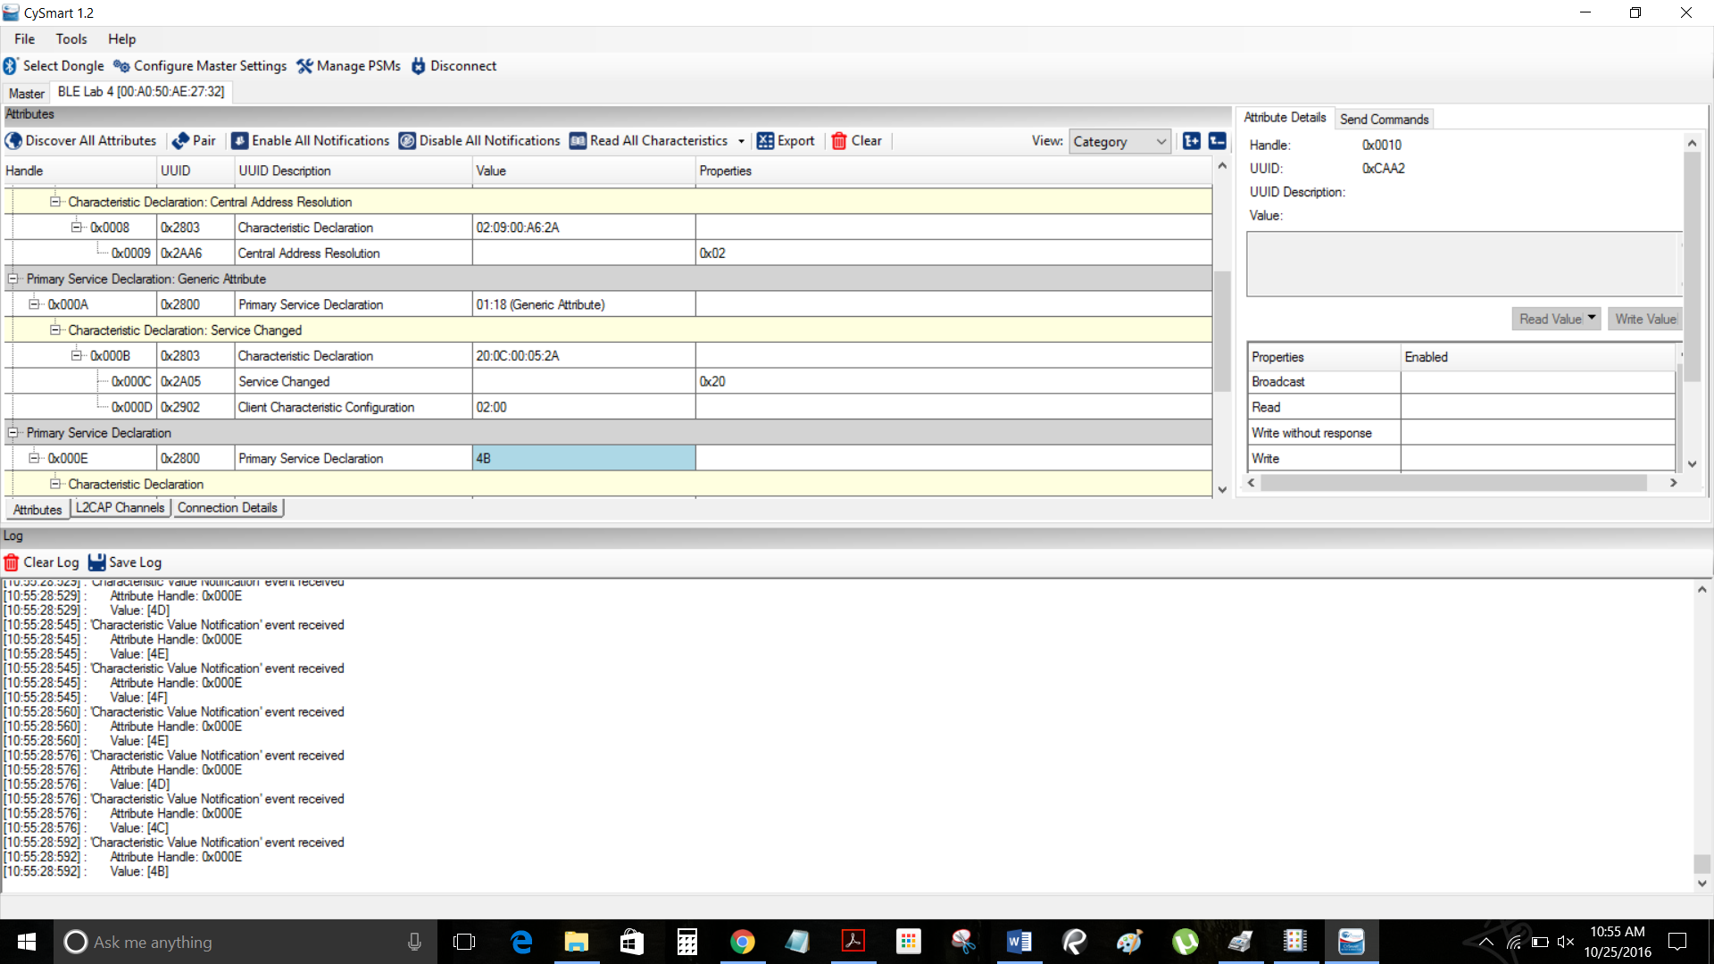running our finger across the CapSense on the kit we were able to see the different values being written