Latex · the page compiled, in its own folder

1 · What sits in the folder, and what a rebuild overwrites
What the folder holds: three files, all built for you, and every one can be built again. 📌 This part settles which three files live in latex/, and that a rebuild may overwrite any of them. Edit one of these files by hand and the next build overwrites it. That is the rule for a folder the machine rebuilds, not a fault. Nobody keeps the view page up to date by hand. export.py writes it again at the end of every run, whether or not xelatex produced a PDF. The bibliography looks first at the page's own bibex/ list (QPf8). When bibex/<stem>.bib holds an entry, the PDF cites exactly what the page cites. With no page bib, the export looks for a 0-*.bib by walking up from the page toward the server's root folder. Outside any paper it still compiles with no citations, printing each \citep as [key] rather than refusing. With either bib the master gains natbib, plainnat, and a bibtex pass.

2 · What survives the trip to LaTeX, and what is lost
What md2tex keeps and what it drops on a board page: most of it lines up, and the losses are written down, not hidden. 📌 This part says what a board page loses on its way to LaTeX: the > lanes, and some emoji. The Content parts map cleanly, because a part already is a section. () and [] come through untouched, because they were LaTeX before the export started. The > lanes are the one real loss. The Word export lands them as comments pinned to a spot, and a LaTeX section has nowhere to put them. The writer also refuses to go backwards: a rewrite that loses citations is refused, not written quietly. The proof run is QPf4b's Content: ten parts became a real nine-page PDF, driven in a browser through the tab. The board's emoji-heavy ascii figures do not survive. xelatex drops any glyph its fonts lack, so a page full of figures reads thinner in PDF than on screen. A2 below is where that gap gets measured instead of guessed.

3 · The tab shows something even when the build fails
The 📜 tab: the registry's tab: {url, write} spec, url first, then a HEAD check, then a build, with the latex route behind it. 📌 This part settles that the 📜 tab always has a page to show: the PDF when the build works, the log when it does not. One view page is written either way, so the tab is never empty. A run that works shows the PDF, with the raw source folded under it. A run that fails opens that fold and prints the tail of the log, so the error sits where the finished page would have been. QPf6-Display1 (Figure 1) shows the working case at the size a reader reads it: page 1 of this page's own export, rendered at 150 dpi, so the claim that the projection works is shown rather than asserted a third time.
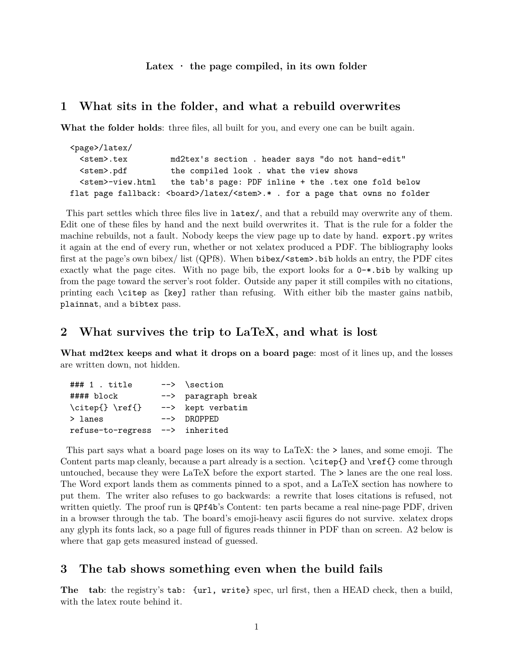
Figure 1. Page 1 of this page's own LaTeX export, rendered at 150 dpi. The projection is asserted to work in three places on this page and was never shown; this is the showing. A reader who doubts the export can compare this image against latex/QPf6-latex.pdf directly.

