4 Measuring Patient-Perceived Physician Traits

4.1 Study Design
Our design measures a physician trait in one data world and observes prescribing in another, joining them only by the physician's national identifier.
Perceived agreeableness is scored from patient-written review text while prescribing is recorded in Medicare claims, so an association between them cannot be an artifact of a single instrument or a single reporter.
We then hold the estimating model fixed and vary the clinical context, building first-encounter cohorts for conditions that differ in how far the condition itself settles the treatment.
Because the specification does not change across cohorts, the comparison among them is a single test of the discretion boundary rather than five separate studies.
The metformin cohort is not the low end of that comparison but a falsification arm on a different outcome: if the trait predicts a prescription that objective laboratory values already determine, the accommodation account is wrong.
Figure 1 shows the four steps and their ordering; Section 5 gives the data, cohorts, and specification, and Section 6 reports the estimates.
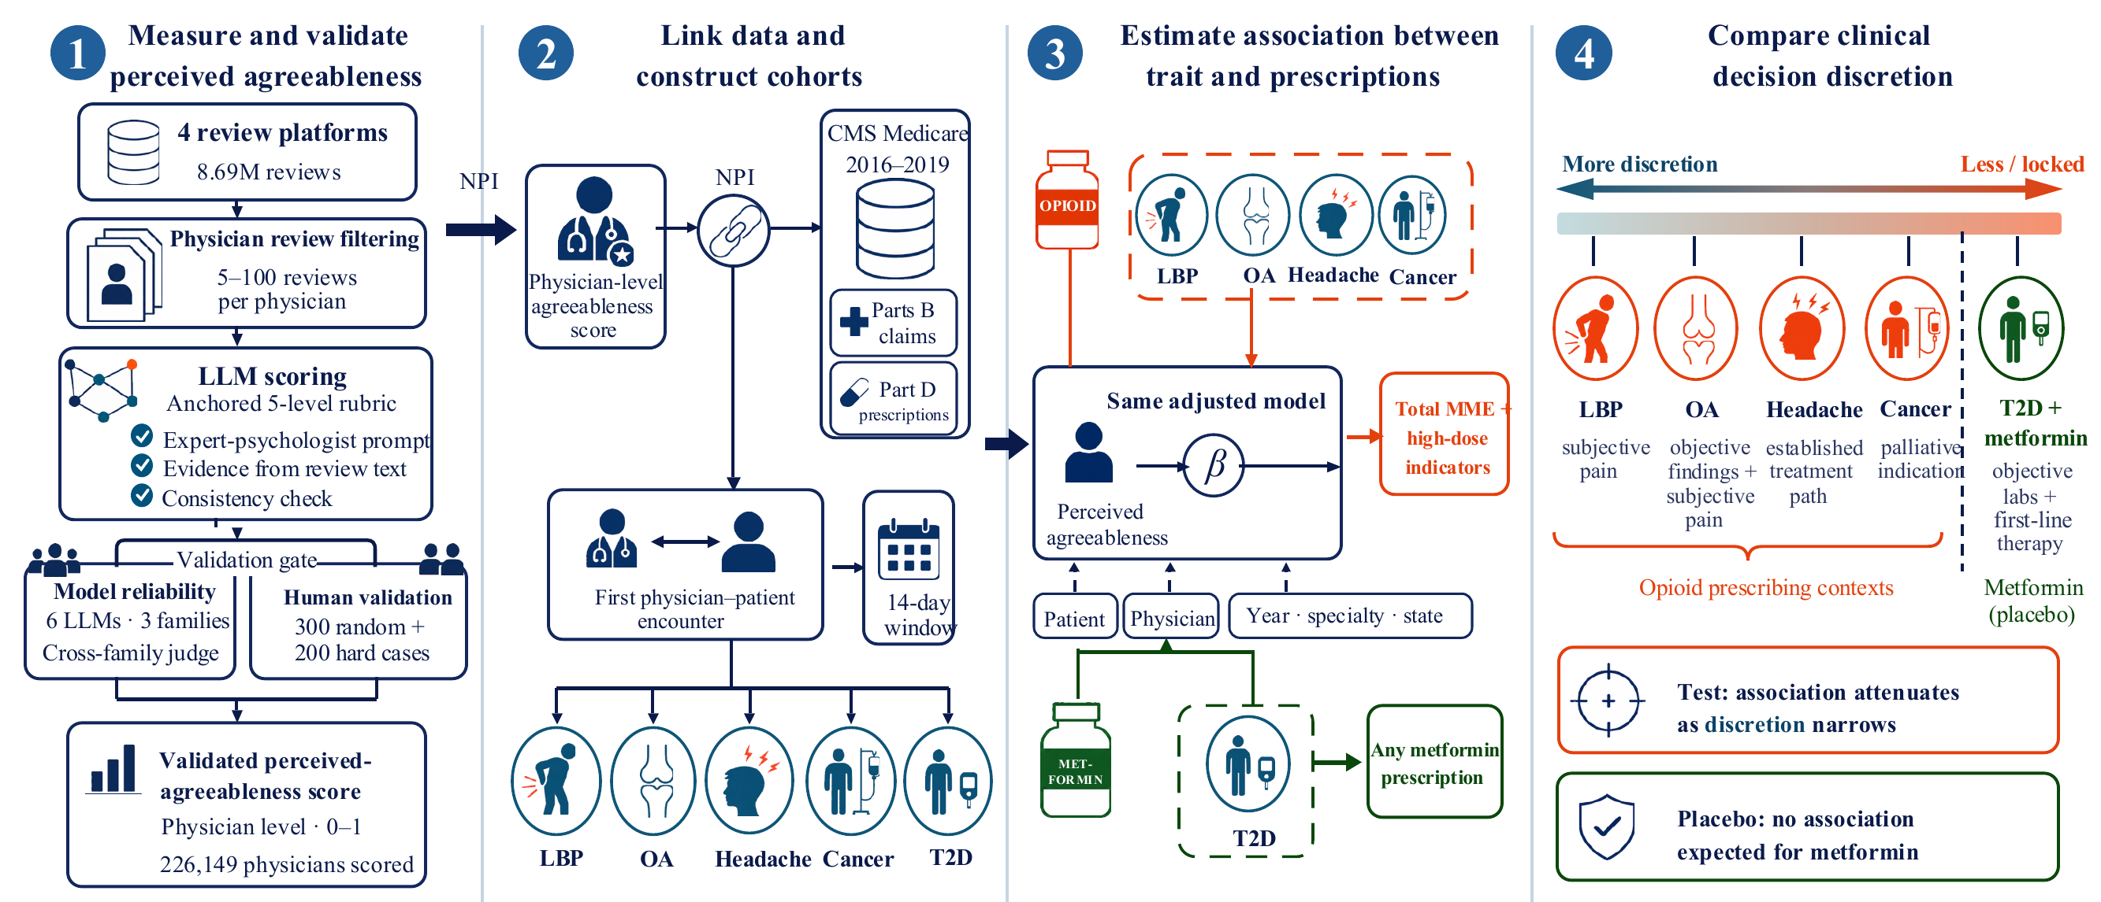
Figure 1. Research design. Perceived agreeableness is scored from patient reviews with an anchored five-level LLM rubric, validated against cross-model agreement and a human panel, then joined by NPI to Medicare claims. In each of five cohorts, the first physician-patient encounter opens a 14-day outcome window. One adjusted model (OLS, SPEC5 controls, clustered by NPI) is estimated per cohort, and the cohorts are ordered by clinical discretion to test whether the association attenuates as discretion narrows, with metformin as the placebo. The trait measure is adopted from prior work and enters as a cited enabler.

4.2 Measuring Perceived Agreeableness
Following the pipeline in [Authors 2025], we collected online reviews from four major U.S. physician rating platforms through 2021: Healthgrades, Vitals, RateMDs, and Yelp.
Among 1,141,176 physicians with MD/DO credentials in the NPPES registry (Centers for Medicare & Medicaid Services 2025), 587,562 received at least one review, for 8.69 million reviews in total (Wang et al. 2022).
We merged reviews across platforms with the National Provider Identifier (NPI) and combined each physician's review text into a single composite document.
We kept the 226,999 physicians with five to one hundred reviews, a range that gives enough text for reliable scoring without letting the highest-volume physicians dominate the sample.
This analytic sample covers about 20% of U.S. physicians, and we discuss its selection and generalizability in Section 5.
The full data collection protocol, preprocessing, and IRB approval appear in [Authors 2025].
Machine-learning inference of personality traits from text is an established measurement strategy (Schwartz et al. 2013; Youyou et al. 2015; Yang et al. 2023a).
Within IS, Big Five traits machine-inferred from review and social-media text already serve as research constructs (Liu et al. 2021; Adamopoulos et al. 2018), and large language models extend this measurement line (Peters et al. 2024; Hu et al. 2024).
We score perceived agreeableness with a large language model that reads each physician's aggregated reviews and rates agreeableness on a five-level anchored scale, from Low to High, with chain-of-thought reasoning (Wei et al. 2022).
The prompt casts the model as an expert psychologist and asks for a rating, two or three sentences of evidence quoted from the reviews, and a consistency assessment.
The evidence must describe the physician rather than the patient.
The full prompt template and scoring rubric appear in Appendix A.
To choose a production model, we benchmarked six LLMs from three families: Gemini-2.5 Pro, Flash, and Flash-Lite (Google), GPT-4.1 and GPT-4o (OpenAI), and Claude 3.7 Sonnet (Anthropic).
Claude Opus 4.7 served as the cross-family judge, so that no candidate model judged itself (Zheng et al. 2023).
We selected Gemini-2.5 Flash and applied it to all 226,999 physicians in range: its cross-model agreement of 0.095 MAE sits just behind the pricier Gemini-2.5 Pro at 0.085, so the cheaper model tracks the panel almost as closely.
Each review-level score maps to a 0-1 scale, and we average across a physician's reviews to form the physician-level score.
Panel 1 of Figure 1 summarizes this scoring workflow, from a physician's aggregated review text through the anchored five-level rating to the physician-level score.
Agreeableness links directly to prescribing through the accommodation pathway in Section 3.
After normalization, agreeableness scores take five levels: 0, 0.25, 0.50, 0.75, and 1.0.
We construct a binary indicator, HighAgreeableness, equal to 1 when a physician's score is at least 0.75.
This cutoff is the Moderate-to-High boundary on the original scale, and it labels about 49% of the low back pain sample as high-agreeableness.
The binary form suits the instrumental-variable estimation in Section 6 and keeps interpretation simple, since each coefficient is the outcome gap between high- and low-agreeableness physicians.
We use the continuous five-level score for robustness checks.

4.3 Scoring Results
Scoring succeeded for 226,149 of the 226,999 physicians in range; the remaining 850 lacked a usable score.
The population distribution is polarized rather than bell-shaped.
The maximum level holds 43.0% of scored physicians, the two lowest levels together hold 35.7%, and the mean score is 0.61.
Just over half of scored physicians (53.9%) clear the high-agreeableness threshold of 0.75.
Table 1 reports the full five-level distribution and descriptive statistics.
Table 1. Distribution of LLM-scored agreeableness across the scored physician population. The distribution is polarized rather than bell-shaped, with most of the mass at the top of the scale. Scored physicians are those meeting the review-count filter, not the full registry.
Panel A: Agreeableness Score Distribution (N = 226,149 physicians)
Level | Score | N | Share
Low | 0.00 | 37,829 | 16.7%
Low-to-Moderate | 0.25 | 42,877 | 19.0%
Moderate | 0.50 | 23,483 | 10.4%
Moderate-to-High | 0.75 | 24,720 | 10.9%
High | 1.00 | 97,240 | 43.0%
Mean (SD) |  | 0.611 (0.394)
≥q 0.75 (HighAgreeableness) |  | 53.9%
Panel B: Sample Characteristics
Characteristic |  | N | Share
Male |  | 158,359 | 70.0%
Female |  | 67,790 | 30.0%
Reviews per physician |  | median 10 (IQR: 7–18)
Panel C: Mean Score by Subgroup
Subgroup | N | Mean | ≥q 0.75
Overall | 226,149 | 0.611 | 53.9%
Male | 158,359 | 0.615 | 54.4%
Female | 67,790 | 0.603 | 52.8%
Family Medicine | 34,929 | 0.640 | 57.1%
Internal Medicine | 32,302 | 0.636 | 56.8%
Obstetrics & Gynecology | 15,936 | 0.599 | 52.4%
Orthopaedic Surgery | 12,383 | 0.598 | 51.7%
Specialist | 10,332 | 0.556 | 47.2%

The continuous five-level score gives similar results in robustness checks.

4.4 Validation
The validation question is whether LLM-derived scores approximate what patients perceive.
It is not whether they recover a physician's true personality, which review text cannot reveal.
Measuring the perceived trait is a deliberate scope choice: how others perceive a person is itself a valid and informative object of trait judgment [CITATION OWED].
We answer the question two ways, through cross-model reliability and through human validation.
Both follow the three-layer framework in [Authors 2025], which separates LLM-derived traits, patient-perceived traits, and a physician's real personality, and we test alignment between the first two.
IS research on text-inferred traits draws the same distinction between the machine-inferred construct and the underlying attribute it proxies (Liu et al. 2021; Yang et al. 2023a).
Six LLMs independently rated the same reviews for a 1,197-physician pool.
Their agreeableness scores converge to a mean absolute error of 0.095, and the top models fall within 0.03 MAE of one another.
This convergence shows the agreeableness signal does not depend on any single model's architecture.
Table 2 summarizes the validation evidence for all six models, pairing each model's cross-model agreement with its agreement against the two human panels.
Table 2. Validation of the agreeableness measure: cross-model reliability across six candidate LLMs and agreement with human raters. Per-model and per-trait detail is in Appendix B.
Model | Cross-Model MAE | Human Panel MAE | Hard-Case MAE
 | (n = 1,197) | (n = 300) | (n = 200)
Gemini-2.5 Pro | 0.085 | 0.185 | 0.207
Gemini-2.5 Flash | 0.095 | 0.180 | 0.244
GPT-4.1 | 0.110 | 0.149 | 0.386
Claude 3.7 Sonnet | 0.104 | 0.158 | 0.230
GPT-4o | 0.126 | 0.155 | 0.279
Gemini-2.5 Flash-Lite | 0.131 | 0.184 | 0.310

Full cross-model comparison tables appear in Appendix B.
To test whether the LLM matches human perception, we compare its scores against trained human raters who read and scored the same reviews independently.
Benchmarking machine annotation against independent human raters is the standard validation design for text-derived measures [CITATION OWED].
The raters scored a random sample of 300 physicians and formed their assessments before seeing any LLM output.
On this panel, all six LLMs fall within an MAE band of 0.149 to 0.185 against the human raters, matching or exceeding the agreement among the raters themselves.
An additional 200 hard cases, drawn from the physicians where the six models agreed least, test whether the alignment holds where the models disagree most.
The full protocol and reliability statistics follow [Authors 2025] and appear in Appendix B.
The measurement reflects how patients perceive the physician, not the physician's objective personality, and this follows from how the scores are built.
The scores come from review text written by patients, not from physician self-report, so they avoid the social-desirability bias of professional self-assessment [CITATION OWED].
Observer reports of personality also converge with self-reports and can exceed them in predicting behavior (Connelly and Ones 2010).
Averaging many reviews per physician cancels the quirks of any single patient encounter.
Because the model must quote the review text behind each rating, a human can check whether the score is grounded in what patients actually wrote.
Patient perception is also the construct the accommodation theory needs, since the mechanism in Section 3 runs through how patients experience the physician's manner.
Together, the cross-model and human evaluations establish that LLM-derived agreeableness aligns with what patients perceive.
Independent models agree with one another, and they agree with trained human raters.
Perceived agreeableness and the overall star rating both come from the same review text, so the two are correlated.
A discriminant analysis separating the trait from generic review positivity is reported in Appendix B.
Section 6 then provides predictive validity, testing whether agreeableness scores predict opioid prescribing in Medicare claims, an independent behavior recorded outside the review text.

References
Adamopoulos, P., Ghose, A., and Todri, V. 2018. "The impact of user personality traits on word of mouth: Text-mining social media platforms," Information Systems Research (29:3), pp. 612–640.
Centers for Medicare & Medicaid Services 2025. "National Plan and Provider Enumeration System (NPPES)," https://nppes.cms.hhs.gov/, accessed: 2025-09-07.
Connelly, B. S., and Ones, D. S. 2010. "An other perspective on personality: meta-analytic integration of observers' accuracy and predictive validity." Psychological bulletin (136:6), p. 1092.
Hu, L., He, H., Wang, D., Zhao, Z., Shao, Y., and Nie, L. 2024. "Llm vs small model? large language model based text augmentation enhanced personality detection model," in Proceedings of the AAAI Conference on Artificial Intelligence, vol. 38, , vol. 38.
Liu, A. X., Li, Y., and Xu, S. X. 2021. "Assessing the unacquainted: Inferred reviewer personality and review helpfulness," MIS quarterly (45:3), pp. 1113–1148.
Peters, H., Cerf, M., and Matz, S. C. 2024. "Large language models can infer personality from free-form user interactions," arXiv preprint arXiv:240513052 .
Schwartz, H. A., Eichstaedt, J. C., Kern, M. L., Dziurzynski, L., Ramones, S. M., Agrawal, M., Shah, A., Kosinski, M., Stillwell, D., Seligman, M. E., et al. 2013. "Personality, gender, and age in the language of social media: The open-vocabulary approach," PloS ONE (8:9), p. e73,791.
Wang, W., Luo, J., Dugas, M., Gao, G. G., Agarwal, R., and Werner, R. M. 2022. "Recency of online physician ratings," JAMA Internal Medicine (182:8), pp. 881–883.
Wei, J., Wang, X., Schuurmans, D., Bosma, M., Xia, F., Chi, E., Le, Q. V., Zhou, D., et al. 2022. "Chain-of-thought prompting elicits reasoning in large language models," Advances in neural information processing systems (35), pp. 24,824–24,837.
Yang, K., Lau, R. Y., and Abbasi, A. 2023a. "Getting personal: A deep learning artifact for text-based measurement of personality," Information Systems Research (34:1), pp. 194–222.
Youyou, W., Kosinski, M., and Stillwell, D. 2015. "Computer-based personality judgments are more accurate than those made by humans," Proceedings of the National Academy of Sciences (112:4), pp. 1036–1040.
Zheng, L., Chiang, W.-L., Sheng, Y., Zhuang, S., Wu, Z., Zhuang, Y., Lin, Z., Li, Z., Li, D., Xing, E., et al. 2023. "Judging llm-as-a-judge with mt-bench and chatbot arena," Advances in neural information processing systems (36), pp. 46,595–46,623.

