1 · The contract, adopted and not forked
The plugin's full tree: one display/ per page, one folder per unit, every unit the same shape. The layout above is display-unit-output-contract.md, quoted rather than redesigned. intake/ and recipe/ are primary material a person rules; assets/ and preview.pdf are derived and a rebuild may overwrite them. The one page-side change is the address: the unit root is the page's own display/ folder, so the unit travels with the page it illustrates.

2 · The surface: one card per unit in the right pane
The tab: what a reader sees when they open 🖼 Display on a page. The tab is the Slides sandwich with a different filling: a drawer plugin posts to a live/ endpoint, the endpoint lists the page's units, and the pane frames each preview.pdf through the PDF object path src/body.py already renders. 🔄 rebuild runs the unit's recipe and refreshes the derived half; it never touches intake/ and never touches an acceptance row. A unit is EVIDENCE the content cites, and the citation lives IN the sentence: the unit's id named in prose chips as the evidence card in place, carrying its acceptance state and linking its block in the strip. The > Display: lane beside > Citation: and > Value: stays the FILING surface: a machine appending evidence writes a lane and never edits prose, and a binding no sentence carries naturally lands there. Either surface naming a ⬜ unit binds a pending render, not accepted evidence. The projections inherit the citation (JL 260816): the latex export embeds a cited unit as a real float after the citing paragraph, built from the winning asset and the unit's own caption, and the word export embeds the rasterized figure with an inline figure number and a 🖼 Display comment on the sentence.

3 · The writers, and the row no machine may tick
Who writes what: three hands on one unit, each confined to its half. The renderers are the display family's existing skills, dispatched the way task-for-display already dispatches them; this page adds no renderer. Acceptance follows the model the slide plugin already borrowed: a ✅ means a person looked at a specific render and said yes, so a machine that ticks one has forged a judgment, not saved time. The four renderers: which skill draws which kind, and what each one's recipe is. A data-driven renderer may not recompute from raw data; it reads the approved extract in intake/ and nothing else. A concept-driven renderer carries no numbers, so its intake is the spec it draws. The rebuild differs the same way: a figure rebuild reruns its python script, a diagram rebuild is deterministic from its spec, and an illustration rebuild replays a receipted prompt.

4 · How a unit is generated
The pipeline: five steps from approved numbers to an accepted render, and who moves each one. The pipeline never starts at ②: a renderer given no ruled intake/ has nothing provenance-bound to draw, which is what display-intake-contract.md exists to refuse. Steps ① ③ ⑤ are a person's and steps ② ④ are machinery, the split of hands QPf5-Display1 (Figure 1) draws; 🔄 rebuild on the tab is step ④ alone, rerun.
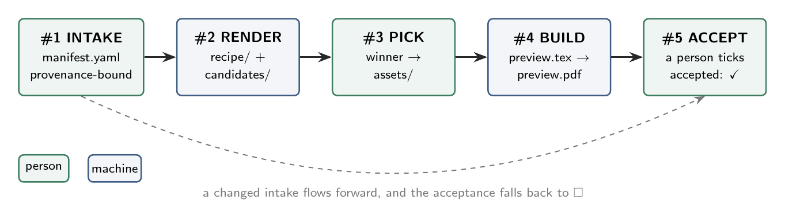
Figure 1. The display pipeline: five steps from approved intake to an accepted render. Green steps belong to a person, blue steps to machinery, and a changed intake returns the acceptance to open.
A changed intake/ flows forward, ② to ⑤, and the acceptance falls back to ⬜ because the bytes a person said yes to are gone. Where ①'s numbers come from: the evidence chain behind an intake, id-bound at every hop. intake/ is not a second data store: the task output stays canonical, and the manifest points back at the exact holder and run that produced it. A unit names its evidence by id, never by path, and never types a number; QPf5-Display2 (Figure 2) draws this ask-once-cite-twice move.
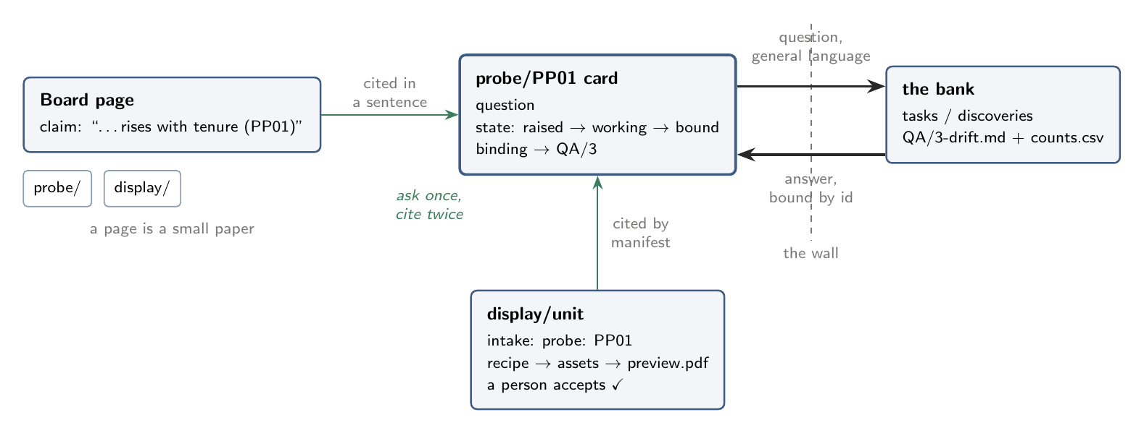
Figure 2. A page as a small paper: the probe plugin asks a question once, the bank answers behind the wall, and both the display intake and the page's own sentence cite the same card by id.
The slide plugin already walks this chain on QPf3: its deck declares needs: QA-probe/QBt5-for-value/1-artifact-paths, the resolver turns the id into the artifact's path, and the template carries no digits, so a hand-typed value has nowhere to live. A1's adapter is what makes the same id resolution work for a unit under a page.

