The first unified View specimen

1 · QA inputs
The incoming side: one View may bind one or several answered Probes, and those Probes may come from one or several Task QA-banks.
QA-bank ─▶ answered Probe ─┐
QA-bank ─▶ answered Probe ─┼─▶ View input collection
QA-bank ─▶ answered Probe ─┘
This specimen imports three answered QA Probes: a literature definition, a project-observable signal, and a construct boundary.
Evidence card. Card three answered QA Probes: QI1 · QA input · Bindings: QBt-page-types/views/QBt1-for-view/input/QA-probes/1-canonical-definition.md, QBt-page-types/views/QBt1-for-view/input/QA-probes/2-observable-signal.md, QBt-page-types/views/QBt1-for-view/input/QA-probes/3-measurement-boundary.md. Status: answered. Role: supply the material organized by this View.
The value Probe resolves the checked count through its task QA-bank answer rather than ending at a copied number.
Evidence card. Card task QA-bank answer: QI2 · QA bank · Binding: tasks/QV1-agreeableness/QA/1-bound-source-count.md. Consumer question: Q-View-1. Status: answered.
The current View binds 3 source Probe records [Q-View-1].
The Probe records remain the full answers; the View body selects and organizes what a person needs to read.

2 · View body
The readable middle: topic-specific subsections hold the actual substance, while Cards attach provenance and relationships to exact words.
readable sentence + exact-span Card ─▶ inspect evidence without leaving the body

2.1 · Trait meaning
Agreeableness is an interpersonal trait expressed through warmth and cooperation.
Evidence card. Card interpersonal trait: EC1 · Literature · Finding: agreeableness is treated as an interpersonal construct. Bearing: supports. Boundary: trait description only. Binding: QBt-page-types/views/QBt1-for-view/input/QA-probes/1-canonical-definition.md. Freshness: current. Used by: QBt1-Display1 QBt1-Display2.
Evidence card. Card warmth and cooperation: EC2 · Literature · Finding: warmth and cooperation are the facets selected for this specimen. Bearing: supports. Boundary: illustrative, not exhaustive. Binding: QBt-page-types/views/QBt1-for-view/input/QA-probes/1-canonical-definition.md. Freshness: current. Used by: QBt1-Display1 QBt1-Display2.
The literature-side construct frame resolves through the real bibliography (John et al., 1999).

2.2 · Observable project signal
Review text records patient descriptions of patient-facing behavior, so this View treats review-derived scores as patient-perceived signals.
Evidence card. Card patient-perceived signals: EC3 · Value · Finding: the project observes descriptions and evaluations of behavior. Bearing: qualifies. Boundary: observed signal, not direct latent trait. Binding: QBt-page-types/views/QBt1-for-view/input/QA-probes/2-observable-signal.md. Freshness: current. Used by: QBt1-Display1 QBt1-Display2.

2.3 · Measurement boundary
The score is not treated as an error-free measure of latent personality.
Evidence card. Card not treated as an error-free measure of latent personality: EC4 · Construct · Finding: the current evidence does not justify direct latent-personality measurement. Bearing: bounds this specimen. Boundary: patient-perceived manifestation only. Binding: QBt-page-types/views/QBt1-for-view/input/QA-probes/3-measurement-boundary.md. Freshness: current. Used by: QBt1-Display1 QBt1-Display2.
The body is not a hidden evidence ledger.
It is the human-readable synthesis produced from the inputs; Citation, Value, and other Evidence Cards let the reader inspect why each exact phrase is present.

3 · Displays
The visible outputs: a View produces one or several Displays only when a visual or tabular form helps a reader inspect or reuse part of the body.
QBt1-Display1 is the trait-description table. Its current raster is embedded below; click QBt1-Display1 and the same preview appears first, before its View-body bindings, files, and independent acceptance state.
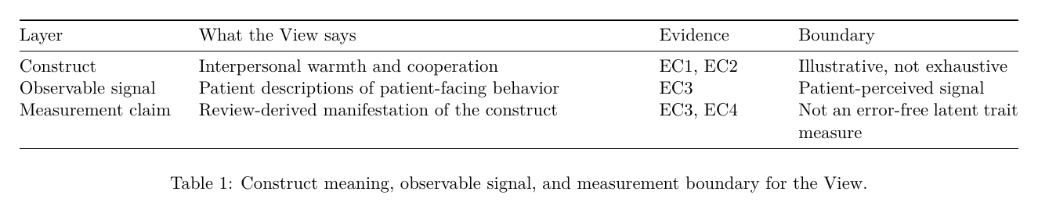
QBt1-Display2 is the two-panel illustration. Its current raster is embedded below; click QBt1-Display2 and the same preview appears first, before its panel bindings, files, and independent acceptance state.
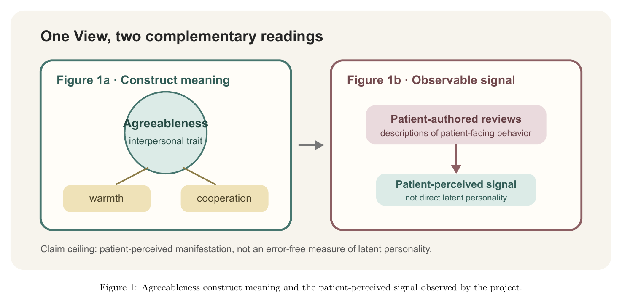
Each output also carries preview.pdf as the printable inspection surface. PNG is shown inline because it renders reliably in the Board browser; PDF remains linked in the Card at full fidelity.
Each authored output folder is also a complete generic renderer unit. output.md owns the View-level semantic judgment; intake/ binds approved evidence or context; recipe/ records reproducibility; candidates/, assets/, and versions/ separate alternatives, the winner, and history. No second Display adapter folder is created.
The two Displays remain separate because a person can inspect and accept them independently.
They remain inside one View because both are outputs selected from the same named View body.
QBt1-Display1 and QBt1-Display2 are the only required outputs in this specimen; prose packs and evidence ledgers are optional outputs, not universal folders.

4 · Consumers
The outgoing side: consumers may link to the whole View or to selected Displays, and the View exposes that relationship before handoff.
View ─▶ whole-View consumer
└──▶ QBt1-Display1/2 consumer + placement + gate state
The Main Results section plans to consume QBt1-Display1 for its construct-interpretation passage.
Evidence card. Card Main Results section: C1 · Consumer · Target Page: S-Main-4 · Binding: QBt-page-types/consumer/S-Main-4-results.md. Uses: QBt1-Display1. Placement: Results / construct interpretation. Status: planned, blocked on View and Display acceptance.
Other legal consumers include Appendix sections, Narrative pages, reports, and applications.
A consumer may still reach a Probe directly when its own contract allows it; the View route is the normal human-readable handoff, not a ban on every direct link.

References
John, Oliver P.; Srivastava, Sanjay (1999). The Big-Five Trait Taxonomy: History, Measurement, and Theoretical Perspectives. Handbook of Personality: Theory and Research

