Agreeableness evidence specimen (QY2 skill-forward validation)

1 · QA inputs
Input bindings: two answered Probes copied locally into this View's own
input/QA-probes/ folder.
input/QA-probes/1-canonical-definition.md → canonical trait meaning
input/QA-probes/2-observable-signal.md → observable signal + bound source count
This View imports two answered QA Probes, both copied (not moved, not edited)
from the QBt1 specimen's own input folder for this skill-validation exercise.
Evidence card. Card two answered QA Probes: QI1 · QA input · Bindings: views/QY2-for-view/input/QA-probes/1-canonical-definition.md, views/QY2-for-view/input/QA-probes/2-observable-signal.md. Status: answered. Role: supply the material organized by this View.

2 · View body
Readable body: the topic-specific material a person should understand before
opening any Card.

2.1 · Trait meaning
Agreeableness is an interpersonal trait expressed through warmth and cooperation.
Evidence card. Card interpersonal trait: EC1 · Literature · Finding: agreeableness is treated as an interpersonal construct. Bearing: supports. Boundary: trait description only. Binding: views/QY2-for-view/input/QA-probes/1-canonical-definition.md. Freshness: current. Used by: QY2-Display1.
The literature-side construct frame resolves through the real bibliography (John et al., 1999).

2.2 · Observable project signal
Review text records patient descriptions of patient-facing behavior, and the
current View binds 3 source Probe records into one evidence judgment, so this
View treats review-derived scores as patient-perceived signals rather than an
error-free latent trait measure.
Evidence card. Card 3 source Probe records: EC2 · Value · Finding: the project observes descriptions and evaluations of behavior across 3 bound source records. Bearing: qualifies. Boundary: observed signal, not direct latent trait. Binding: views/QY2-for-view/input/QA-probes/2-observable-signal.md. Freshness: current. Used by: QY2-Display1.
The body is not a hidden evidence ledger. It is the human-readable synthesis
produced from the two inputs above; the Citation and Value Cards let a reader
inspect why each exact phrase is present.

3 · Displays
Display outputs: one rendered table selects and compares both View-body
findings.
QY2-Display1 is the agreeableness evidence table. Its current raster is embedded
below; opening QY2-Display1 shows the same preview first, before its View-body
bindings, files, and independent acceptance state.
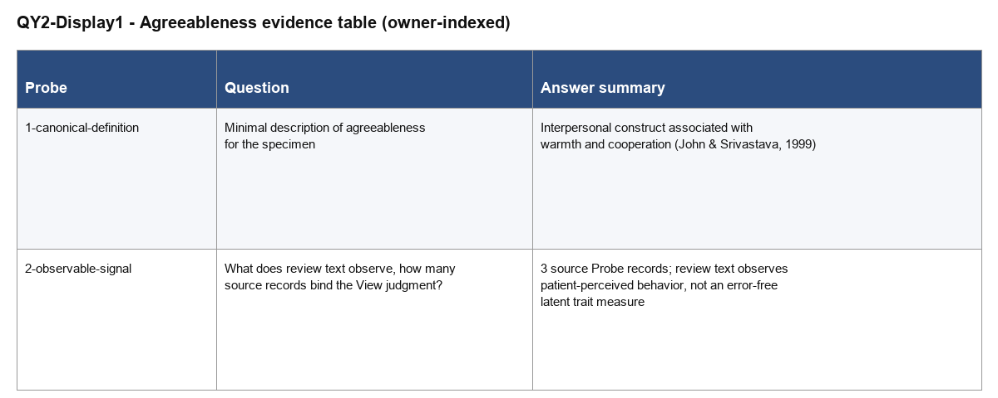
Evidence card. Card QY2-Display1: D1 · Display · kind: table · reader job: compare the canonical trait definition and the observable project signal. Bindings: EC1, EC2. Binding: views/QY2-for-view/output/QY2-Display1-agreeableness-evidence-table/output.md. Status: rendered. Acceptance: waiting.
preview.pdf is the printable inspection surface for the same table; it sits
alongside preview.png in the same Display folder.

4 · Consumers
Consumer bindings: one local Results-section stand-in inside the QY2 sandbox
plans to use QY2-Display1.
The Results section plans to consume QY2-Display1 for its construct-interpretation passage.
Evidence card. Card Results section: C1 · Consumer · Target Page: S-Results · Binding: consumers/S-Results.md. Uses: QY2-Display1. Placement: Results / construct interpretation. Status: planned, blocked on View and Display acceptance.

References
John, Oliver P.; Srivastava, Sanjay (1999). The Big-Five Trait Taxonomy: History, Measurement, and Theoretical Perspectives. Handbook of Personality: Theory and Research

