The second unified View regression: two probes, one table, one local consumer

1 · QA inputs
The incoming side: this View binds two of QBt1's three answered Probes, reused by path into its own input/QA-probes/ copy.
QA-bank ─▶ answered Probe (definition) ─┐
QA-bank ─▶ answered Probe (boundary) ─┴─▶ QY3 input collection
This View imports two answered QA Probes: the canonical trait definition and the measurement boundary.
Evidence card. Card two answered QA Probes: QI1 · QA input · Bindings: views/QY3-for-view/input/QA-probes/1-canonical-definition.md, views/QY3-for-view/input/QA-probes/3-measurement-boundary.md. Status: answered. Role: supply the material organized by this View.
The observable-signal Probe is deliberately excluded from this regression; only construct meaning and measurement boundary carry through to the Display.

2 · View body
The readable middle: two short subsections hold the actual substance, while Cards attach provenance to exact words.
readable sentence + exact-span Card ─▶ inspect evidence without leaving the body

2.1 · Trait meaning
Agreeableness is an interpersonal trait expressed through warmth and cooperation.
Evidence card. Card interpersonal trait: EC1 · Literature · Finding: agreeableness is treated as an interpersonal construct. Bearing: supports. Boundary: trait description only. Binding: views/QY3-for-view/input/QA-probes/1-canonical-definition.md. Freshness: current. Used by: QY3-Display1.
The literature-side construct frame resolves through the real bibliography (John et al., 1999).

2.2 · Measurement boundary
The score is not treated as an error-free measure of latent personality.
Evidence card. Card not treated as an error-free measure of latent personality: EC2 · Construct · Finding: the current evidence does not justify direct latent-personality measurement. Bearing: bounds this specimen. Boundary: patient-perceived manifestation only. Binding: views/QY3-for-view/input/QA-probes/3-measurement-boundary.md. Freshness: current. Used by: QY3-Display1.
The body stays a human-readable synthesis; the two Evidence Cards let a reader inspect why each exact phrase is present.

3 · Displays
The visible output: QY3-Display1 is the trait-boundary table. Its current raster is embedded below; the same preview appears first in its Display Card, before its bindings, files, and acceptance state.
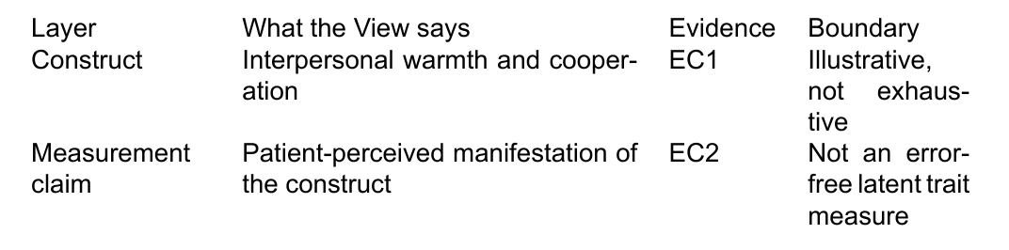
Evidence card. Card QY3-Display1: QY3-Display1 · Display · Binding: views/QY3-for-view/output/QY3-Display1-trait-boundary-table/output.md. Kind: table. Reader job: separate construct meaning from the measurement boundary the two bound Probes support. View-body bindings: EC1, EC2. Status: rendered. Acceptance: waiting. Files: views/QY3-for-view/output/QY3-Display1-trait-boundary-table/preview.png, views/QY3-for-view/output/QY3-Display1-trait-boundary-table/preview.pdf, views/QY3-for-view/output/QY3-Display1-trait-boundary-table/float.tex.
preview.pdf is the printable inspection surface for the same table; float.tex is the printable wrapper the review build embeds.

4 · Consumers
The outgoing side: this regression hands off to one local consumer Page instead of a shared QS-consumers Page, so the run stays self-contained.
View ─▶ QY3-Display1 consumer + placement + gate state
The local boundary note plans to consume QY3-Display1 for its construct-boundary passage.
Evidence card. Card local boundary note: C1 · Consumer · Target Page: QY3-Consumer-boundary-note · Binding: consumers/QY3-Consumer-boundary-note.md. Uses: QY3-Display1. Placement: Local regression consumer / construct-boundary passage. Status: planned, blocked on View and Display acceptance.

References
John, Oliver P.; Srivastava, Sanjay (1999). The Big-Five Trait Taxonomy: History, Measurement, and Theoretical Perspectives. Handbook of Personality: Theory and Research

