Measurement-boundary regression

1 · QA inputs
Two answered Probe records define the observable signal and its measurement boundary.
Evidence card. Card two answered Probe records: QI1 · QA input · Bindings: input/QA-probes/Q1-observable-signal.md, input/QA-probes/Q2-measurement-boundary.md. Status: answered.

2 · View body

2.1 · Observable signal
The source describes patient-perceived behavior rather than direct access to a latent trait (John et al., 1999).
Evidence card. Card patient-perceived behavior: EC1 · Value · Finding: observed descriptions are the signal. Binding: input/QA-probes/Q1-observable-signal.md. Freshness: current.

2.2 · Measurement boundary
The interpretation must preserve the distinction between an observed description and an error-free latent measure.
Evidence card. Card distinction: EC2 · Construct · Finding: direct latent measurement is not established. Binding: input/QA-probes/Q2-measurement-boundary.md. Freshness: current.

3 · Displays
QY4-Display1 turns EC1 and EC2 into one inspection table while retaining independent acceptance.
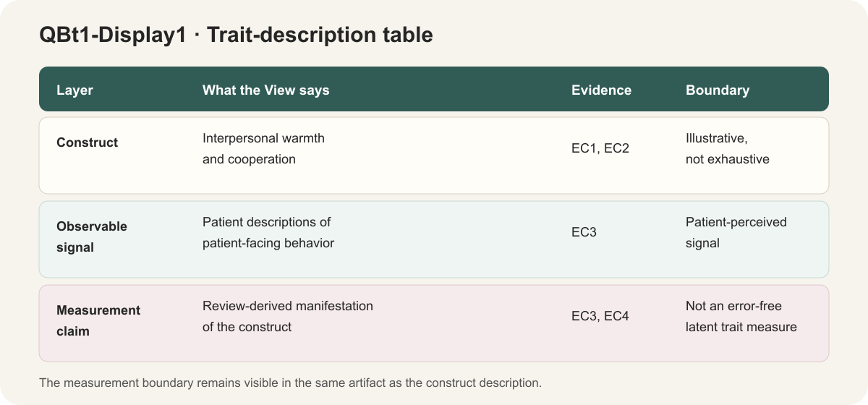

4 · Consumers
The local Results consumer plans to use QY4-Display1 after human acceptance.
Evidence card. Card local Results consumer: C1 · Consumer · Target: consumers/S-Results.md. Uses: QY4-Display1. Placement: Results / construct boundary. Status: planned.

References
John, Oliver P.; Srivastava, Sanjay (1999). The Big-Five Trait Taxonomy: History, Measurement, and Theoretical Perspectives. Handbook of Personality: Theory and Research

