一 redis集群

１，基础

－－集群工作原理

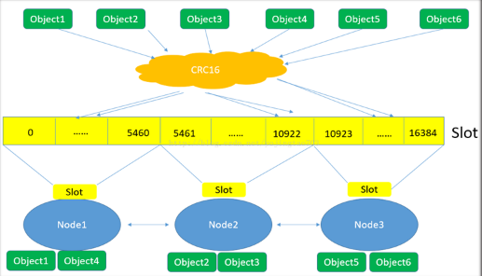

２，

参数名--->crc16--->数字--->%16384 -->数字 --> (0~16384)

Redis-trib.rb create --replicas 1 host:port host:port .....

--replicas 1 :每个master节点分配一个slave节点

提示：主库的个数不能少于3台

[root@mysql-51 jluo]# redis-trib.rb create --replicas 1 \

> 192.168.4.51:6351 192.168.4.52:6352 192.168.4.53:6353 \

> 192.168.4.54:6354 192.168.4.55:6355 192.168.4.56:6356

[OK] All 16384 slots covered.

测试：

测试一

[root@mysql-50 ~]# redis-cli -c -h 192.168.4.51 -p 6351

192.168.4.51:6351> set x 101

-> Redirected to slot [16287] located at 192.168.4.53:6353

OK

53主库：

[root@mysql-53 jluo]# redis-cli -p 6353 -h 192.168.4.53

192.168.4.53:6353> keys \*

1) "x"

192.168.4.53:6353> get x

"101"

53的54从库

[root@mysql-54 jluo]# redis-cli -p 6354 -h 192.168.4.54

192.168.4.54:6354> keys \*

1) "x"

192.168.4.54:6354> get x

(error) MOVED 16287 192.168.4.53:6353

测试二：

[root@mysql-50 ~]# redis-cli -c -h 192.168.4.51 -p 6351

192.168.4.51:6351> set x 101

-> Redirected to slot [16287] located at 192.168.4.53:6353

OK

192.168.4.53:6353> set y 102

OK

192.168.4.53:6353> set z 103

-> Redirected to slot [8157] located at 192.168.4.52:6352

OK

192.168.4.52:6352> keys \*

1) "z"

192.168.4.52:6352> get x

-> Redirected to slot [16287] located at 192.168.4.53:6353

"101"

二

Redis集群什么情况不能访问？