Performance Test Report

Name | A | B
Date | Oct 4, 2021, 10:54:50 AM | Oct 4, 2021, 10:43:55 AM
Project | GenDemos_2021 | GenDemos_2021
Scenario | JPetStore | JPetStore
Comment
Notes

Summary
Results summary
 | A | B
Project | GenDemos_2021 | GenDemos_2021
Scenario | JPetStore | JPetStore
Name | JPetstore-QTest - 10:54 - 4 Oct 2021 | JPetStore-Qtest 10:43 - 4 Oct 2021
Description
NeoLoad Web | https://neoload.saas.neotys.com/#!result/77ff58d4-689d-4026-9b4f-b8e7eb6f6ab2/overview | https://neoload.saas.neotys.com/#!result/8932b525-1f10-404e-98e9-8738a8a0fc2c/overview
External URL | https://neoload.qtestnet.com/p/101280/portal/project#tab=testexecution&object=3&id=115348705
Status | Failed | Failed
Start date | Oct 4, 2021, 10:54:50 AM | Oct 4, 2021, 10:43:55 AM
End date | Oct 4, 2021, 10:57:12 AM | Oct 4, 2021, 10:46:16 AM
Duration | 00:02:21 | 00:02:21
Termination reason | Execution policy | Execution policy
Load Policy | • The population JPetStore is constant with 4 users for 1 iteration(s). | • The population JPetStore is constant with 6 users for 1 iteration(s).
LG Hosts | l​o​c​a​l​h​o​s​t​:​7​1​0​0​ | l​o​c​a​l​h​o​s​t​:​7​1​0​0​
Filters | None | None
Debug | Disabled | Disabled
Statistics Summary
 | A | B | %
Average pages/s | 0.4 | 0.6 | +50%
Average requests/s | 1.3 | 1.9 | +46.2%
Total pages | 56 | 84 | +50%
Total requests | 184 | 274 | +48.9%
Average Request response time | 0.105 s | 0.128 s | +21.9%
Total request errors | 0 | 3 | +INF
Error rate | 0 | 1.1 | +INF
Average Page response time | 0.194 s | 0.209 s | +7.7%
Total throughput | 0.66 MB | 1.2 MB | +81.8%
Average throughput | 0.04 Mb/s | 0.07 Mb/s | +75%
Total users launched | 4 | 6 | +50%
Total iterations completed | 4 | 6 | +50%
Total action errors | 0 | 0 | +0%
Alerts total duration | 0% | 0% | +0%

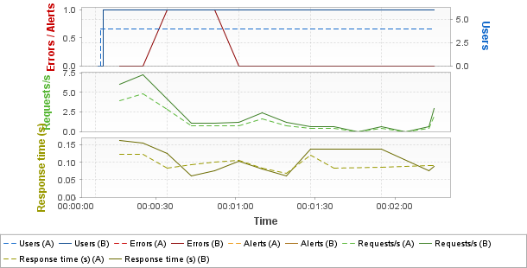
Hot spots
Top 3 errors
Greatest increases
Page Results | Count A | Count B | %
/jpetstore/shop/viewProduct.shtml | 0 | 1 | +INF
/jpetstore/shop/viewCategory.shtml | 0 | 1 | +INF
/jpetstore/shop/signon.shtml | 0 | 1 | +INF
Greatest decreases
Page Results | Count A | Count B | %
No errors on pages
Top 3 alerts
Greatest increases
Sev. | Alert Results | Duration % A | Duration % B | %
Empty list
Greatest decreases
Sev. | Alert Results | Duration % A | Duration % B | %
Empty list
Top 3 average response times (Pages)
Greatest increases
Page Results | Duration A | Duration B | %
/jpetstore/shop/signon.shtml | 0.178 | 0.321 | +80.3%
/jpetstore/shop/newOrder.shtml | 0.082 | 0.137 | +67.1%
/jpetstore/shop/index.shtml | 0.406 | 0.458 | +12.8%
Greatest decreases
Page Results | Duration A | Duration B | %
/jpetstore/shop/viewCategory.shtml | 0.185 | 0.111 | -40%
/jpetstore/shop/viewProduct.shtml | 0.201 | 0.138 | -31.3%
/jpetstore/shop/addItemToCart.shtml | 0.204 | 0.184 | -9.8%
Top 3 average response times (Push messages)
Greatest increases
Push messages results | Duration A | Duration B | %
Empty list
Greatest decreases
Push messages results | Duration A | Duration B | %
Empty list
Top 3 maximum response times (Pages)
Greatest increases
Page Results | Duration A | Duration B | %
/jpetstore/shop/signonForm.shtm...1953A535F34EA986C2F3 | 0.242 | 0.592 | +145%
/jpetstore/shop/signon.shtml | 0.219 | 0.478 | +118%
/jpetstore/shop/newOrder.shtml | 0.101 | 0.157 | +55.4%
Greatest decreases
Page Results | Duration A | Duration B | %
/jpetstore/shop/viewProduct.shtml | 0.228 | 0.162 | -28.9%
/jpetstore/shop/viewCategory.shtml | 0.234 | 0.171 | -26.9%
/jpetstore/shop/addItemToCart.shtml | 0.236 | 0.222 | -5.9%
Top 3 maximum response times (Push messages)
Greatest increases
Push messages results | Duration A | Duration B | %
Empty list
Greatest decreases
Push messages results | Duration A | Duration B | %
Empty list
Errors
Request errors
Error Type | Count A | Count B | % | Description
500 |  | 2 |  | Internal Server Error
Assertions |  | 1 |  | Validation of the response failed.
Total |  | 3 |  | Total error count.
Action errors
Error Type | Count A | Count B | % | Description
No errors
Alerts
Element | Critical A | Critical B | % | Warning A | Warning B | %
Enter | 0 | 0 | +0% | 0 | 0 | +0%
/jpetstore/ | 0 | 0 | +0% | 0 | 0 | +0%
Home | 0 | 0 | +0% | 0 | 0 | +0%
/jpetstore/shop/index.shtml | 0 |  |  | 0
Login | 0 | 0 | +0% | 0 | 0 | +0%
/jpetstore/shop/signonForm.shtml;jsessionid=1BE83382FB1B1953A535F34EA986C2F3 | 0 |  |  | 0
/jpetstore/shop/signonForm.shtml;jsessionid=1BE83382FB1B1953A535F34EA986C2F3 | 0 | 0 | +0% | 0 | 0 | +0%
/jpetstore/images/button_register_now.gif | 0 | 0 | +0% | 0 | 0 | +0%
/jpetstore/images/button_submit.gif | 0 | 0 | +0% | 0 | 0 | +0%
/jpetstore/shop/signon.shtml | 0 |  |  | 0
/jpetstore/shop/signon.shtml | 0 | 0 | +0% | 0 | 0 | +0%
/jpetstore/images/sign-out.gif | 0 | 0 | +0% | 0 | 0 | +0%
/jpetstore/images/banner_dogs.gif | 0 | 0 | +0% | 0 | 0 | +0%
/jpetstore/images/my_account.gif | 0 | 0 | +0% | 0 | 0 | +0%
Category | 0 | 0 | +0% | 0 | 0 | +0%
/jpetstore/shop/viewCategory.shtml | 0 |  |  | 0
/jpetstore/shop/viewCategory.shtml | 0 | 0 | +0% | 0 | 0 | +0%
/jpetstore/images/button_next.gif | 0 | 0 | +0% | 0 | 0 | +0%
Product | 0 | 0 | +0% | 0 | 0 | +0%
/jpetstore/shop/viewProduct.shtml | 0 |  |  | 0
/jpetstore/shop/viewProduct.shtml | 0 | 0 | +0% | 0 | 0 | +0%
/jpetstore/images/button_add_to_cart.gif | 0 | 0 | +0% | 0 | 0 | +0%
Item | 0 | 0 | +0% | 0 | 0 | +0%
/jpetstore/shop/viewItem.shtml | 0 |  |  | 0
/jpetstore/shop/viewItem.shtml | 0 | 0 | +0% | 0 | 0 | +0%
/jpetstore/images/dog2.gif | 0 | 0 | +0% | 0 | 0 | +0%
AddToCart | 0 | 0 | +0% | 0 | 0 | +0%
/jpetstore/shop/addItemToCart.shtml | 0 |  |  | 0
/jpetstore/shop/addItemToCart.shtml | 0 | 0 | +0% | 0 | 0 | +0%
/jpetstore/images/button_remove.gif | 0 | 0 | +0% | 0 | 0 | +0%
/jpetstore/images/button_update_cart.gif | 0 | 0 | +0% | 0 | 0 | +0%
/jpetstore/images/button_checkout.gif | 0 | 0 | +0% | 0 | 0 | +0%
ProceedToCheckout | 0 | 0 | +0% | 0 | 0 | +0%
/jpetstore/shop/checkout.shtml | 0 |  |  | 0
/jpetstore/shop/checkout.shtml | 0 | 0 | +0% | 0 | 0 | +0%
/jpetstore/images/button_continue.gif | 0 | 0 | +0% | 0 | 0 | +0%
Continue | 0 | 0 | +0% | 0 | 0 | +0%
/jpetstore/shop/newOrderForm.shtml | 0 |  |  | 0
/jpetstore/shop/newOrderForm.shtml | 0 | 0 | +0% | 0 | 0 | +0%
Submit | 0 | 0 | +0% | 0 | 0 | +0%
/jpetstore/shop/newOrder.shtml | 0 |  |  | 0
/jpetstore/shop/newOrder.shtml | 0 |  |  | 0
Confirm | 0 | 0 | +0% | 0 | 0 | +0%
/jpetstore/shop/newOrder.shtml | 0 |  |  | 0
/jpetstore/shop/newOrder.shtml | 0 | 0 | +0% | 0 | 0 | +0%
BackHome | 0 | 0 | +0% | 0 | 0 | +0%
/jpetstore/shop/index.shtml | 0 |  |  | 0
/jpetstore/shop/index.shtml | 0 | 0 | +0% | 0 | 0 | +0%
LogOut | 0 | 0 | +0% | 0 | 0 | +0%
/jpetstore/shop/signoff.shtml | 0 |  |  | 0
/jpetstore/shop/signoff.shtml | 0 | 0 | +0% | 0 | 0 | +0%
General statistics
Avg A | Avg B | Avg % | Max A | Max B | Max % | Err A | Err B | Err %
Empty list
Transaction statistics
Avg A | Avg B | Avg % | Max A | Max B | Max % | Err A | Err B | Err %
Empty list

Scenario A
Summary
Name | JPetstore-QTest - 10:54 - 4 Oct 2021 | Project | GenDemos_2021
Description |  | Scenario | JPetStore
External URL | https://neoload.qtestnet.com/p/101280/portal/project#tab=testexecution&object=3&id=115348705
Status | Failed | Load Policy | • The population JPetStore is constant with 4 users for 1 iteration(s).
Start date | Oct 4, 2021, 10:54:50 AM | Load Policy
End date | Oct 4, 2021, 10:57:12 AM | Stop Policy | • Population JPetStore: immediate.
Duration | 00:02:21 | Stop Policy | • Population JPetStore: immediate.
Termination reason | Execution policy | Filters | None
LG Hosts | l​o​c​a​l​h​o​s​t​:​7​1​0​0​ | Debug | Disabled
Populations
JPetStore
User Path | Percentage | WAN Emulation | Signal strength | Bandwidth ↑ | Latency ↑ | Packet loss % ↑ | Bandwidth ↓ | Latency ↓ | Packet loss % ↓ | Browser | Handle cookies | Connections | Handle cache
JPetstore | 100.0% | Unlimited |  | Unlimited | 0ms | 0% | Unlimited | 0ms | 0% | Recorded one | Yes | 6 | New user
User Paths
Name | Description | On failed assertion | On error | Think time | Thinktime range
JPetstore |  | Do nothing | Do nothing | From pages | 0%
Rendezvous
Enabled | Name | Policy | Value | Timeout
Empty list
SLA Profiles
JPetstore

Criteria Description | Operator | value | severity
Per Run - Average Request Response Time
When Average Request Response Time is greater than 6.0 sec., the Average Request Response Time severity is failed. | >= | 6.0
When Average Request Response Time is greater than 3.0 sec., the Average Request Response Time severity is warning. | >= | 3.0
Per Run - Average Page Response Time
When Average Page Response Time is greater than 8.0 sec., the Average Page Response Time severity is failed. | >= | 8.0
When Average Page Response Time is greater than 5.0 sec., the Average Page Response Time severity is warning. | >= | 5.0
Per Run - Average Transaction Response Time
When Average Transaction Response Time is greater than 9.0 sec., the Average Transaction Response Time severity is failed. | >= | 9.0
When Average Transaction Response Time is greater than 5.0 sec., the Average Transaction Response Time severity is warning. | >= | 5.0
Per Run - Percentile Transaction Response Time
When Percentile Transaction Response Time is greater than 9.0 sec., the Percentile Transaction Response Time severity is failed. | >= | 9.0
When Percentile Transaction Response Time is greater than 4.0 sec., the Percentile Transaction Response Time severity is warning. | >= | 4.0
Per Run - Average Requests per Second
When Average Requests per Second is less than 7.0 Elt/sec., the Average Requests per Second severity is warning. | <= | 7.0
When Average Requests per Second is less than 2.0 Elt/sec., the Average Requests per Second severity is failed. | <= | 2.0
Per Run - Average Throughput per Second
When Average Throughput per Second is less than 20.0 Mbit/sec., the Average Throughput per Second severity is failed. | <= | 20.0
When Average Throughput per Second is less than 50.0 Mbit/sec., the Average Throughput per Second severity is warning. | <= | 50.0
Per Run - Total Errors
When Total Errors is greater than 10.0 err., the Total Errors severity is failed. | >= | 10.0
When Total Errors is greater than 3.0 err., the Total Errors severity is warning. | >= | 3.0
Per Run - Total count
When Total count is greater than 10.0 Elt, the Total count severity is failed. | >= | 10.0
When Total count is greater than 5.0 Elt, the Total count severity is warning. | >= | 5.0
Per Run - Total Throughput
When Total Throughput is less than 2.0 MBytes, the Total Throughput severity is failed. | <= | 2.0
When Total Throughput is less than 10.0 MBytes, the Total Throughput severity is warning. | <= | 10.0
Per Run - Error Rate
When Error Rate is greater than 10.0 %, the Error Rate severity is failed. | >= | 10.0
When Error Rate is greater than 5.0 %, the Error Rate severity is warning. | >= | 5.0
Per Time Interval - Average Response Time
When Average Response Time is greater than 9.0 sec., the Average Response Time severity is failed. | >= | 9.0
When Average Response Time is greater than 5.0 sec., the Average Response Time severity is warning. | >= | 5.0
Per Time Interval - Average Elements per Second
Per Time Interval - Average Throughput per Second
Per Time Interval - Errors per Second
Per Time Interval - Error Rate

= No SLA | = Passed | = Warning | = Failed
JPetstore

Criteria Description | Operator | value | severity
Per Run - Average Request Response Time
When Average Request Response Time is greater than 6.0 sec., the Average Request Response Time severity is failed. | >= | 6.0
When Average Request Response Time is greater than 3.0 sec., the Average Request Response Time severity is warning. | >= | 3.0
Per Run - Average Page Response Time
When Average Page Response Time is greater than 8.0 sec., the Average Page Response Time severity is failed. | >= | 8.0
When Average Page Response Time is greater than 5.0 sec., the Average Page Response Time severity is warning. | >= | 5.0
Per Run - Average Transaction Response Time
When Average Transaction Response Time is greater than 9.0 sec., the Average Transaction Response Time severity is failed. | >= | 9.0
When Average Transaction Response Time is greater than 5.0 sec., the Average Transaction Response Time severity is warning. | >= | 5.0
Per Run - Percentile Transaction Response Time
When Percentile Transaction Response Time is greater than 9.0 sec., the Percentile Transaction Response Time severity is failed. | >= | 9.0
When Percentile Transaction Response Time is greater than 4.0 sec., the Percentile Transaction Response Time severity is warning. | >= | 4.0
Per Run - Average Requests per Second
When Average Requests per Second is less than 7.0 Elt/sec., the Average Requests per Second severity is warning. | <= | 7.0
When Average Requests per Second is less than 2.0 Elt/sec., the Average Requests per Second severity is failed. | <= | 2.0
Per Run - Average Throughput per Second
When Average Throughput per Second is less than 20.0 Mbit/sec., the Average Throughput per Second severity is failed. | <= | 20.0
When Average Throughput per Second is less than 50.0 Mbit/sec., the Average Throughput per Second severity is warning. | <= | 50.0
Per Run - Total Errors
When Total Errors is greater than 10.0 err., the Total Errors severity is failed. | >= | 10.0
When Total Errors is greater than 3.0 err., the Total Errors severity is warning. | >= | 3.0
Per Run - Total count
When Total count is greater than 10.0 Elt, the Total count severity is failed. | >= | 10.0
When Total count is greater than 5.0 Elt, the Total count severity is warning. | >= | 5.0
Per Run - Total Throughput
When Total Throughput is less than 2.0 MBytes, the Total Throughput severity is failed. | <= | 2.0
When Total Throughput is less than 10.0 MBytes, the Total Throughput severity is warning. | <= | 10.0
Per Run - Error Rate
When Error Rate is greater than 10.0 %, the Error Rate severity is failed. | >= | 10.0
When Error Rate is greater than 5.0 %, the Error Rate severity is warning. | >= | 5.0
Per Time Interval - Average Response Time
When Average Response Time is greater than 9.0 sec., the Average Response Time severity is failed. | >= | 9.0
When Average Response Time is greater than 5.0 sec., the Average Response Time severity is warning. | >= | 5.0
Per Time Interval - Average Elements per Second
Per Time Interval - Average Throughput per Second
Per Time Interval - Errors per Second
Per Time Interval - Error Rate

= No SLA | = Passed | = Warning | = Failed

Scenario B
Summary
Name | JPetStore-Qtest 10:43 - 4 Oct 2021 | Project | GenDemos_2021
Description |  | Scenario | JPetStore
Status | Failed | Load Policy | • The population JPetStore is constant with 6 users for 1 iteration(s).
Start date | Oct 4, 2021, 10:43:55 AM | Load Policy
End date | Oct 4, 2021, 10:46:16 AM | Stop Policy | • Population JPetStore: immediate.
Duration | 00:02:21 | Stop Policy | • Population JPetStore: immediate.
Termination reason | Execution policy | Filters | None
LG Hosts | l​o​c​a​l​h​o​s​t​:​7​1​0​0​ | Debug | Disabled
Populations
JPetStore
User Path | Percentage | WAN Emulation | Signal strength | Bandwidth ↑ | Latency ↑ | Packet loss % ↑ | Bandwidth ↓ | Latency ↓ | Packet loss % ↓ | Browser | Handle cookies | Connections | Handle cache
JPetstore | 100.0% | Unlimited |  | Unlimited | 0ms | 0% | Unlimited | 0ms | 0% | Recorded one | Yes | 6 | New user
User Paths
Name | Description | On failed assertion | On error | Think time | Thinktime range
JPetstore |  | Do nothing | Do nothing | From pages | 0%
Rendezvous
Enabled | Name | Policy | Value | Timeout
Empty list
SLA Profiles
JPetstore

Criteria Description | Operator | value | severity
Per Run - Average Request Response Time
When Average Request Response Time is greater than 6.0 sec., the Average Request Response Time severity is failed. | >= | 6.0
When Average Request Response Time is greater than 3.0 sec., the Average Request Response Time severity is warning. | >= | 3.0
Per Run - Average Page Response Time
When Average Page Response Time is greater than 8.0 sec., the Average Page Response Time severity is failed. | >= | 8.0
When Average Page Response Time is greater than 5.0 sec., the Average Page Response Time severity is warning. | >= | 5.0
Per Run - Average Transaction Response Time
When Average Transaction Response Time is greater than 9.0 sec., the Average Transaction Response Time severity is failed. | >= | 9.0
When Average Transaction Response Time is greater than 5.0 sec., the Average Transaction Response Time severity is warning. | >= | 5.0
Per Run - Percentile Transaction Response Time
When Percentile Transaction Response Time is greater than 9.0 sec., the Percentile Transaction Response Time severity is failed. | >= | 9.0
When Percentile Transaction Response Time is greater than 4.0 sec., the Percentile Transaction Response Time severity is warning. | >= | 4.0
Per Run - Average Requests per Second
When Average Requests per Second is less than 7.0 Elt/sec., the Average Requests per Second severity is warning. | <= | 7.0
When Average Requests per Second is less than 2.0 Elt/sec., the Average Requests per Second severity is failed. | <= | 2.0
Per Run - Average Throughput per Second
When Average Throughput per Second is less than 20.0 Mbit/sec., the Average Throughput per Second severity is failed. | <= | 20.0
When Average Throughput per Second is less than 50.0 Mbit/sec., the Average Throughput per Second severity is warning. | <= | 50.0
Per Run - Total Errors
When Total Errors is greater than 10.0 err., the Total Errors severity is failed. | >= | 10.0
When Total Errors is greater than 3.0 err., the Total Errors severity is warning. | >= | 3.0
Per Run - Total count
When Total count is greater than 10.0 Elt, the Total count severity is failed. | >= | 10.0
When Total count is greater than 5.0 Elt, the Total count severity is warning. | >= | 5.0
Per Run - Total Throughput
When Total Throughput is less than 2.0 MBytes, the Total Throughput severity is failed. | <= | 2.0
When Total Throughput is less than 10.0 MBytes, the Total Throughput severity is warning. | <= | 10.0
Per Run - Error Rate
When Error Rate is greater than 10.0 %, the Error Rate severity is failed. | >= | 10.0
When Error Rate is greater than 5.0 %, the Error Rate severity is warning. | >= | 5.0
Per Time Interval - Average Response Time
When Average Response Time is greater than 9.0 sec., the Average Response Time severity is failed. | >= | 9.0
When Average Response Time is greater than 5.0 sec., the Average Response Time severity is warning. | >= | 5.0
Per Time Interval - Average Elements per Second
Per Time Interval - Average Throughput per Second
Per Time Interval - Errors per Second
Per Time Interval - Error Rate

= No SLA | = Passed | = Warning | = Failed
JPetstore

Criteria Description | Operator | value | severity
Per Run - Average Request Response Time
When Average Request Response Time is greater than 6.0 sec., the Average Request Response Time severity is failed. | >= | 6.0
When Average Request Response Time is greater than 3.0 sec., the Average Request Response Time severity is warning. | >= | 3.0
Per Run - Average Page Response Time
When Average Page Response Time is greater than 8.0 sec., the Average Page Response Time severity is failed. | >= | 8.0
When Average Page Response Time is greater than 5.0 sec., the Average Page Response Time severity is warning. | >= | 5.0
Per Run - Average Transaction Response Time
When Average Transaction Response Time is greater than 9.0 sec., the Average Transaction Response Time severity is failed. | >= | 9.0
When Average Transaction Response Time is greater than 5.0 sec., the Average Transaction Response Time severity is warning. | >= | 5.0
Per Run - Percentile Transaction Response Time
When Percentile Transaction Response Time is greater than 9.0 sec., the Percentile Transaction Response Time severity is failed. | >= | 9.0
When Percentile Transaction Response Time is greater than 4.0 sec., the Percentile Transaction Response Time severity is warning. | >= | 4.0
Per Run - Average Requests per Second
When Average Requests per Second is less than 7.0 Elt/sec., the Average Requests per Second severity is warning. | <= | 7.0
When Average Requests per Second is less than 2.0 Elt/sec., the Average Requests per Second severity is failed. | <= | 2.0
Per Run - Average Throughput per Second
When Average Throughput per Second is less than 20.0 Mbit/sec., the Average Throughput per Second severity is failed. | <= | 20.0
When Average Throughput per Second is less than 50.0 Mbit/sec., the Average Throughput per Second severity is warning. | <= | 50.0
Per Run - Total Errors
When Total Errors is greater than 10.0 err., the Total Errors severity is failed. | >= | 10.0
When Total Errors is greater than 3.0 err., the Total Errors severity is warning. | >= | 3.0
Per Run - Total count
When Total count is greater than 10.0 Elt, the Total count severity is failed. | >= | 10.0
When Total count is greater than 5.0 Elt, the Total count severity is warning. | >= | 5.0
Per Run - Total Throughput
When Total Throughput is less than 2.0 MBytes, the Total Throughput severity is failed. | <= | 2.0
When Total Throughput is less than 10.0 MBytes, the Total Throughput severity is warning. | <= | 10.0
Per Run - Error Rate
When Error Rate is greater than 10.0 %, the Error Rate severity is failed. | >= | 10.0
When Error Rate is greater than 5.0 %, the Error Rate severity is warning. | >= | 5.0
Per Time Interval - Average Response Time
When Average Response Time is greater than 9.0 sec., the Average Response Time severity is failed. | >= | 9.0
When Average Response Time is greater than 5.0 sec., the Average Response Time severity is warning. | >= | 5.0
Per Time Interval - Average Elements per Second
Per Time Interval - Average Throughput per Second
Per Time Interval - Errors per Second
Per Time Interval - Error Rate

= No SLA | = Passed | = Warning | = Failed

User Paths
User Paths
Avg A | Avg B | Avg % | Max A | Max B | Max % | Err A | Err B | Err %
JPetstore
2.71 | 2.93 | +7.9% | 2.78 | 3 | +8% | 0 | 1 | +INF

Transactions
Shared Containers
Avg A | Avg B | Avg % | Max A | Max B | Max % | Err A | Err B | Err %
Empty list
JPetstore
Avg A | Avg B | Avg % | Max A | Max B | Max % | Err A | Err B | Err %
JPetstore
2.71 | 2.93 | +7.9% | 2.78 | 3 | +8% | 0 | 1 | +INF
Init
0 | 0 | +0% | 0 | 0 | +0% | 0 | 0 | +0%
Actions
2.71 | 2.93 | +7.9% | 2.78 | 3 | +8% | 0 | 1 | +INF
Enter
0.506 | 0.566 | +11.9% | 0.527 | 0.595 | +12.9% | 0 | 0 | +0%
Home
0.406 | 0.458 | +12.8% | 0.461 | 0.527 | +14.3% | 0 | 0 | +0%
Login
0.39 | 0.56 | +43.6% | 0.433 | 0.744 | +71.8% | 0 | 1 | +INF
Category
0.185 | 0.111 | -40% | 0.234 | 0.171 | -26.9% | 0 | 1 | +INF
Product
0.201 | 0.138 | -31.3% | 0.228 | 0.162 | -28.9% | 0 | 1 | +INF
Item
0.211 | 0.206 | -2.4% | 0.23 | 0.24 | +4.3% | 0 | 0 | +0%
AddToCart
0.204 | 0.184 | -9.8% | 0.236 | 0.222 | -5.9% | 0 | 0 | +0%
ProceedToCheckout
0.136 | 0.123 | -9.6% | 0.167 | 0.161 | -3.6% | 0 | 0 | +0%
Continue
0.121 | 0.136 | +12.4% | 0.161 | 0.16 | -0.6% | 0 | 0 | +0%
Submit
0.082 | 0.137 | +67.1% | 0.101 | 0.157 | +55.4% | 0 | 0 | +0%
Confirm
0.086 | 0.138 | +60.5% | 0.093 | 0.163 | +75.3% | 0 | 0 | +0%
BackHome
0.09 | 0.075 | -16.7% | 0.098 | 0.082 | -16.3% | 0 | 0 | +0%
LogOut
0.091 | 0.089 | -2.2% | 0.131 | 0.157 | +19.8% | 0 | 0 | +0%
End
0 | 0 | +0% | 0 | 0 | +0% | 0 | 0 | +0%

Push messages
Shared Containers
Avg A | Avg B | Avg % | Max A | Max B | Max % | Err A | Err B | Err %
Empty list
JPetstore
Avg A | Avg B | Avg % | Max A | Max B | Max % | Err A | Err B | Err %
Empty list

Pages
Shared Containers
Avg A | Avg B | Avg % | Max A | Max B | Max % | Err A | Err B | Err %
Empty list
JPetstore
Avg A | Avg B | Avg % | Max A | Max B | Max % | Err A | Err B | Err %
JPetstore
2.71 | 2.93 | +7.9% | 2.78 | 3 | +8% | 0 | 1 | +INF
Actions
2.71 | 2.93 | +7.9% | 2.78 | 3 | +8% | 0 | 1 | +INF
Enter
0.506 | 0.566 | +11.9% | 0.527 | 0.595 | +12.9% | 0 | 0 | +0%
/jpetstore/
0.506 | 0.566 | +11.9% | 0.527 | 0.595 | +12.9% | 0 | 0 | +0%
Home
0.406 | 0.458 | +12.8% | 0.461 | 0.527 | +14.3% | 0 | 0 | +0%
/jpetstore/shop/index.shtml
0.406 | 0.458 | +12.8% | 0.461 | 0.527 | +14.3% | 0 | 0 | +0%
Login
0.39 | 0.56 | +43.6% | 0.433 | 0.744 | +71.8% | 0 | 1 | +INF
/jpetstore/shop/signo...1953A535F34EA986C2F3
0.212 | 0.239 | +12.7% | 0.242 | 0.592 | +145% | 0 | 0 | +0%
/jpetstore/shop/signon.shtml
0.178 | 0.321 | +80.3% | 0.219 | 0.478 | +118% | 0 | 1 | +INF
Category
0.185 | 0.111 | -40% | 0.234 | 0.171 | -26.9% | 0 | 1 | +INF
/jpetstore/shop/viewCategory.shtml
0.185 | 0.111 | -40% | 0.234 | 0.171 | -26.9% | 0 | 1 | +INF
Product
0.201 | 0.138 | -31.3% | 0.228 | 0.162 | -28.9% | 0 | 1 | +INF
/jpetstore/shop/viewProduct.shtml
0.201 | 0.138 | -31.3% | 0.228 | 0.162 | -28.9% | 0 | 1 | +INF
Item
0.211 | 0.206 | -2.4% | 0.23 | 0.24 | +4.3% | 0 | 0 | +0%
/jpetstore/shop/viewItem.shtml
0.211 | 0.206 | -2.4% | 0.23 | 0.24 | +4.3% | 0 | 0 | +0%
AddToCart
0.204 | 0.184 | -9.8% | 0.236 | 0.222 | -5.9% | 0 | 0 | +0%
/jpetstore/shop/addItemToCart.shtml
0.204 | 0.184 | -9.8% | 0.236 | 0.222 | -5.9% | 0 | 0 | +0%
ProceedToCheckout
0.136 | 0.123 | -9.6% | 0.167 | 0.161 | -3.6% | 0 | 0 | +0%
/jpetstore/shop/checkout.shtml
0.136 | 0.123 | -9.6% | 0.167 | 0.161 | -3.6% | 0 | 0 | +0%
Continue
0.121 | 0.136 | +12.4% | 0.161 | 0.16 | -0.6% | 0 | 0 | +0%
/jpetstore/shop/newOrderForm.shtml
0.121 | 0.136 | +12.4% | 0.161 | 0.16 | -0.6% | 0 | 0 | +0%
Submit
0.082 | 0.137 | +67.1% | 0.101 | 0.157 | +55.4% | 0 | 0 | +0%
/jpetstore/shop/newOrder.shtml
0.082 | 0.137 | +67.1% | 0.101 | 0.157 | +55.4% | 0 | 0 | +0%
Confirm
0.086 | 0.138 | +60.5% | 0.093 | 0.163 | +75.3% | 0 | 0 | +0%
/jpetstore/shop/newOrder.shtml
0.086 | 0.138 | +60.5% | 0.093 | 0.163 | +75.3% | 0 | 0 | +0%
BackHome
0.09 | 0.075 | -16.7% | 0.098 | 0.082 | -16.3% | 0 | 0 | +0%
/jpetstore/shop/index.shtml
0.09 | 0.075 | -16.7% | 0.098 | 0.082 | -16.3% | 0 | 0 | +0%
LogOut
0.091 | 0.089 | -2.2% | 0.131 | 0.157 | +19.8% | 0 | 0 | +0%
/jpetstore/shop/signoff.shtml
0.091 | 0.089 | -2.2% | 0.131 | 0.157 | +19.8% | 0 | 0 | +0%

Media Contents
JPetstore
Err A | Err B | Err % | Lag A | Lag B | Lag % | Buffer A | Buffer B | Buffer %
Empty list

Monitors
Controller
Performance Counters
Min A | Min B | Min % | Avg A | Avg B | Avg % | Max A | Max B | Max %
Controller/User Load
0 | 0 | +0% | 3.97 | 5.92 | +48.9% | 4 | 6 | +50%
Controller/Throughput
0 | 0 | +0% | 0.036 | 0.066 | +81.7% | 1.51 | 2.26 | +50.2%
Controller/Alerts
0 | 0 | +0% | 0 | 0 | +0% | 0 | 0 | +0%
Controller/Critical Alerts
0 | 0 | +0% | 0 | 0 | +0% | 0 | 0 | +0%
Controller/Warning Alerts
0 | 0 | +0% | 0 | 0 | +0% | 0 | 0 | +0%
Controller/CPU Load
4 | 9 | +125% | 10.81 | 15.5 | +43.6% | 36 | 53 | +47.2%
Controller/Memory Used
4 | 3 | -25% | 7.27 | 5.82 | -20% | 9 | 8 | -11.1%
Controller/Thread Count
563 | 556 | -1.2% | 591.3 | 586.7 | -0.8% | 599 | 595 | -0.7%
Controller/Connected
1 | 1 | +0% | 1 | 1 | +0% | 1 | 1 | +0%
Controller/Total Disconnections
0 | 0 | +0% | 0 | 0 | +0% | 0 | 0 | +0%
Controller/Total Reconnections
0 | 0 | +0% | 0 | 0 | +0% | 0 | 0 | +0%
Controller/Network/Segments sent/sec.
0 | 0 | +0% | 329.7 | 340.2 | +3.2% | 1,676 | 3,215 | +91.8%
Controller/Network/Segments retransmitted/sec.
0 | 0 | +0% | 0 | 0 | +0% | 0 | 0 | +0%
Controller/Network/eth7 (Dell GigabitEthernet)/Megabits received/sec.
0 | 0 | +0% | 0 | 0 | +0% | 0 | 0 | +0%
Controller/Network/eth7 (Dell GigabitEthernet)/Megabits sent/sec.
0 | 0 | +0% | 0 | 0 | +0% | 0 | 0 | +0%
Controller/Network/eth3 (TAP-Windows Adapter V9)/Megabits received/sec.
0 | 0 | +0% | 0 | 0 | +0% | 0 | 0 | +0%
Controller/Network/eth3 (TAP-Windows Adapter V9)/Megabits sent/sec.
0 | 0 | +0% | 0 | 0 | +0% | 0 | 0 | +0%
Controller/Network/wlan6 (Qualcomm QCA61x4A 802.11ac Wireless Adapter)/Megabits received/sec.
0.006 | 0.068 | +1,081% | 0.076 | 0.244 | +220% | 1.63 | 2.64 | +61.6%
Controller/Network/wlan6 (Qualcomm QCA61x4A 802.11ac Wireless Adapter)/Megabits sent/sec.
0.006 | 0.008 | +27.3% | 0.038 | 0.05 | +31.9% | 0.284 | 0.445 | +56.3%
Controller/Network/eth10 (Bluetooth Device (Personal Area Network) #3)/Megabits received/sec.
0 | 0 | +0% | 0 | 0 | +0% | 0 | 0 | +0%
Controller/Network/eth10 (Bluetooth Device (Personal Area Network) #3)/Megabits sent/sec.
0 | 0 | +0% | 0 | 0 | +0% | 0 | 0 | +0%
Controller/Network/eth21 (Hyper-V Virtual Ethernet Adapter)/Megabits received/sec.
0 | 0 | +0% | 0 | 0 | +0% | 0 | 0 | +0%
Controller/Network/eth21 (Hyper-V Virtual Ethernet Adapter)/Megabits sent/sec.
0 | 0 | +0% | 0 | 0 | +0% | 0 | 0 | +0%
Controller/NeoLoad Web/Megabits received/sec.
0 | 0 | +0% | 0 | 0 | +0% | 0 | 0 | +0%
Controller/NeoLoad Web/Megabits sent/sec.
0 | 0 | +0% | 0.01 | 0.01 | +6.4% | 0.017 | 0.076 | +349%
Controller/Default zone/User Load
0 | 0 | +0% | 3.97 | 5.96 | +50% | 4 | 6 | +50%
Controller/Default zone/JPetStore/User Load
4 | 6 | +50% | 4 | 6 | +50% | 4 | 6 | +50%
Controller/Default zone/JPetStore/JPetstore/User Load
4 | 6 | +50% | 4 | 6 | +50% | 4 | 6 | +50%
LG localhost:7100
Performance Counters
Min A | Min B | Min % | Avg A | Avg B | Avg % | Max A | Max B | Max %
LG localhost:7100/CPU Load
0 | 0 | +0% | 11 | 15 | +36.5% | 82 | 34 | -58.5%
LG localhost:7100/Memory Used
0 | 0 | +0% | 2.11 | 2.67 | +26.2% | 4 | 4 | +0%
LG localhost:7100/Throughput
0 | 0 | +0% | 0.036 | 0.066 | +83% | 1.51 | 2.26 | +50.2%
LG localhost:7100/User Load
0 | 0 | +0% | 3.97 | 5.96 | +50% | 4 | 6 | +50%
LG localhost:7100/Thread Count
0 | 0 | +0% | 65.1 | 68.6 | +5.4% | 70 | 74 | +5.7%
LG localhost:7100/Http client/Thread Pool used
0 | 0 | +0% | 0.11 | 0.117 | +6.6% | 0.13 | 0.14 | +7.7%
LG localhost:7100/Http client/Task Pool used
0 | 0 | +0% | 0 | 0 | +0% | 0 | 0 | +0%
LG localhost:7100/Controller Connection/Disconnections
0 | 0 | +0% | 0 | 0 | +0% | 0 | 0 | +0%
LG localhost:7100/Controller Connection/Reconnections
0 | 0 | +0% | 0 | 0 | +0% | 0 | 0 | +0%
LG localhost:7100/Controller Connection/Ping Duration (ms)
2 | 3 | +50% | 5.98 | 4.47 | -25.3% | 7 | 6 | -14.3%
LG localhost:7100/Network/Segments sent/sec.
0 | 0 | +0% | 21.6 | 16.6 | -23.1% | 1,072 | 703.1 | -34.4%
LG localhost:7100/Network/Segments retransmitted/sec.
0 | 0 | +0% | 0 | 0 | +0% | 0 | 0 | +0%
LG localhost:7100/Network/eth7 (Dell GigabitEthernet)/Megabits received/sec.
0 | 0 | +0% | 0 | 0 | +0% | 0 | 0 | +0%
LG localhost:7100/Network/eth7 (Dell GigabitEthernet)/Megabits sent/sec.
0 | 0 | +0% | 0 | 0 | +0% | 0 | 0 | +0%
LG localhost:7100/Network/eth3 (TAP-Windows Adapter V9)/Megabits received/sec.
0 | 0 | +0% | 0 | 0 | +0% | 0 | 0 | +0%
LG localhost:7100/Network/eth3 (TAP-Windows Adapter V9)/Megabits sent/sec.
0 | 0 | +0% | 0 | 0 | +0% | 0 | 0 | +0%
LG localhost:7100/Network/wlan6 (Qualcomm QCA61x4A 802.11ac Wireless Adapter)/Megabits received/sec.
0 | 0.068 | +INF | 0.075 | 0.246 | +229% | 1.63 | 2.64 | +61.9%
LG localhost:7100/Network/wlan6 (Qualcomm QCA61x4A 802.11ac Wireless Adapter)/Megabits sent/sec.
0 | 0.007 | +INF | 0.037 | 0.05 | +36.8% | 0.284 | 0.444 | +56.2%
LG localhost:7100/Network/eth10 (Bluetooth Device (Personal Area Network) #3)/Megabits received/sec.
0 | 0 | +0% | 0 | 0 | +0% | 0 | 0 | +0%
LG localhost:7100/Network/eth10 (Bluetooth Device (Personal Area Network) #3)/Megabits sent/sec.
0 | 0 | +0% | 0 | 0 | +0% | 0 | 0 | +0%
LG localhost:7100/Network/eth21 (Hyper-V Virtual Ethernet Adapter)/Megabits received/sec.
0 | 0 | +0% | 0 | 0 | +0% | 0 | 0 | +0%
LG localhost:7100/Network/eth21 (Hyper-V Virtual Ethernet Adapter)/Megabits sent/sec.
0 | 0 | +0% | 0 | 0 | +0% | 0 | 0 | +0%

Main graphs
Average page response time

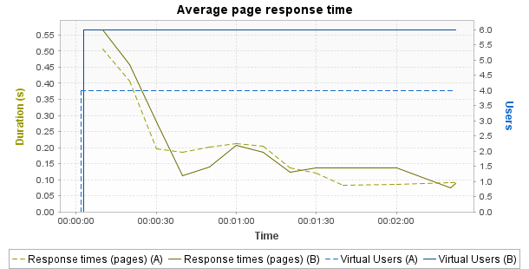

 | Min | Average | Max
A | 0.082 | 0.194 | 0.507
B | 0.075 | 0.209 | 0.567
% | -8.4% | +7.9% | +11.9%
Notes: Displays the average response time, in seconds, of all pages during the test.
Average request response time

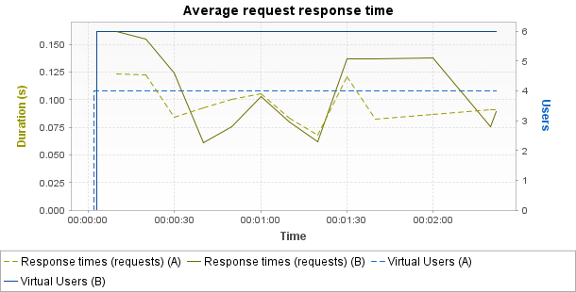

 | Min | Average | Max
A | 0.068 | 0.105 | 0.123
B | 0.061 | 0.128 | 0.162
% | -10.6% | +21.5% | +31.8%
Notes: Displays the average response time, in seconds, of all requests during the test.
Average response time (Transactions)

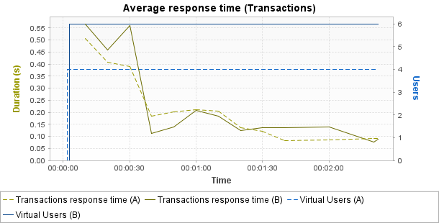

 | Min | Average | Max | Median | Avg-90% | Std. Dev.
A | 0.082 | 0.209 | 0.507 | 0.185 | 0.195 | 0.135
B | 0.075 | 0.225 | 0.567 | 0.138 | 0.212 | 0.172
% | -8.4% | +7.9% | +11.9% | -25.4% | +8.8% | +27.3%
Notes: Displays the average response time, in seconds, of all Transactions during the test.
Requests per second

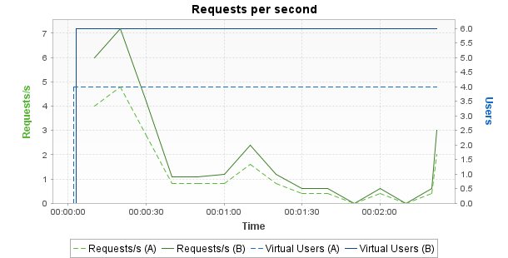

 | Min | Average | Max
A | 0 | 1.3 | 4.8
B | 0 | 1.9 | 7.2
% | +0% | +48.9% | +50%
Notes: Displays the number of requests per second.
Errors

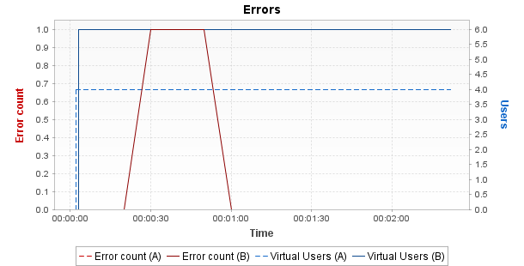

 | Min | Average | Max
A | 0 | 0 | 0
B | 0 | 0.2 | 1
% | +0% | +INF | +INF
Notes: Displays the number of errors per sampling interval.
Throughput

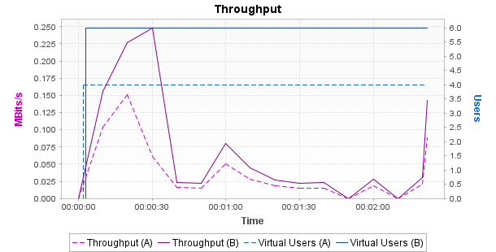

 | Min | Average | Max
A | 0 | 0.04 | 0.15
B | 0 | 0.07 | 0.25
% | +0% | +78.8% | +64.7%
Notes: Displays the number of megabits of data per second returned by the server.
Distribution of Transaction Durations

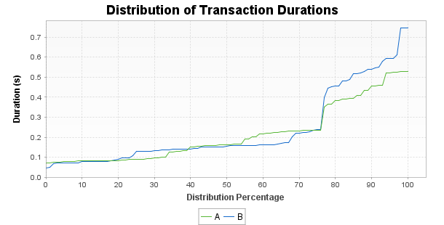
Notes: Displays the percentage of Transactions that were performed within a given time range. This graph helps determine the percentage of Transactions that meet a performance objective. For example, it may show that 90% of the Transactions have a duration under n seconds.

