Draft Tutorial for the VPL Spectra Explorer

Jacob Lustig-Yaeger

**Choose a type of spectrum to explore:** Select between “Direct” imaging and “Transmission” spectroscopy using the option box at the top left.

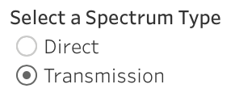

**Selecting different spectrum models:** Use the interactive table at the bottom to select the specific type of planetary spectrum to graph.

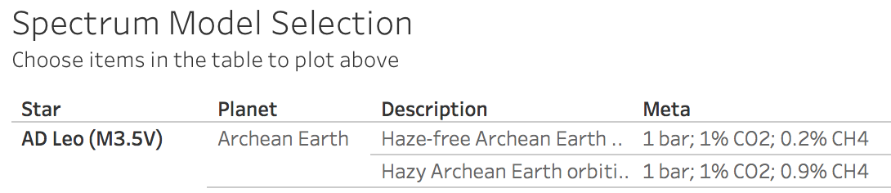

Click on any cell in the table to plot all spectra associated with that selection. For instance, clicking on the “Archean Sun” under “Star” will plot all spectra for planets simulated orbiting the Archean Sun.

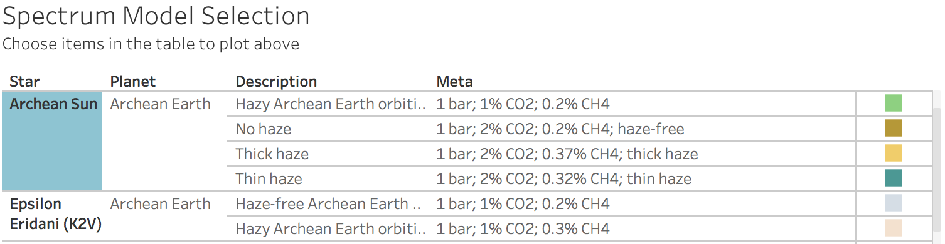

Multiple spectra can be plotted simultaneously by holding “command” (on a mac) or “control” (on a PC) while selecting items in the table.

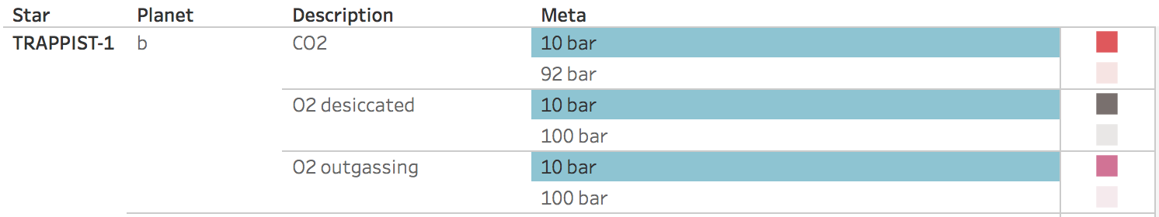

**Finding additional information about each spectrum:** Hover the mouse over a plotted spectrum to view specific information about it, such as the type of star-planet-atmosphere from which the spectrum was generated and the citable reference for the spectrum.

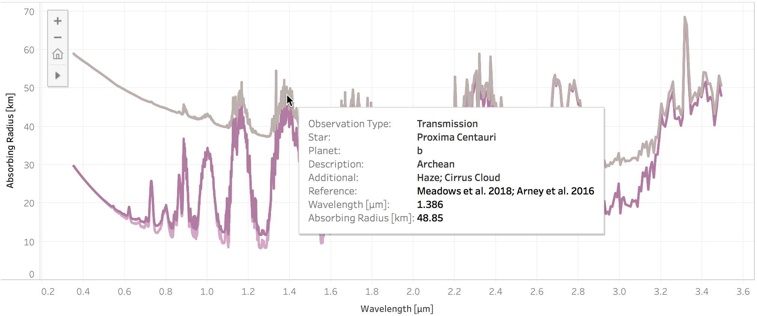

**Downloading Spectral Data:** Click the plotted line or a single item in the table to access a “Download Spectrum” link to the raw data file.

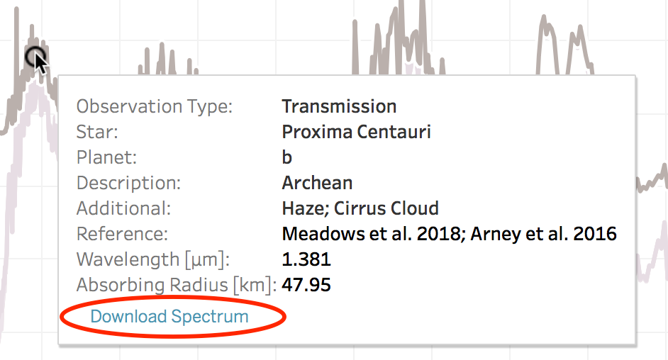

**Selecting Plotted Wavelength Range:** Select the wavelength range you wish to plot using the sliders at the top right of the Spectral Explorer.

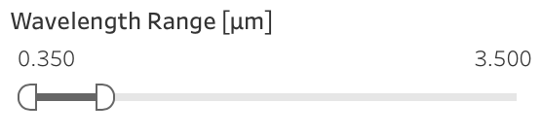

If you encounter any issues operating the data visualization, try refreshing the page to restart the Spectral Explorer.