**Philippines AWS – Offline Development Environment Setup Guide**

Created Date: 02 June 2016

Created By: Shanley L Xie

Update History

|  |  |  |  |
| --- | --- | --- | --- |
| **Version** | **Date** | **Prepared By** | **Remarks** |
| 1.0 | 02 June 2016 | Shanley L. Xie | Initial Draft |
| 2.0 | 10 March 2020 | RemyLi | Updated JDK Version |

Table of Contents

1. Introduction 3

2. Prerequisite 3

3. Environment Setup 3

# Introduction

This document is to provide information about steps on how to setup on PH AWS offline development environment.

# Prerequisite

1. 32 bit JDK 7 and OEPE Eclipse already installed.
2. Tortoise SVN client and necessary SVN account has been created.

# Environment Setup

1. Usually we will create new branch for each production release. So we use one dedicated folder as workspace for each branch. Let’s use “C:\evn_setup\workspace_branch_20160523-AWS_Enhancement” for example.
2. Check out SVN source code for **AWS**, **PrintEngine**, **ProposalEngine** and **ProductEngine**. Below is the screenshot for **AWS**, others can follow the similar steps.

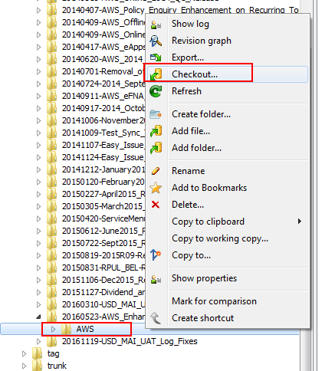

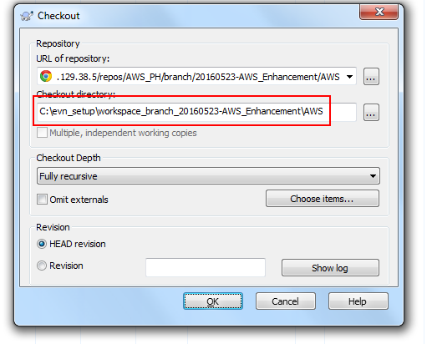

1. After checkout all source codes for above mentioned 4 modules, you should see the folder structure as below:

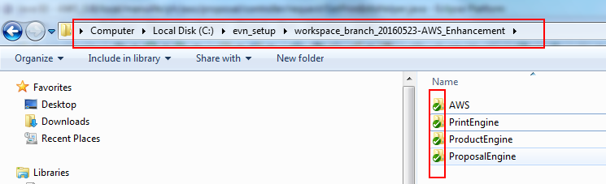

1. Rename the ‘**AWS**’ to ‘**AWS_Offline**’, the purpose is to prevent the eclipse project naming conflict with online environment setup which also will use ‘**AWS**’ as the project name.

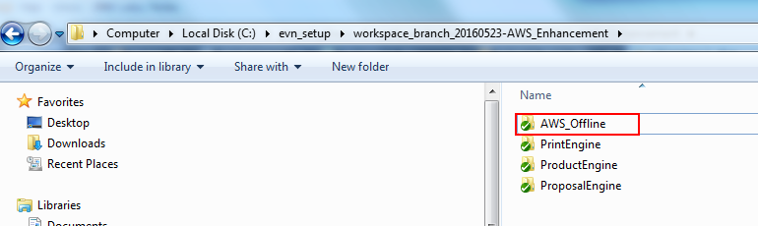

1. Create eclipse workspace under the same SVN working copy location.

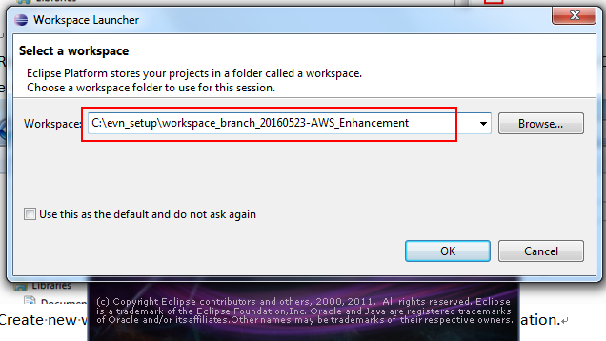

1. Import **ProductEngine** into OEPE IDE

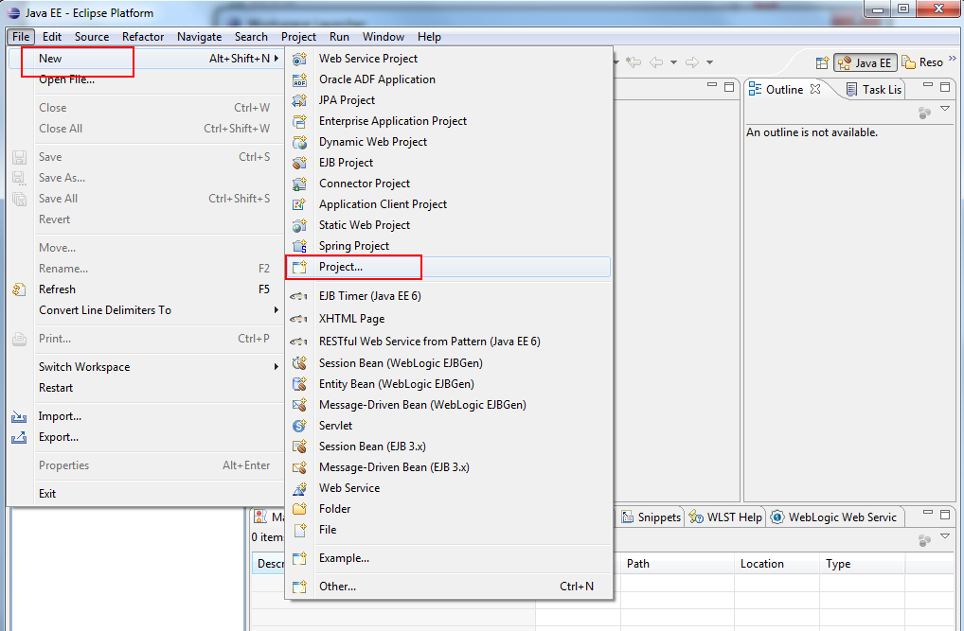

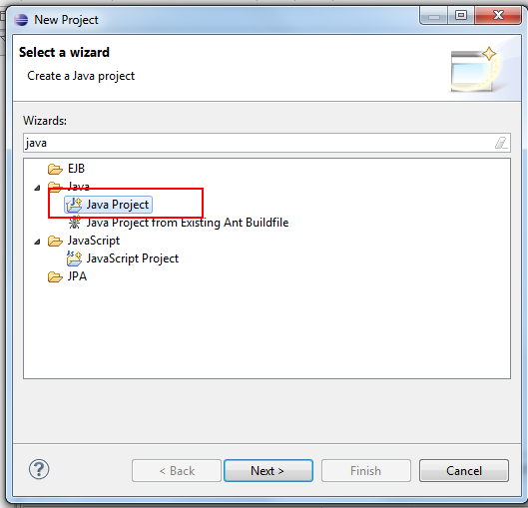

Please check whether the JDK is 1.7

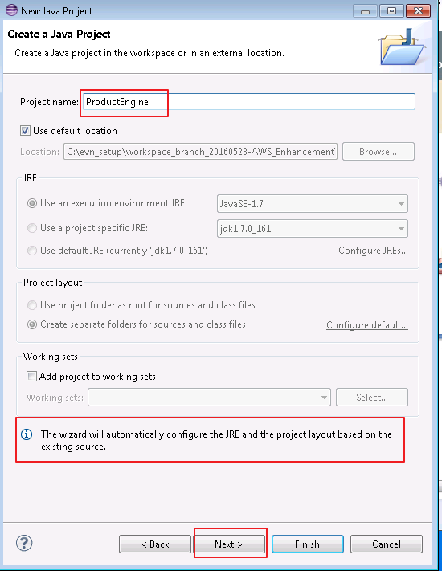

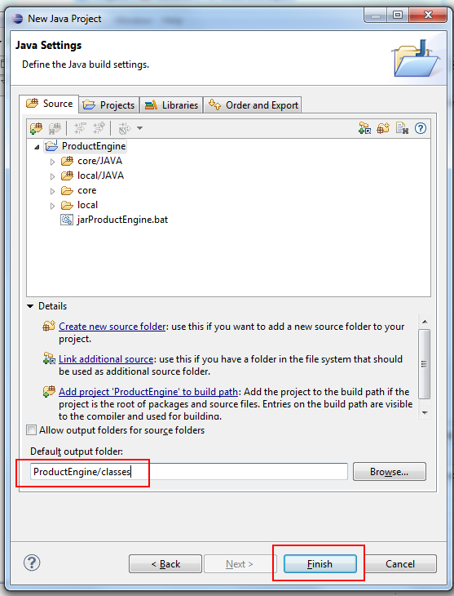

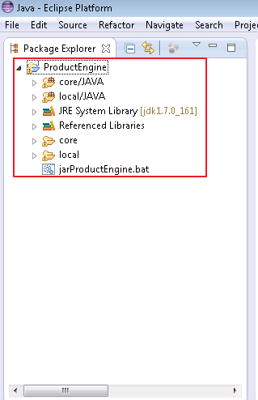

1. Import **PrintEngine** into OEPE IDE

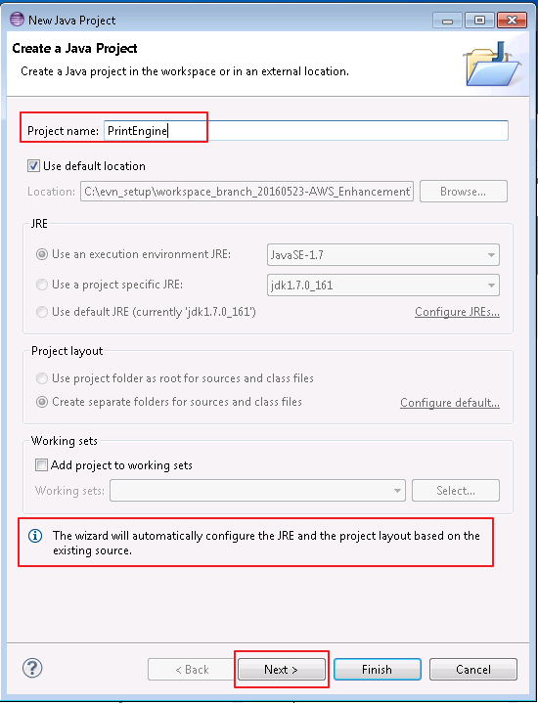

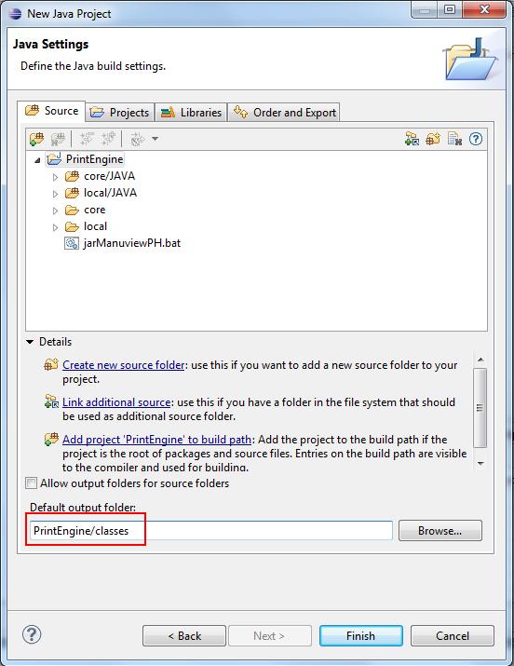

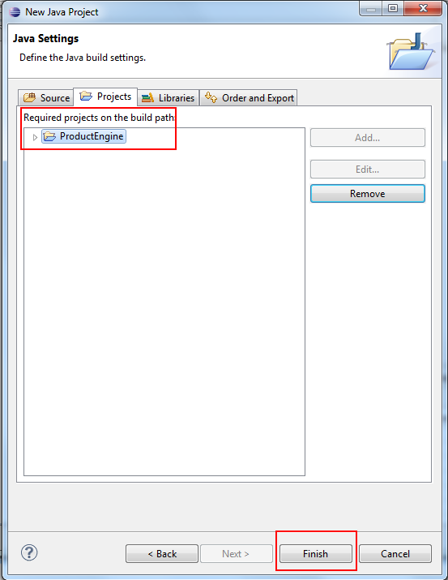

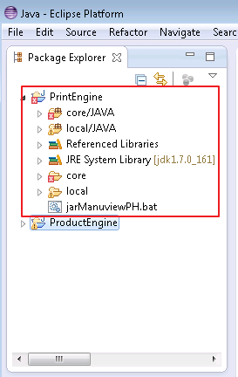

Can input ‘BIG5-HKSCS’ manually.

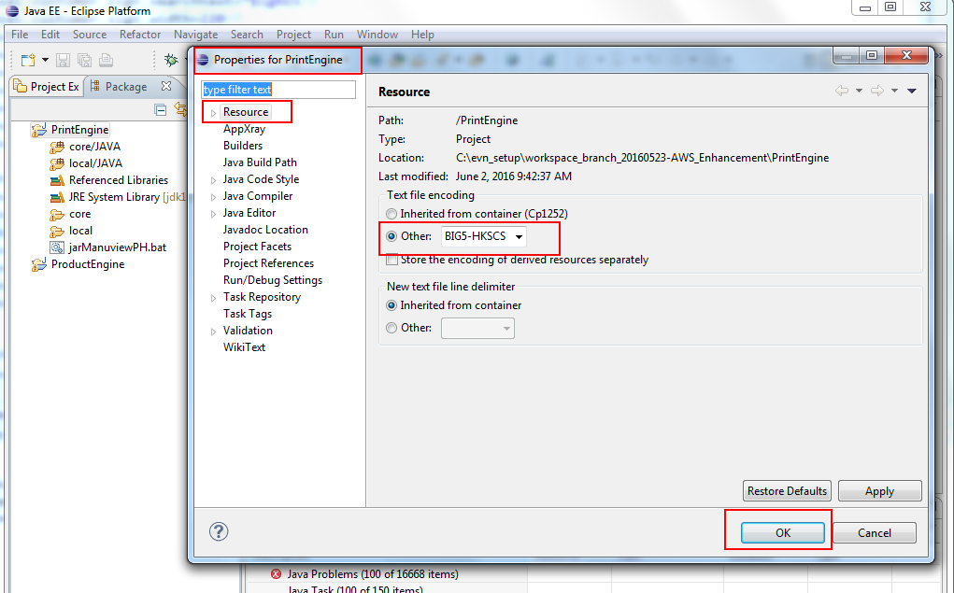

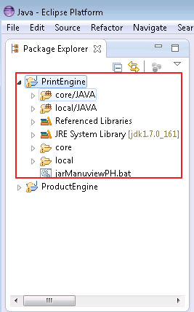

1. Import **ProposalEngine** into OEPE IDE

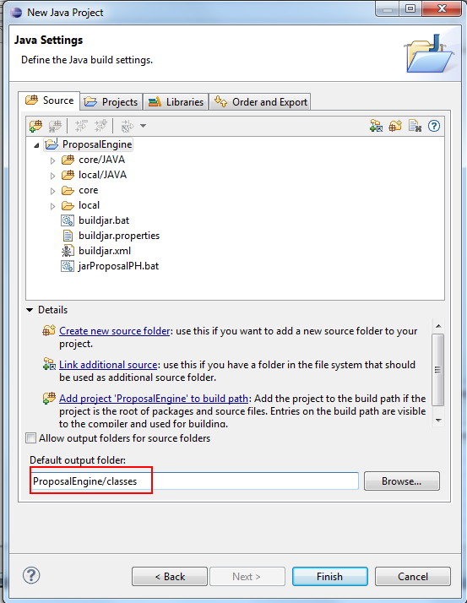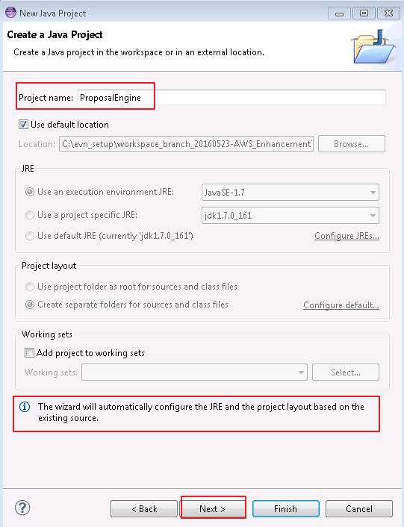

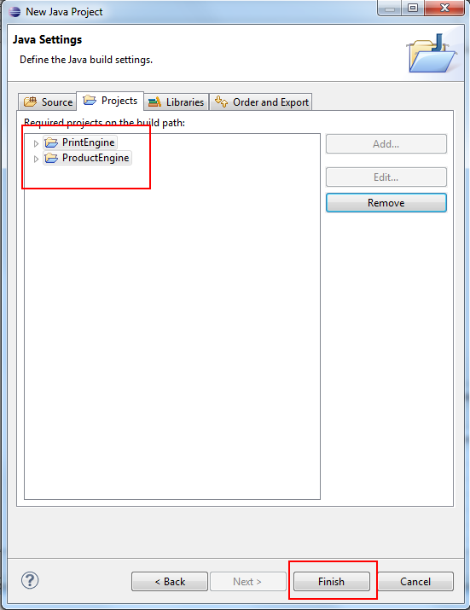

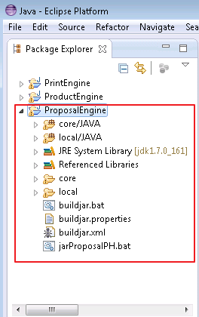

1. Import **AWS_Offline** into OEPE IDE

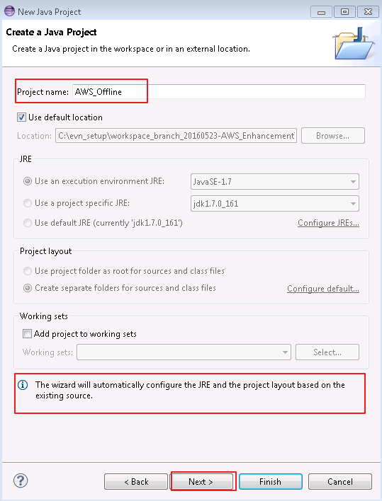

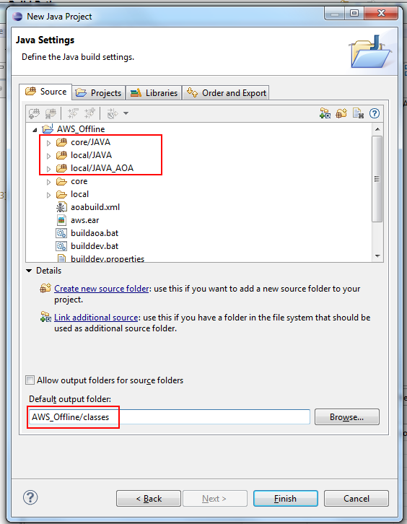

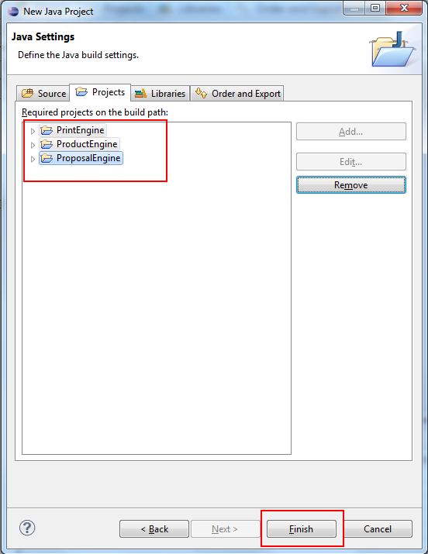

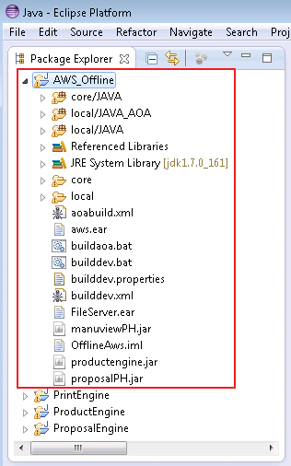

1. Add the ODBC data source (This step can be ignored once your ENV already have added the ODBC data source)

