LIS590DCL Assignment3 - Jialu Wang (jwang282)

problem1

1. √
2. Questions:

what does left join and right join mean?

what if the original data has differences between capitalization?

how can the sql define date<1930-01-01

is null vs = ‘ ‘?

why I can select lat instead of site.lat?





1. select name from site;



2. select distinct dated from visited;



select personal ||‘ ‘|| family from person order by family;



3. select \* from survey where reading>1.0 or reading < 0.0;

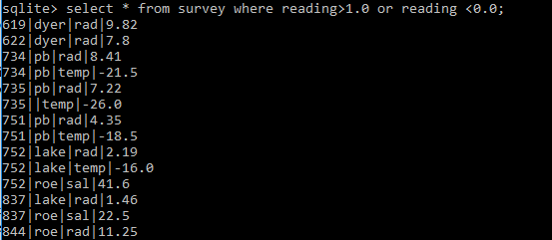

4. select reading/100 from survey where person=’roe’;



select taken,reading from survey where person !='roe' union select taken,reading/100 from survey where person = 'roe';



5. select \* from visited where dated !=' ' order by dated;



Pros  
  
NULL values are easily confused with empty character strings, which return a blank value to the user when selected. In this sense, default values are less confusing and are the safer option, unless the default value is set to the empty string.  
  
If NULL values are allowed in the database, they may cause the designer some extra time and work as they can make the database logic more complicated, especially when there are a lot of comparisons to null values in place.

Cons  
  
NULL value does not have the data type, therefore can be inserted to any data structure and any database column. Default values, on the other hand, need to have their data type specified and a default value in one column might look the same in another column, but it might be of a different type.  
  
NULL value takes up only 1 bit of memory space, they may be useful when optimising the database. Using those values is much more efficient than default values, e.g. character’s 8 bits and integers 16 bits.  
  
While your system requirements may change over time and the default value types with them, NULL value is always NULL so there is no need to update the type of data.

6. select count(reading) from survey where person='pb' and quant='temp';



select avg(reading) from survey where person='pb' and quant='temp';



deviation of each radiation reading values from the average

7. select \* from survey join visited on survey.taken=visited.id where survey.quant=’rad’;

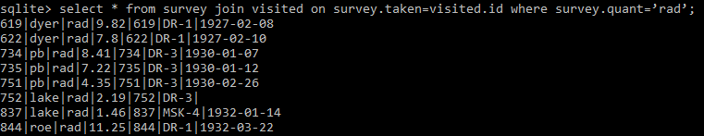

select distinct site

from visited join survey join person

on person.id=survey.person

and survey.taken=visited.id

where person.personal=’Frank’;



sqlite> select name,lat,long,dated, personal, family, taken, reading

...> from site as t join person as p join visited as v join survey as s

...> on p.id=s.person

...> and s.taken=v.id

...> and v.site=t.name

...> where v.dated !=' '

...> order by v.dated, p.personal, p.family,s.taken, s.reading;

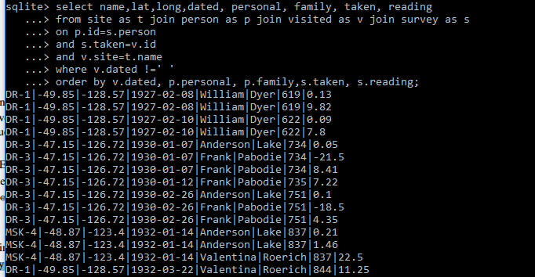

problem2

a.

Problem 2a FD-1: if a row agrees with another row on the key attribute PID, then it should agree on ALL other attributes.   
Problem 2a FD-2: every journal has a single publisher  
Problem 2a NC-1: The last page Lp cannot be smaller than the first page Fp  
Problem 2b ID: Every cited publication in CITES also occurs in PUBLICATION.

b. Foreign key constraints are used to check referential integrity between tables in a database as they can enforce "exists" relationships between tables.