1. **Overview** of the analysis: Explain the purpose of this analysis.
   1. To create an algorithm to predict whether or not applicants for funding will be successful.
2. **Results**: Using bulleted lists and images to support your answers, address the following questions.

* Data Preprocessing
  + What variable(s) are considered the target(s) for your model? “IS_SUCCESSFUL” Application Type
  + What variable(s) are considered to be the features for your model? APPLICATION_TYPE, AFFILIATION, CLASSIFICATION, USE_CASE, ORGANIZATION, STATUS, INCOME_AMT, SPECIAL_CONSIDERATIONS, and ASK_AMT.
  + What variable(s) are neither targets nor features, and should be removed from the input data? EIN and NAME.
* Compiling, Training, and Evaluating the Model
  + How many neurons, layers, and activation functions did you select for your neural network model?
    - All models had 3 layers. First layer with 80 units, second layer with 30 units, and output layer with 1 unit.
  + Were you able to achieve the target model performance?
    - None of my three attempts resulted in the target model performance.
  + What steps did you take to try and increase model performance?
    - My second attempt came closest to the target model performance. In my second attempt I increased the cutoff value for application types, which removed 2 application types from the model. I also decreased the cutoff value for classifications. Adding 2 classifications to the model.
    - Since the previous attempt increased accuracy minimally, for my 3rd attempt I increased the number of epochs thinking it would increase my model accuracy, when in fact it decreased it back to my first attempt levels.

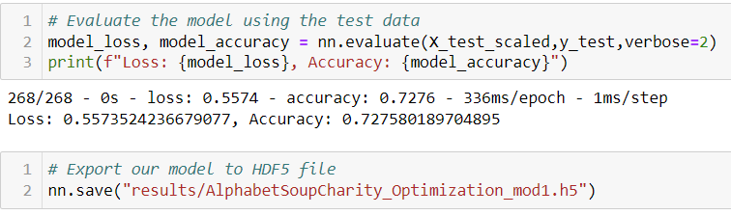

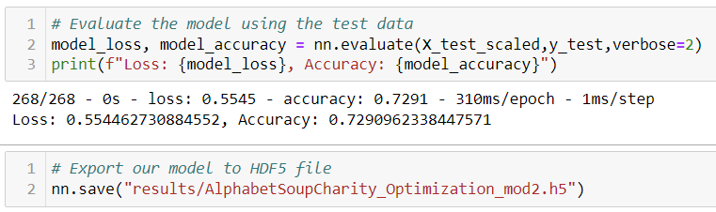

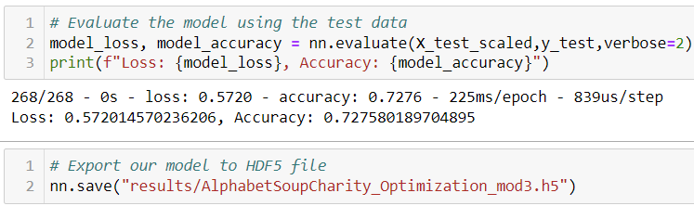

1. **Summary**: Summarize the overall results of the deep learning model. Include a recommendation for how a different model could solve this classification problem, and explain your recommendation.
   1. **I think possibly decreasing the types of applications might aid in increasing accuracy but it would also make it more difficult to know if those application types that were excluded will be successful, and decreasing funding to these application types unnecessarily**.