# Project – Part 2– Joyce Woznica

## Physical Database Design

Included in this submission is the SQL file: *CreateTables4Project.sql*. This file has all the create table SQL code to create the tables as outlined in the normalized logical model provided.

For removing the data, there is a single SQL file: *DropTables4Project.sql* which reflects the proper way to drop the tables in order. Then you can run the *CreateTables4Project.sql* file to recreate the tables in that order.

## Data Creation

There are also the following SQL files that provide the INSERTs into the tables to populate them.

* *01-InsertintoVaccine.sql*
* *02-InsertintoBarn.sql*
* *03-InsertintoHorse.sql*
* *04-InsertintoClinic.sql*
* *05-InsertintoVet.sql*
* *06-InsertintoHorseVaccine.sql*

In generating these statements, I made some mistakes and had to drop tables and recreate them. The key to doing this is that there is an order that must be followed when dropping and, in most cases, when I dropped one – I had to drop more than one table.

Because of dependencies, I could not drop the Clinic table because of the dependencies of the Vet table on that. Same with the Barn table because of the dependencies in the Horse table. The order for dropping is in the *DropTables4Project.sql*. Because of dependencies, all tables had to be dropped before I could drop HorseVaccine.

## Data Manipulation

I have provided some updates and deletions to the data based on what I had to do in the short term to provide changes to the table data. The following are provided:

* *NumMonthsFunction.sql* – this is a function that will determine the number of months to add to the VaccineDate to derive the ScheduledVaccineDate based on the Cycle in the Vaccine table. It accepts the VaccineID.
* *UpdateMicrochip.sql* – this file updates based on the current microchip number, the new one reported by the vet when inserted.
* *UpdateVaccines.sql* – this file shows the removal of the Potomac-Spring vaccine, the change of the Potomac-Fall vaccine to just Potomac and an update to the Cycle of Semi-Annual.  
  **Still need to remove Potomac-Spring and replace all occurrences in HorseVaccine with the Semi-Annual vaccine. So, need to update all 2’s in HorseVaccine to reflect 7’s for Potomac and then delete the 2 Potomac-Spring from the Vaccine table.
* *UpdateScheduledDate*.*sql* – Updates the Scheduled Date on all rows to be the proper date based on the Cycle for the specific Vaccine in that row.
* *AddHorseVaccine*.sql – this file updates the HorseVaccine table with a recent vaccine passing it the required parameters to update the row.

## Answering Data Questions

There are several questions that I would like for this data to answer. Here is some of the queries I put together for this?

### When is a Horse Due for a Specific Vaccine

* *WhenDue.sql* – This stored procedure uses others created (like NumMonths for deriving the schedule date for a vaccine) to provide the answer to the question “When is <HORSE> due for <VACCINE>?”
* WhenWhat vet did <HORSE>’s last <VACCINE>?

SELECT VaccineDate FROM HorseVaccine WHERE

* When did <HORSE> get the last dose of <VACCINE>?
* How much money did I spent on vaccine(s) in a given year?
* What is the average price for <VACCINE>?
* What <BATCH> was used for <VACCINE> on <HORSE> on last vaccination?
* How much was spent on <HORSE> for vaccines in a given year?
* What <VET> can I use in <STATE> for vaccines?
* *AddHorseVaccine*.*sql* – this file is a stored procedure to actually allow an end-user to pass in the Vaccine Name, Date, Horse Microchip, Cost, and Vet and then have it add a row to the HorseVaccine table matching all the required foreign keys to give a proper insert.

For my project, I will be creating a database that will help me keep track of my horses’ vaccination requirements and information. The information in this database will allow me to answer the following types of inquiries:

* When is <HORSE> due for a <VACCINE>?
* What vet did <HORSE>’s last <VACCINE>?
* When did <HORSE> get the last dose of <VACCINE>?
* How much money did I spent on vaccine(s) in a given year?
* What is the average price for <VACCINE>?
* What <BATCH> was used for <VACCINE> on <HORSE> on last vaccination?
* How much was spent on <HORSE> for vaccines in a given year?
* What <VET> can I use in <STATE> for vaccines?

This is very important because certain vaccines are due every 6 months, some once per year. Each horse might get a different batch and this can be important if there is a reaction of some kind to the vaccine. It is very hard to keep track with multiple horses getting vaccines in different locations from different vets. It is important for all horse owners to keep track of when a horse is vaccinated and when he/she is due for his/her next vaccine. It is very important not to miss the proper vaccines as it puts not only that horse in jeopardy, but any horses they come in contact with at their own location and any shows that they might attend.

## Entities

* Horse
  + Horse Microchip
  + Horse Name
  + Show Name
  + Foal Date
  + Breed
* Barn
  + Barn Name
  + Barn Address
  + Barn City
  + Barn State
  + Barn Zip
  + Barn Phone
* Vaccine
  + Name
  + Cycle
* Veterinarian
  + Last Name
  + First Name
  + Cell Phone
  + License Number
  + Clinic Associated
* Vet Clinic
  + Clinic Name
  + Clinic Address
  + City
  + State
  + Zip
  + WebSite
* Horse/Vaccine
  + Horse
  + Vaccine
  + Batch
  + Date Given
  + Vet Used
  + Clinic Used

## Relationships

* One horse can have 0 to many vaccines.
* One veterinarian can provide 0 to many vaccines to 0 to many horses.
* One clinic can have one or more veterinarians that gives vaccines.
* A veterinarian has to provide all vaccines.
* One clinic can have one to many veterinarians.
* One horse can be located at one and only one barn.
* One barn can have 0 to many horses.

One of the most important relationships is where everything comes together mapping the vet, the clinic, the horse, the vaccine and the dates and batches.

## Miscellaneous Information

* The date the vaccine is given and the “batch” is very important.
* Each vaccine should have an “cycle” with it to note how often it should be given. For sake of this project – I have only used Annual, but there are two vaccines that I could put on semi-annual at a later time.
* It is important to know the due date of the next vaccine.

## Example Real Data

I have moved all my data to the spreadsheet included with this submission.

### Entity Diagram

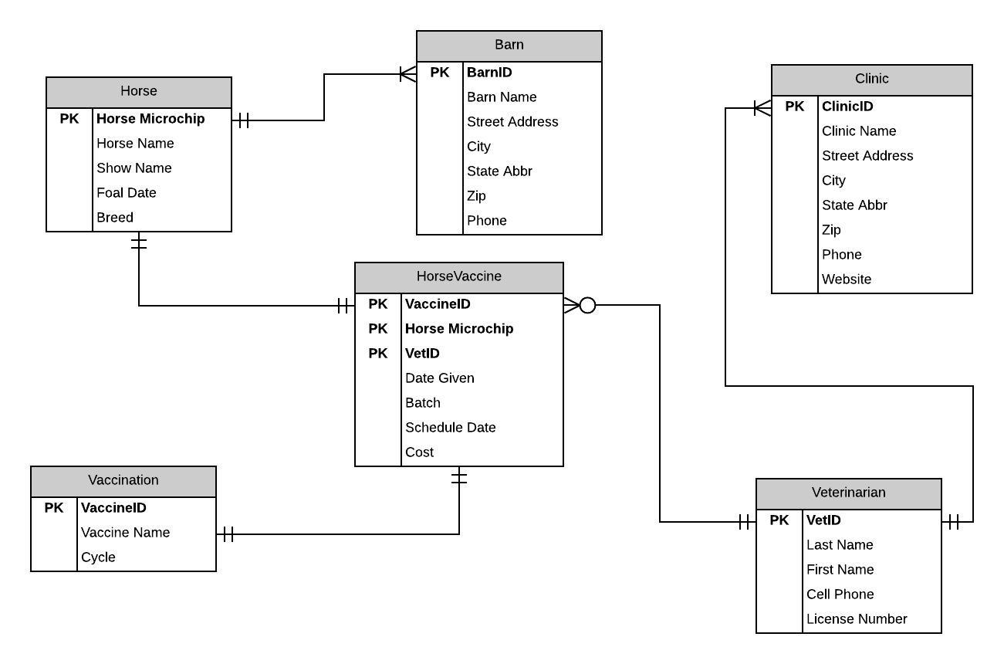

## Normalized Model

