# Lab 10

## Part 1 – Creating a Graphical User Interface (GUI)

### UserLogin Subform

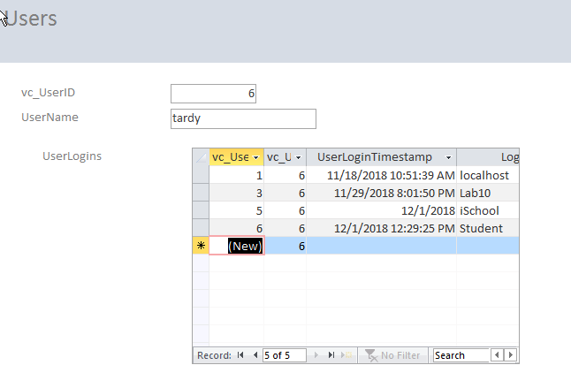

**Responses**:

1. If we only provide a value for LoginLocation, how did the software know what to use for vc_UserLoginID and UserLoginTimestamp?  
   **RESPONSE**: We are currently on the VC_UserID record for ‘tardy’, UserID = 6, so it knows this value. The UserLoginTimestamp defaults to GetDate(), so it automatically has this value. On the above screen, I was playing around with the lab which is why under ‘iSchool’, the date shows 12/1/2018 – as I picked that from a calendar when I was working with the form to understand how it worked.
2. Based on what the behavior we saw and the form/subform relationship, how did the software know which vc_UserID to use for the vc_UserLogin record?  
   **RESPONSE**: In the relationship diagram, we linked the UserLogin and User tables with the UserID, so this is how it knows.
3. What are some pros and cons (at least 2 of each) to using Access to manage SQL Server data?  
   **RESPONSE**:   
   Pros: (a) No need to worry about the relationships with code, as access handles this for us. (b) It provides a very simple interface tool to insert rows into tables without code.  
   Cons: (a) It is almost too easy to modify data this way – I did this and removed a row by accident. Of course, this could be remedied by not providing certain access to certain tables for certain users. (b) I think that a user interface should even be more straightforward.

## Part 2 – Using R to Connect to SQL Server

### Sqlresult from RStudio

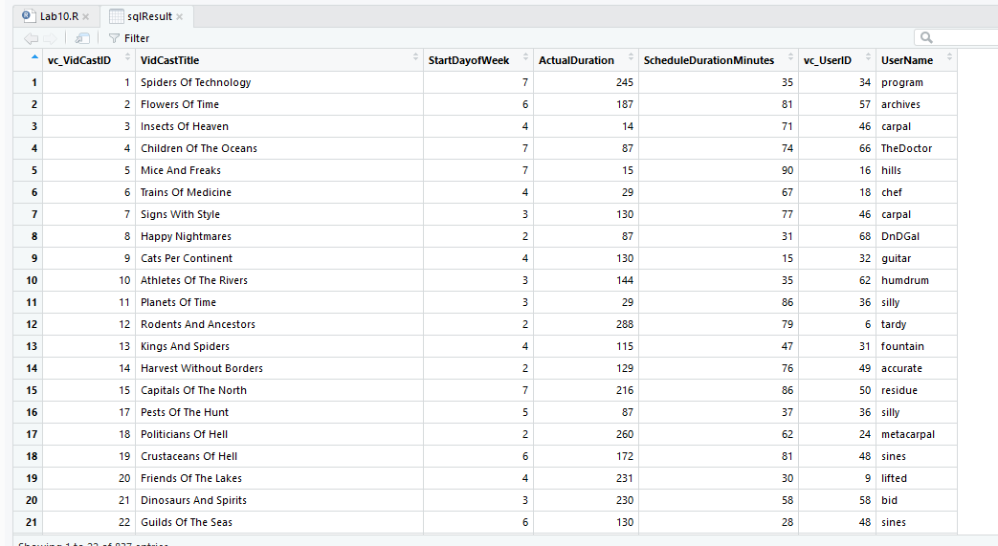

### VidCastHist

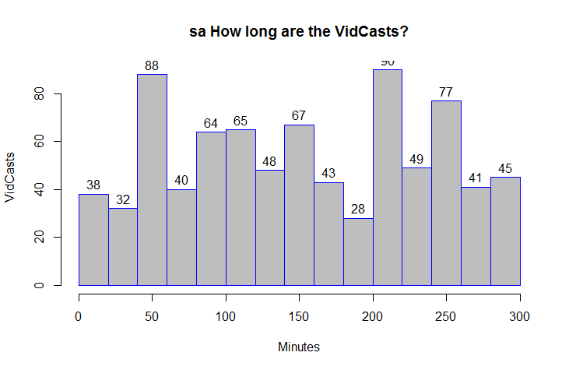

### VidCastCount

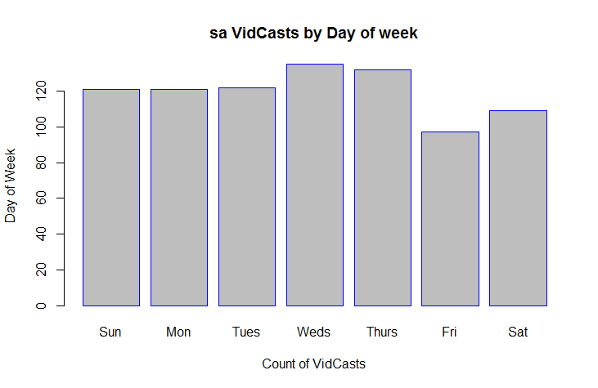

**Responses**:

1. In reference to the script in step 4, what does the SQL code on Line 12 do?  
   **RESPONSE**: Line 12 is the DATEPART function and it returns the day of the week (dw) from the StartDateTime value.
2. What is one way to simplify lines 8 through 19?  
   **RESPONSE**: A way to simplify these lines is to actually create a VIEW that has the data what we want already selected.