# Lab 03

## Case Study 1 – Obligatory College Course Modeling

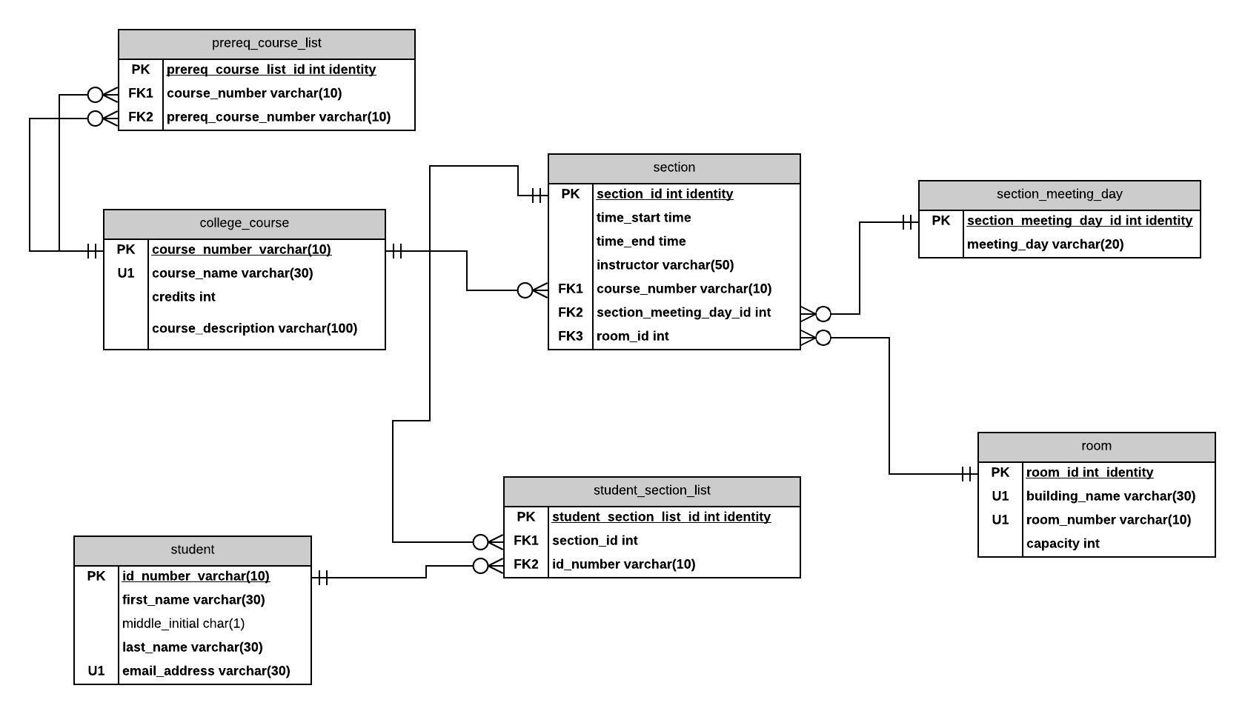

## Case Study 2 – Project Management

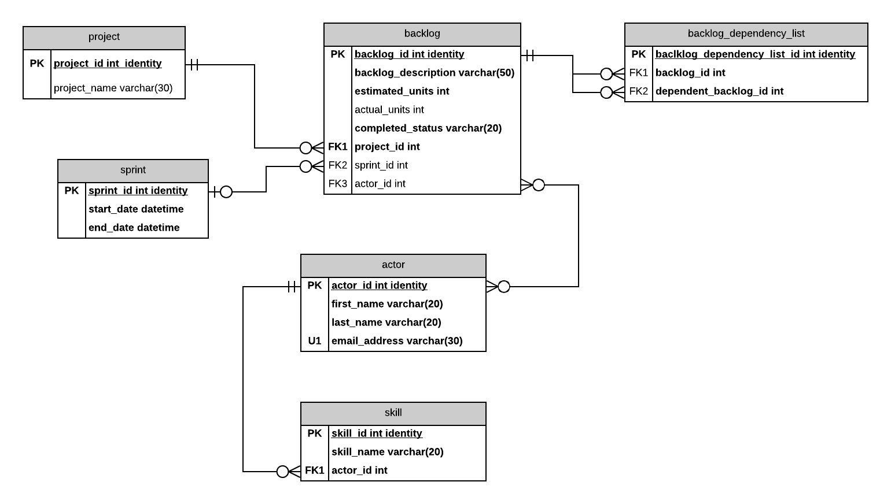

## Case Study 3 – Book Publishing Database

I really struggled with this one – I feel like there needs to be a relationship between the ISBN and the royalty and the check, but I wasn’t sure if I did that work foreign keys or bridge table or what. SORRY!

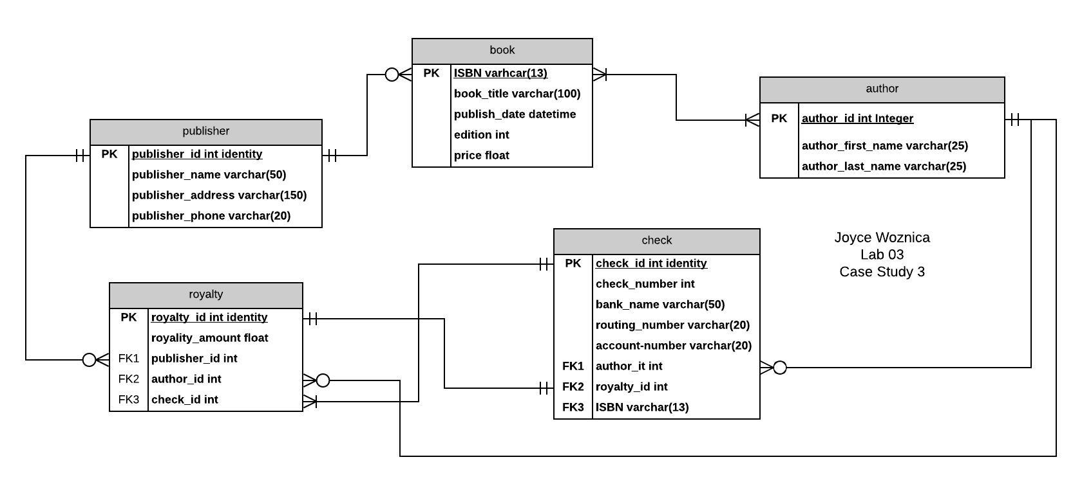

## Part 2 – VidCast Logical Model

