# Lab 04

## Part 1 – Normalizing an Existing Data Set

### Case Study 2 – More Bikes

So, if we have the following:

OrderItem(*Order Num*, Line, Item Number, Description, Qty Ordered, Price Each)

For the following dataset:

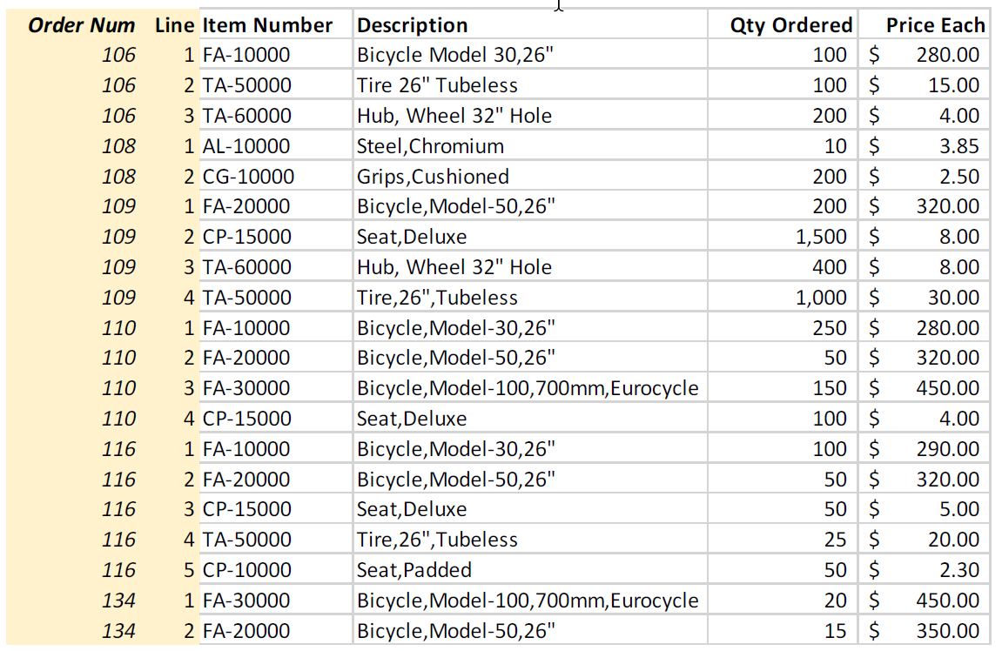

We have duplicate item numbers that have descriptions and prices that are dependent on the item number, so we can make this a new entity like:

Item(Item Number, Description, Price Each)

That would them make the OrderItem entity look like this:

OrderItem(*Order Num*, Line, *Item Number*, Qty Ordered)

### Case Study 3 – Books Again

1. Here is a screen shot of my database.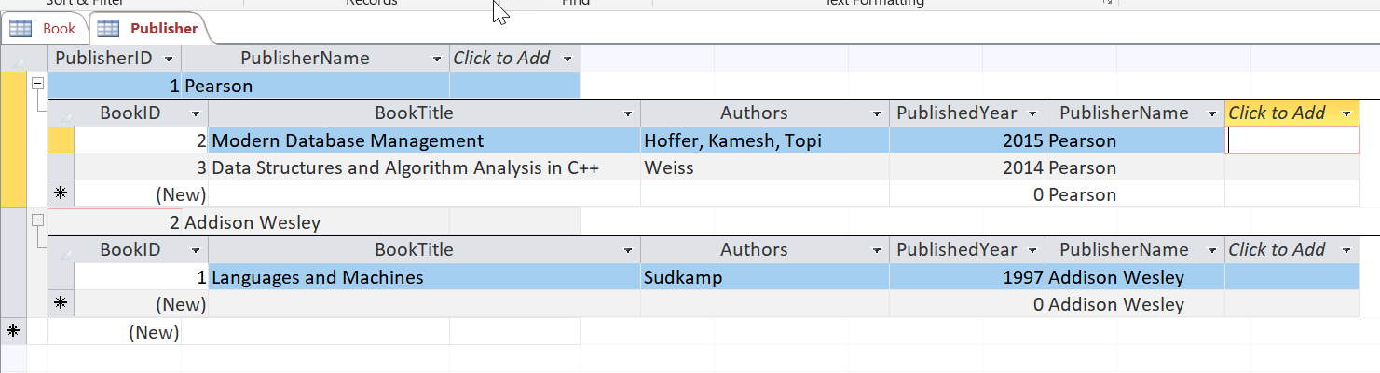
2. I believe that the book table is actually in 1NF, because I think that there are multi-valued attributes (Authors) in the table. It is entirely possible that Hoffer, for example, could be an author alone on another book or Hoffer and Sudkamp, for example, could co-author another book.   
     
   To fix this situation, I would create another entity:  
     
   Author(AuthorID, Author Name)  
     
   which would change the Book table (entity) to something like this:   
     
   Book(BookID, BookTitle, *AuthorID*, PublishedYear, PublisherName)  
     
   But I struggle with this answer because then I would have to have a duplicate line in the book database for each author. So – I am not really sure this is the correct answer.

## Part 2 – Normalizing the Video Data for VidCast

I am taking a stab at this, but not sure it is correct.

Video(VideoID, Video Title, Video Duration, Stream Start, *Content Rating, UserID*)

Rating(Content Rating, Rating Description)

User(UserID, User Name, *User Tier*)

Tier(User Tier, Min Tier Followers)