# Project – Joyce Woznica

## Summary

For my project, I will be creating a database that will help me keep track of my horses’ vaccination requirements. The information in this database will allow me to answer the following types of inquiries:

* When is my horse due for a vaccine?
* What vet did my last vaccine?
* When did a horse get the last vaccine?
* How much money did I spent on vaccine(s)?
* What batch for a particular vaccine was used?
* What clinic can I use in the same state as my horse’s location?

This is very important because certain vaccines are due every 6 months, some once per year. Each horse might get a different batch and this can be important if there is a reaction of some kind to the vaccine. It is very hard to keep track with multiple horses getting vaccines in different locations from different vets. It is important for all horse owners to keep track of when a horse is vaccinated and when he/she is due for his/her next vaccine. It is very important not to miss the proper vaccines as it puts not only that horse in jeopardy, but any horses they come in contact with at their own location and any shows that they might attend.

## Entities

* Horse
  + Horse Name
  + Show Name
  + Foal Date
  + Breed
* Barn
  + Barn Name
  + Barn Address
  + Barn City
  + Barn State
  + Barn Zip
  + Barn Phone
* Vaccine
  + Name
  + Cycle
* Veterinarian
  + Last Name
  + First Name
  + Cell Phone
  + License Number
* Clinic
  + Name
  + Phone Number
  + Street Address
  + City
  + State
  + Zip
  + Website
* Horse/Vaccine
  + Horse
  + Vaccine
  + Batch
  + Date Given
  + Vet Used
  + Clinic Used

## Relationships

* One horse can have 0 to many vaccines.
* One veterinarian can provide 0 to many vaccines to 0 to many horses.
* One clinic can have one or more veterinarians that gives vaccines.
* A veterinarian has to provide all vaccines.
* One clinic can have one to many veterinarians.
* One horse can be located at one and only one barn.
* One barn can have 0 to many horses.

## Miscellaneous Information

* The date the vaccine is given and the “batch” is very important.
* Each vaccine should have an “cycle” with it to note how often it should be given.
* It is important to know the due date of the next vaccine.

## Example Real Data

I have moved all my data to the spreadsheet included with this submission.

### Entity Diagram

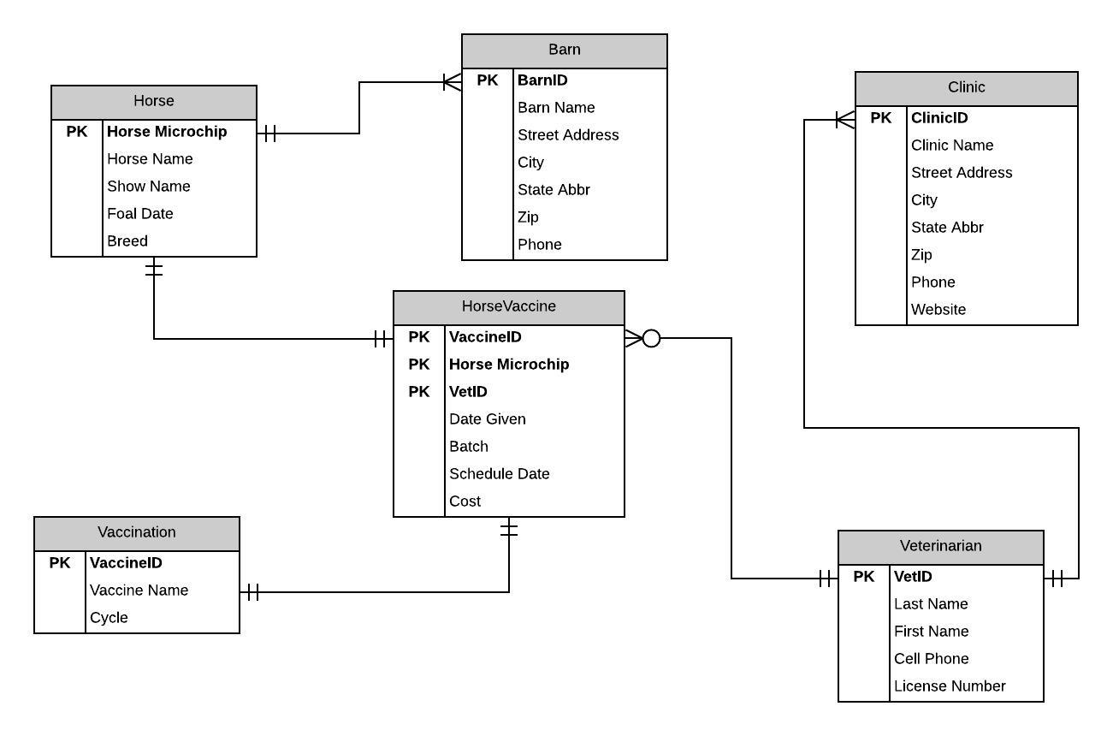

## Normalized Model

