# Lab 05

## Part 1 – Creating Tables

### User Table

Here is the User table created with MS SQL Server (2017).

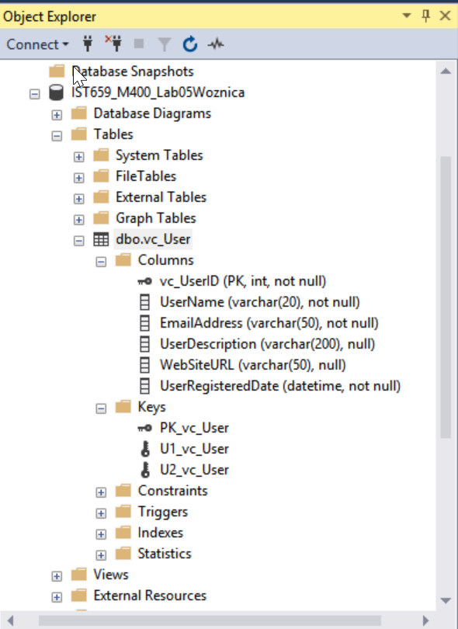

### User Login Table

Here is the User Login table created with MS SQL Server (2017).

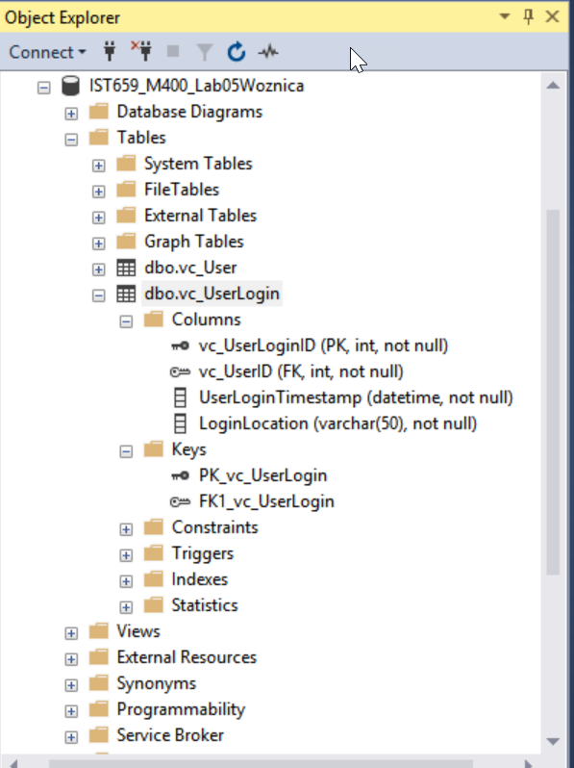

### User Records

Here are the User records inserted into the User table.

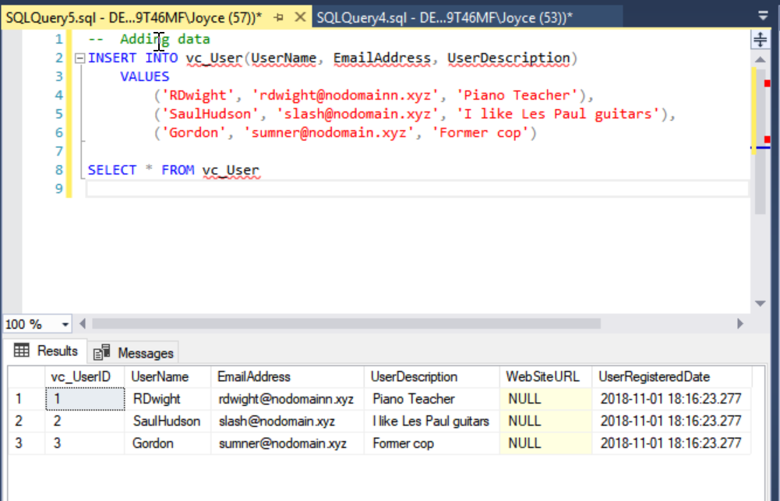

### Follower List table

Here is the Follower List table. ** Not asked for, but included to make sure I did correctly. **

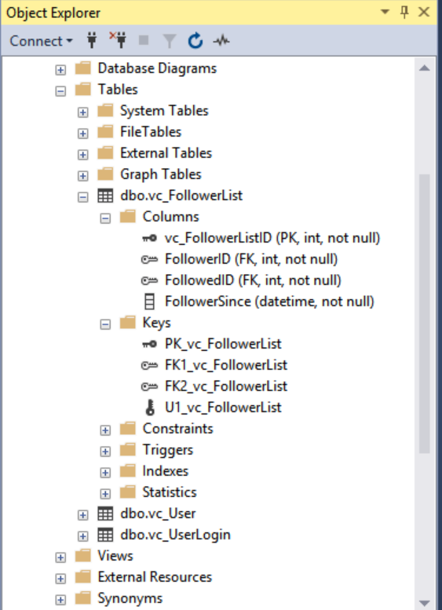

### User Tables

Here are the user tables that I created.

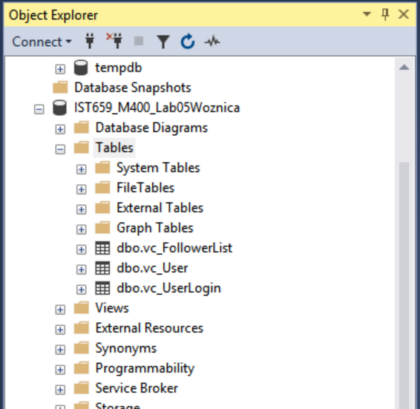

## Part 2 – The Rest of the Tables

VidCast Tables in SQL Server.

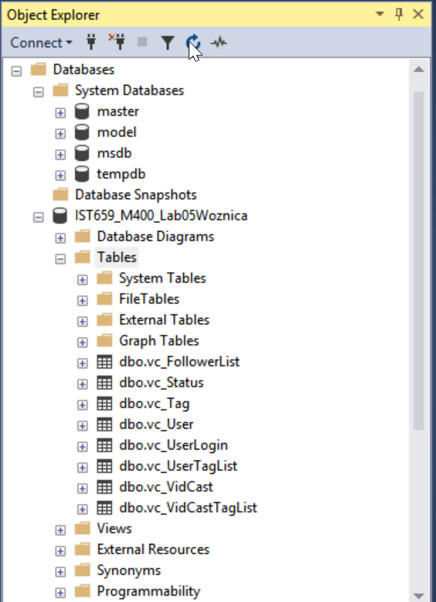

## SQL Query File Used for the exercise

Here is the query file that I used.

Please note that I could not figure out the syntax to make foreign keys unique – so I did not do that in my database. You will see my note in the comments of my SQL statements following.

select 'Hello, SQL' as Greeting

/*

Author: Joyce Woznica

Course: IST659 M400

Term: Fall 2018

*/

-- Creating the User Table for Vidcast

CREATE TABLE vc_User (

-- Columns for the User table

vc_UserID int identity,

UserName varchar(20) not null,

EmailAddress varchar(50) not null,

UserDescription varchar(200),

WebSiteURL varchar(50),

UserRegisteredDate datetime not null default GetDate(),

-- Constraints on the User Table

CONSTRAINT PK_vc_User PRIMARY KEY (vc_UserID),

CONSTRAINT U1_vc_User UNIQUE(UserName),

CONSTRAINT U2_vc_User UNIQUE(EmailAddress)

)

-- End Creating User Table

-- Creating UserLogin table

CREATE TABLE vc_UserLogin (

-- Columns for UserLogin table

vc_UserLoginID int identity,

vc_UserID int not null,

UserLoginTimestamp datetime not null default GetDate(),

LoginLocation varchar(50) not null,

-- Constraints on the UserLogin table

CONSTRAINT PK_vc_UserLogin PRIMARY KEY (vc_UserLoginID),

CONSTRAINT FK1_vc_UserLogin FOREIGN KEY (vc_UserID) REFERENCES vc_User(vc_UserID)

)

-- End Creating the User Login Table

-- Adding data

INSERT INTO vc_User(UserName, EmailAddress, UserDescription)

VALUES

('RDwight', 'rdwight@nodomainn.xyz', 'Piano Teacher'),

('SaulHudson', 'slash@nodomain.xyz', 'I like Les Paul guitars'),

('Gordon', 'sumner@nodomain.xyz', 'Former cop')

SELECT * FROM vc_User

-- Creating the Follower List table

CREATE TABLE vc_FollowerList (

-- Columns for the Follower table

vc_FollowerListID int identity,

FollowerID int not null,

FollowedID int not null,

FollowerSince datetime not null,

-- Constraints on the FollowerList table

CONSTRAINT PK_vc_FollowerList PRIMARY KEY (vc_FollowerListID),

CONSTRAINT U1_vc_FollowerList UNIQUE (FollowerID, FollowedID),

CONSTRAINT FK1_vc_FollowerList FOREIGN KEY (FollowerID) REFERENCES vc_User(vc_UserID),

CONSTRAINT FK2_vc_FollowerList FOREIGN KEY (FollowedID) REFERENCES vc_User(vc_UserID)

)

-- End creating table FollowerList

-- Creating the Tag table

CREATE TABLE vc_Tag (

-- Columns for the Tag table

vc_TagID int identity,

TagText varchar(20) not null,

TagDescription varchar(100),

-- Constraints on the Tag table

CONSTRAINT U1_vc_Tag UNIQUE (TagText),

CONSTRAINT PK_vc_Tag PRIMARY KEY (vc_TagID)

)

-- End creating Tag Table

-- Creating the Status table

CREATE TABLE vc_Status (

-- Columns for the Status table

vc_StatusID int identity,

StatusText varchar(20),

-- Constraints on the Status table

CONSTRAINT PK_vc_Status PRIMARY KEY (vc_StatusID),

CONSTRAINT U1_vc_Status UNIQUE (StatusText)

)

-- Creating the VidCast table

CREATE TABLE vc_VidCast (

-- Columns for the VidCast table

vc_VidCastID int identity,

VidCastTitle varchar(50) not null,

StartDateTime datetime,

EndDateTime datetime,

ScheduleDurationMinutes int,

RecordingURL varchar(50),

vc_UserID int not null,

vc_StatusID int not null,

-- Constraints on the VidCast table

CONSTRAINT PK_vc_VidCast PRIMARY KEY (vc_VidCastID),

CONSTRAINT FK1_vc_VidCast FOREIGN KEY (vc_UserID) REFERENCES vc_User(vc_UserID),

CONSTRAINT FK2_vc_VidCast FOREIGN KEY (vc_StatusID) REFERENCES vc_Status(vc_StatusID)

)

-- Creating VidCast Tag List table

CREATE TABLE vc_VidCastTagList (

-- Columns for the VidCast Tag List table

vc_VidCastTagListID int identity,

vc_TagID int not null,

vc_VidCastID int not null,

-- Constraints on the VidCast Tag List table

CONSTRAINT PK_vc_VidCastTagList PRIMARY KEY (vc_VidCastTagListID),

CONSTRAINT FK1_vc_VidCastTagList FOREIGN KEY (vc_TagID) REFERENCES vc_Tag(vc_TagID),

CONSTRAINT FK2_vc_VidCastTagList FOREIGN KEY (vc_VidCastID) REFERENCES vc_VidCast(vc_VidCastID)

-- I cannot figure out how to make the FK1 and FK2 unique - or are they be default?

)

-- Creating the User Tag List table

CREATE TABLE vc_UserTagList (

-- Columns for the User Tag List table

vc_UserTagListID int identity,

vc_TagID int not null,

vc_UserID int not null,

-- Constraints on the User Tag List table

CONSTRAINT PK_vc_UserTagList PRIMARY KEY (vc_UserTagListID),

CONSTRAINT FK1_vc_UserTagList FOREIGN KEY (vc_TagID) REFERENCES vc_Tag(vc_TagID),

CONSTRAINT FK2_vc_UserTagList FOREIGN KEY (vc_UserID) REFERENCES vc_User(vc_UserID)

-- I cannot figure out how to make the FK1 and FK2 unique - or are they be default?

)