# Lab 06

## Part 1 – Filling our Tables with Data

### First VidCast

Tables now created with SQL Server 2014 on an old virtual machine 😊

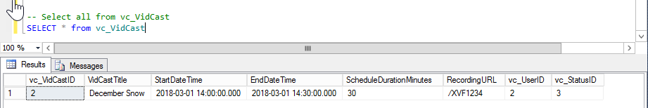

### Saul’s First VidCast

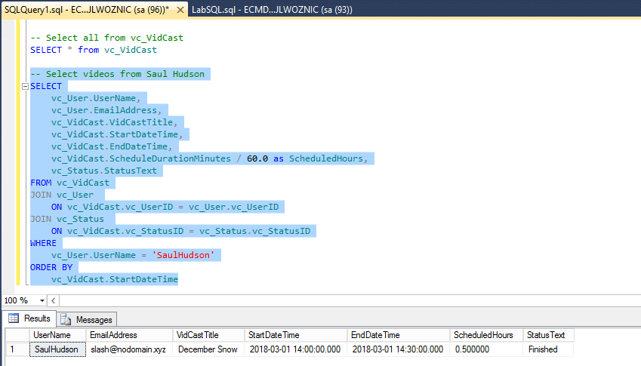

### Update a User

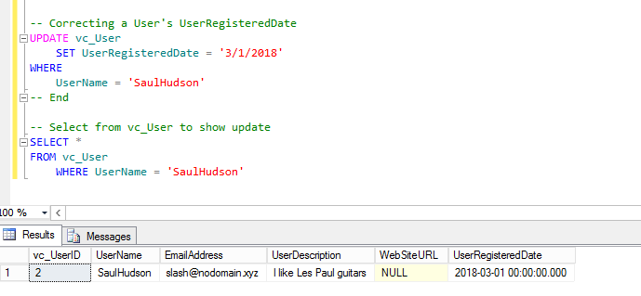

### No more on time

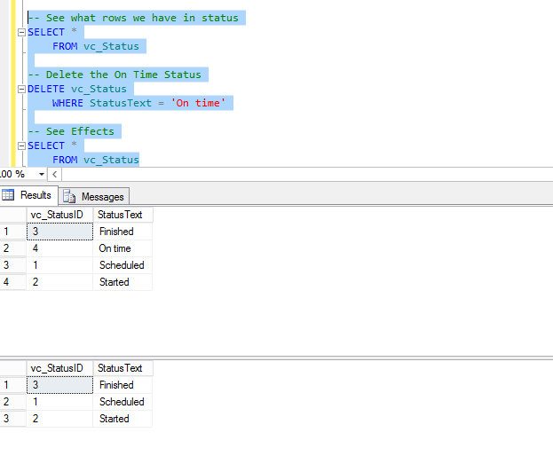

## Part 2 – Putting it All Together

### Tags

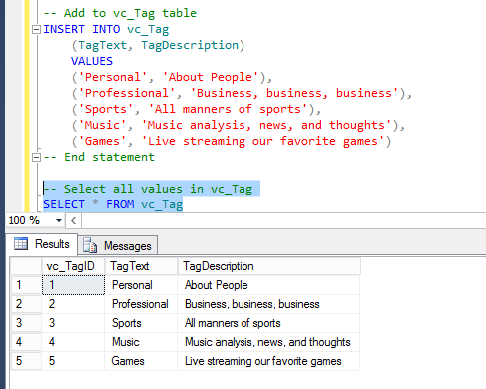

### Users

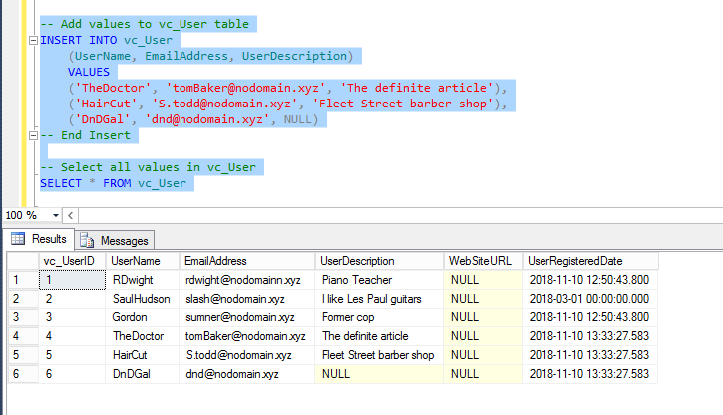

### User Tag List

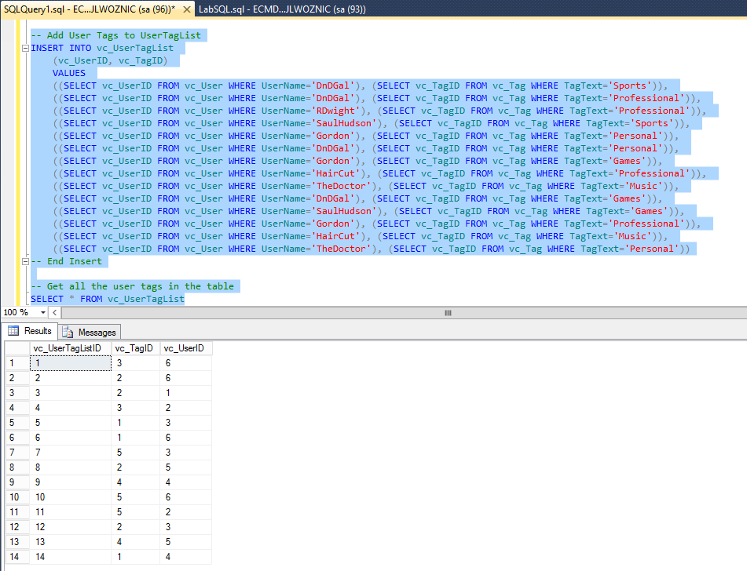

### User Tags Report

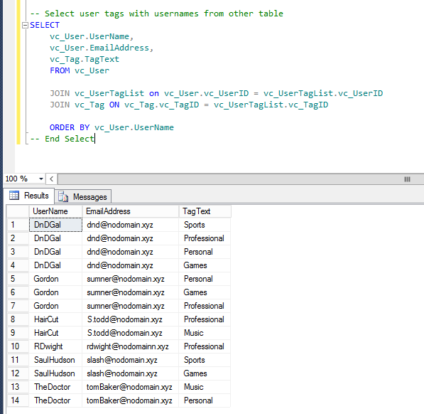

## SQL Query File

Here is the SQL File that I used:

-- Adding a row to the vc_Status table

INSERT INTO vc_Status

(StatusText)

VALUES ('Scheduled')

-- Select from vc_Status

SELECT * FROM vc_Status

-- Insert more values into vc_Status

INSERT INTO vc_Status

(StatusText)

VALUES ('Started'), ('Finished'), ('On time')

-- Select from vc_User and vc_Status

SELECT * FROM vc_User

WHERE UserName = 'SaulHudson'

SELECT * FROM vc_Status

WHERE StatusText = 'Finished'

-- Add to vc_VidCast

INSERT INTO vc_VidCast

(VidCastTitle, StartDateTime, EndDateTime, ScheduleDurationMinutes, RecordingURL, vc_UserID, vc_StatusID)

VALUES

('December Snow', '3/1/2018 14:00', '3/1/2018 14:30', 30, '/XVF1234', 2, 3)

-- Select all from vc_VidCast

SELECT * FROM vc_VidCast

-- Select videos from Saul Hudson

SELECT

vc_User.UserName,

vc_User.EmailAddress,

vc_VidCast.VidCastTitle,

vc_VidCast.StartDateTime,

vc_VidCast.EndDateTime,

vc_VidCast.ScheduleDurationMinutes / 60.0 as ScheduledHours,

vc_Status.StatusText

FROM vc_VidCast

JOIN vc_User

ON vc_VidCast.vc_UserID = vc_User.vc_UserID

JOIN vc_Status

ON vc_VidCast.vc_StatusID = vc_Status.vc_StatusID

WHERE

vc_User.UserName = 'SaulHudson'

ORDER BY

vc_VidCast.StartDateTime

--- End

-- Correcting a User's UserRegisteredDate

UPDATE vc_User

SET UserRegisteredDate = '3/1/2018'

WHERE

UserName = 'SaulHudson'

-- End

-- Select from vc_User to show update

SELECT *

FROM vc_User

WHERE UserName = 'SaulHudson'

-- See what rows we have in status

SELECT *

FROM vc_Status

-- Delete the On Time Status

DELETE vc_Status

WHERE StatusText = 'On time'

-- See Effects

SELECT *

FROM vc_Status

-- Add to vc_Tag table

INSERT INTO vc_Tag

(TagText, TagDescription)

VALUES

('Personal', 'About People'),

('Professional', 'Business, business, business'),

('Sports', 'All manners of sports'),

('Music', 'Music analysis, news, and thoughts'),

('Games', 'Live streaming our favorite games')

-- End statement

-- Select all values in vc_Tag

SELECT * FROM vc_Tag

-- Add values to vc_User table

INSERT INTO vc_User

(UserName, EmailAddress, UserDescription)

VALUES

('TheDoctor', 'tomBaker@nodomain.xyz', 'The definite article'),

('HairCut', 'S.todd@nodomain.xyz', 'Fleet Street barber shop'),

('DnDGal', 'dnd@nodomain.xyz', NULL)

-- End Insert

-- Select all values in vc_User

SELECT * FROM vc_User

-- Add User Tags to UserTagList

INSERT INTO vc_UserTagList

(vc_UserID, vc_TagID)

VALUES

((SELECT vc_UserID FROM vc_User WHERE UserName='DnDGal'), (SELECT vc_TagID FROM vc_Tag WHERE TagText='Sports')),

((SELECT vc_UserID FROM vc_User WHERE UserName='DnDGal'), (SELECT vc_TagID FROM vc_Tag WHERE TagText='Professional')),

((SELECT vc_UserID FROM vc_User WHERE UserName='RDwight'), (SELECT vc_TagID FROM vc_Tag WHERE TagText='Professional')),

((SELECT vc_UserID FROM vc_User WHERE UserName='SaulHudson'), (SELECT vc_TagID FROM vc_Tag WHERE TagText='Sports')),

((SELECT vc_UserID FROM vc_User WHERE UserName='Gordon'), (SELECT vc_TagID FROM vc_Tag WHERE TagText='Personal')),

((SELECT vc_UserID FROM vc_User WHERE UserName='DnDGal'), (SELECT vc_TagID FROM vc_Tag WHERE TagText='Personal')),

((SELECT vc_UserID FROM vc_User WHERE UserName='Gordon'), (SELECT vc_TagID FROM vc_Tag WHERE TagText='Games')),

((SELECT vc_UserID FROM vc_User WHERE UserName='HairCut'), (SELECT vc_TagID FROM vc_Tag WHERE TagText='Professional')),

((SELECT vc_UserID FROM vc_User WHERE UserName='TheDoctor'), (SELECT vc_TagID FROM vc_Tag WHERE TagText='Music')),

((SELECT vc_UserID FROM vc_User WHERE UserName='DnDGal'), (SELECT vc_TagID FROM vc_Tag WHERE TagText='Games')),

((SELECT vc_UserID FROM vc_User WHERE UserName='SaulHudson'), (SELECT vc_TagID FROM vc_Tag WHERE TagText='Games')),

((SELECT vc_UserID FROM vc_User WHERE UserName='Gordon'), (SELECT vc_TagID FROM vc_Tag WHERE TagText='Professional')),

((SELECT vc_UserID FROM vc_User WHERE UserName='HairCut'), (SELECT vc_TagID FROM vc_Tag WHERE TagText='Music')),

((SELECT vc_UserID FROM vc_User WHERE UserName='TheDoctor'), (SELECT vc_TagID FROM vc_Tag WHERE TagText='Personal'))

-- End Insert

-- Get all the user tags in the table

SELECT * FROM vc_UserTagList

-- Select user tags with usernames from other table

SELECT

vc_User.UserName,

vc_User.EmailAddress,

vc_Tag.TagText

FROM vc_User

JOIN vc_UserTagList on vc_User.vc_UserID = vc_UserTagList.vc_UserID

JOIN vc_Tag ON vc_Tag.vc_TagID = vc_UserTagList.vc_TagID

-- End Select