# Lab 08

## Part 1 – Introducing Functions, Views, and Stored Procedures

### Describing the use of the *dbo.vc_VidCastCount* function

These statements are designed to select the top 10 values (from largest to smallest) for the counted number of videos all users in the vc_VidCast table. These results are then listed in descending order from the user with the most broadcasted videos to the least (up to a count of ten users).

The code knows that user 20 (username “ecstatic”) has 20 videos because it looked at all the rows for user 20 in the vc_VidCast table and then added all those rows to come up with the “VidCastCount” of 22 total videos broadcasted.

### Describing the use of the *dbo.vc_TagIDLookup* function

The select statements from the dbo.vc_TagIDLookup provides the TagID (the unique ID) for the tagtext passed to the function, so ‘Music’ has a TagID of 4 and there is not Tag ‘Tunes’ so that is why it returns NULL.

### Describing the use of VIEW *dbo.vc_MostProlificUsers*

The select statement from the view provides a provide the same results as what we did in our first dbo.vc_VidCastCount function by giving us all the information in the vc_User table and then the total number of videos broadcast by each of those users. However, it subsets the return to only the top 10 users with the most video broadcast (the Most Prolific users).

### Describing the use of STORED PROCEDURE *vc_ChangeUserEmail*

The stored procedure is basically a function we can call to do an update (in this case). We provide the function the username and a new email address for that username. The procedure does an UPDATE on the vc_User table updating the user Email Address to the one passed to the procedure.

### Describing the use of STORED PROCEDURE *vc_AddUserLogin*

The timestamp when I execute this stored procedure is my current time/date because it reflects the “GetDate()” that we put in as a default for the UserLoginTimeStamp when we created the table and I just created the line for username ‘tardy’.

One way to simply the code is: ANSWER THIS

## Part 2 – Putting it All Together

### Coding your Own Functions

#### dbo.vc_UserIDLookup

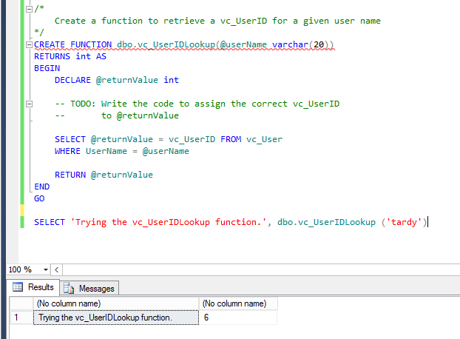

#### dbo.vc_TagVidCastCount

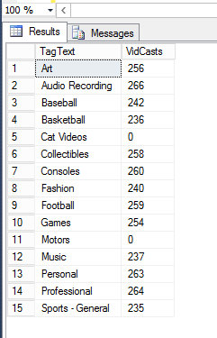

#### vc_VidCastDuration

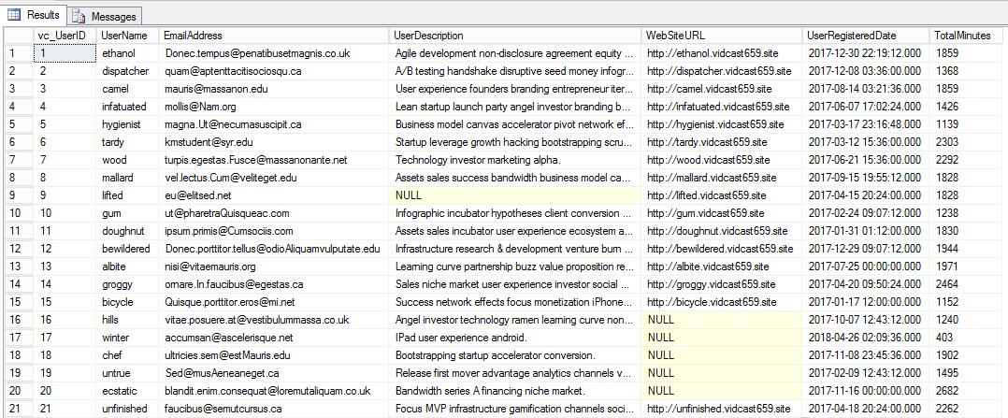

### Coding your own Views

#### Vc_TagReport View

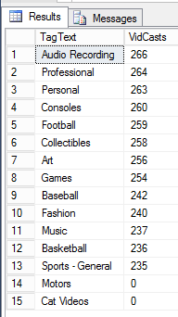

#### Altered vc_MostProlificUsers

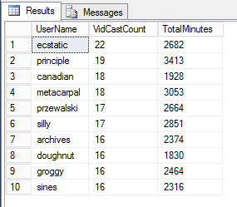

### Coding your own Stored Procedures

#### Add new Tag Stored Procedure

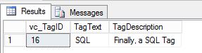

#### Vc_FinishVidCast

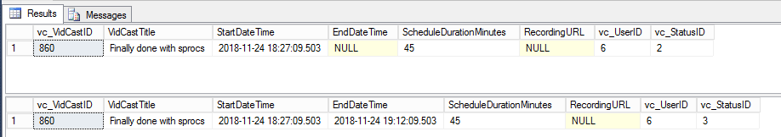

# SQL Used

-- Declare a variable

declare @isThisNull varchar(30) -- Starts out as NULL

SELECT @isThisNull, ISNULL(@isThisNull, 'Yep, it is null') -- see?

-- Set the variable to somethin gother than NULL

SET @isThisNull = 'Nope. It is not NULL'

SELECT @isThisNull, ISNULL(@isThisNull, 'Yep, it is no null') -- how about now??

CREATE FUNCTION dbo.AddTwoInts(@firstNumber int, @secondNumber int)

RETURNS int AS

BEGIN

-- First, declare the variable to temporarily hold the result

DECLARE @returnValue int -- the data time matches the RETURNS clause

-- Do whatever needs to be done to set that variable to the correct value

SET @returnValue = @firstNumber + @secondNumber

-- Return the value to the calling statement

RETURN @returnValue

END

GO

SELECT dbo.AddTwoInts(5,10)

-- Function to count the VidCasts made by given User

CREATE FUNCTION dbo.vc_VidCastCount(@userID int)

RETURNS int AS -- COUNT() is an integer value, so return it as an int

BEGIN

DECLARE @returnValue int -- matches the function's return type

/*

Get the count of the VidCasts for the provided UserID and

assign that value to @returnValue. Note that we use the

@userID parameter in the WHERE clause to limit our count

to that user's VidCast recrods.

*/

SELECT @returnValue = COUNT(vc_UserID) FROM vc_VidCast

WHERE vc_VidCast.vc_UserID = @userID

-- Return @returnvalue to the calling code

RETURN @returnValue

END

GO

SELECT TOP 10

*,

dbo.vc_VidCastCount(vc_userID) as VidCastCount

FROM vc_User

ORDER BY VidCastCount DESC

GO

-- Function to retrieve the vc_TagID for a given tag's text

CREATE FUNCTION dbo.vc_TagIDLookup(@tagText varchar(20))

RETURNS int AS -- vc_TagID is an int, so we will match that

BEGIN

DECLARE @returnValue int -- Matches the function's return type

/*

Get the vc_TagID of the vc_Tag record whose TagText

matches the parameter and assign that value to @returnValue

*/

SELECT @returnValue = vc_TagID FROM vc_Tag

WHERE TagText = @tagText

-- Send the vc_TagID back to the caller

RETURN @returnValue

END

GO

-- Test our function

SELECT dbo.vc_TagIDLookup('Music')

SELECT dbo.vc_TagIDLookup('Tunes')

-- Create a view to retrieve the top 10 vc_Users and their

-- VidCast counts

CREATE VIEW vc_MostProlificUsers AS

SELECT TOP 10

*,

dbo.vc_VidCastCount(vc_UserID) as VidCastCount

FROM vc_User

ORDER BY VidCastCount DESC

GO

-- Select all from this new view

SELECT * from vc_MostProlificUsers

-- Create a procedure to update a vc_User's email address

-- the first parameter is the user name for the user to change

-- the second is the new email address

CREATE PROCEDURE vc_ChangeUserEmail(@userName varchar(20), @newEmail varchar(50))

AS

BEGIN

UPDATE vc_User SET EmailAddress = @newEmail

WHERE UserName = @userName

END

GO

-- Execute the stored procedure

EXEC vc_ChangeUserEmail 'tardy', 'kmstudent@syr.edu'

SELECT * from vc_User WHERE UserName = 'tardy'

INSERT INTO vc_Tag (TagText) VALUES ('Cat Videos')

SELECT * FROM vc_Tag WHERE vc_TagID = @@identity

/*

Create a procedure that adds a row to the UserLogin tabl

This procedure is run when a user logs in and we need

to record who they are and from where they're logging in

*/

CREATE PROCEDURE vc_AddUserLogin(@userName varchar(20), @loginFrom varchar(50))

AS

BEGIN

-- We have the user name, but we need tthe ID for the login table

-- First, declare a variable to hold the ID

DECLARE @userID int

-- Get the vc_userID for the UserName provided and store it in the UserID

SELECT @userID = vc_UserID FROM vc_User

WHERE UserName = @userName

-- Now we can add the row using the INSERT statement

INSERT INTO vc_UserLogin (vc_userID, LoginLocation)

VALUES (@userID, @loginFrom)

-- Now return the @@identity (unique identity key) so the calling code

-- knows where the data ended up

RETURN @@identity

END

GO

DECLARE @addedValue int

EXEC @addedValue = vc_AddUserLogin 'tardy', 'localhost'

SELECT

vc_User.vc_UserID,

vc_User.UserName,

vc_UserLogin.userLoginTimestamp,

vc_UserLogin.LoginLocation

FROM vc_user

JOIN vc_UserLogin on vc_User.vc_UserID = vc_UserLogin.vc_UserID

WHERE vc_UserLoginID = @addedValue

/*

Create a function to retrieve a vc_UserID for a given user name

*/

CREATE FUNCTION dbo.vc_UserIDLookup(@userName varchar(20))

RETURNS int AS

BEGIN

DECLARE @returnValue int

-- TODO: Write the code to assign the correct vc_UserID

-- to @returnValue

SELECT @returnValue = vc_UserID FROM vc_User

WHERE UserName = @userName

RETURN @returnValue

END

GO

SELECT 'Trying the vc_UserIDLookup function.', dbo.vc_UserIDLookup ('tardy')

/*

Create a fucntion called dbo.vc_TagVidCastCount that calculates the count

of vc_VidCastIDs for a given vc_TagID.

*/

CREATE FUNCTION dbo.vc_TagVidCastCount(@Tag_ID int)

-- COUNT() is an integer value, so return it as an int

RETURNS int AS

BEGIN

DECLARE @returnValue int -- matches the function's return type

/*

Get the count of the VidCasts for the provided TagID and

assign that value to @returnValue. Note that we use the

@TagID parameter in the WHERE clause to limit our count

to those VidCast with the TagID passed to the function.

*/

SELECT @returnValue = COUNT(vc_VidCastID)

FROM vc_VidCastTagList

JOIN vc_Tag on vc_VidCastTagList.vc_TagID = vc_Tag.vc_TagID

WHERE vc_VidCastTagList.vc_TagID = @Tag_ID

-- Return @returnvalue to the calling code

RETURN @returnValue

END

GO

-- Test function

SELECT

vc_Tag.TagText,

dbo.vc_TagVidCastCount(vc_Tag.vc_TagID) as VidCasts

FROM vc_Tag

/*

Function vc_VidCastDuration that sums the total number of minutes of

actual duration of VidCasts with a Finished Status given a specific

vc_UserID as a parameter. Should return the SUM as an integer

*/

CREATE FUNCTION dbo.vc_VidCastDuration(@User_ID int)

-- SUM() is an integer value, so return it as an int

RETURNS int AS

BEGIN

DECLARE @returnValue int -- matches the function's return type

/*

Get the sum of the vidcast actual durations for the

provided @User_ID tag and assign that value to @returnValue.

Note that we use the @User_ID parameter in the WHERE clause

limit our sum to those VidCast associated with @User_ID

that was passed to the function.

*/

SELECT @returnValue = SUM(DATEDIFF(n, StartDateTIme, EndDateTime))

FROM vc_VidCast

INNER JOIN vc_User ON vc_VidCast.vc_UserID = vc_User.vc_UserID

INNER JOIN vc_Status on vc_VidCast.vc_StatusID = (SELECT vc_Status.vc_StatusID FROM vc_Status where vc_Status.StatusText = 'Finished')

WHERE vc_VidCast.vc_UserID = @User_ID AND vc_Status.StatusText = 'Finished'

GROUP BY vc_VidCast.vc_UserID

-- Return @returnvalue to the calling code

RETURN @returnValue

END

GO

-- Test function

SELECT

*,

dbo.vc_VidCastDuration(vc_UserID) as TotalMinutes

FROM vc_User

/*

Create a View to hold the TagText and the total number of VidCasts

that are tagged with that text

*/

CREATE VIEW vc_TagReport AS

SELECT TOP 15

vc_Tag.TagText,

dbo.vc_TagVidCastCount(vc_Tag.vc_TagID) as VidCasts

FROM vc_Tag

ORDER BY VidCasts DESC

GO

-- test new view

SELECT * from vc_TagReport

-- Alter a view to retrieve the top 10 vc_Users and their

-- VidCast counts adding in the total VidCastDuration

ALTER VIEW vc_MostProlificUsers AS

SELECT TOP 10

*,

dbo.vc_VidCastCount(vc_UserID) as VidCastCount,

dbo.vc_VidCastDuration(vc_UserID) as TotalMinutes

FROM vc_User

ORDER BY VidCastCount DESC

GO

-- Select all from this altered view

SELECT UserName, VidCastCount, TotalMinutes

FROM vc_MostProlificUsers

/*

Create a stored procedure to add a new Tag to the database

Inputs:

@Tag_Text : the text of the new tag

@description : a brief description of the tag (nullable)

Returns:

@@identity with the value inserted

*/

CREATE PROCEDURE vc_AddTag(@Tag_Text varchar(20), @description varchar(100)=NULL) AS

BEGIN

--- Code Procedure Here

INSERT INTO vc_Tag

(TagText, TagDescription)

VALUES

(@Tag_Text, @description)

RETURN @@identity

END

GO

DECLARE @newTagID int

EXEC @newTagID = vc_AddTag 'SQL', 'Finally, a SQL Tag'

SELECT * FROM vc_Tag WHERE vc_TagID = @newTagID

/*

vc_FinishVidCast Stored Procedure

Inputs : @Vid_CastID (integer) - that will need to be marked as Finished

To accomplish this, we need to change the EndDateTime in the vc_VidCast table to the current date/time - GetDate()

and then change the StatusID on the Vid_CastID to match the vc_StatusID in the Status table for Finished

- the change vc_StatusID will be updated to this value in the vc_VidCast table

*/

CREATE PROCEDURE vc_FinishVidCast(@Vid_CastID int) AS

BEGIN

--- Code Procedure Here

-- Update the VidCast EndDate to now

UPDATE vc_VidCast

SET

vc_StatusID = (SELECT vc_StatusID FROM vc_Status WHERE StatusText = 'Finished'),

EndDateTime = GETDATE()

WHERE vc_VidCastID = @Vid_CastID

RETURN @@identity

END

GO

DECLARE @newVC int

INSERT INTO vc_VidCast

(VidCastTitle, StartDateTime, ScheduleDurationMinutes, vc_UserID, vc_StatusID)

VALUES

('Finally done with sprocs',

DATEADD(n, -45, GETDATE()),

45,

(SELECT vc_UserID FROM vc_User WHERE UserName = 'tardy'),

(SELECT vc_StatusID FROM vc_Status WHERE StatusText = 'Started'))

SET @newVC = @@identity

SELECT * FROM vc_VidCast WHERE vc_VidCastID = @newVC

EXEC vc_FinishVidCast @newVC

SELECT * FROM vc_VidCast WHERE vc_VidCastID = @newVC