# Lab 09

## Part 1 – Securing Data Objects

### Creating a Database User

Here is the code and results from creating the *guestuser* using SQL.

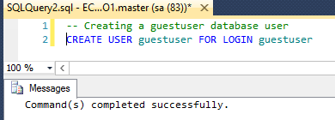

### Managing a User’s Permission

Select all from vc_UserLogin table.

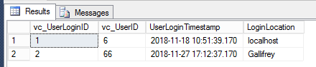

After updating the “Rock Your Way to Success” VidCast to Finished by the *guestuser*



#### SQL Used for this exercise

##### Sa tab

-- Grant read permissions on this user table

GRANT SELECT ON vc_User to guestuser

-- revoke vc_User rights

REVOKE SELECT ON vc_User to guestuser

-- give them view rights instead

GRANT SELECT ON vc_MostProlificUsers to guestuser

--Grant various rights

--GRANT SELECT, UPDATE, INSERT, DELETE ON vc_User to guestuser

-- Allow guestuser to run some stored procedures

GRANT EXECUTE ON vc_AddUserLogin TO guestuser

GRANT EXECUTE ON vc_FinishVidCast TO guestuser

-- select all from UserLogin to show results of adding new user as guestuser

SELECT * from vc_UserLogin

-- find out what user has this vidcast

SELECT * from Vc_Vidcast where VidCastTitle = 'Rock Your Way to Success'

-- check user name from the userid returned from statement above

SELECT * from vc_User where vc_UserID = 62

-- verify that the status is NOT finished by checking the vc_StatusID against all the status

select * from vc_Status

-- Start the vidcast

DECLARE @newVC int

INSERT INTO vc_VidCast

(VidCastTitle, StartDateTime, ScheduleDurationMinutes, vc_UserID, vc_StatusID)

VALUES

('Rock Your Way to Success',

DATEADD(n, -63, GETDATE()),

63,

(SELECT vc_UserID FROM vc_User WHERE UserName = 'humdrum'),

(SELECT vc_StatusID FROM vc_Status WHERE StatusText = 'Started'))

-- set @newVC as the ID (861 as found) for the record

SET @newVC = @@identity

SELECT * FROM vc_VidCast WHERE vc_VidCastID = @newVC

SELECT * FROM vc_VidCast WHERE vc_VidCastID = 861

##### Guestuser tab

-- Guest user tab

SELECT * FROM vc_User

select * from vc_MostProlificUsers

DECLARE @addedvalue int

-- Add the user using the procedure we can access with our permissions

EXEC @addedvalue = vc_AddUserLogin 'TheDoctor', 'Gallifrey'

-- Finish the vidcast 861

EXEC vc_FinishVidCast 861

## Part 2 – Data Integrity Through Transactions

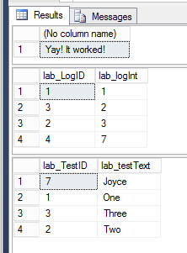

It is very clear why the first transaction failed and the second did not, and it appears in the messages pain, so I feel like I am cheating, but I would have guessed that anyway.

The lab_testText is set a UNIQUE and we already had a ‘One’ in that table, so when we tried to insert it again – it failed. However, since ‘Joyce’ was not in the table, it succeeded. This is working as I expected that it would.