# Introduction

Use Google analytics to analyze the data to identify patterns and opportunities of the Whiteman School of Management internet recruiting campaigns. Our goal is to recruit the best United States students, measured by GMAT scores, but we are limited to a budget of $100,000. The budget must cover advertising costs, but no Whitman administration costs.

Budget $100,000

# Questions

## Question 1

What were the time frames for each marketing campaign? How much was spent on each campaign? What was the effectiveness of previous campaigns? (40%)

1. whitman.syr.edu
2. MBA Marketing – Full-time
3. MBA Marketing – iMBA
4. Delta

The table below shows the time frames for each campaign.

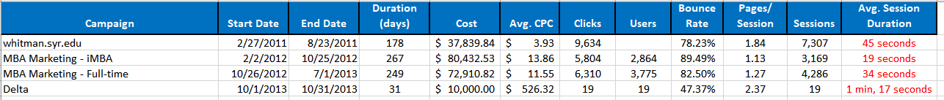

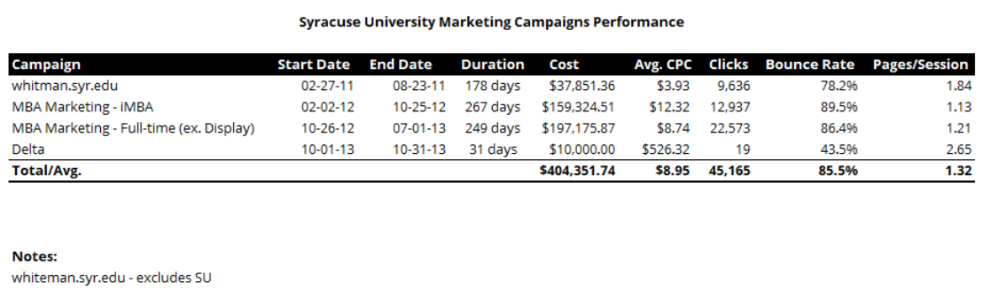

Based on the information in the table provided, the *whitman.syr.edu* campaign was the most successful. The campaign ran for a short time than the MBA Marketing campaigns (almost 100 days less) and cost about half as much. The cost per click was significantly lower as was the bounce rate at 78.23%. The number of pages per session was also higher than the other campaigns as was the average session duration. This campaign also generated almost twice the number of sessions over the other campaigns. Overall, this campaign was a better “bang for the buck” than the other campaigns.

## Question 2

Identify the key aspects of a United States campaign for next year (20%)

1. In which geographic region would you advertise? Which states? Why?

** Need to check how to get US traffic only **

1. What key words would you use? Why?

It does not look like many keywords were successful or possibly part of the original campaign, but “MBA” was a successful keyword.

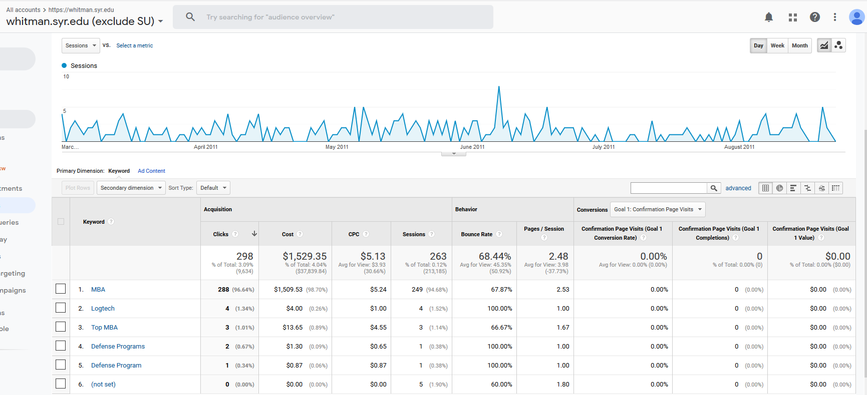

Reviewing the activity based on this keyword, we see that although the cost per click is $5.34, the bounce rate is low at 68.44%.

Based on this information, we would definitely use the keyword “MBA” again.

** What about “online MBA” or “certified MBA” – maybe check other campaigns?

1. Which days of the week and what time of day would you advertise? Why?

Based on the campaign activity by hour, we would suggest advertising starting at 3:45 PM EST until 1:00 AM EST. This is when traffic is most significant and would minimize our costs if we did not run the campaign during hours when traffic is insignificant.

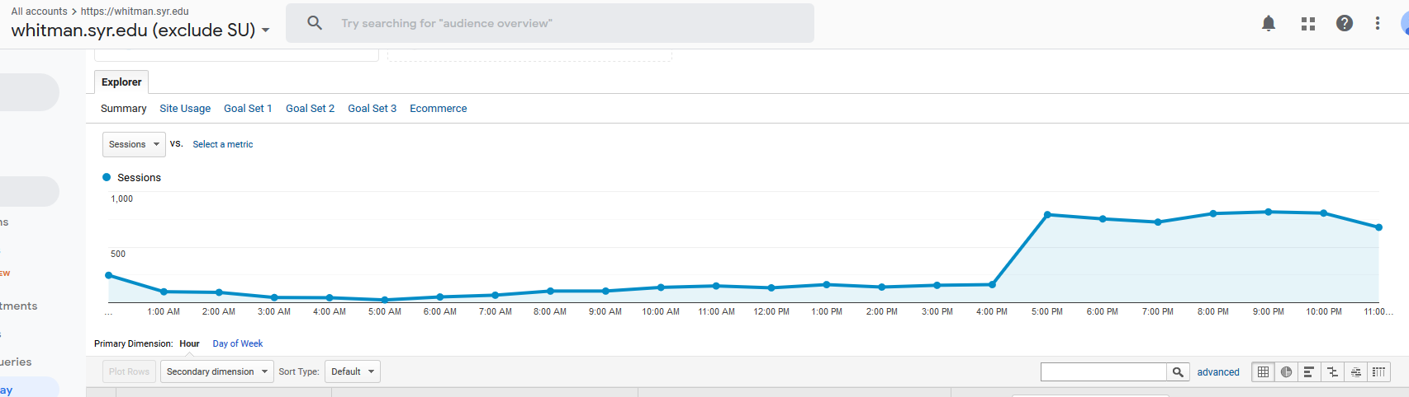

For days of the week, the campaign is most active between Saturday (day 6) and Tuesday (day 2). So, for a new US campaign, I would suggest starting the campaign at 1:00 AM on Saturday morning and run it until 1:00 AM on Wednesday morning taking into account the most active days of the week and times of day.

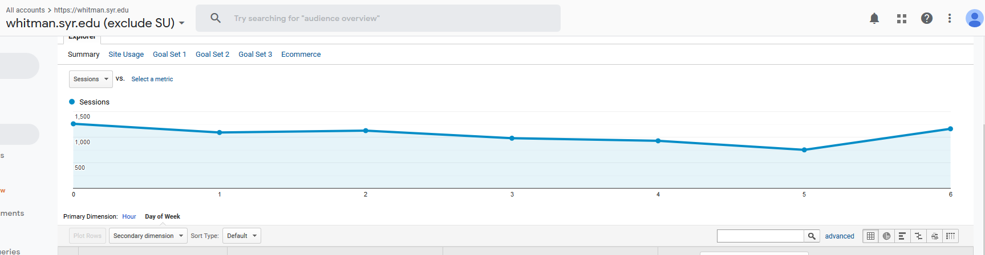

## Question 3

Identify the costs for your advertising campaigns (10%)

1. By region
2. By degree program

## Question 4

How would you measure performance of your decisions after implementation? (20%)

## Question 5

What other factors or considerations are important? What other data would help in developing an Internet advertising strategy, if you could collect it? (10%)

Maybe design the program to be more mobile friendly, as there was quite a bit of traffic on mobile. This is a very common platform for college-age individuals and maybe if the pages were enhanced to make mobile access easier/more aesthetically pleasing, this would help bring in more individuals in this age group.

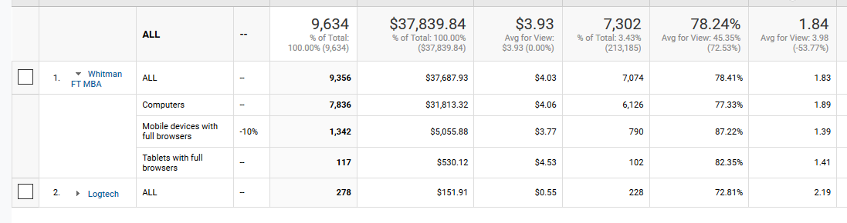

# Appendix

Whitman.syr.edu

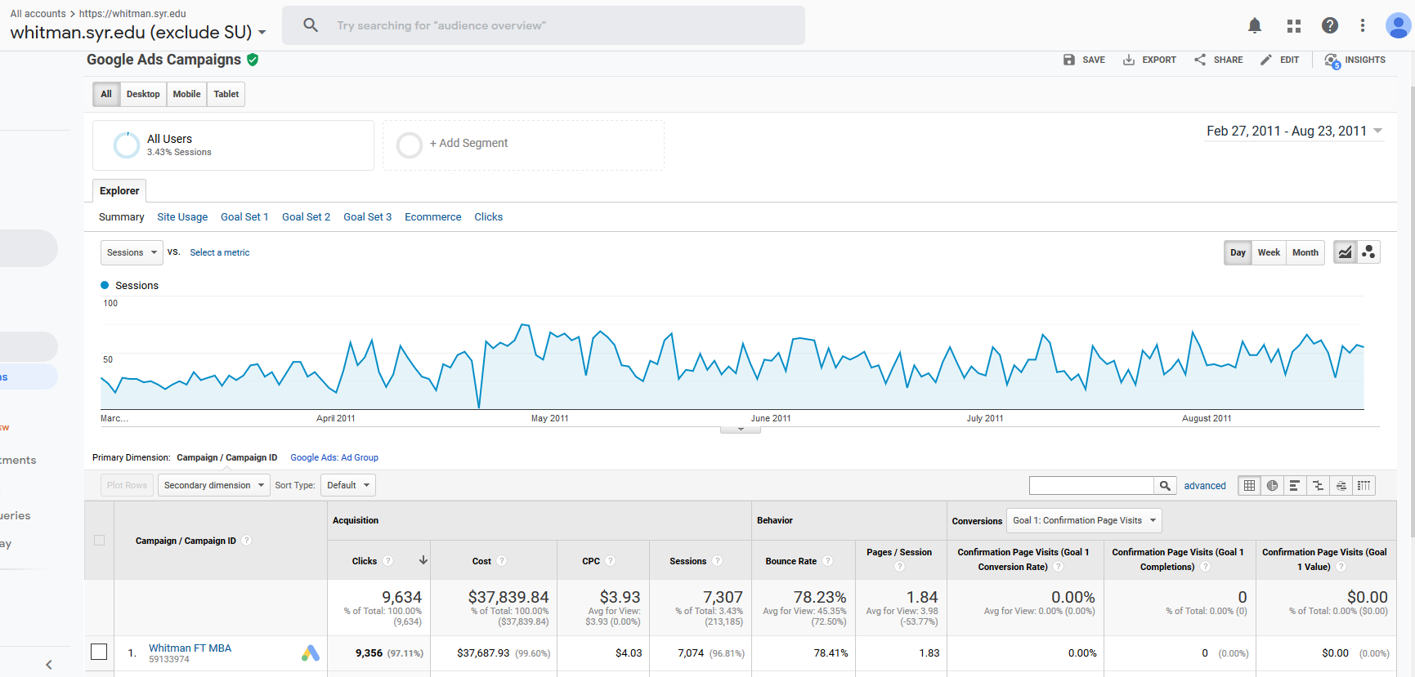

MBA – Full time

iMBA

Delta campaign

