Clifford Forrester, Kathleen Fox, Mashundra Maclin, Courtney Smith, and Joyce Woznica

TEam 73  
Homework #2

Recruiting Advertising Strategy

Contents

Introduction 1

#1 – Campaign Effectiveness 1

#2 – Key Aspects of a United States Campaign 2

A – Geographic Region 2

B - Keywords 3

C - Day of Week and Hours of Day 5

Day of the Week 5

Hour of Day 6

#3 – Campaign Costs 8

A – By Region 8

B - By degree program 9

#4 – Performance Measurements 9

#6 – Factors and Considerations 10

List of Figures

Figure 1: Syracuse University Marketing Campaign Performance 1

Figure 2: Syracuse University Marketing Campaign Performance - Normalized 1

Figure 3: Campaign Performance by State ranked by Sessions 3

Figure 4: Campaign Performance by State – Normalized – ranked by Sessions 3

Figure 5: Keyword Performance by Campaign 4

Figure 6: Keywords for New Campaign 5

Figure 7: Percent of Sessions by Day of the Week 5

Figure 8: Day of the Week – Metrics Index 6

Figure 9: Budget Allocation for each Day of the Week 6

Figure 10: Percent of Sessions by Hour-of-Day 7

Figure 11: Hour of Day Metrics Index 8

Figure 12: State Budget Allocation – Accounting 80% of Total Session 9

Figure 13: Budget Allocation by Degree Program 9

# Introduction

In this exercise, we will be using Google Analytics to examine the Whitman Graduate Programs Internet marketing campaigns. We will be analyzing data to identify patterns and opportunities. Our goals are to recruit the best United States students, measured by GMAT scores. However, for these campaigns, we are limited to a budget of only $100,000. This must cover all of our advertising costs, but not the Whitman administration costs.

To do this analysis, we will be executing the following:

* Campaign Effectiveness (Question #1)
* United States Campaign (Question #2)
* Campaign Costs (Question #3)
* Performance Measurements (Question #4)
* Factors and Considerations (Question #5)

# #1 – Campaign Effectiveness

We gathered data from Google Analytics by reviewing the Google Ad/Campaigns within the Google Analytics interface. We used information about number of sessions, users, etc. to determine the start and end dates, total amount spent and other performance metrics for each campaign as noted in the table in Figure 1.

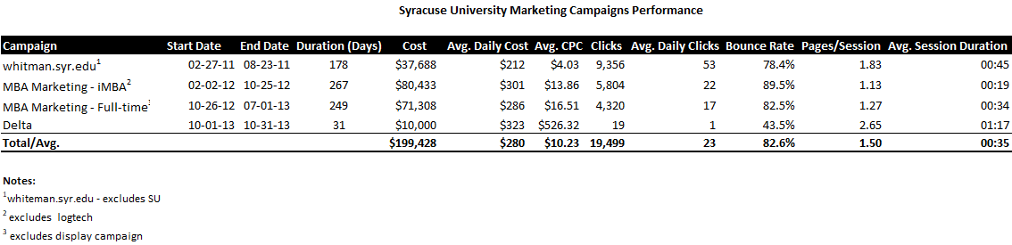

Figure 1: Syracuse University Marketing Campaign Performance

To be able to better analyze this data, we normalized the performance data relative to total performance which is reflected in Figure 2.



Figure 2: Syracuse University Marketing Campaign Performance - Normalized

As reflected in the tables on the previous page:

* The *whitman.syr.edu* campaign
  + Start Date: 2/27/11
  + End Date: 8/23/11
  + Total Spent over timeframe: $37.7K
* The *MBA Marketing – iMBA* campaign
  + Start Date: 2/02/12
  + End Date: 10/25/12
  + Total Spent over timeframe: $80.4K
* The *MBA Marketing – Full-time* campaign
  + Start Date: 10/26/12
  + End Date: 7/01/13
  + Total Spent over timeframe: $71.3K
* The Delta campaign
  + Start Date: 10/1/13
  + End Date: 10/31/13
  + Total Spent over timeframe: $10K

Overall, the *whitman.syr.edu* campaign was the best performing campaign. As shown in Figure 2 with the normalized data, the average daily cost was 25% lower when compared to aggregate performance, with average daily clicks 118% higher at a more efficient average Cost Per Click (CPC) (61% lower). Further, users visited more pages in each session (+22%), which helped increase the average session duration (+30%).

# #2 – Key Aspects of a United States Campaign

## A – Geographic Region

When we researched in which states to advertise for next year’s campaign, we considered both traffic volume and site behavior. We approached our research by investigating those states which accounted for 80% of all sessions and elected to focus on these areas. However, we identified the state of Illinois as a bad candidate for Google Ad campaigns because of an over-indexes on bounce rate (+21%), and under-indexes on pages per session and session duration (-14% and -25%, respectively). However, we still generate more non-bounce traffic than if we were to advertise in two or three smaller states due to Illinois’ traffic volume.

Note: An index compares specific data points to a baseline value. For example, if we wanted to create an index for pages per session, we would divide 1.83 (whitman.syr.edu pages/sessions) by 1.50 (the overall average) to get an index value of 122%. It essentially means that users who engaged with the whitman.syr.edu campaign visited 22% more pages per session.

The details used in our research around prospective states for advertising in next year’s campaign can be found in Figure 3 and Figure 4 on the following page.



Figure 3: Campaign Performance by State ranked by Sessions



Figure 4: Campaign Performance by State – Normalized – ranked by Sessions

## B - Keywords

The tables found in Figure 5 summarize keyword performance for each marketing campaign.

* The *whitman.syr.edu* campaign appears to largely be a display campaign (evident by the ‘content targeting’ parameter passed to Google Analytics).
* The Full-Time campaign’s keywords are not relevant for the campaign’s purpose of driving only on-campus student enrollments. For example, the keyword ‘online MBA’ is not relevant if the ad copy/campaign purpose is to target potential on-campus students. Additionally, on-campus students are required to table the GMAT, thus keywords like “MBA No GMAT”, and ‘MBA without GMAT” provide a poor user experience, and could potentially decrease quality score due to high bounce or exit rate, low click-through rate, etc.
* The keywords in the iMBA campaign are more targeted by qualifying the type of MBA a student is looking for (e.g., “online MBA”, “distance learning MBA”). However, some keywords are too broad (e.g., “MBA” and “MBA no GMAT”) for this campaign’s focus. Short-tail keywords are generally higher volume keywords, thus can be significantly more expensive to bid on.

Note: Additionally, there is overlap in the keywords bidding bid on in the Full-Time and iMBA campaigns, which could artificially drive up the CPC as we are essentially competing with ourselves in the auction.



Figure 5: Keyword Performance by Campaign

Based on our findings, we would restructure the campaigns to bid on the following phrase and exact match keywords in ensure highly relevant ads and landing pages are delivered to searchers.



Figure 6: Keywords for New Campaign

## C - Day of Week and Hours of Day

### Day of the Week

The chart below illustrates the percent of sessions by day of week. Saturday through Tuesday are our highest traffic days, and begins to trend down beginning Wednesday. Friday is our lowest traffic day, representing 10% of total traffic.

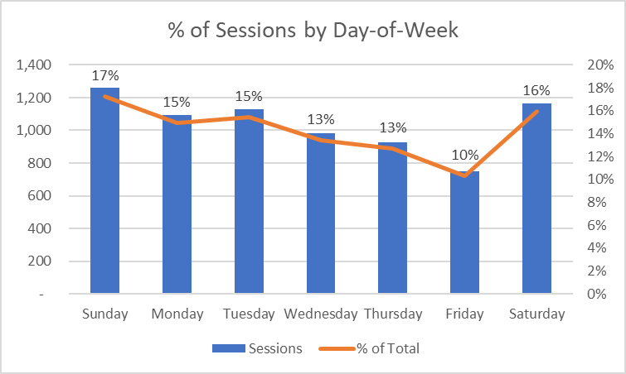

Figure 7: Percent of Sessions by Day of the Week

While bounce rate, pages per session, and average session duration fluctuate slightly day-to-day, no one day deviates more than 10% from the weekly average for each Key Performance Indicator (KPI). Based on this, we would not recommend turning off campaigns since no day severely underperforms relative to other days of the week.



Figure 8: Day of the Week – Metrics Index

Despite the fact certain days of the week did not provide significant traffic, we felt it was important to keep the campaign available on all days of the week in case trends changed. Based on the distribution of sessions by day of week, we would allocate the following amounts for each day as shown in Figure 9. Since a day-of-week budget cannot be applied in Google Ads, we would utilize automated rules as a workaround. Automated rules will enable us to create rules to increase or decrease a budget based on a condition, such as day of week.



Figure 9: Budget Allocation for each Day of the Week

### Hour of Day

In reviewing the hours when the campaigns had the most sessions, you can see that a significant jump was made after work hours from Hours 5PM – 12AM EST. In fact, this represents 77% of total sessions in a given day as reflected in Figure 10.

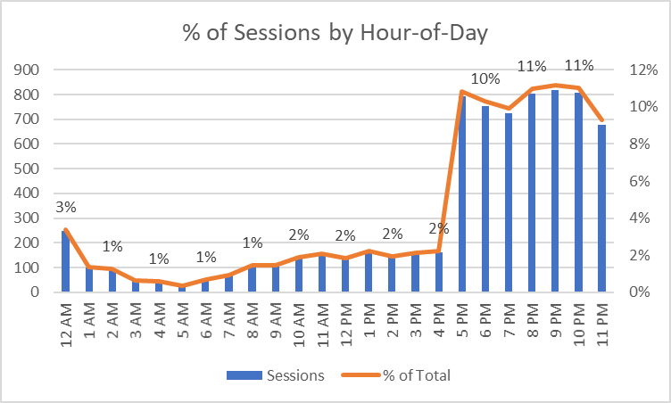

Figure 10: Percent of Sessions by Hour-of-Day

The table shown in Figure 11 compares the normalized values for bounce rate, pages per session, and average session duration across hours. The 4AM hour underperforms across all metrics based on a +/-10% threshold relative to the daily average. (+11% bounce rate, -23% fewer pages per session, -16% lower session duration), thus would set a -100% bid multiplier for hour. Additionally, the 12PM – 1PM hours have some of the lowest session durations relative to other hours (~31% - 36% lower), coupled with a 4%-7% higher bounce rate and 3%-9% lower pages per session, thus would be hours we would also set negative bid multipliers.



Figure 11: Hour of Day Metrics Index

# #3 – Campaign Costs

## A – By Region

Based on the states previously selected where it would make the most sense to advertise (see section A – Geographic Region beginning on page 5), we calculated the average daily budget for each region. As these states represent approximately 80% of total sessions, we normalized the representation and multiplied the average daily budget ($1,918) by this ratio to determine a state-level budget. For example, New York represents 44.8% of total sessions. To normalize this percentage, we divided 44.8% by 80.7% to get the percent it represents based on this subset (55.5%). We then multiplied 55.5% by $1,918 to get an average daily budget of $1,065.



Figure 12: State Budget Allocation – Accounting 80% of Total Session

## B - By degree program

We would allocate 50% of the total budget across the Full-Time and iMBA campaigns. While the Full-Time campaign historically had higher CPCs and lower traffic volume than the iMBA campaign, this could be because the campaign was bidding on irrelevant keywords, driving up the minimum we must bid to appear in the auction. By improving our quality score, we can more efficiently drive traffic via the full-time campaign. However, we will closely monitor performance and shift budget away from the full-time campaign if it under-performs in order to efficiently recruit students to the Syracuse MBA program (either on-campus or online).



Figure 13: Budget Allocation by Degree Program

# #4 – Performance Measurements

As we reviewed the previous campaigns and determined that the we would use the *whitman.syr.edu* campaign “Whitman FT MBA” campaign as a baseline for our performance measurement. We selected this campaign because we felt it was the best performing campaign (see section #1 – Campaign Effectiveness beginning on page 3). Using this as a baseline, we determined the following performance metrics:

* Maintain an average cost per click (CPC) of less than $4.03
* Maintain a bounce rate of less than 78.41%
* Increase the average pages per session to more than 1.84
* Increase the average time per session to more than 45 seconds. This is one area where the previous campaign did not perform as well as we would have liked.
* Maintaining or increase sessions over 7,300

Ideally, we would like to perform at a higher rate than previous campaigns, but without conversion rate information, it is more difficult to come up with realistic success metrics for the new campaign. This is why we elected to use a previous campaign as a benchmark to meet or exceed.

Please see the section entitled #6 – Factors and Considerations beginning on page 4 for additional factors and considerations that would help us review our campaign performance. If we could set a desired conversion rate, we could use this information in our performance metric as well.

# #6 – Factors and Considerations

Additional performance signals that are important to consider include impressions, click-through rate, conversions/goal completions, cost per conversion/goal completion, and hourly cost for campaigns.

By having impression data, we can calculate click-through rate to get a sense of relevance for our keyword/ad combinations – for example, if particular keyword/ad combinations resulted in a very low click-through rate, we might adjust our strategy to exclude that keyword as it doesn’t appear to be relevant, or A/B test ad copy to improve click-through rate.

Additionally, by setting up conversion/goal completion tracking, we could better analyze the efficacy of our efforts. While session duration, pages per session, and bounce rate are adequate measures of performance, having conversion/goal completions would allow us to see a more complete picture. Without having this data, we don’t know if someone who came in on a high CPC keyword and had a short session duration ultimately didn’t find value in the Whitman site, or quickly found what they needed and submitted a request for additional information. Further, we could better efficiency by calculating the cost per conversion. This will allow us to better allocate marketing funds to the most efficient areas.

Lastly, hourly campaign data is null in Google Analytics. It would be helpful to either have this available, or have read-only access to Google Ads to view this data. This would make it possible to calculate hourly bid multipliers based on historical CPCs, traffic, and conversion data.

We determined that there were many factors and considerations that would be pertinent to a successful campaign. The first of these was the GMAT score. We have been asked to create a successful campaign for United States students with the highest GMAT scores. If we want to truly see the details of how our campaign helped us to recruit those with the highest scores, it would be important to gather the GMAT scores from those that go to our site via the Google Ad campaign.

Another item we felt might help the campaign is to open up or run an additional campaign for those without the highest GMAT scores. There are many successful college students that are over 30 years of age that are going back to college to increase their skill sets to be more competitive. By running a campaign without the concern of GMAT scores for those that may have taken the GMAT quite some ago or not at all could increase university enrollment in the MBA program significantly. This is apparent by the information gathered around keywords and other campaigns specific to online or distance learning.