Clifford Forrester, Kathleen Fox, Mashundra Maclin, Courtney Smith, and Joyce Woznica

TEam 73  
Homework #3

Optimizing Product Pricing

Contents

Introduction 1

Definitions 1

Assumptions 1

#1 Regression Analysis 2

#1b – Power Regression 2

#1bi – Graphing the Curve 2

#1bii –Equation of the Line 3

#1biii – R2 Meaning 3

#1c – Estimation of Number of Books Sold 3

#1d – Calculation of Revenue 3

#1e – Calculation of Profit 4

#1f – Profit Values for Prices 5

#2 – Optimization Analysis 5

#2a – Price Point for Highest Profit 5

#2ai – Publisher Price of $5.00 and no Minimum Order 5

#2aii – Publisher Price of $4.50 and at least 30,000 books 6

#2aiii – Publisher Price of $4.00 and at least 50,000 books 6

#2b – Constrained Optimization 6

#3 - Discussion 6

#3a - Risks 6

#3b – Additional Data 6

List of Figures

Figure 1: Percentage of Books Purchased vs Book Sale Price 2

Figure 2: Percentage of Books Purchased vs Book Sale Price Showing Power Regression Predicted Line 2

Figure 3: Predicted Sales Column Based on Assumptions 3

Figure 4: Revenue Column Based on Assumptions 4

Figure 5: Profit Column Based on Assumptions 4

Figure 6: Conditional Formatting of the Profit Column Based on Assumptions 5

Figure 7: Highest Profit for $5.00 Book and no Minimum Order 5

Figure 8: Highest Profit for $4.50 Book and Minimum Order of 30,000 6

Figure 9: Highest Profit for $4.00 Book and Minimum Order of 50,000 6

# Introduction

The Book Emporium wants to price books to optimize profits. To help achieve this goal, they have gathered data on the sale of the Harry Potter book 7. Each week, the Book Emporium varied their prices on this book to determine a demand curve. They also gathered information on the percent of customers that visited the website and purchased the Harry Potter 7 book. For this exercise, we are working on the assumption that J.K. Rowling has announced she will write a sequel to the Harry Potter series and we want to determine the optimal price point for the sequel.

## Definitions

The following reflects that the data gathered in the spreadsheet provided for the exercise.

* Price what you will charge each customer who purchases the new book
* Book Cost what you must pay the publisher for each book
* % purchased in your pricing test, the percent of people who bought at that price
* Predicted % your regression model estimate of the percent sold based on price
* Predicted sales estimate of number of customers who buy the book from you
* Revenue total revenue generated (price * predicted sales)
* Profit (price – book cost) * predicted sales

## Assumptions

The following assumptions will be used to

1. Assume that the demand for the book sequel will be similar to Harry Potter 7.
2. Assume that 100,000 customers will consider purchasing a book from you
3. The data is not an entirely accurate prediction of the demand, but a regression on the data using a power model will give a reasonable prediction
4. Assume that you pay the publisher $5.00 for each book.

# #1 Regression Analysis

Regression analysis (40%) a. Graph the percent purchased against price (5%)

To graph the percent purchased against price, the following graph was created.

Figure 1: Percentage of Books Purchased vs Book Sale Price

## #1b – Power Regression

Perform a regression using power regression to determine the predicted % column

Using power regression in the chart, we came up with the following graph to determine the predicted percentage of books purchased.

Figure 2: Percentage of Books Purchased vs Book Sale Price Showing Power Regression Predicted Line

### #1bi – Graphing the Curve

Graph the new curve (5%)

Please see the graph in Figure 2 to see the curve (shown in red font) for the prediction curve.

### #1bii –Equation of the Line

Estimate the equation of the line (5%)

As shown in the graph in Figure 2, the equation for the prediction curve is as follows:

$$y=14.098x^{-1.872}$$

### #1biii – R2 Meaning

What does the R2 mean? (5%)

In this set of data, our R2 was .9908 which is extremely close to 1 (a perfect correlation). This value means that 99.08% of the change in predicted sales percent is explained by the change in book price.

## #1c – Estimation of Number of Books Sold

Assuming there are 100,000 customers who visit your website and the publisher cost is $5.00, estimate the number of books sold (predicted sales column) (5%)

Using the assumption that there are 100,000 customers that visit our website for books and a publisher cost per book of $5.00, we created the predicted sales column shown marked with the yellow box in the figure below.

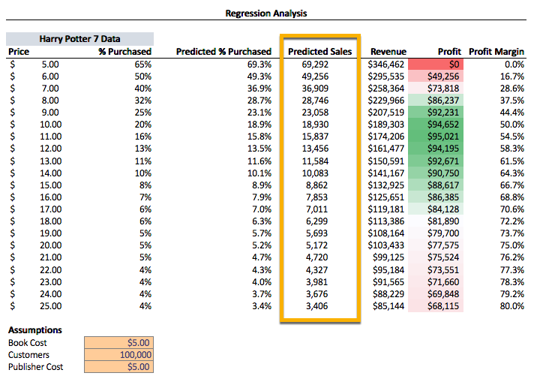

Figure 3: Predicted Sales Column Based on Assumptions

## #1d – Calculation of Revenue

Calculate the revenue column (price * predicted sales) (5%)

Using the assumption that there are 100,000 customers that visit our website to purchase books and a publisher cost per book of $5.00, we created the revenue column shown marked with the green box in the following figure (Figure 4).

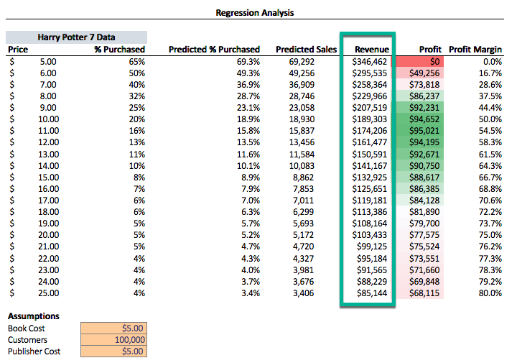

Figure 4: Revenue Column Based on Assumptions

## #1e – Calculation of Profit

Calculate the profit column ((price – book cost) * predicted sales) (5%)

Using the assumption that there are 100,000 customers that visit our website to purchase books and a publisher cost per book of $5.00, we created the revenue column shown marked with the purple box in the following figure (Figure 5).

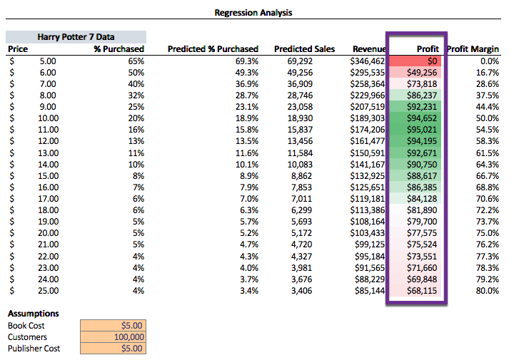

Figure 5: Profit Column Based on Assumptions

## #1f – Profit Values for Prices

Use conditional formatting to highlight the profit values for all prices (5%)

As shown in Figure 6, we used conditionally formatting that clearly indicates that between the values of $8.00 and $17.00 is where we would likely see the best profit if 100,000 customers visit the site, the prediction percentage purchased the book and the publisher cost to us is $5.00 for each book.

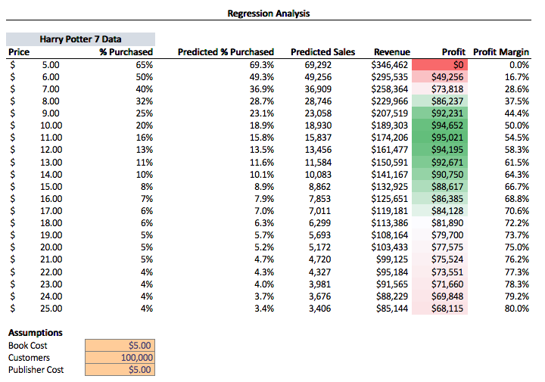

Figure 6: Conditional Formatting of the Profit Column Based on Assumptions

# #2 – Optimization Analysis

Optimization analysis (with constraints) (30%)

## #2a – Price Point for Highest Profit

Calculate the price point for the highest profit possible.

### #2ai – Publisher Price of $5.00 and no Minimum Order

The publisher will sell the books to you at $5.00 each with no minimum order (10%)

For no minimum order and a publisher price of $5.00 per book, the profit would be $95,066.94 (shown in Figure 7).

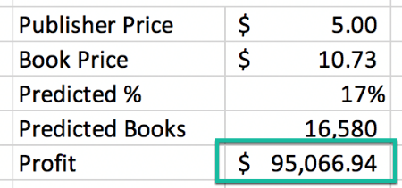

Figure 7: Highest Profit for $5.00 Book and no Minimum Order

### #2aii – Publisher Price of $4.50 and at least 30,000 books

The publisher has agreed to sell you the books at $4.50 each if you sell at least 30,000 (10%)

For a minimum order of at least 30,000 and a publisher price of $4.50 per book, the profit would be $99,586.50 (shown in Figure 8).

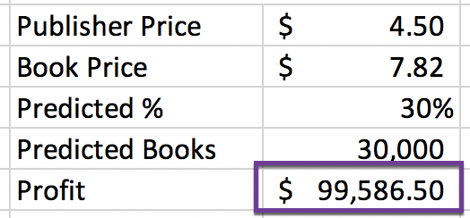

Figure 8: Highest Profit for $4.50 Book and Minimum Order of 30,000

### #2aiii – Publisher Price of $4.00 and at least 50,000 books

The publisher has agreed to sell you the books at $4.00 each if you sell at least 50,000 (10%)

For no minimum order and a publisher price of $4.00 per book, the profit would be $97,606.78 (shown in Figure 9).

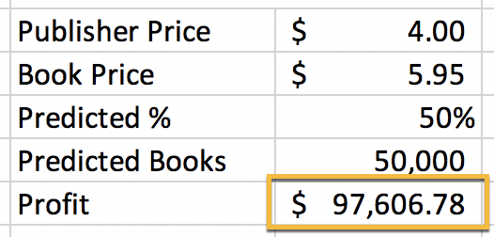

Figure 9: Highest Profit for $4.00 Book and Minimum Order of 50,000

## #2b – Constrained Optimization

Run a constrained optimization for each of the above situations to determine which cost point (from the publisher) and price (to your customer) maximizes your profit. Which cost point should you accept from the publisher?

Based on the constrained optimization we did using Solver for each of the situations in #2, the cost point (cost of book from the publisher) that maximizes profit is $4.50 with a minimum of 30,000 books in our order. We would need to sell this book at the price of $7.82 to achieve a maximum profit of $99,586.50.

# #3 - Discussion

Discussion (30%)

## #3a – Risks

What are the risks of using Harry Potter 7 data in predicting your new demand curve for the Harry Potter sequel? (15%)

There are several risks involved in using the *Harry Potter 7*’s historical data to predict the new demand for the Harry Potter sequel. Taking this approach can be highly impactful to the sales forecast because we are assuming that the market condition for the sequel would remain the same as that of the previous book. For example, it is possible that the demand for the new book (sequel) could be significantly lower because of a competing book on the market selling a much lower price. Alternatively, the first book could have saturated the market; therefore, the demand for the sequel would be very low. We may or may not have 100,000 customers that will be visiting the website, so using this assumption could provide misleading results. Additional factors that could negatively affective the demand of the book include the time of the year the book was released, the effectiveness of the marketing campaign for the sequel, or if the market conditions change unexpectedly.

## #3b – Additional Data

What other data would you like to have to perform your analysis? (15%)

There are several other data items that would be useful to perform our analysis. These include:

* What is our marketing strategy for the new book?
* Segment of the population that bought book *Harry Potter 7*
* Demography of the people that bought book *Harry Potter 7* (adults for their children, young adults, teens, etc.)
* Correlation data between sales of the book *Harry Potter 7* and release of the movie
* Additional data from various sales channels
* Release date for *Harry Potter 7* and the sequel (new releases before holidays can significantly increase sales, for example)
* Competitive information (to know if there were any book released at or around the same time)