***Pre-Condition:*** Read and analyze the User Story details. If candidate has a smart phone, the use case described can be replicated by deleting the existing instance of Chase Mobile App (if they already have this installed), then re-install or install the Chase Mobile App from the App Store.

Story Name:  [Display dual log on screen after app install](https://jira-digital.jpmchase.net/browse/IOSS-686)

##### Value Statement

As Bank, I want to display alternate/ dual log on screen for the first time when user launches app after app install

##### Requirements

* Displayed for the first time after app install
* When user taps enroll, user will land on Basic Info screen.
* When user taps Log on, user will land on BAU (Business As Usual) logon screen
  + Anytime after using the app, when user returns to logon screen, the BAU logon screen is displayed
* Applies to Chase Spanish app also (Referenced in Spanish assets card).

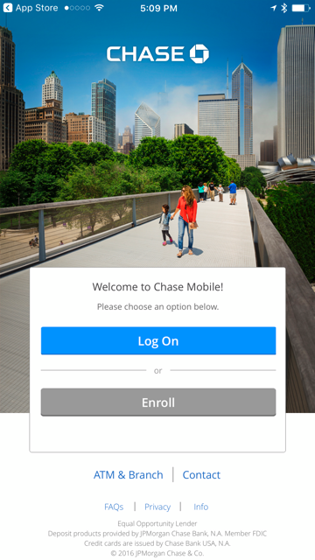

##### Acceptance Criteria

|  |  |  |  |
| --- | --- | --- | --- |
|  | Given | When | Then |
| 1 | User installs app | User launches app | Alternate log on screen is displayed  Note: Alternate logon screen does not have User Id/ Password fields, Enroll link, Forgot User Id or Password link and Remember me option |
| 2 | User is on alternate logon screen | User taps Enroll | Basic Info screen is displayed |
| 3 | User is on alternate logon screen | User taps Log On | BAU Logon screen is displayed |
| 4 | User views alternate logon screen first time | User taps 'Enroll' or 'Logon', closes app and launches app again | BAU Logon screen is displayed |
| 5 | User views alternate logon screen first time | User closes app without taking any action OR taps on any link other than 'Enroll' or 'Logon' and launches app again | Alternate log on screen is displayed |
| 6 | User updates app | User launches app | BAU Logon screen is displayed |
| 7 | User deletes and reinstalls app | User launches app again | Alternate log on screen is displayed |
| 8 | User launches app | Device language is set to Spanish | 'Welcome to Chase in Spanish' pop up is displayed - BAU before the corresponding logon screen is displayed |
| 9 | User is on alternate logon screen | App is in ECD/ Read Only/ Splash mode | Behavior of ‘FAQs’, ‘Branch locator’, ‘Contact Us’, 'Enroll' links should be BAU as they are today in those modes Note: Clicking on 'Log on' button on alternate logon screen should always take user to BAU logon screen |

***Assessment Question 1:*** Based on the User Story narrative above, list down at least **five** critical test scenarios/ test cases to validate and sign off the story. List the test scenario name only, no details.

1. Scenario1: User launches app after a fresh install and taps Log On
2. Scenario2: User launches app after a fresh install and taps Enroll
3. Scenario3: User launches app after previous use of the app
4. Scenario4: Spanish user launches app
5. Scenario5: User launches app after a fresh install and exits without clicking Enroll or Log On and then relaunches app

***Assessment Question 2***: Pick 2 items from the Test Scenario list and create the actual gherkin test.

Scenario1: User launches app after a fresh install and taps Log On

Given App is not present on the device

When App is installed on the device

And User launches the app

And User lands on the alternate log on screen

And User taps Log On

Then User lands on BAU Logon screen

Scenario3: User launches app after previous use of the app

Given User has previously used the app

When User launches the app

Then User lands on BAU Logon screen

***Assessment Question 3:*** What are the different **locator strategies** to identify an element in Appium?

1. By.id
2. By.xpath
3. By.className
4. By.AccessibilityId

***Assessment Question 4:*** Consider HTML snippet below for an element whose id is changing dynamically in different executions as:

•         <input  name=ChaseBank1234454454> </input>

•         <input  name=ChaseBank90980989979> </input>

•         <input  name=ChaseBank_fdfdfdfdfdfddf> </input>

How do you handle the above situation and write a generic locator to match any of the above locators?

Use a contains “ChaseBank” in the locator

Possible example:

By.xpath(“.//*[contains(@name,’ChaseBank’)])”