ABSTRACT

High carbon emissions are one of the major environmental challenges facing the world today. Activities such as transportation, electricity consumption, industrial processes, food production and waste generation contribute to the release of greenhouse gases into the atmosphere. These emissions increase the concentration of greenhouse gases and contribute to global warming and climate change. Although people are becoming more aware of climate change, many individuals are still unable to determine how much their everyday activities contribute to carbon emissions.

This project proposes a Web-Based Carbon Footprint Calculator with Personalized Reduction Recommendations to address this problem. The system allows users to enter information related to their electricity usage, transportation, food habits, air travel and waste generation. Based on this information and predefined emission factors, the system estimates the user's carbon footprint in terms of carbon dioxide equivalent (CO₂e).

In addition to calculating the total footprint, the proposed system displays the contribution of different activities and identifies the user's major sources of emissions. It also provides personalized recommendations and reduction targets to encourage users to adopt more sustainable habits. The solution is designed to be simple, accessible and inexpensive to implement using common web technologies.

The proposed system supports environmental sustainability by increasing awareness, encouraging responsible consumption and promoting climate action. It is particularly relevant to SDG 7 (Affordable and Clean Energy), SDG 12 (Responsible Consumption and Production), and SDG 13 (Climate Action). Overall, the project demonstrates how information technology can be used as a practical tool to measure environmental impact and encourage individuals to take meaningful steps towards reducing their carbon footprint.

INTRODUCTION
Climate change is one of the major environmental challenges facing the world. Human activities such as burning fossil fuels, transportation, electricity generation and industrial production release greenhouse gases into the atmosphere.
Carbon dioxide is one of the major greenhouse gases. Other gases also contribute to climate change, so emissions are commonly expressed as carbon dioxide equivalent (CO₂e) .
Individuals contribute to emissions through everyday activities such as travelling by vehicle, using electricity, purchasing products and producing waste. However, the environmental impact of these activities is often difficult to understand because the emissions are not directly visible.
A Carbon Footprint Calculator can solve this information gap by converting everyday activities into estimated emissions. The proposed system allows users to understand their carbon footprint and identify areas where emissions can be reduced.

PROBLEM STATEMENT
The main problem addressed by this project is:
Individuals lack a simple method to calculate their carbon footprint, identify major sources of emissions and understand how they can reduce them.
The major problems include:
- Lack of awareness about personal carbon emissions.
- Difficulty in manually calculating emissions.
- Difficulty identifying major sources of emissions.
- Lack of personalized reduction suggestions.
- Lack of a simple method to track improvements.

Objectives
The proposed system aims to:
- Calculate an estimated personal carbon footprint.
- Divide emissions into different categories.
- Identify the largest source of emissions.
- Provide suggestions for reducing emissions.
- Encourage users to adopt sustainable habits.

SUSTAINABILITY ANALYSIS

Sustainable Development Goals
The project is connected to several United Nations Sustainable Development Goals.

SDG 7 – Affordable and Clean Energy
The calculator helps users understand the environmental impact of electricity consumption. This can encourage energy-efficient habits such as reducing unnecessary electricity usage and using efficient appliances.

SDG 12 – Responsible Consumption and Production
The system can encourage responsible consumption by showing the impact of activities such as food consumption and waste generation. Users can be encouraged to reuse, recycle and reduce unnecessary consumption.

SDG 13 – Climate Action
The project directly supports climate awareness and action. Users can understand their contribution to greenhouse gas emissions and take steps to reduce their carbon footprint.

ISO 14001
ISO 14001 provides a framework for an Environmental Management System (EMS) . It focuses on identifying environmental impacts, setting objectives, monitoring performance and achieving continual improvement.
The Carbon Footprint Calculator can support these principles by:
- Measuring estimated emissions.
- Identifying major environmental impacts.
- Setting emission-reduction targets.
- Monitoring changes over time.
- Increasing environmental awareness.

LCA and EIA
Life Cycle Assessment (LCA) evaluates environmental impacts throughout the life cycle of a product or service. The concept can help in understanding that emissions may occur during production, transportation, use and disposal.
Environmental Impact Assessment (EIA) is generally used to evaluate the environmental effects of proposed projects. The proposed calculator is not an EIA tool, but its emission data can support environmental decision-making.

PROPOSED ENGINEERING / IT SOLUTION
The proposed solution is a:
Web-Based Carbon Footprint Calculator with Personalized
Recommendations
The website collects information about a user's daily activities and calculates their estimated carbon footprint.

Main Categories
- Electricity consumption
- Transportation
- Air travel
- Food
- Waste

Working Process

User Input → Data Processing → Emission Calculation → Results → Recommendations
The user enters information such as electricity consumption or distance travelled. The system applies appropriate emission factors and calculates the corresponding emissions.
A basic calculation is:
Carbon Emissions = Activity Data × Emission Factor
The total footprint is calculated by adding emissions from all categories.

Example
If: Electricity Consumption = 200 kWh and the selected emission factor is X kg CO₂e/kWh , then: Electricity Emissions = 200 × X kg CO₂e
The same process is applied to transportation, food and other categories.

MAIN FEATURES

User Input
Users enter information about their electricity usage, transportation, food habits and waste generation.

Carbon Footprint Dashboard
The result page displays:
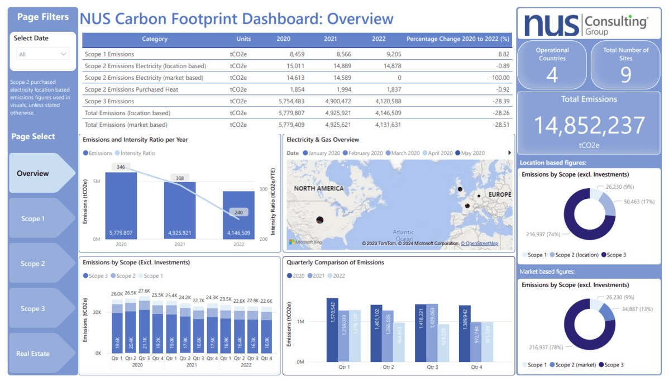
- Total carbon footprint.
- Emissions by category.
- Highest-emission activity.
- Percentage contribution of each category.
Charts can be used to make the results easier to understand.

Personalized Recommendations
The system identifies the user's largest emission source and provides relevant suggestions.
For example, if transportation produces the highest emissions, the system may recommend:
- Using public transportation.
- Carpooling.
- Walking or cycling for short distances.
- Reducing unnecessary trips.

Reduction Target
Users can set a target for reducing their carbon footprint and compare their current result with their target.
Progress Tracking
Previous calculations can be stored so that users can compare their emissions over time.

FEASIBILITY ANALYSIS

Technical Feasibility
The project is technically feasible because it can be developed using common web technologies such as:
- HTML
- CSS
- JavaScript
- MySQL/SQLite, if a database is required
No specialized hardware is necessary.

Economic Feasibility
The system can be developed at a low cost using free development tools and open-source technologies. Basic hosting and database services can also be obtained at relatively low cost.

Operational Feasibility
The application is simple to use. Users only need to enter information about their daily activities. No technical knowledge is required.

Environmental Feasibility
The software itself has very little direct environmental impact. Its main benefit comes from encouraging users to reduce energy consumption, transportation emissions and waste.

EXPECTED ENVIRONMENTAL BENEFITS
The proposed system can provide the following benefits:
Increased Awareness
Users can understand the approximate environmental impact of their lifestyle.
Identification of Major Emission Sources
The system shows which activities contribute most to the user's footprint.
Energy Conservation
Users can identify high electricity usage and adopt energy-saving practices.
Sustainable Transportation
The system can encourage walking, cycling, public transportation and carpooling.
Waste Reduction
Users can be encouraged to reduce waste, reuse products and recycle.
Long-Term Behavioural Change
Regularly tracking emissions can encourage users to continuously improve their habits.

JUSTIFICATION OF THE PROPOSED SOLUTION
The Carbon Footprint Calculator is a suitable solution because it addresses the problem through measurement, awareness and action .
Unlike general environmental awareness campaigns, the calculator provides users with a numerical estimate of their own emissions. This makes the problem more personal and measurable.
The solution also has several advantages:
- Low development cost.
- Easy to access.
- Simple to use.
- Can be used by students, households and organizations.
- Can be expanded with additional features.
- Encourages sustainable behaviour.
- Provides measurable progress.

LIMITATIONS
The system has some limitations:
- Results depend on the accuracy of user-provided information.
- Emission factors may vary depending on location and energy sources.
- Calculated values are estimates rather than exact measurements.
- The system cannot guarantee that users will follow the recommended actions.
- Emission-factor databases need to be updated periodically.

FUTURE SCOPE
The system can be improved in the future by adding:
- A mobile application.
- GPS-based transportation calculations.
- Smart-meter integration.
- AI-based personalized recommendations.
- Gamification and achievement systems.
- Community emission-reduction challenges.
- Historical emission graphs.

CONCLUSION

High carbon emissions are a significant environmental challenge associated with energy consumption, transportation, waste and other human activities. The IPCC has established that human activities and greenhouse gas emissions are responsible for the observed global warming trend.

One important challenge in addressing emissions at the individual level is the lack of clear information about the environmental impact of everyday activities. A person may understand that driving, consuming electricity or producing waste creates environmental impacts, but may not know the approximate scale of those impacts.

The proposed Carbon Footprint Calculator addresses this problem through an accessible web-based solution. The system collects information about user activities, applies appropriate emission factors and provides an estimated carbon footprint in CO₂e. It further improves upon a basic calculator by identifying major emission sources, providing personalized recommendations and allowing users to set reduction targets.

The project is technically and economically feasible because it can be developed using commonly available web technologies. It also has strong sustainability relevance through its connection with SDG 7, SDG 12 and SDG 13. In addition, its measurement and monitoring approach can support broader environmental management practices associated with ISO 14001.

The calculator itself cannot solve the problem of carbon emissions. Its primary role is to provide information that can lead to action. By transforming invisible environmental impacts into understandable numbers and practical recommendations, the system can encourage individuals to make more sustainable choices.

Therefore, the proposed Carbon Footprint Calculator represents a practical example of how information technology can contribute to environmental sustainability and climate action.

REFERENCES
- Intergovernmental Panel on Climate Change (IPCC), Climate Change 2023: Synthesis
Report .
- United Nations, Sustainable Development Goal 7 – Affordable and Clean Energy.
- United Nations, Sustainable Development Goal 12 – Responsible Consumption and Production .
- United Nations, Sustainable Development Goal 13 – Climate Action .
- International Organization for Standardization, ISO 14001 – Environmental Management Systems .
- United States Environmental Protection Agency, Household Carbon Footprint Calculator .
- Greenhouse Gas Protocol, GHG Protocol Standards .

ENVIROMENTAL SCIENCE

AND

SUSTAINABLE ENGINEERING

ASSIGNMENT

JOHAN BYJU JOSE
S3 CS-C
ROLL NO: 09
U2503149

