Supplementary Table 1. Ant species collected and their abundances at each site (data combined from ground and arboreal traps). Total abundances are provided for low and ambient fire frequencies. Vegetation types are: O = Open woodland; W = Woodland; F = Open forest.

Fire frequency | LOW |  |  |  |  |  |  |  | AMBIENT |  |  |  |  |  |  |  | TOTALS
Vegetation type | O |  |  | W |  | F |  |  | O |  | W |  |  |  | F |  | Low | Ambient | Total
Site | Lo1 | Lo2 | Lo3 | Lw1 | Lw2 | Lf1 | Lf2 | Lf3 | Ao1 | Ao2 | Aw1 | Aw2 | Aw3 | Aw4 | Af1 | Af2
subfamily Aenictinae
Aenictus sp. 5 (ceylonicus gp.) |  |  |  |  |  |  |  |  | 14 | 41 |  |  |  |  |  |  |  | 55 | 55
subfamily Cerapachyinae
Cerapachys sp. 4 (singularis gp.) |  |  |  |  |  |  |  |  |  |  |  |  |  |  |  | 1 |  | 1 | 1
Cerapachys sp. 11 (turneri gp.) |  |  |  |  |  |  |  | 1 |  |  |  |  |  |  |  |  | 1 |  | 1
Sphinctomyrmex sp. 1 |  |  |  |  |  |  |  |  |  |  |  | 3 |  |  |  |  |  | 3 | 3
subfamily Pseudomyrmicinae
Tetraponera punctulata |  |  | 1 |  |  |  |  |  |  | 23 |  | 1 |  | 3 |  |  | 1 | 27 | 28
Tetraponera sp. nr. punctulata |  |  |  |  |  |  |  |  |  |  |  |  |  | 1 |  |  |  | 1 | 1
subfamily Ectatominae
Rhytidoponera aurata |  | 19 | 71 | 65 | 3 | 25 | 38 | 1 | 174 | 82 | 22 | 129 | 31 | 117 | 12 | 160 | 222 | 727 | 949
R. borealis |  | 24 | 4 | 3 |  | 1 | 6 | 2 | 10 | 7 | 4 | 2 | 14 | 12 |  | 10 | 40 | 59 | 99
R. dubia |  | 1 |  |  |  |  | 1 |  | 1 |  |  | 2 | 3 |  |  |  | 2 | 6 | 8
R. reticulata |  |  |  |  |  |  |  |  | 10 |  | 10 | 1 | 1 |  |  |  |  | 22 | 22
R. trachypyx |  |  |  |  |  |  |  |  | 10 | 7 | 3 |  |  |  |  | 1 |  | 21 | 21
subfamily Ponerinae
Anochetus paripungens | 2 |  | 1 |  | 1 |  | 1 | 5 |  |  |  |  |  |  | 4 | 3 | 10 | 7 | 17
A. rectangularis |  |  |  |  | 1 |  | 1 |  |  |  |  | 2 |  |  |  |  | 2 | 2 | 4
Brachyponera lutea | 7 |  | 4 | 1 |  |  | 1 |  |  |  |  |  | 7 | 4 |  | 2 | 13 | 13 | 26
Ectomomyrmex ruficornis |  |  |  |  |  |  |  |  |  |  |  |  |  |  | 1 |  |  | 1 | 1
Leptogenys sp. nr. conigera |  |  |  |  |  |  |  |  | 2 |  |  |  |  |  |  |  |  | 2 | 2
L. exigua |  |  |  |  |  |  |  |  |  |  |  |  | 3 |  |  | 1 |  | 4 | 4
Odontomachus sp. nr. turneri | 9 | 2 | 16 | 4 | 9 | 19 | 8 | 4 |  |  | 5 | 30 | 9 | 5 | 16 | 2 | 71 | 67 | 138
subfamily Myrmicinae
Cardiocondyla sp. 1 (nuda complex) |  | 5 |  | 5 | 2 |  |  |  |  | 25 |  |  |  | 1 |  |  | 12 | 26 | 38
Cardiocondyla wroughtonii | 1 |  |  |  |  |  |  |  |  |  |  |  |  |  |  |  | 1 |  | 1
Crematogaster queenslandica | 31 | 7 | 8 | 3 | 15 | 30 | 28 | 12 |  | 1 | 1 | 10 | 2 | 55 | 5 | 3 | 134 | 77 | 211
Crematogaster sp. 2 (australis complex) | 9 | 4 | 10 | 93 | 3 | 71 | 24 | 359 | 3 | 1 | 1 | 28 |  | 30 | 1 | 1 | 573 | 65 | 638
Crematogaster sp. 4 (Group A) | 1 | 1 |  |  | 1 |  |  | 4 |  |  |  |  |  |  |  | 1 | 7 | 1 | 8
Crematogaster sp. 5 (conigera gp.) |  | 1 |  |  |  |  |  |  |  |  |  |  |  | 1 |  |  | 1 | 1 | 2
Crematogaster sp. 9 (conigera gp.) |  |  |  |  |  |  |  | 1 |  |  |  |  |  |  |  | 1 | 1 | 1 | 2
Meranoplus sp. 4 (mjobergi gp.) |  |  |  |  |  |  |  |  |  |  |  |  | 22 | 1 |  |  |  | 23 | 23
Meranoplus sp.8 (Group F) |  |  |  |  |  |  |  |  | 1 |  |  |  |  |  |  |  |  | 1 | 1
Meranoplus sp. 10 (Group C) |  | 1 |  |  |  |  |  |  |  |  |  |  |  |  |  |  | 1 |  | 1
Meranoplus sp. 14 (aureolus complex) | 17 |  |  |  |  |  |  |  |  | 1 | 1 |  |  |  |  |  | 17 | 2 | 19
Monomorium disetigerum | 4 |  | 18 | 18 | 11 | 43 | 3 | 57 |  | 4 | 17 | 5 | 11 | 34 | 1 | 2 | 154 | 74 | 228
M. donisthorpei | 10 | 279 | 1 | 8 |  |  | 7 |  | 2 | 6 |  | 24 | 26 | 3 |  |  | 305 | 61 | 366
M. ?fieldi |  | 1 |  |  | 17 |  |  |  |  |  |  |  |  |  |  |  | 18 |  | 18
M. ?nigrius | 219 | 330 | 276 | 89 | 53 | 19 | 116 |  | 54 |  | 2 | 19 | 60 | 36 | 69 | 86 | 1102 | 326 | 1428
Monomorium sp. 1 (rothsteini gp.) |  | 1 |  | 1 |  |  |  |  | 4 |  |  |  |  |  |  |  | 2 | 4 | 6
Monomorium sp. 7 (insolescens gp.) | 10 | 1 |  | 7 | 1 |  | 11 | 5 | 1 |  |  |  |  |  |  | 1 | 35 | 2 | 37
Monomorium sp. 8 (carinatum gp.) |  |  |  | 11 | 1 |  | 7 | 1 | 145 |  | 12 | 30 | 1 | 10 |  |  | 20 | 198 | 218
Monomorium sp. 14 (nigrius gp.) | 2 | 6 | 10 | 4 | 1 | 59 | 8 | 17 | 3 |  | 17 | 3 | 24 |  | 4 |  | 107 | 51 | 158
Monomorium sp. 24 (laeve gp.) | 137 | 177 | 213 | 144 | 206 | 64 | 179 | 147 | 289 | 60 | 12 | 98 | 32 | 65 | 121 | 132 | 1267 | 809 | 2076
Monomorium sp. 26 (sydneyense gp.) |  |  |  |  |  |  |  |  | 16 |  |  |  |  |  | 1 |  |  | 17 | 17
Monomorium sp. 33 (laeve gp.) |  |  |  |  |  |  |  | 7 |  |  |  |  |  |  |  | 1 | 7 | 1 | 8
Monomorium sp. 37 (nigrius gp.) |  |  | 220 | 80 | 74 | 15 | 25 | 69 | 15 | 2 | 91 |  | 5 | 79 | 107 | 36 | 483 | 335 | 818
Monomorium sp. 39 (nigrius gp.) |  |  |  |  |  |  |  |  |  |  |  | 1 |  |  |  |  |  | 1 | 1
Pheidole sp. 1 (mjobergi gp.) |  |  |  | 2 |  |  |  |  | 7 |  | 1 |  |  |  |  |  | 2 | 8 | 10
Pheidole sp. 2 (longiceps gp.) |  |  | 6 | 1 |  |  | 1 |  | 1 |  |  |  |  |  |  |  | 8 | 1 | 9
Pheidole sp. 3 (variabilis gp.) | 14 | 92 | 41 | 1 |  |  | 12 | 67 | 28 |  |  |  |  | 1 | 24 | 16 | 227 | 69 | 296
Pheidole sp. 8 (Group F) | 2 | 2 | 9 | 11 | 6 | 10 | 14 | 10 |  |  | 7 | 2 | 11 | 8 | 8 | 6 | 64 | 42 | 106
Pheidole sp. 13 (ampla gp.) |  |  | 1 | 23 |  |  | 8 |  | 10 | 5 | 1 | 15 |  | 1 | 11 |  | 32 | 43 | 75
Pheidole sp. 14 (ampla gp.) |  |  |  |  |  |  |  | 2 | 1 |  |  |  |  |  |  |  | 2 | 1 | 3
Pheidologeton affinis |  |  | 3 |  |  |  |  | 1 |  |  |  |  |  | 1 |  |  | 4 | 1 | 5
Solenopsis sp. 1 |  | 6 |  | 1 |  | 1 | 1 | 6 | 8 | 14 |  | 5 |  |  |  |  | 15 | 27 | 42
Solenopsis sp. 2 |  |  |  |  |  |  |  | 1 |  |  |  |  |  |  | 1 |  | 1 | 1 | 2
Solenopsis sp. 9 |  |  |  | 1 |  |  |  |  |  |  |  |  | 1 |  |  |  | 1 | 1 | 2
Tetramorium lanuginosum |  | 3 |  | 2 |  |  | 5 | 3 | 6 |  |  |  |  |  | 2 |  | 13 | 8 | 21
T.simillimum | 9 | 98 |  | 4 | 1 |  | 4 | 1 | 49 |  | 2 | 1 |  |  |  |  | 117 | 52 | 169
Tetramorium sp. 1 (striolatum gp.) |  |  |  | 2 |  |  | 1 |  |  |  |  | 1 |  |  |  |  | 3 | 1 | 4
Tetramorium sp. 2 (striolatum gp.) |  |  |  |  |  |  |  | 3 |  |  |  |  |  |  |  |  | 3 |  | 3
Tetramorium sp. 8 (striolatum gp.) | 1 | 12 | 4 | 5 | 3 | 9 | 6 | 10 | 3 | 28 | 3 | 1 | 4 |  | 1 | 6 | 50 | 46 | 96
subfamily Dolichoderinae
Arnoldius sp. 1 |  |  |  |  | 1 |  |  |  |  |  |  |  |  |  |  |  | 1 |  | 1
Froggattella kirbyi |  |  |  |  |  |  |  |  |  |  |  |  |  |  | 3 |  |  | 3 | 3
Iridomyrmex pallidus | 82 | 75 | 12 | 44 | 72 | 15 | 186 | 126 | 451 | 65 | 38 | 144 | 7 | 22 |  | 4 | 612 | 731 | 1343
I. reburrus | 8 |  |  |  | 1 | 53 |  |  |  | 49 | 258 | 3 | 27 | 2 |  | 126 | 62 | 465 | 527
Iridomyrmex sp. 1 (anceps gp.) | 291 | 265 | 31 | 231 | 222 | 31 | 91 | 12 | 370 | 167 | 4 | 148 | 82 | 313 |  | 1 | 1174 | 1085 | 2259
Iridomyrmex sp. 3 (mattiroloi gp.) | 23 |  |  | 6 | 1 |  | 2 |  | 6 | 1 |  |  |  | 12 |  | 5 | 32 | 24 | 56
Iridomyrmex sp. 21 (gracilis gp.) | 11 | 13 |  | 26 |  | 60 | 19 | 19 | 339 |  |  | 184 | 6 | 3 |  | 5 | 148 | 537 | 685
Ochetellus sp. 1 (glaber gp.) |  |  |  |  |  |  |  |  |  |  |  | 1 |  |  |  |  |  | 1 | 1
Ochetellus sp. 2 (glaber gp.) |  |  |  |  |  | 2 | 3 |  |  | 2 | 1 | 4 | 8 | 15 |  | 2 | 5 | 32 | 37
Papyrus sp. 1 (nitidus gp) |  | 419 | 3 | 134 | 37 | 57 |  | 1 | 217 | 282 | 64 | 3 | 156 | 50 |  | 4 | 651 | 776 | 1427
Tapinoma sp. 1 (minutum gp) | 1 | 1 | 1 | 1 |  |  |  |  | 10 |  |  | 1 |  |  |  |  | 4 | 11 | 15
Tapinoma sp. 2 (minutum gp) | 2 |  |  | 1 | 1 | 5 |  |  | 3 | 1 |  | 1 |  | 1 | 1 |  | 9 | 7 | 16
Tapinoma sp. 5 (minutum gp) |  |  |  |  |  |  |  |  |  |  |  |  |  |  | 1 |  |  | 1 | 1
subfamily FORMICINAE
Camponotus crozieri |  |  | 6 | 4 | 1 | 3 | 3 |  | 13 | 17 | 6 |  |  | 1 | 1 |  | 17 | 38 | 55
Camponotus sp. 4 (pellax gp.) |  | 1 |  | 1 |  | 1 |  |  |  |  |  |  |  | 1 |  |  | 3 | 1 | 4
Camponotus sp. 6 (claripes gp.) |  |  |  |  |  |  |  |  |  |  |  |  |  | 1 |  |  |  | 1 | 1
Camponotus sp. 8 (discors gp.) |  |  |  |  |  |  |  |  |  |  |  |  |  | 2 |  |  |  | 2 | 2
Camponotus sp. 9 (novaehollandiae gp.) | 8 | 16 | 5 | 4 | 8 | 2 | 2 | 6 |  | 2 | 4 | 27 | 12 | 2 | 2 |  | 51 | 49 | 100
Camponotus sp. 16 (rubiginosus gp.) |  |  |  | 5 | 2 |  |  |  |  |  | 4 |  | 7 | 11 |  | 6 | 7 | 28 | 35
Camponotus sp. 24 (claripes gp.) |  |  |  |  |  |  |  |  |  |  |  | 1 |  |  |  |  |  | 1 | 1
Melophorus sp. 1 (aeneovirens gp.) |  |  | 13 | 1 | 3 | 5 |  | 3 |  |  |  |  | 5 | 4 |  | 8 | 25 | 17 | 42
Melophorus sp. 5 (Group A) | 1 |  |  |  |  |  |  |  |  |  |  |  | 2 | 10 |  | 12 | 1 | 24 | 25
Melophorus sp. 6 (froggatti gp.) |  |  |  |  |  |  |  |  | 1 | 1 |  |  |  |  |  |  |  | 2 | 2
Melophorus sp. 12 (mjobergi gp.) |  |  |  |  |  |  |  |  |  |  |  |  |  | 1 |  |  |  | 1 | 1
Melophorus sp. 10 (Group D) |  |  |  |  | 1 | 11 | 3 | 35 | 1 | 4 | 22 | 14 |  | 6 |  |  | 50 | 47 | 97
Oecophylla smaragdina | 27 | 44 | 22 | 15 | 59 | 5 | 4 | 35 |  |  | 14 | 23 | 6 | 4 | 24 | 44 | 211 | 115 | 326
Opisthopsis haddoni | 10 | 12 | 2 | 1 | 4 | 4 | 7 | 14 |  | 1 | 6 | 9 | 1 | 1 | 2 |  | 54 | 20 | 74
O. rufoniger |  |  | 1 |  | 6 | 9 |  | 8 | 8 | 2 | 7 | 3 |  |  |  |  | 24 | 20 | 44
Paratrechina longicornis |  |  |  |  |  |  |  | 2 | 1 |  |  |  |  |  |  |  | 2 | 1 | 3
Paratrechina sp. 1 (minutula gp.) |  | 1 |  |  |  | 5 | 1 | 13 | 4 |  | 4 | 2 |  | 13 |  |  | 20 | 23 | 43
Paratrechina sp. 2 (minutula gp.) | 1 | 1 |  |  |  |  |  |  |  |  |  |  |  |  | 6 |  | 2 | 6 | 8
Paratrechina sp. 4 (vaga gp.) | 1 | 2 | 6 | 13 |  | 5 | 2 | 14 |  | 3 | 1 | 23 |  | 2 | 10 | 2 | 43 | 41 | 84
Polyrhachis creusa |  | 2 |  |  |  |  |  |  |  |  |  |  |  |  |  |  | 2 |  | 2
P. cyrus |  | 2 |  | 1 |  |  |  |  |  |  | 1 |  |  | 2 |  |  | 3 | 3 | 6
P. inconspicua | 1 | 2 | 3 | 2 | 4 | 2 | 2 | 3 | 3 |  |  | 2 |  | 5 |  | 1 | 19 | 11 | 30
P. schenkii |  |  | 3 | 1 |  | 5 | 1 | 4 |  |  | 17 | 1 | 3 |  |  | 1 | 14 | 22 | 36
P. senilis |  | 3 | 21 | 3 |  | 11 | 7 | 3 | 2 | 6 | 55 | 4 | 40 | 11 |  | 3 | 48 | 121 | 169
Polyrhachis sp. 12 (obtusa gp.) |  |  |  |  |  |  |  |  | 2 |  |  |  |  |  |  |  |  | 2 | 2
Stigmacros aciculata |  |  |  |  |  |  |  |  |  |  | 1 |  |  |  |  |  |  | 1 | 1
S. pilosella |  |  |  |  |  |  |  |  |  |  | 1 |  |  |  |  |  |  | 1 | 1
Stigmacros sp. 1 (rufa gp.) |  |  | 2 |  |  |  |  |  |  |  |  |  |  |  |  |  | 2 |  | 2
Total ant abundance | 952 | 1932 | 1048 | 1083 | 832 | 657 | 849 | 1094 | 2298 | 910 | 720 | 1011 | 629 | 963 | 439 | 696 | 8447 | 7666 | 16113
Species richness | 32 | 39 | 35 | 46 | 35 | 33 | 41 | 42 | 43 | 31 | 38 | 43 | 33 | 46 | 27 | 36 | 74 | 90 | 98

Supplemetary Fig. 1 Photographs of the three major vegetation types at the study site: (a) open woodland dominated by Eucalyptus miniata and Grevillea pteridifolia; (b) woodland dominated by E. miniata, E. tetrodonta and E. bleeseri; and (c) open forest dominated by E. miniata. [Photos: M. Duclaux]
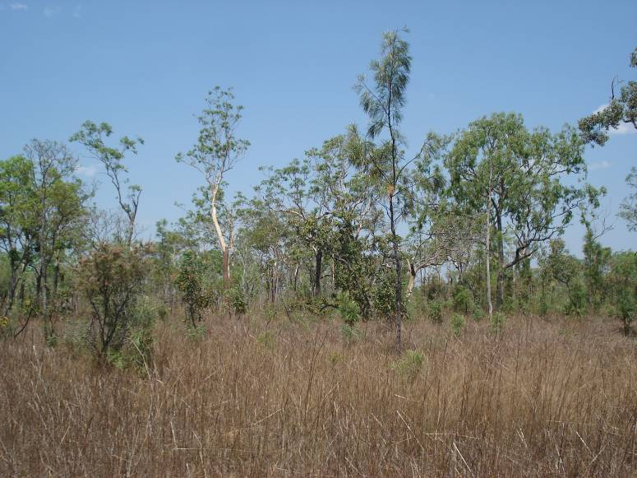
(a)
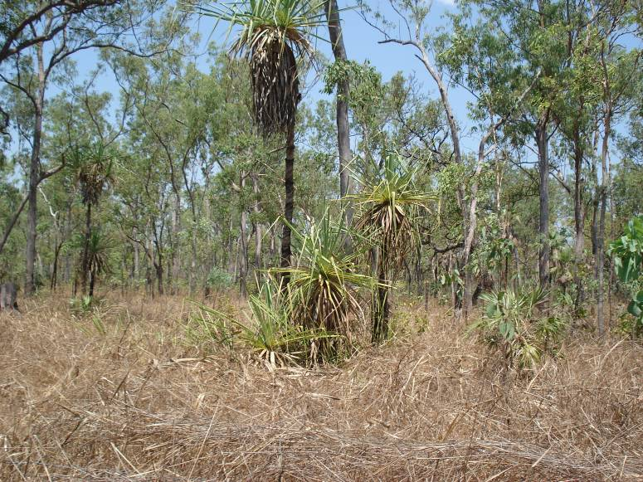
(b)
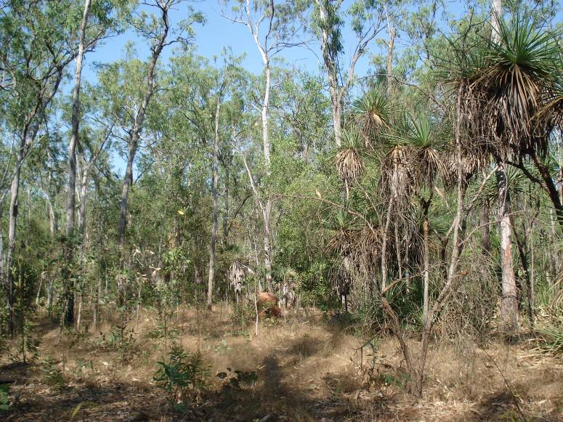
(c)

