**Weaver University Higher Education | Creates a Storyboard for an E-Learning Solution**

### **A. Context**

**A1. LxD Foundation 1**

### **A1. Instructional Setting and Target Learners**

As a member of the LxD team, I am assigned to improve the instructional problems at Weaver University in WR001.  
   
My focus in the “Empathize” phase of Design Thinking was on two groups:

High-tech and diverse – Group D. This group consists of highly technical and diverse learners. They are active in e-learning, enjoy online options, and bring significant prior knowledge and work experience in their fields. These students are credentialing in the USA and are highly motivated, especially when given opportunities to share knowledge with peers.

Low-tech and diverse – Group H. This group is equally capable and motivated. They are pursuing education in their field of passion in a new country. These learners are dedicated but prefer low-tech approaches. They would rather read a book than engage with a mobile app. They often study in isolation, sometimes excessively, without guidance from more experienced peers.

**B. Goal**

Students will demonstrate improved mastery of key academic writing skills (APA citation, coherency, research paper development), which are essential for avoiding plagiarism, maintaining academic integrity, and success in WR001.

**A2. LxD Foundation 2**

**C1. Learning Objective**

Learners will apply correct APA citation techniques to revise a research paper that contains plagiarism errors, demonstrating mastery of academic integrity skills required for WR001.

**C2. Module Description**

The proposed one-hour e-learning module is the **“APA Citation Workshop.”** This session addresses a fundamental mastery challenge—avoiding plagiarism—by integrating two complementary strategies: direct instruction in APA citation and a **Plagiarism Case Study** to capture learner attention and increase relevance.

The workshop follows **Merrill’s First Principles of Instruction**:

* **Activation**
  + Present a research paper containing plagiarism.
  + Discuss the academic and professional consequences of plagiarism.
  + Equip learners with guidelines for correction.
* **Demonstration**
  + Instructor models correcting one example as a class activity.
  + Advanced cohorts perform a live demonstration of revisions.
  + A pre-recorded video is available for replay and reinforcement.
* **Application**
  + Learners revise the remaining plagiarism errors in the research paper.
  + Provide a rubric detailing common citation fault.
  + Small peer groups (1:8–10 ratio) give immediate feedback.
* **Integration**
  + Learners demonstrate mastery by earning a completion certificate.
  + The module concludes by assigning the next scaffolded task: drafting a **Mock Research Paper**.

**C3. Learner Experience**

Learners will progress through the **lower levels of Bloom’s Taxonomy**:

* **“Remember**:” The instructional video and presentation help learners recall citation rules.
* **“Understand”:** Activation and demonstration phases build conceptual knowledge.
* **“Apply”**: Learners immediately practice correcting citations using the rubric.
* **“Analyze”**: Learners evaluate the research paper, identify errors, and justify corrections.

This hybrid design combines **Merrill’s problem-centered approach** with **Fink’s Human Dimension**, using real failure cases to promote deeper, personally meaningful learning.

**B. Part I: Refining an E-Learning Solution**

**B1. Incorporating UDL Principles**

To refine the e-learning solution, each of the three **Universal Design for Learning (UDL)** principles—**Engagement (The Why), Representation (The What), and Action & Expression (The How)**—can be intentionally integrated:

**Engagement (The Why)**

* Provide an authentic task by presenting a mock research paper containing plagiarism.
* Discuss the academic and professional consequences of plagiarism to capture interest and motivation.
* Foster community through small peer groups that review and revise mock papers together.
* *Refinement*: Incorporate structured reflection activities so learners can connect new knowledge to personal goals and prior experiences.

**Representation (The What)**

* Present content through multiple modalities: instructor presentation, live demonstration, and recorded video for review.
* *Refinement*: Strengthen connections to prior learning by explicitly linking plagiarism and citation instruction to earlier assignments in WR001.

**Action & Expression (The How)**

* Support learning through small peer-mentor groups (1:8–10 ratio) that provide immediate, formative feedback.
* Allow learners to demonstrate progress by correcting plagiarism errors in a shared paper.
* *Refinement*: Integrate assistive technologies (e.g., captions on video, citation management tools) to ensure accessibility for all learners.

**B2. Measurement for Learning Objective**

Learner progress toward the objective (“Apply correct APA citation techniques to revise a research paper”) can be measured using a structured rubric. The rubric provides clear expectations for performance, guides peer review, and allows for formative and summative assessment.

**Rubric for APA Citation Correction**

|  |  |  |  |
| --- | --- | --- | --- |
| Criterion | **Proficient (3 pts)** | **Developing (2 pts)** | **Needs Work (1 pt)** |
| **Quotation Formatting** | All quotes are enclosed in quotation marks and punctuated correctly. | Some quotes missing quotation marks or incorrect punctuation. | Many quotes are missing quotation marks or incorrectly punctuated. |
| **In-Text Citations** | All quotes include proper APA in-text citation (author, year, page/line if applicable). | Some quotes missing elements (e.g., year, page) or formatted incorrectly. | Most or all quotes are missing or incorrectly cited. |
| **Reference List** | Complete reference list in correct APA format with all sources cited in-text. | Partial reference list, some APA formatting errors. | Reference list missing, incomplete, or incorrectly formatted. |
| **Plagiarism Identification** | Demonstrates clear correction of all plagiarism by citing original sources | Corrects some plagiarism issues but leaves gaps. | Fails to correct plagiarism; most sources uncited. |

**B3. Instructional Strategy Guiding the Storyboard**

The design of the storyboard is guided by **Merrill’s First Principles of Instruction**, which provide a structured framework for sequencing learner activities:

1. **Activation**: Learners are presented with a flawed research paper containing plagiarism.
2. **Demonstration**: The instructor and advanced cohorts model how to identify and correct citation errors.
3. **Application**: Learner's practice correcting the remaining errors using a rubric, with peer mentors providing immediate feedback.
4. **Integration**: Learners reflect on the activity and apply their skills in the next scaffolded assignment (a Mock Research Paper).
5. This strategy supports both high-tech and low-tech learners identified in the analysis (Part A). High-tech learners contribute as peer mentors, while low-tech learners benefit from guided, structured practice.
6. By aligning Merrill’s principles with UDL, the solution not only scaffolds instruction but also ensures inclusivity and accessibility. My reflection shows that what began as a focus on **problem-centered instruction** in ideation now clearly intersects with **UDL principles** as I move into prototyping.

**B4. Storyboard to Objectives Planning**

The storyboard will be organized to align directly with the instructional strategy from B3 and the learning objective from Part A: Learners will apply correct APA citation techniques to revise a research paper that contains plagiarism errors. The storyboard will detail personas, mock content, and the sequence of e-learning materials so that both high-tech and low-tech learners can achieve mastery.

**Preparation of Content**

1. **Instructor or administrator uploads the flawed research paper, rubric, and instructional video into the LMS.**
2. **Persona roles are integrated into the storyboard to ensure scaffolding for both high-tech (mentor roles) and low-tech learners (guided practice).**

**Demonstration of Content**

1. **The advanced cohorts (mentor roles) present citation correction through live demonstrations and share references to recorded examples and rubric.**
2. **The storyboard will emphasize design features (clear visuals, chunked steps, replayable videos) that support diverse learner needs.**

**Application and Assessment**

1. **Learner's practice correcting citations and building an APA reference list within the mock paper.**
2. **The rubric is embedded as both a guide and an assessment tool, with peer mentors providing immediate feedback.**
3. **Assessment data (rubric scores, completion, feedback) is captured to document progress toward the objective.**
4. **This storyboard plan ensures that instruction flows logically from preparation to demonstration to application, reinforcing Merrill’s First Principles of Instruction while incorporating UDL principles for inclusivity and accessibility.**

**C. Part II: Storyboard Prototype**

The LxD storyboard approach below uses GitHub Pages, Markdown, and HTML. It is published on the internet [here](https://jm1021.github.io/student/english/plagiarism), but all relevant elements for this assignment are captured within the document in slide-like visuals.

**C1a. Why Plagiarism Matters**

Page 1: Key questions and content, this would likely be personalized by the instructor.

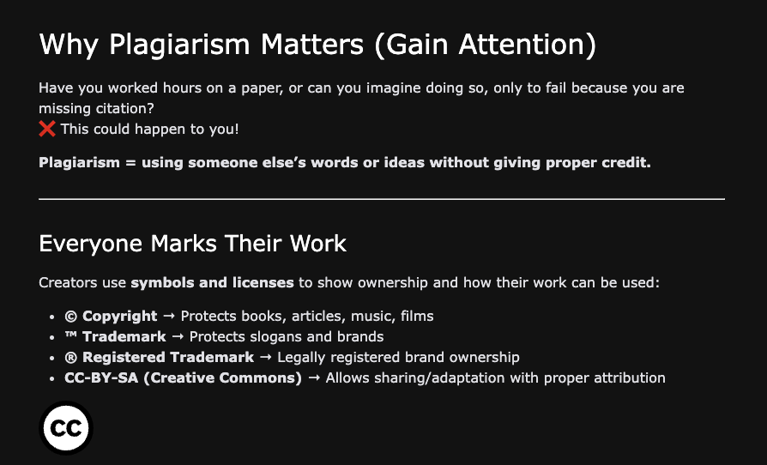

**C1b. Introduction**

Page 2: Insight provided to the learner on the training objectives. This is Merril’s 1st principle with slight modifications to meet objectives of this assignment.

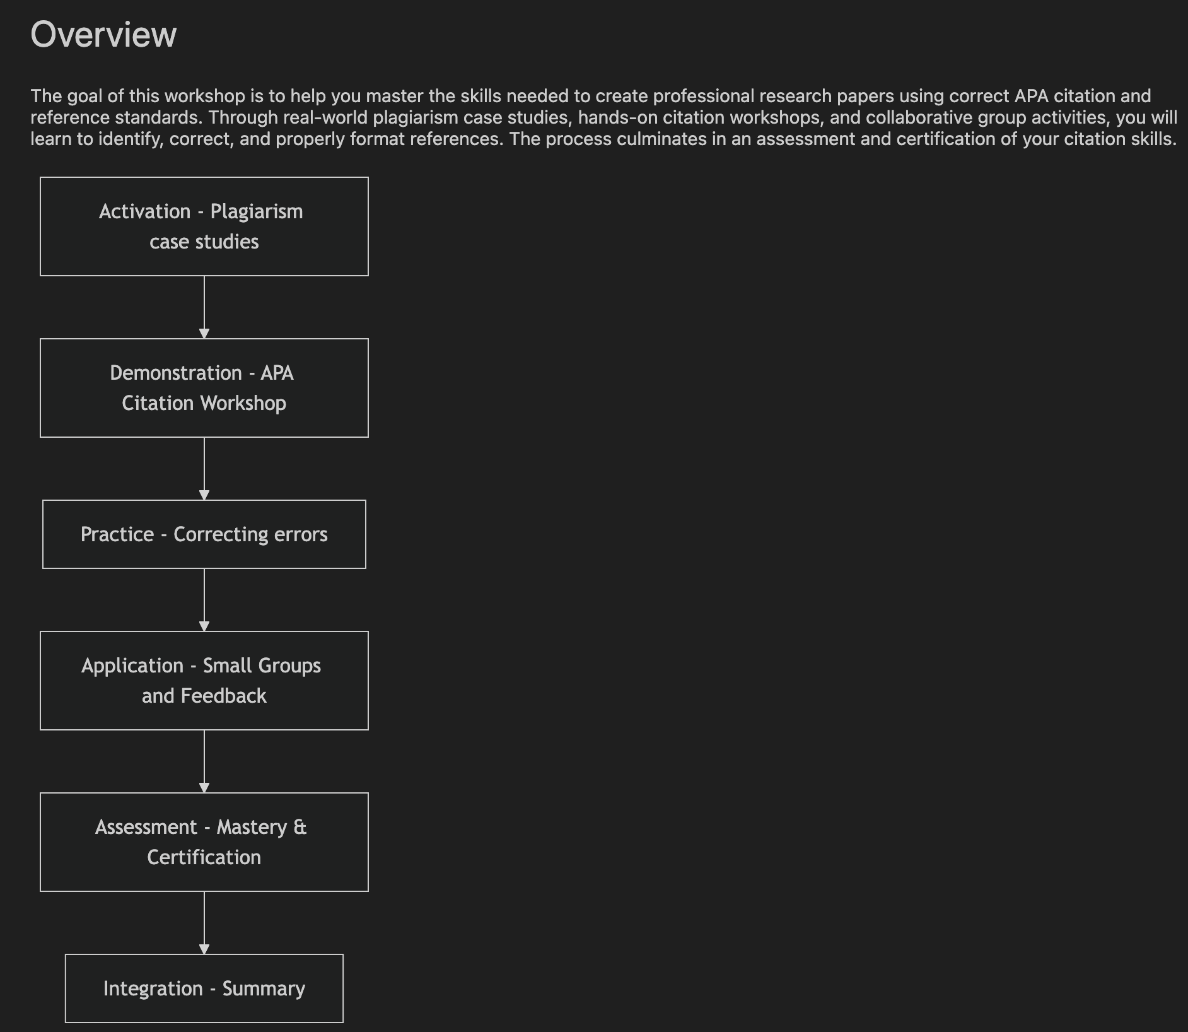

**C2a. The Importance of Plagiarism**

Page 3: Grab learners’ attention with plagiarism cases.

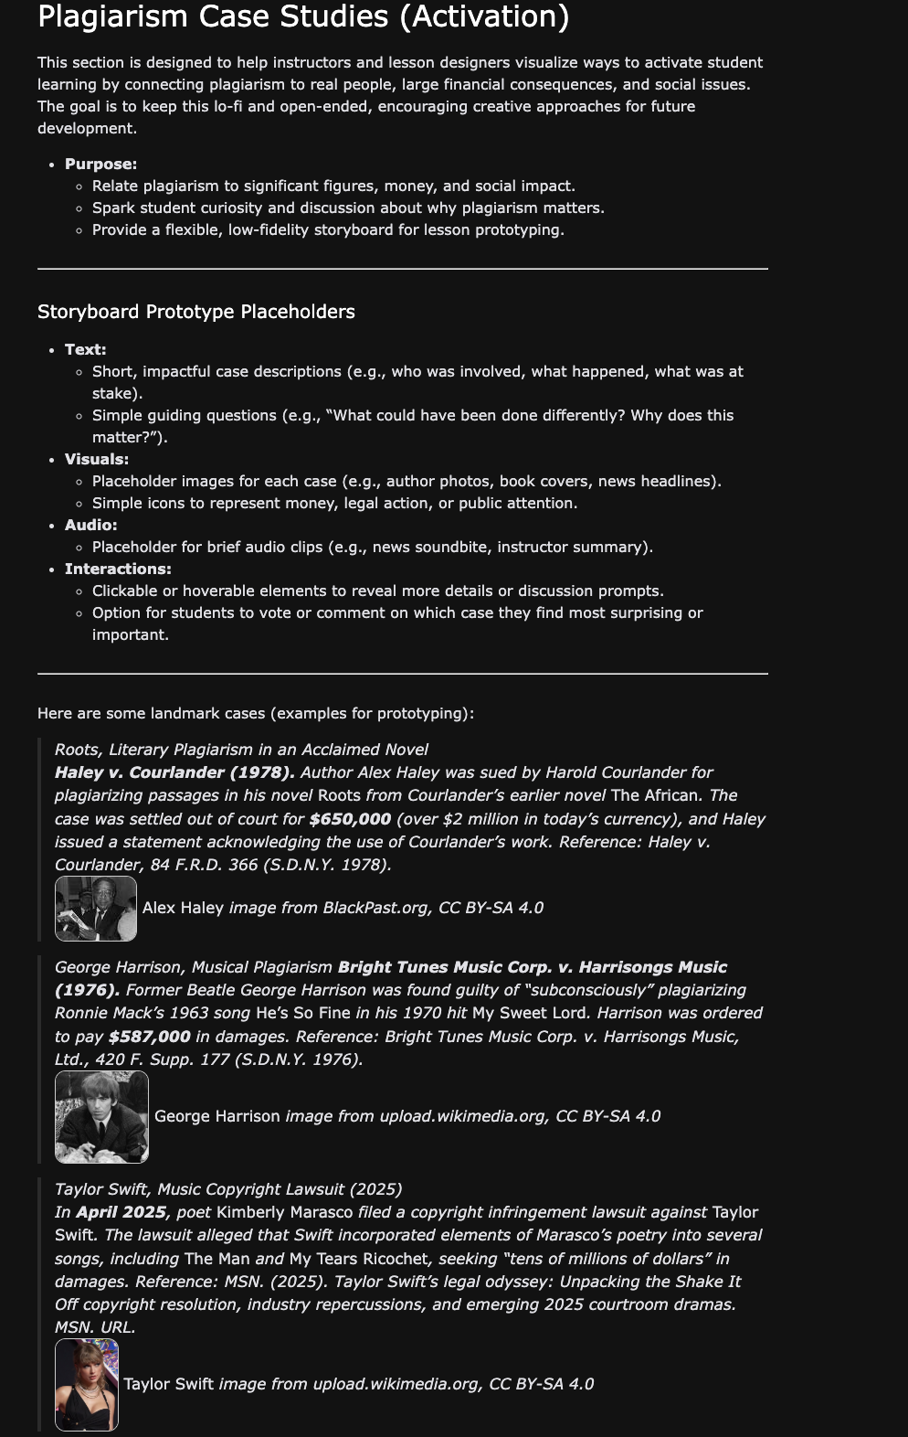

**C2c. Practice correcting errors**

Page 4: This is where the citation learning happens.

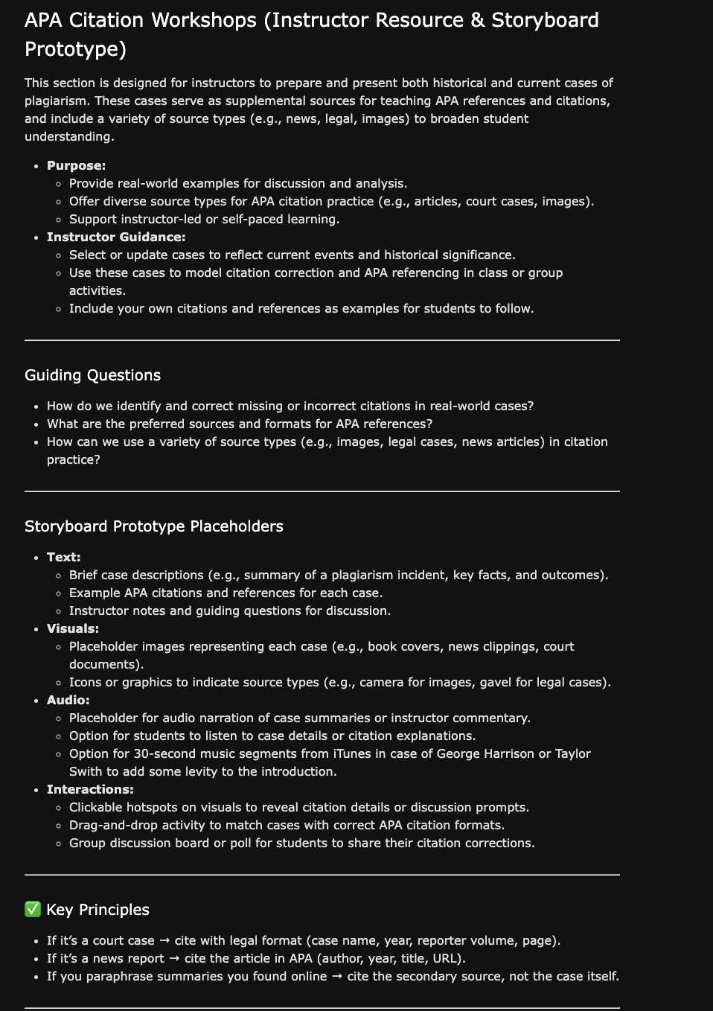

Workshop Tool

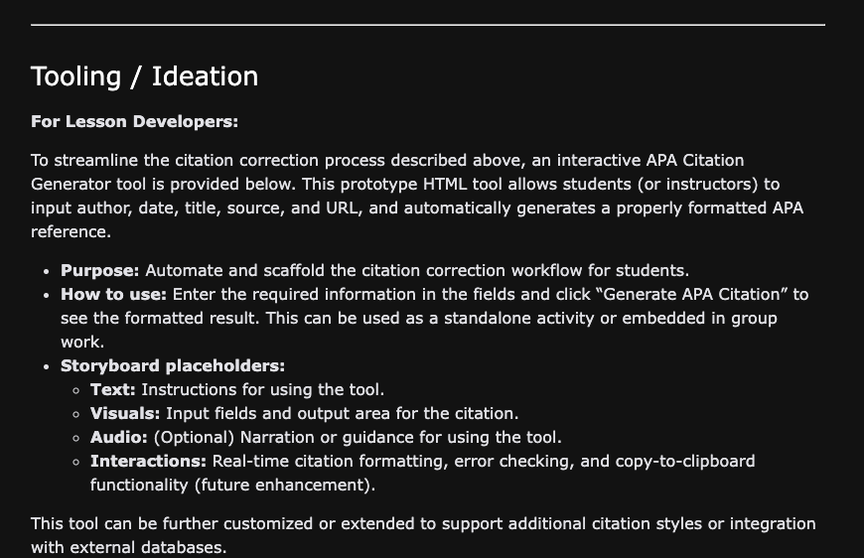

Tool Sample

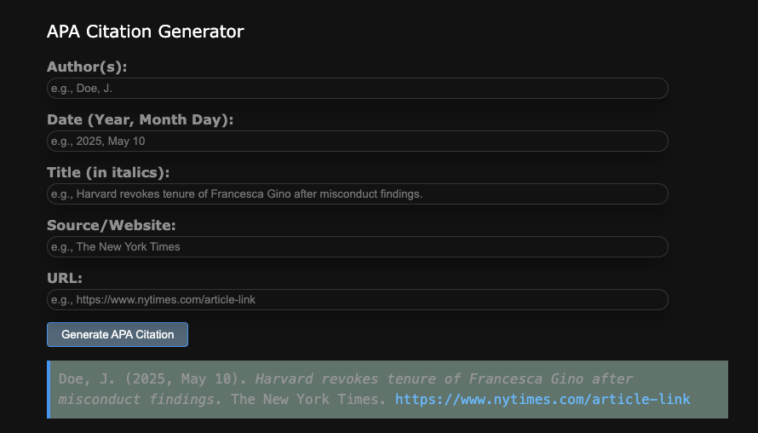

**C2d Group Workshop**

Page 5: Group meeting to correct paper that lacks citations and references.

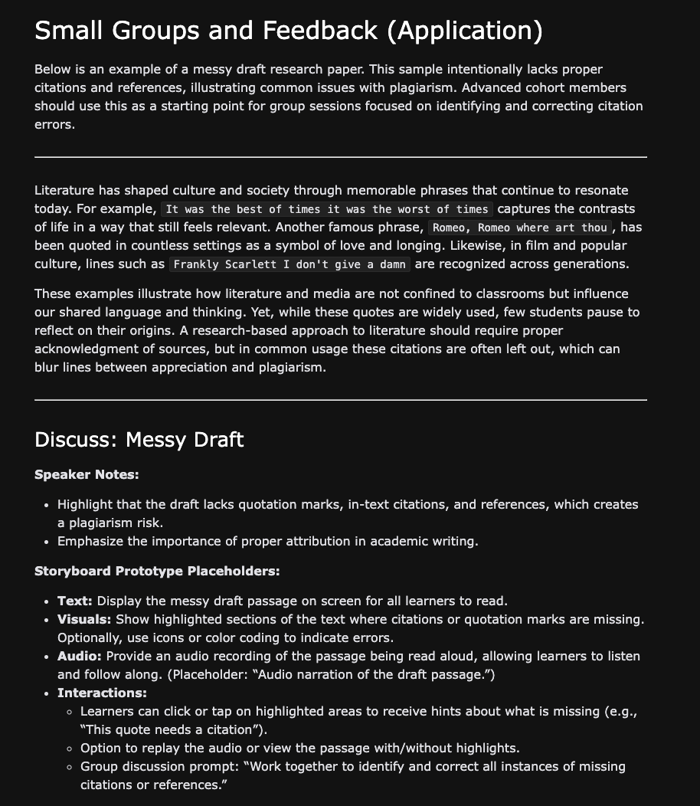

**C3a. Assessment of Workshop**

Page 6: Instructor assessment.

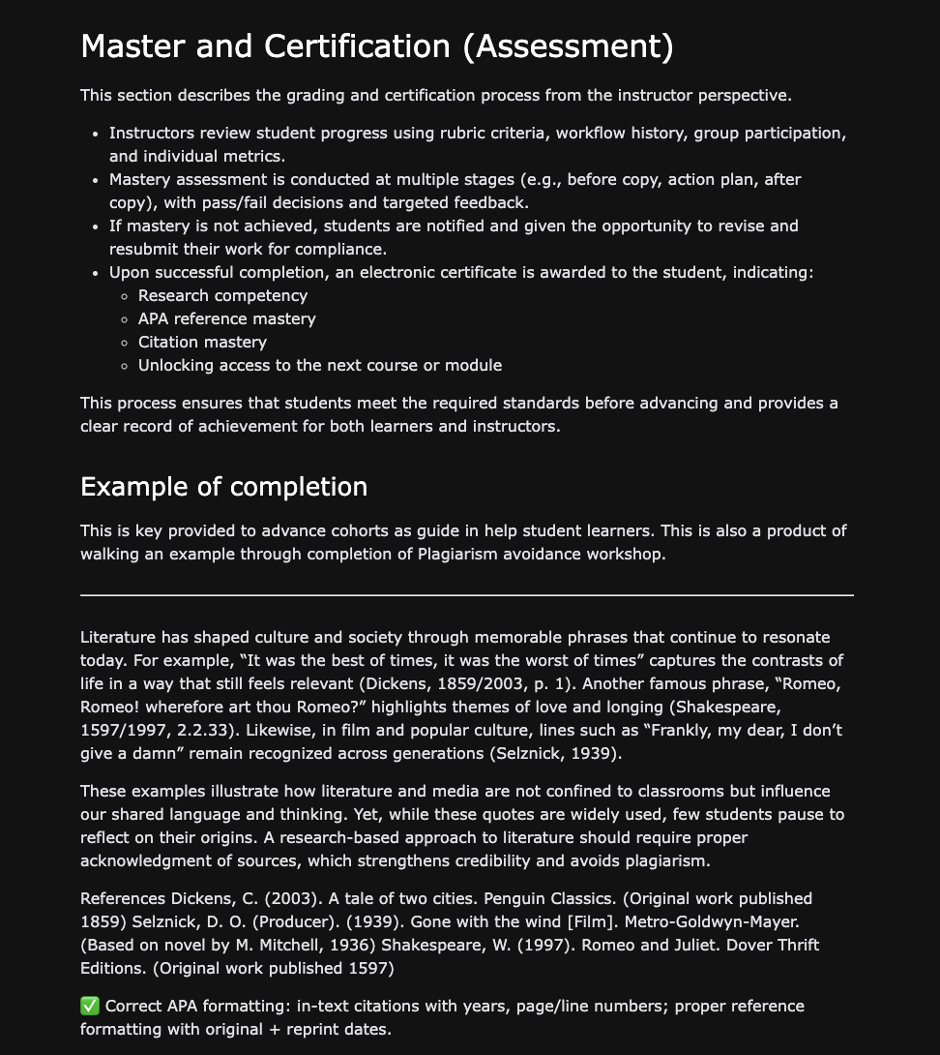

**C3b. Summary**

Page 7: Student learning outcome.

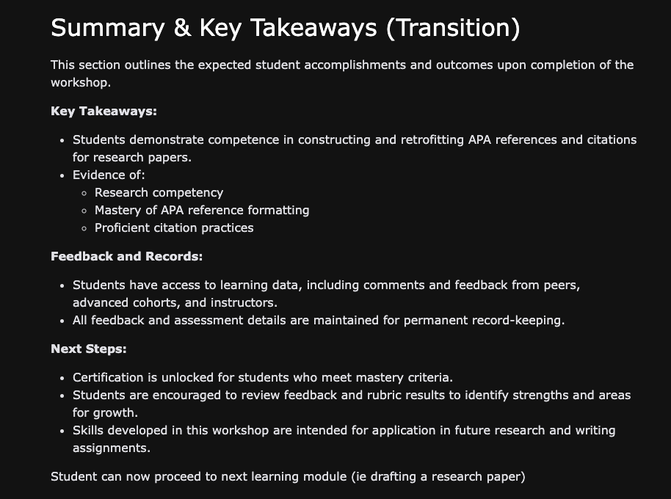

**D. Acknowledgment of Sources**

No sources used outside of WGU-provided materials. Sources used in visuals are self-contained and managed outside of this document.