Miracle Property Management System - Design Document

# 1. Class Diagram (C# Structure)

We define three main classes:  
  
Class: Property  
- int PropertyID  
- string Address  
- decimal Rent  
- string Status (Available / Occupied)  
- Method: DisplayProperty()  
  
Class: Tenant  
- int TenantID  
- string Name  
- int? PropertyID (Nullable if not assigned)  
- Method: DisplayTenant()  
  
Class: PropertyManager  
- List<Property> Properties  
- List<Tenant> Tenants  
- Methods: AddProperty(), ViewProperties(), AddTenant(), ViewTenants(), AssignTenant(), VacateProperty()  
  
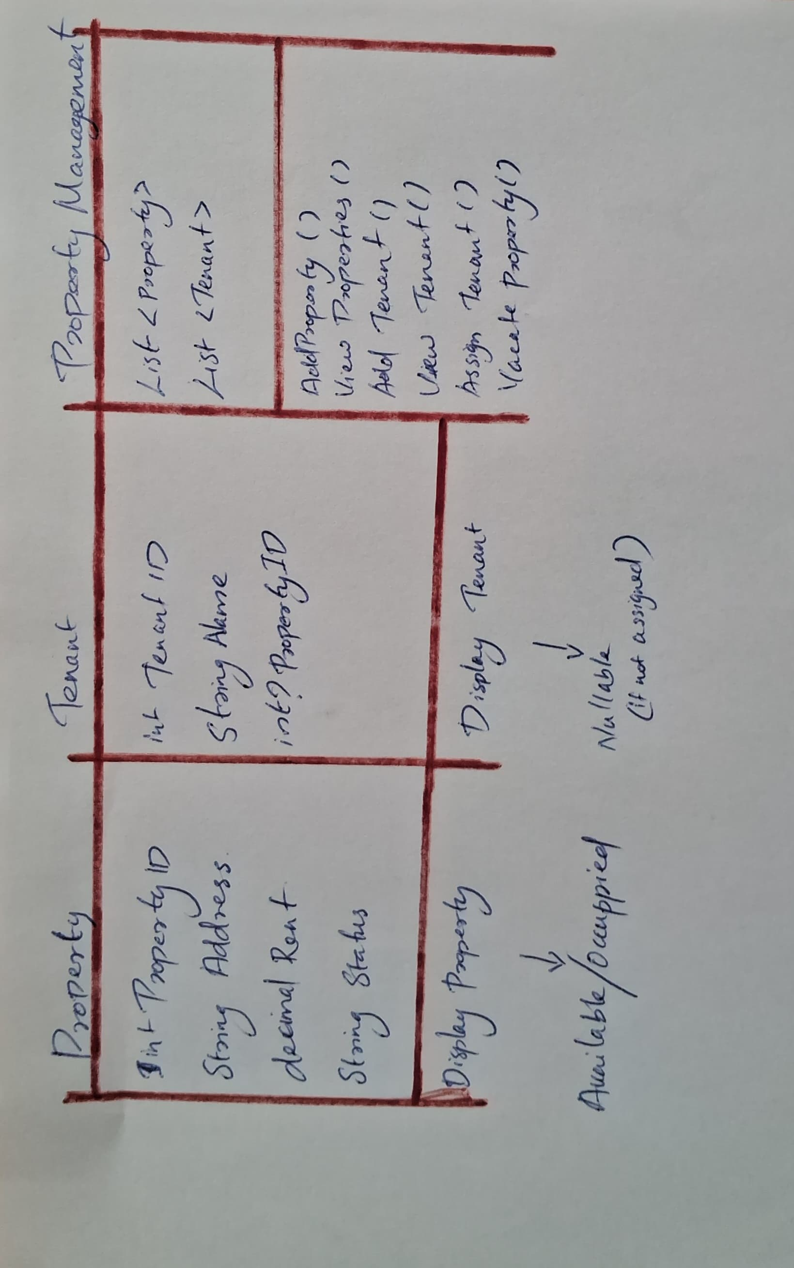

# 2. Database ERD (Entity Relationship Diagram)

Two tables: Property and Tenant  
  
Property Table:  
- PropertyID (Primary Key)  
- Address  
- Rent  
- Status  
  
Tenant Table:  
- TenantID (Primary Key)  
- Name  
- PropertyID (Foreign Key to Property.PropertyID)  
  
Relationship:  
- One Property can be linked to one Tenant  
- One Tenant can be unassigned or assigned to one Property  
  
  
  
  
  
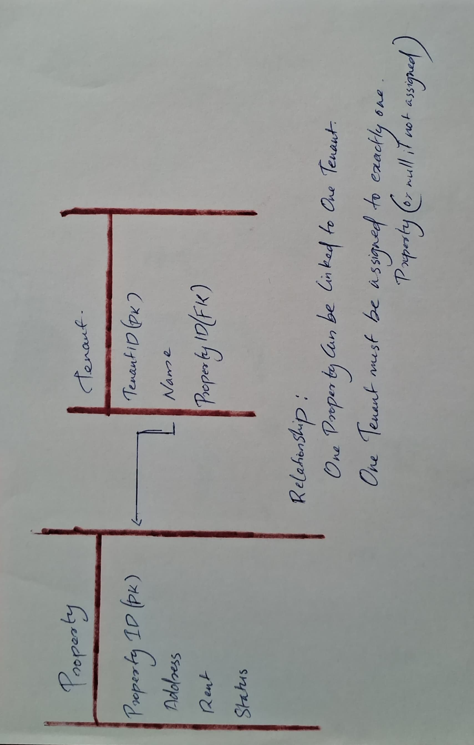

# 3. Console Menu Design

========= Miracle Property Management =========  
  
1. Add Property  
2. View All Properties  
3. Add Tenant  
4. View All Tenants  
5. Assign Tenant to Property  
6. Vacate Property  
7. Exit  
  
===============================================  
Enter your choice: _