Initialise repo

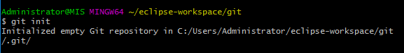









Push all

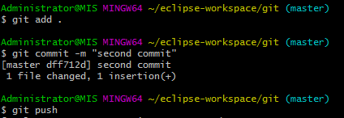

Clone

